## C:\Users\JBird\Downloads\Untitled design (17).png

## Application Pack - Peer Recovery Navigator – Mid & East Ross

**Hours:** 16 hours

**Salary:** £25,425 fulltime equivalent (£11,623 pro rata: £13.97 per hour)

**Pension:** SPIRIT Advocacy operates under the NEST pension scheme. 5% contributions are made to your nest pension after 3 months of probation. The employee contribution to the pension is 3%.

**Holidays:** The Annual Leave entitlement per year is 5 weeks plus public holidays (pro rata)

**Contract:** 9 months

**Location:** Hybrid – community-based across Mid and East Ross, with some home working supported by provision of equipment (e.g. laptop and phone) and occasional travel to Inverness for meetings, development sessions and training

**Line Manager:** Peer Recovery Co-ordinator

**Flexibility And Working Conditions**

This role is designed to be flexible. Hours can be arranged to suit the needs and wellbeing of the postholder and can accommodate caring responsibilities or phased working patterns.

**About the Pathways to Recovery Project**

Pathways to Recovery is a collaborative initiative between Spirit Advocacy, Connecting Carers, and NHS Highland. It supports people 18 and over who have lived experience and/or caring for someone who has lived experience in Mid and East Ross with their mental health and well-being by providing peer-led, relational support grounded in lived experience.

Peer Navigators work alongside individuals to help them make sense of their experiences, build confidence in navigating services, and feel empowered in their recovery. The project aims to:

* Improve access to compassionate, person-led support
* Reduce feelings of isolation, distress or being 'stuck'
* Strengthen collaboration between communities, services, and support networks
* Build local capacity through values-based training and partnership working

We are recruiting for two Peer Recovery Navigators to join our Highland-based team. The posts will work across Mid and East Ross, offering flexible and relational support depending on local needs.

Wherever possible, each Peer Recovery Navigator will provide continuity in the areas and communities they know best.

**About Spirit Advocacy**

Spirit Advocacy is a lived-experience-led organisation that exists to amplify the voice of those with lived experience of mental ill health, neurodiversity, learning disability, and related issues.

We believe in compassionate and relational support models that challenge stigma and promote recovery, rights, and inclusion.

Our work is grounded in CRIES values framework that reflects the character and culture of our work

* Compassionate
* Respectful
* Inclusive
* Empowering
* Supportive.

Spirit Advocacy operates across Highland through regionally based collective advocacy services such as HUG (Action for Mental Health), People First Highland, and localised Experience Matters Advisory Panels.

This new Pathways to Recovery Project is funded through the Scottish Government’s Community Mental Health and Wellbeing Fund and delivered in collaboration with Connecting Carers and NHS Highland.

To find out more about Spirit Advocacy visit [**www.spiritadvocacy.org.uk**](http://www.spiritadvocacy.org.uk).

**About the role**

Peer Recovery Navigators draw upon their own lived experience to provide one-to-one and group-based relational support for people in Mid and East Ross who are navigating challenges relating to their mental health or wellbeing.

This is a strengths-based, person-led role where peer relationships are grounded in mutuality, empathy, and trust. Peer Navigators act as knowledgeable allies – walking alongside individuals as they connect with services, rediscover a sense of purpose, and define their own recovery.

**Key Responsibilities:**

**1. Peer Support and Relationship Building**

* Build trusting, non-judgemental relationships with people referred to the service
* Provide trauma-informed 1:1 intentional peer support with the potential to develop small group work
* Offer support and insights drawn from your own lived experience
* Support people to not only access services but to feel confident and comfortable engaging with them

**2. Recovery Planning and Navigation**

* Co-develop personal recovery or well-being plans based on what matters to the individual
* Help individuals navigate local services, systems, and supports
* Attend appointments or meetings alongside participants as a peer supporter or ally
* Support individuals to make meaningful connections with wider services, supports or community groups

**3. Collaborative Working**

* Promote awareness of and encourage participation in Spirit Advocacy’s collective advocacy membership, helping individuals to connect with peer-led networks and opportunities to influence change
* Work in collaboration with the Peer Recovery Navigation Coordinator and our project partners: the Mid and East Ross Community Mental Health Team and Connecting Carers
* Build relationships with a broad range of local and regional third sector organisations to support onward referrals and wider community engagement

**4. Record Keeping, Learning, and Evaluation**

* Maintain accurate, confidential records in line with data protection standards
* Support evaluation and feedback processes with the National Centre for Remote and Rural Health and Care to ensure the service remains responsive and impactful

**Person Specification**

**Essential Experience and Knowledge**

* Personal lived experience of mental ill health, distress, or unpaid caring responsibilities
* Understanding of boundaries, safeguarding, and trauma-informed practice
* Awareness of local issues and challenges within Mid and/or East Ross
* Basic knowledge of services within the third sector and public sector mental health landscape

**Essential Skills and Qualities**

* Ability to build supportive, equal relationships based on trust and empathy
* A compassionate, person-centred, and strengths-based approach
* Excellent communication and active listening skills
* Basic IT proficiency (email, online communication, digital record-keeping)
* Willingness to undertake relevant training (e.g. intentional peer support)

**Desirable Experience**

* Experience of providing peer support, group facilitation, advocacy or activism
* Involvement in community-led initiatives or collective advocacy
* Confidence using local community assets and working with referral partners
* Speaking up or presenting in partnership or co-production settings

**Additional Requirements:**

* **Education:** While formal qualifications are not mandatory, relevant experience and training in mental health, community work, or a related field are highly valued.
* **Driving License:** A full clean UK Driving Licence and access to a vehicle for site visits are highly desirable. Alternative travel arrangements may be considered depending on local availability and accessibility needs.
* **References:** Candidates should provide references who can speak to their suitability for this role, particularly regarding their lived experience and community engagement skills.
* **Background Check:** A PVG (Protecting Vulnerable Groups) check will be required as part of the hiring process to ensure the safety and well-being of all participants.

**Safeguarding and Boundaries**

Spirit Advocacy is committed to the safety and wellbeing of all individuals we work with. As a Peer Recovery Navigator, you will build trusting relationships with people who are experiencing mental ill health, distress, or vulnerability.

**We provide induction and ongoing supervision to support colleagues:**

* Understand when and how to raise a safeguarding concern
* Recognise signs of distress, risk, or exploitation
* Maintain appropriate boundaries in peer relationships
* Follow safe lone working practices
* Navigate Spirit Advocacy’s safeguarding and data protection policies

All colleagues must attend regular reflective practice sessions and supervision to ensure safe, trauma-informed peer support.

**How to Apply**

Spirit Advocacy is committed to creating an inclusive and supportive work environment and recruitment process. We provide reasonable accommodations to ensure that all employees can thrive. Please let us know if you have any specific needs or require support during the application process.

* **Discuss the opportunity:** For an informal discussion about the role, contact John Beaton, Chief Executive Officer, at [**john@spiritadvocacy.org.uk**](mailto:john@spiritadvocacy.org.uk) or call **07553 206666.**
* **Submit your application:** Complete and send your online application via the link below.
* [**https://bit.ly/SAApplyHerePeerRecoveryNavigator**](https://bit.ly/SAApplyHerePeerRecoveryNavigator)
* **Deadline for applications:** Monday the 30th, June 2025 at 12.00 noon.

**What happens next?**

* **Notification:** Candidates will be notified of the outcome within two weeks of the application deadline.
* **Interviews:** Scheduled to take place the following week
* **Start Date:** Flexible start date based on candidate availability

**Join us**

This is more than a job — it’s an opportunity to make a tangible difference in the lives of people in Mid and East Ross experiencing mental health and wellbeing challenges.

If you have the passion, empathy, and commitment to walk alongside others in their recovery, we’d love to hear from you!

Spirit Advocacy is committed to diversity and equality and welcomes applications from all sections of the community. **We look forward to receiving your application and exploring how you can contribute to our mission of empowerment and advocacy.**

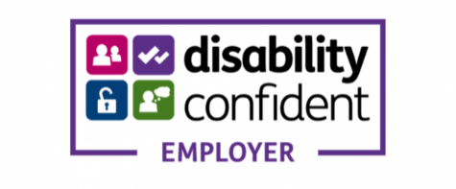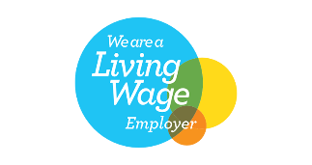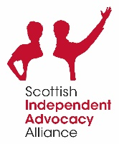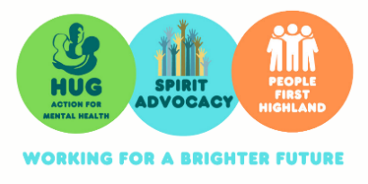**Spirit Advocacy is Scottish Incorporated Charitable Organisation SC042513**