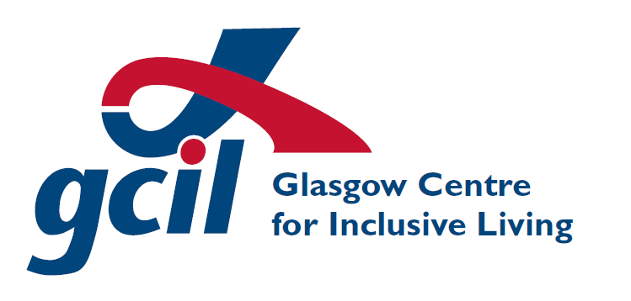
Glasgow Centre for Inclusive Living
Application for Employment Notes for Guidance

These guidance notes are designed to assist you to complete the attached application form. Please read this guidance carefully before you complete the form. All recruitment documents and correspondence can be provided in alternative formats – if you require an alternative format, please contact us recruitment@gcil.org.uk or 0141 550 4455.

Introduction

Before completing the application form, make sure you have read through the job description and any accompanying information carefully. The information you provide will be used to decide whether you are invited to interview.

All applicants should complete the application form; CVs will not be accepted. Applications received after the closing date will also not be accepted, regardless of when the form was signed.

A Job Details
The advert reference number and job title can be found in the advertisement for the post.

B Personal Details
Please ensure that you give us your current address and telephone number(s). If you provide your email address, it will only be used for recruitment correspondence; it will not be used for marketing purposes.

If you are invited to interview, you will be required to provide certain documentation to demonstrate that you are entitled to work in the UK e.g. a valid passport, a birth certificate issued in the UK or Ireland, a P45, a P60, or a formal document showing your National Insurance number.

C Job Sharing
GCIL operates a job sharing policy, and all jobs are eligible. A request to job share will not affect your application.

D Rehabilitation of Offenders
The Rehabilitation of Offenders Act 1974 (Exceptions) Order 1975, as amended, applies to some posts within GCIL. Successful applicants for specific posts will be required to submit to a Disclosure Application, the results of which might impact on your suitability to work in a particular job. The Terms and Conditions of the post will tell you if the above applies.

G Declaration
Applicants are reminded that all information contained in the form must be true and correct to the best of your knowledge. Any false information or omissions may lead to summary dismissal. By signing and dating this section, you are agreeing that you understand how GCIL will use the information you have provided and you are also giving your consent for GCIL to do this.

H Qualifications and / or Training
Refer to the job description and list any qualifications, training or courses etc. from school, further education or elsewhere, which are relevant to the job. Please also list any qualifications you are working towards.

I Membership of Professional Institutes
Refer to the job description and if it is necessary for you to be a current member of a professional body, please indicate your current membership status.

J Present Employment
This section is to provide details of your current employer, or, if you are not working at present, your most recent employer. You should provide brief details of this position, with an emphasis on those areas most relevant to the job applied for.

K Previous Employment
Please list here, in date order with the most recent first, brief details of your previous employment history. Include any periods of vacation or voluntary work, especially where you feel this is relevant to your application. Please account for any gaps in your employment history.

L Relevant Skills, Experience and Abilities
Before completing this section, pleased read and consider the job description, person specification and any other details about the post again. You should explain here the skills, abilities, knowledge and experience you have, giving examples of how these demonstrate your ability and aptitude for the post. You can give examples from previous posts (paid or unpaid) you have held, your leisure interests or from your life experiences. Your responses in this section and in section M should be numbered in line with the person specification.

M Continuation sheet
Use this sheet to continue your answer from section L, or to add any further relevant information to support your application.

N References
Provide details of two referees, one of whom should be your present / last employer. If you are a school leaver, or have been out of employment for some time, a reference from a person who can comment on your abilities in relation to the job would be acceptable. References from colleagues, relatives, partners, or friends are generally not acceptable.

O Access Requirements
If you require any particular equipment or access arrangements for an interview, or to undertake this post if your application is successful, or for any other part of the recruitment process, it is important to complete this section with as much detail as possible in order that we can make appropriate arrangements.

Recruitment Charter

We are committed to achieving high standards of quality in recruitment, to ensuring that our appointments are made solely on the basis of merit and that you are treated in a fair and equitable manner.

- When you request a recruitment pack, it will be sent out to you by the end of the next working day.

- The information you provide will be treated in confidence and with discretion.

- We will normally advise you within two weeks of the closing date if you are invited to interview. If you have not heard from us within this timeframe please assume that on this occasion your application has not been successful. Unfortunately we do not have the financial resources to acknowledge application forms or regret letters further to application.

- We will normally give you at least one week’s notice of the interview, and we ask that you confirm that you are able to attend. If you are unable to attend on the day or at the time requested, we will try, where possible to make alternative arrangements.

- The selection process will be conducted in a professional manner and we shall provide you with sufficient information to enable you to make an informed choice regarding the position applied for.

- If you are successful, we will advise you as soon as possible. Written confirmation will normally be made within two weeks of the interviews.

- If you have been unsuccessful at interview, we will normally advise you, in writing, within two weeks.

- On request, we will give you constructive feedback on your interview.

