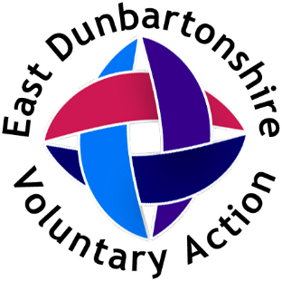

Recruitment Pack
Project Officer – Vaping and Nicotine Use

Role Details:
Part-time (16 hours per week) with some flexibility on which days are worked.
Fixed Term Contract – 12 months
Salary £28,119 per annum (pro-rated salary £12854.40)
Base: Jointly within the EDVA office, 18 Townhead, Kirkintilloch G66 1NL and Kirkintilloch Health and Care Centre, with travel around East Dunbartonshire.

About East Dunbartonshire Voluntary Action:
East Dunbartonshire Voluntary Action (EDVA) is a charity. We are the Third Sector Interface (TSI) in East Dunbartonshire. Our main source of funding is from the Scottish Government, who fund a network of 32 TSIs across Scotand and we work to 4 key priority areas:
Building Capacity – We help community groups and organisations to become established, grow, and utilise good practice so they are well equipped to deliver their purpose.
Sharing Knowledge and Information – We help to share information about the sector and with the sector
Ensure Voice – we advocate for the Third Sector
Building Positive Connections – we help connect organisations and volunteers, help connect organisations with each other and with statutory partners, enhancing their ability to strengthen communities in East Dunbartonshire through collaboration, inclusion and involvement.
In addition we deliver short term projects in collaboration with partners e.g. raising awareness of the locally relevant findings of the GGC Health Board Health and Wellbeing Survey, and distributing social enterprise and community food and nutrition grants.
Our office in Kirkintilloch has a tenant organisation who sublets space from us and in addition we have meeting room space which can be hired by local organisations, statutory sector or businesses.
Our business hours are generally 9-5, Monday to Friday with occasional evening/ weekend work
About the role:
We are looking to recruit a project officer to deliver a fixed term project around attitudes to, and awareness of, vaping and nicotine products within East Dunbartonshire. More details are provided in the job description below.
This role will suit someone with experience of engaging with communities, health needs assessment and project management.

Job Description:
- To assess the prevalence of vaping and nicotine product use among young people aged 12-17
- To understand the attitudes and perceptions of young people towards vaping and nicotine products
- To identify factors influencing vaping and nicotine product use, behaviours in this age group
- To provide localised evidence-based recommendations for public health interventions and to evidence the local need for policy and practice
- To deliver reports and presentations around findings and recommendations to a variety of audiences
- To undertake public health interventions to decrease the acceptability and accessibility of young people initiating vaping or using new nicotine products
- Any other relevant duties as required by the Chief Officer

Skills/ Experience:
Used to working independently and with limited supervision | Essential
Experience in engaging with communities, including seldom reached communities | Essential
Understanding of/ experience in delivering health needs assesments | Essential
Good communication skills including verbal, written and presentation | Essential
Experience in creating recommendations from evidence | Essential
Excellent time management | Essential
Confident in use of Microsoft packages including Word, Excel, Powerpoint and Sharepoint | Essential

To apply please complete the application form and return to Ann Innes at ann.innes@edva.org . Closing date 6th July 2025 at midnight. If you have any questions about the role please contact Ann on the above email address.

