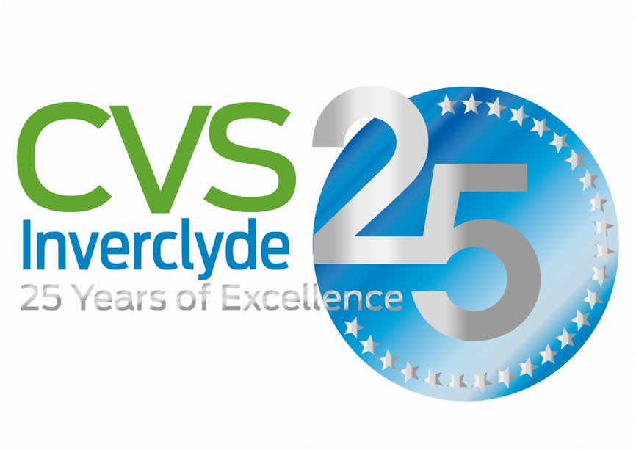
CVS Inverclyde
75-81 Cathcart Street, Greenock, PA15 1DE
Tel: 01475 711733
e-mail: admin@cvsinverclyde.org.uk

Employment Application

All information supplied by applicants will be treated as confidential. The information supplied on this first sheet will be detached and will not form part of the selection process.

Position applied for: |  | Office use Only

Where did you first hear of this post?

PERSONAL INFORMATION

Full name
Address & post code

Telephone no.
E-mail address

DECLARATION (please read carefully before signing)

I certify that all information contained in this application is true and correct to the best of my knowledge. I realise that false information or omissions may lead to dismissal without notice. I understand that in the event of being shortlisted I will be required to complete a confidential declaration regarding unspent criminal convictions.

Signature Date

Private & Confidential
Employment Application

All sections of this application form must be completed. Please do not send us a supporting curriculum vitae.

Position applied for: |  | Office Use Only

1 CURRENT / MOST RECENT EMPLOYMENT

Post held

Name & address of employer

Dates (from/to)

Salary

Notice required or reason for leaving

Please describe your main responsibilities, achievements, skills & experience.

2 PREVIOUS EMPLOYMENT HISTORY
List previous employment and any relevant voluntary work, starting with the most recent

Dates | Position held, nature of duties & reason for leaving | Name/address of employer

3 EDUCATION & TRAINING
Please describe your formal and informal education, including qualifications gained, and any other training you have undertaken. Please refer to the qualifications required within the Person Specification

4 PROFESSIONAL MEMBERSHIP

Professional body | Category of membership | Date obtained/elected

5 EXPERIENCE & KNOWLEDGE
Please outline how your experience and knowledge make you suitable for this post. The Person Specification covers the requirements that we have for the post. We recommend you take each requirement in turn and provide evidence of how you meet the requirement. You should also provide any further information that you believe is relevant

6 Please describe your reasons for applying for this post and include any other relevant information.

7 CVS Inverclyde is a Disability Confident Employer and all disabled candidates meeting the essential criteria for appointments to this post will be interviewed. If you wish to take advantage of this opportunity, please give details of any disability or condition that you would wish us to be aware of.

If called for interview, please state any help required (e.g. signer, wheelchair access)

8 REFEREES
Referees will only be contacted after interview and asked to comment on your ability to meet the requirements of the post. Please provide details of two referees, one of whom should be your present or most recent employer.

 | First referee (current or most recent employer) | Second referee
Name

Position & organisation (if appropriate)

Address & post code

Telephone no

E-mail

In what capacity does this referee know you?

