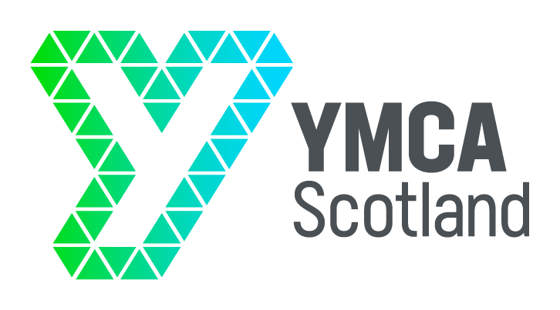

#### APPLICATION FORM

## IN CONFIDENCE

Please note that only the information given in this application form will be considered in determining whether or not you will be called for an interview. Please specifically address the criteria detailed in the Person Specification. CV’s will not be considered.

|  |  |
| --- | --- |
| 1 JOB DETAILS Post applied for: **Project Manager**  Location: Edinburgh/Hybrid | |
|  | |
| 2 PERSONAL DETAILS Surname | First name  *(initial only)* |
| Address | Telephone  Work  May we contact you there? **YES/NO**  Email |
| Are you a settled worker (i.e. do you have the permanent right to work in the UK – for example as a British or EEA citizen)?  **Yes No**  If no, do you already have temporary permission to work in the UK?  **Yes No**  If yes, please specify your visa type and visa end date: | |
| If appointed, when could you take up the position?  If you are currently employed, what notice period are you required to give? | |
| Have you had any previous contact, or do you have any current contact with the YMCA?  If Yes, please give details | |
| Do you hold a current UK driving licence?  *(a full driving licence is required for this position)* | |
| Please state where you first saw this vacancy? | |

|  |  |  |
| --- | --- | --- |
| **3 EDUCATION, TRAINING AND DEVELOPMENT**  Please list your academic and relevant qualifications, and dates passed | | |
| Qualifications gained | Date | Place of study |
|  |  |  |
| Please describe other relevant learning opportunities, e.g. training courses | | |
| Learning opportunity | Date | Place of study |
|  |  |  |

|  |  |  |
| --- | --- | --- |
| 4 EMPLOYMENT INFORMATION Please give details of your employment (paid or unpaid) starting with your present/most recent employer and working backwards | | |
| Dates of Employment | Employer Name & Address | Position and Main Responsibilities |
|  |  |  |

|  |
| --- |
| 5 SUPPORTING INFORMATION Please detail how you meet the person specification for this position, illustrating with examples from work, voluntary or life experiences, and stating why you are applying for this position |

**Please note the closing date is 5pm Friday 11 July 2025**

**Please return completed application forms to jillian@ymca.scot**