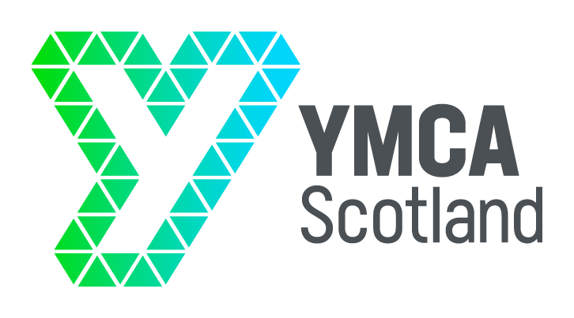

**EQUALITY AND DIVERSITY MONITORING FORM**

**YMCA Scotland is an equal opportunity employer both in the provision of services and as an employer of staff and volunteers. We recognise the benefits of a diverse community and are committed to being an inclusive organisation where everyone is treated with respect, dignity and where there is equal opportunity for all.**

Completing this form is voluntary. The information provided will be kept confidential.

The information you provide does not form part of the selection procedure; it is used only for monitoring purposes. This sheet will be separated from your application form before short-listing.

Post applied for **PROJECT MANAGER**

Please tick the appropriate box

Age Range

up to 25 26-35 36-45 46-55 56 and over

Do you have a disability, impairment or health condition which affects your day-to-day activities?

|  |  |  |  |  |  |
| --- | --- | --- | --- | --- | --- |
| Yes |  | No |  | Prefer not to say |  |

The information in this form is for monitoring purposes only. If you believe you need a ‘reasonable adjustment’, then please discuss this with your manager, or the manager running the recruitment process if you are a job applicant.

What is your ethnicity?

*This may be different to your nationality, place of birth or citizenship*

**Please choose ONE section from A to F, and then circle the appropriate box to indicate your background**

### Asian or Asian British

**☐** Asian British

☐ Bangladeshi

☐ Chinese

☐ Indian

☐ Pakistani

☐ Another Asian background, please say what:Click or tap here to enter text.

☐ Prefer not to say

### 

### Black, African, Caribbean or Black British

**☐** African

☐ Black British

☐ Caribbean

☐ Another Black, African or Caribbean background, please say what:Click or tap here to enter text.

☐ Prefer not to say

### Mixed or Multiple ethnic groups

**☐** Asian and White

☐ Black African and White

☐ Black Caribbean and White

☐ Another Mixed or Multiple ethnic group, please say what:Click or tap here to enter text.  
☐ Prefer not to say

### White

**☐** English

☐ Gypsy or Irish Traveller

☐ Irish

☐ Northern Irish

☐ Scottish

☐ Welsh

☐ Other European

☐ Another White background, please say what:Click or tap here to enter text.

☐ Prefer not to say

### Another ethnic group

**☐** Arab

☐ Another ethnic group, please say what:Click or tap here to enter text.

☐ Prefer not to say

What is your sex?

☐ Female

☐ Male

☐ Prefer to self describe, please say how:Click or tap here to enter text.

☐ Prefer not to say

I understand that this information may be stored and processed as part of the YMCA’s monitoring of equal opportunities and diversity as part of the recruitment procedure and give my consent for my details to be used for this purpose

Signature Date