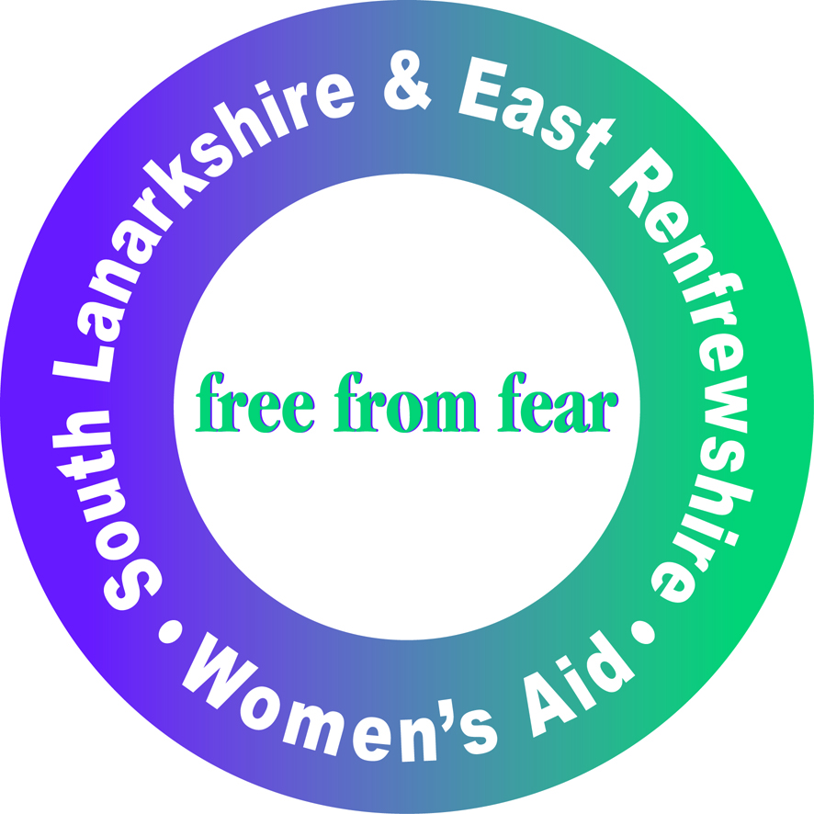

Women’s Aid South Lanarkshire and East Renfrewshire
Director Application Form

Section 1: Personal Details

Please complete all the information requested below

Name:
Address:

Tel No: | Email:

Section 2: Current or past Voluntary Commitments

Please tell us of any Board positions you currently hold.

Section 3: Relevant skills, knowledge and experience

In this section you are asked to outline how your knowledge, skills and experiences meet those required for this role (as outlined in the Person Specification).You should draw on your experiences from your current or previous roles or from other relevant situations (such as activities outside work).

Section 4: The Data Protection Act 1998

WASLER will use the information you provide in this application form to process your application for employment. The personal information that you give us will also be used in a confidential manner to help us monitor our recruitment process.

Section 5: Declaration

I declare that the information contained in this application is correct and complete.

Signature:

Print Name:

Date:

Equal Opportunities Monitoring Form

WASLER is committed to promoting quality of opportunity. You are not required to answer any or all of the questions, but it would assist us in monitoring the effectiveness of our recruitment and selection policy.

The information you provide is for monitoring purposes only and will not be used as part of the recruitment and selection process. This section will be removed before the shortlisting process. The information will be treated in the strictest confidence.

If returning by post, please return in a sealed envelope marked confidential.

Post Applied For

Age (please tick)
- Under 20
- 20-30
- 31-40
- 41-50
- 51-60
- Over 61
- Prefer not to say

Ethnic Origin
A White
- British
- Irish
- Any other White background (please specify)

B Mixed
- White and Black Caribbean
- White and Black African
- White and Asian
- Any other mixed background (please specify)

C Asian or Asian British
- Indian
- Pakistani
- Bangladeshi
- Any other Asian background (please specify)

D Black or Black British
- Caribbean
- African
- Any other Black background (please specify)

E Chinese or other ethnic group
- Chinese
- Any other Chinese background (please specify)

F Other Ethnic background
- Other Ethnic background

G Prefer not to say
- Prefer not to say

Religion or Religious Belief
- Buddhist
- Christian
- Hindu
- Jewish
- Muslim
- Sikh
- Other
- Prefer not to say

Do you consider yourself disabled?
- Yes
- No
- Prefer not to say

Sexuality
- Bisexual
- Gay
- Heterosexual
- Lesbian
- Other
- Prefer not to say

Gender Identity

- Female
- Male
- Other
- Prefer not to say

Transgender

- Yes
- No
- Prefer not to say

