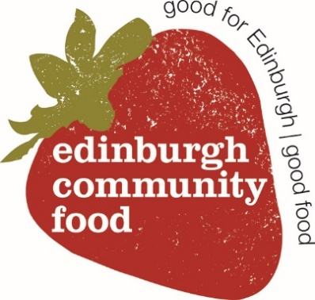 | Job Title: Fundraising and Impact Manager (21 hours)  Location: Edinburgh / Hybrid  Reports to: CEO

Purpose of the Role
This role will lead on developing and delivering a sustainable fundraising strategy while strengthening how Edinburgh Community Food (ECF) demonstrates its impact on food insecurity and community wellbeing. You will secure income from diverse sources, including trusts, foundations, and corporate partnerships, and develop tools to measure and communicate the difference our work makes.
You’ll work closely with the CEO and project leads to ensure ECF has the resources and evidence needed to thrive in a challenging funding environment and to continue delivering high-quality, dignity-based services.
Key Responsibilities
- Develop and deliver the charity’s fundraising strategy.
- Build and maintain relationships with funders, donors and corporate partners.
- Write compelling funding applications and reports.
- Create an impact measurement framework aligned with organisational goals.
- Collaborate with program teams to collect data, stories and outcomes.
- Report impact to stakeholders (funders, Board, partners, community).
- Represent the charity externally at fundraising and sector events.
Person Specification
Essential:
- Proven experience in fundraising (especially grants and trusts, or major donors).
- Strong written and verbal communication skills.
- Track record in researching funding prospects and producing successful bids.
- Experience in monitoring, evaluation and impact reporting.
- Understanding of food insecurity or community development.
- Ability to work independently and collaboratively in a small team.
- Commitment to equity, dignity and inclusion.
Desirable:
- Experience in CRM/database management.
- Familiarity with impact frameworks (e.g., Theory of Change, Logic Models).
- Experience working in the third sector or social enterprise.
- Knowledge of local and national funders in Scotland.
Key Skills
- Fundraising & Bid Writing
- Strategic Thinking & Income Generation
- Impact Reporting & Evaluation
- Prospect Research & Relationship Management
- Verbal and Written Communication
- Team Collaboration & Organisational Insight
- Equity, Inclusion & Values-Driven Practice
Working Conditions / Salary and Benefits
- Part-time (3 days / 21 hours per week)
- Based at Edinburgh Community Food (ECF), with flexible and hybrid working options
- Salary: £35–£38k Pro rata (depending on experience)
- Benefits: Pension scheme and professional development opportunities
How to Apply
Please send your CV and a covering letter to admin@edinburghcommunityfood.org.uk
Please include “Application – Fundraising and Impact Manager” in the subject line.
Closing date: Tuesday 16th July 2025 (noon)
Interview date: Friday 25th July 2025

