Job title: | Senior Community Development Practitioner
Starting salary: | £39,000 – £40,500 (dependent on experience) plus 5% pension contribution
Location: | Hybrid – home, community, and office-based (James Hutton Institute, Craigiebuckler, Aberdeen)  Regular travel across Aberdeen City and Aberdeenshire required.
Contract: | Fixed term until 30th June 2026 (with potential for extension)
Hours: | Full-time (37.5 hours per week) Monday to Friday (flexi-time). Evening and weekend work required with notice.
Reports to: | JTCP Manager (Project and Practice Lead)
Closing Date: | Wednesday 16th July at 23:55
Interviews: | TBC – July / August 2025
To Apply: | Please submit a relevant CV, cover letter and Equality & Diversity form to recruitment@nescan.org
Candidates must have a right to and be eligible to work in the United Kingdom.

About NESCAN Hub
North East Scotland Climate Action Network (NESCAN) Hub is the regional community climate action hub supporting a growing network of people and community-led organisations in Aberdeen City and Aberdeenshire.
We work to create a flourishing, connected and sustainable North East Scotland by offering training, guidance, and development opportunities for community-led climate action.
Our Aims:
- Support and develop community-led climate action across Aberdeen City and Aberdeenshire.
- Enable communities to participate fully in a just transition to a sustainable region - contributing to local, regional, and national policy and decision-making.
🔗 Learn more at www.nescan.org

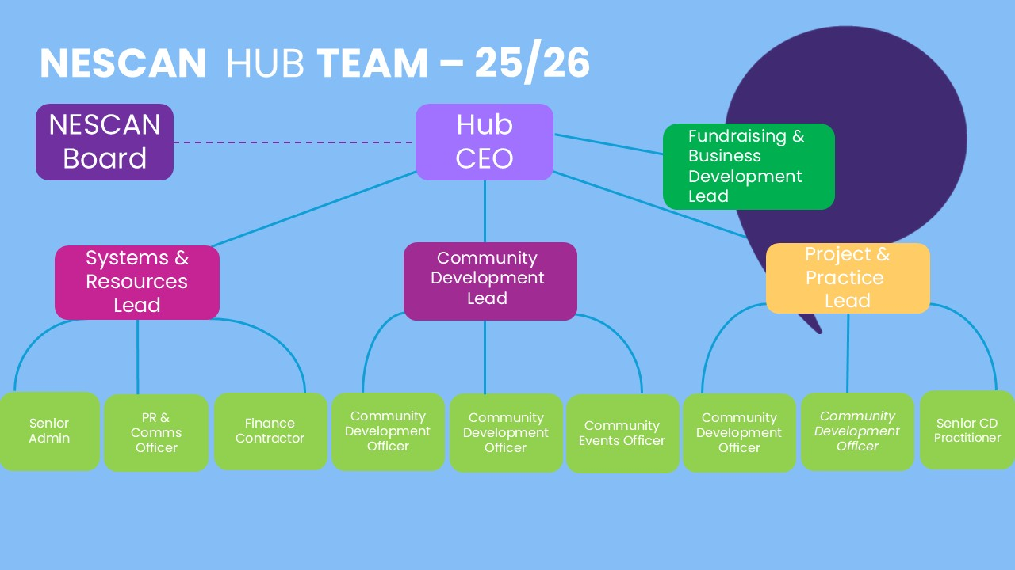

About the Role

Key Project: Just Transition Communities Project (JTCP)
Aim: To improve citizen participation in a just transition toward net zero in the North East of Scotland, ensuring fairer, greener outcomes for all. just-transition-communities
This experienced practitioner post will play a pivotal role in the next phase of the Just Transition Communities Project, building on the work of Community Assemblies and deliberative processes developed during the project’s first three years.
You will:
- Support communities to realise their climate action plans.
- Mentor and guide Community Development Officers.
- Lead on resource development and community learning.
- Represent NESCAN Hub and communities within partnership and stakeholder forums.
- Drive forward meaningful, community-led approaches to climate justice and social transformation.
This is a dynamic, hands-on role requiring strong leadership, deep understanding of community development practice, and a firm commitment to fairness, inclusion, and climate action.

Key Responsibilities
Leadership & Practice Development
- Lead the delivery of NESCAN Hub’s community development work within a just transition framework.
- Support and mentor community development staff to deliver high-quality, values-led practice.
- Develop and deliver innovative training tools and resources rooted in CLD principles.
Community Support & Empowerment
- Work with communities engaged in JTCP (Years 1–3) to activate and implement their action plans.
- Facilitate inclusive capacity-building to support community voices influencing policy.
- Enable green skills, jobs and community wealth-building through local collaboration.
- Support the development of a regional assembly and increased community participation in the wider NESCAN network.
Training, Learning & Resource Development
- Create and deliver training content tailored to diverse audiences and contexts.
- Lead professional learning workshops for staff, stakeholders and wider networks.
- Produce accessible community learning and development materials using JTCP methodology.
- Foster democratic learning for both community members and practitioners.
Partnership & Advocacy
- Build strong relationships with local authorities, delivery partners and community groups.
- Represent NESCAN Hub at events, strategic forums and in stakeholder discussions.
- Advocate for the replication and scaling of community-led just transition models.
Monitoring, Evaluation & Impact
- Use established evaluation tools to track project progress and measure impact.
- Produce accessible, evidence-based reports for multiple audiences.
- Share learning via project websites, media, events and national climate/CLD networks.
Person Specification: EXPERIENCE/SKILLS/QUALITIES

Essential
- Operate as a responsible, reliable, trustworthy and effective team member
- Recognised qualification in Community Learning and Development (CLD)
CLD recognised qualifications
- Strong leadership and reflective practice skills
- Excellent facilitation and communication abilities
- Demonstrated experience in designing and delivering learning content
- Knowledge of CLD standards, safeguarding, and good practice
- Demonstrable commitment to climate justice and just transition principles
- Strong partnership-building and stakeholder engagement experience
- Highly organised with the ability to manage competing demands
- ICT proficiency (Microsoft Office and digital tools)
- Willingness to work evenings/weekends with notice
- Commitment to NESCAN’s values and ongoing professional development
- Ability to unite diverse interests and support consensus-building
- Full UK driving licence and access to a car
Desirable
- CLD Standards Council membership
- Certified in Climate Literacy
- Understanding of relevant local/national just transition policy
- Experience supporting community influence on policy and planning
- Experience with rural, urban, and/or marginalised communities
- Youth engagement in climate justice work
- Experience working within a Diversity, Equity and Inclusion framework

Working Conditions & Benefits
- Hybrid role: home, office (Aberdeen, required in office every Tuesday, as minimum), and community-based
- Extensive travel across Aberdeen City and Aberdeenshire; occasional national travel
- Travel & other business expenses reimbursed
- 35 days annual leave (including public holidays)
- 5% employer pension contributions
- Professional development opportunities
- Employee assistance programme
- Access to flexi-leave (up to 2 full days/month)
- Contractual leave for sickness, parental/maternity, bereavement, and other circumstances
Join Us
This is a rare opportunity to join one of Scotland’s most ambitious and impactful climate networks. You’ll play a vital leadership role in helping communities shape a just, sustainable transition—supporting action that makes a tangible difference to lives, places, and futures.
If you’re a values-driven CLD professional ready to lead change, we’d love to hear from you.

