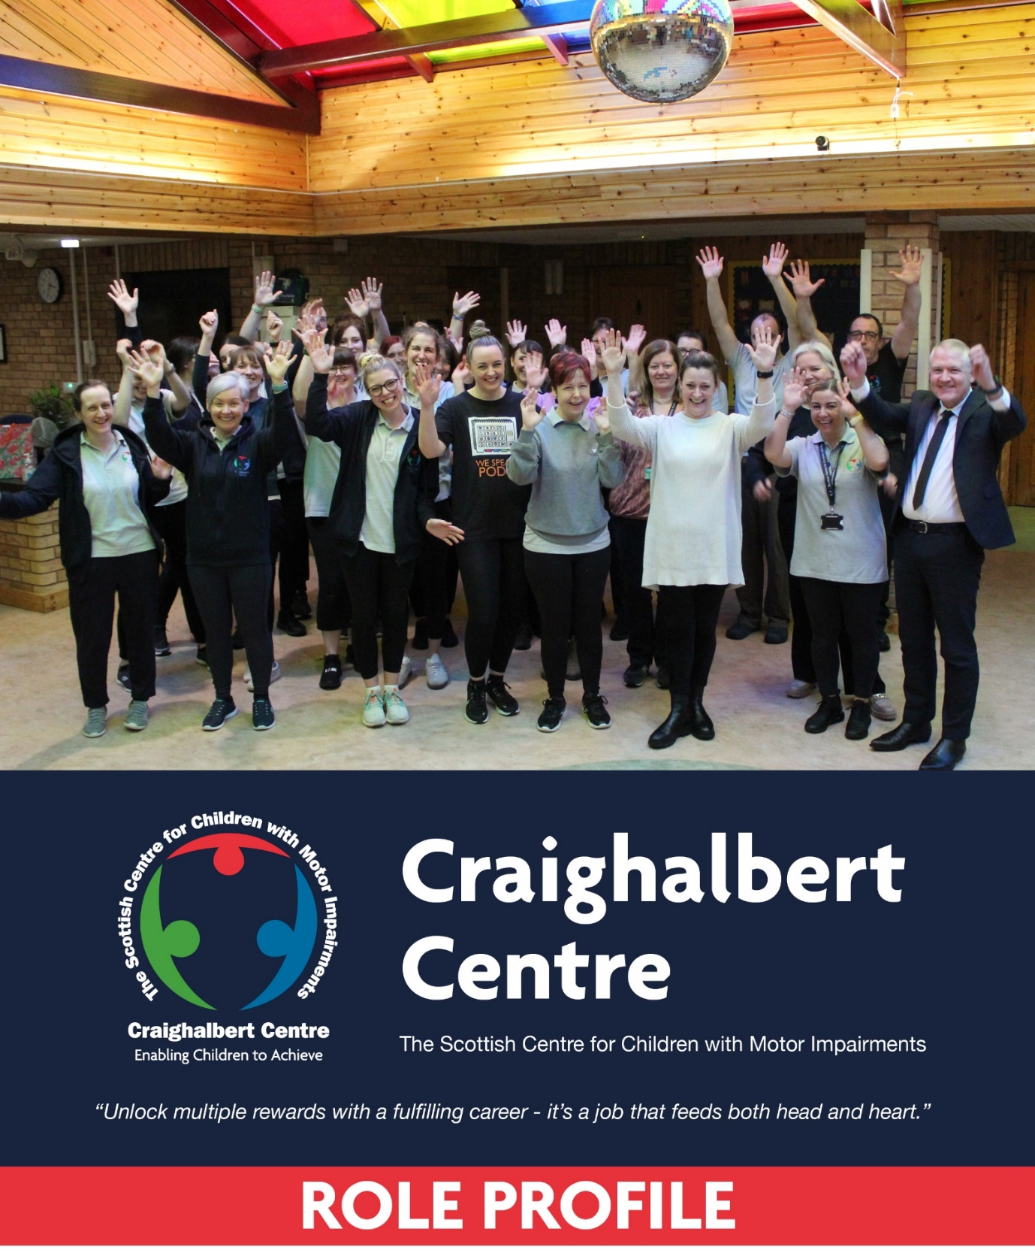
Position: Facilities Officer
Salary: £28,600
Working Hours: 37 hrs/pw (occasional weekend working)
Annual Leave: 55 Days.

Craighalbert Facilities Officer

Reporting Line: Head of Corporate Services

Reports: Facilities Staff (x2), Pool Attendant (x1)

Hours of Work: 37 hours

Salary: £28,600

Contract Type: Permanent

Purpose of the Post

The Craighalbert Centre (The Scottish Centre for Children with Motor Impairments) purpose is to work with families and partners to deliver integrated learning, therapy and care for children in Scotland, supporting the enablement of children affected by motor impairments to achieve their potential and fulfil their ambitions.

The core purpose of the Facilities Officer will to provide support in the maintenance, operation, and general upkeep of the physical facilities and grounds within the Centre.

The Facilities Officer will collaborate with the Head of Corporate Services and other team members to perform a variety of tasks related to facility maintenance, operations, hydrotherapy pool management, and housekeeping services. Additionally, this role requires flexibility to open and close the Centre to external lets as needed.

The main areas of Responsibility include:

- Housekeeping Team Management
- Housekeeping and Facility Cleaning
- Hydrotherapy Pool and Maintenance and Operation
- General Facilities Support
- External Let Management
- Building Security
- Health and Safety
- Record Keeping and Documentation

This role is all about making sure that the Craighalbert Centre and its school have a safe, clean, and working environment. The role helps to keep everything tidy, find and fix things that need to be repaired, recycle, save resources, and most importantly, make sure everyone is safe and they can find what they need.

Responsibilities and Duties

Housekeeping Team Management
- Supervise, schedule, and provide guidance to a small housekeeping team, including two housekeepers and a pool attendant.
- Assign tasks and responsibilities to team members, ensuring efficient and effective utilisation of resources.
- Train new housekeeping staff on cleaning techniques, safety protocols, and school-specific standards.
- Conduct performance evaluations and provide feedback to housekeeping team members, addressing any performance issues and recognising exceptional work.

Housekeeping and Facility Cleaning
- Oversee the housekeeping operations, ensuring that all areas of the Centre premises are cleaned and maintained to high standards.
- Develop and implement cleaning schedules and procedures to meet the needs of the school, including classrooms, offices, restrooms, common areas, residential spaces, and other facilities.
- Ensure that housekeeping supplies, such as cleaning agents, tools, and equipment, are properly stocked and utilised efficiently.
- Monitor and maintain inventory of housekeeping supplies, placing orders as necessary.
- Regularly inspect facilities to ensure cleanliness, safety, and adherence to established standards.

Hydrotherapy Pool and Maintenance and Operation
- Provide guidance and support to the pool attendant in maintaining and operating the hydrotherapy pool.
- Assist in monitoring water quality, temperature, and chemical balance to ensure a safe and clean pool environment.
- Oversee pool maintenance activities, including regular cleaning, water testing, and equipment operation.
- Ensure compliance with health and safety regulations related to hydrotherapy pool operations.
- Collaborate with the Head of Corporate Services to coordinate pool maintenance, repairs, and renovations as needed.

General Facilities Support
- Assist in the maintenance and repair of other facilities and equipment within the school, including classrooms, offices, restrooms, and common areas.
- Perform basic maintenance tasks, such as painting, patching walls, replacing light bulbs, and repairing minor plumbing and electrical issues.
- Support groundskeeping and outdoor maintenance activities as needed, including lawn care, gardening, and snow removal.
- To direct people and contractors to places where they are required and to monitor their work, taking due regard to Centre operational requirements.
- To carry out planned preventative maintenance works to ensure that continued problem-free operation of equipment and facilities within the building. All defects should be reported to the Head of Corporate Services.
- Responsible for the execution of minor project works within the building. This should include items such as hanging pictures, putting up shelves, repair binds, furniture repair etc.

External Let Management
- To cover community use including evenings and weekends for the school as required.
- Ensure proper scheduling, setup, and breakdown of spaces for external events, including verifying availability, arranging furniture, and providing necessary equipment.
- Serve as a point of contact for external organisations, addressing their inquiries, providing information, and coordinating logistics for their events.
- Be flexible with working hours to accommodate the opening and closing of the school for external lets, which may include evenings, weekends, or holidays.

Building Security
- Act as Centre’s designated Key-Holder.
- Serve as the first point of contact for responses to callouts for fire and security alarms and afford out-of-hours access to Centre visitors/ users.

Health and Safety
- Promote and maintain a safe and secure environment by adhering to health and safety guidelines and regulations.
- Report any safety hazards or maintenance issues related to the facilities, hydrotherapy pool, or housekeeping services to the Facilities Manager promptly.
- Support emergency preparedness efforts by participating in drills and assisting with evacuation procedures as needed.
- Assist in maintaining inventory and restocking supplies for first aid kits and emergency response equipment.

Record Keeping and Documentation
- Maintain accurate records of housekeeping services, including cleaning schedules, supply inventory, and maintenance activities.
- Document hydrotherapy pool maintenance and water chemistry readings.
- Document maintenance and repair activities, work orders, and equipment inventory.
- Assist in updating and organising facility-related documentation, including manuals, warranties, and service contracts.
- Provide support in maintaining and updating the computerised maintenance management systems or other relevant databases

Building Security
- To take appropriate responsibility to ensure the grounds and buildings are secure.
- Act as the Centre’s designated key-holder.
- Serve as the first point of contact for responses to callouts for fire and security alarms and afford out-of-hours access to Centre visitors/ users.

Person Specification
CRITERIA | ESSENTIAL | DESIRABLE | ASSESSED BY
Qualifications & Knowledge | Experience working within a facilities role, or similar | Educated to standard grade or equivalent.  First Aid at Work  IOSH Working Safely (or similar)  Prior experience in facility maintenance, housekeeping, or related field is preferred.  Pool Plant Operators Licence | Application / Interview
Experience | Competent at carrying out “handy person”/ “fixer” tasks, e.g. minor electrical works, joinery, painting and decorating, plumbing, mechanical repairs, etc  Ability to keep things in order, maintain schedules, and manage multiple tasks efficiently.  Understanding and adhering to safety protocols, promoting a safe working environment, and reporting potential hazards or incidents.  Have a high standard of cleanliness, accuracy, and proper maintenance of facilities and equipment.  Experience in a customer-facing role and interacting with the public |  | Application / Interview
Professional Development | . |  | Application / Interview
Interpersonal Skills and Competencies | Ability to work on an individual basis or as part of a team.  Collaborative. The ability to work well with colleagues, display a positive attitude, and actively contribute to a harmonious work environment.  Ensure that everyone follows the rules to stay safe while working. You also encourage others to do the same and get them excited and committed to working together.  Physical Stamina - Possessing the physical capability to handle manual tasks, such as lifting, carrying, and moving objects, as required in facilities.  Basic ICT skills. | Experience in a maintenance Department or similar.  Having a familiarity with tools, equipment, and systems commonly used in facility maintenance, or a willingness to learn them.  Knowledge of one or more of the following: Fire Alarm Systems, Security Systems or machines/tools. | Application / Interview
Personal Qualities | Have a proactive mindset to identify and resolve issues that may arise in facilities operations.  The ability to work independently, to show initiative and to organise effectively.  Flexible and Adaptable. Being open to changes in tasks, priorities, and work schedules to meet the dynamic needs of the Centre.  Availability to work flexible hours including mornings, evenings, rotating weekends, holidays and summer if available; agreed in advance.  Able to use common sense and initiative to find pragmatic solutions, seek improvements, and adapt.  Comfortable working as part of a small team with minimal supervision | The ability to relate well to students, parents/carers, staff and other adults. | Application / Interview
Relationships | Being able to communicate effectively with team members, supervisors, and external stakeholders to coordinate tasks and address concerns. | Previous line management experience. | Application / Interview
Other Requirements | Full UK driving licence

