**sd**

**Nursing Officer – full time/part time**

**Application pack – July 2025**

**Contents**

Foreword 2

Our Mission and Purpose 4

Nursing Officer 5

Nursing Officer – Job Description 7

Nursing Officer - Person Specification 10

Employment Information – Nursing Officer 11

How to Apply 13

# Foreword

Dear Candidate,

Thank you for your interest in this post and in the Mental Welfare Commission.

**Our Mission** is to be a leading and independent voice in promoting a society where people with mental illness, learning disabilities, dementia and related conditions are treated fairly, have their rights respected, and have appropriate support to live the life of their choice.

It is an exciting time to join the Mental Welfare Commission to contribute to our strategic priorities, challenging and promoting change, focusing on the most vulnerable, increasing our impact and improving our efficiency and effectiveness.

This is an opportunity to contribute to a national organisation focussing on the rights of individuals. For details of our recent work including our reports following visits, responses to the Scottish Mental Health Law Review, Monitoring reports, Good Practice Guides, Themed Visits or Investigations, please click on our [web-link](https://www.mwcscot.org.uk/visits-and-investigations) to read about the range of work we do. This role will allow you to apply and develop your knowledge of ethical and legal considerations in the care of patients, service users and those important to them across different parts of Scotland.

Our office environment is modern, light, bright and green with superb views and is very close to Haymarket Railway station and transport links.

As an employer, we offer excellent terms and conditions of service including a generous pension scheme, a commitment to learning and development and access to an Employee Assistance Programme and comprehensive staff benefits.

We offer:

* a comprehensive range of HR policies including policies to help balance commitments at work and home and flexible family friendly working arrangements.
* training and development opportunities
* access to occupational health services
* access to an employee assistance programme
* access to staff benefits/staff discounts
* a cycle to work scheme.
* access to the NHS pension scheme

The following information will help you with your application:

* recruitment advertisement
* job description
* person specification
* terms and conditions of employment information sheet

We hope you are encouraged to apply and look forward to receiving your application form

(with font size no smaller than 11).

**HR Recruitment team**

# Our Mission and Purpose

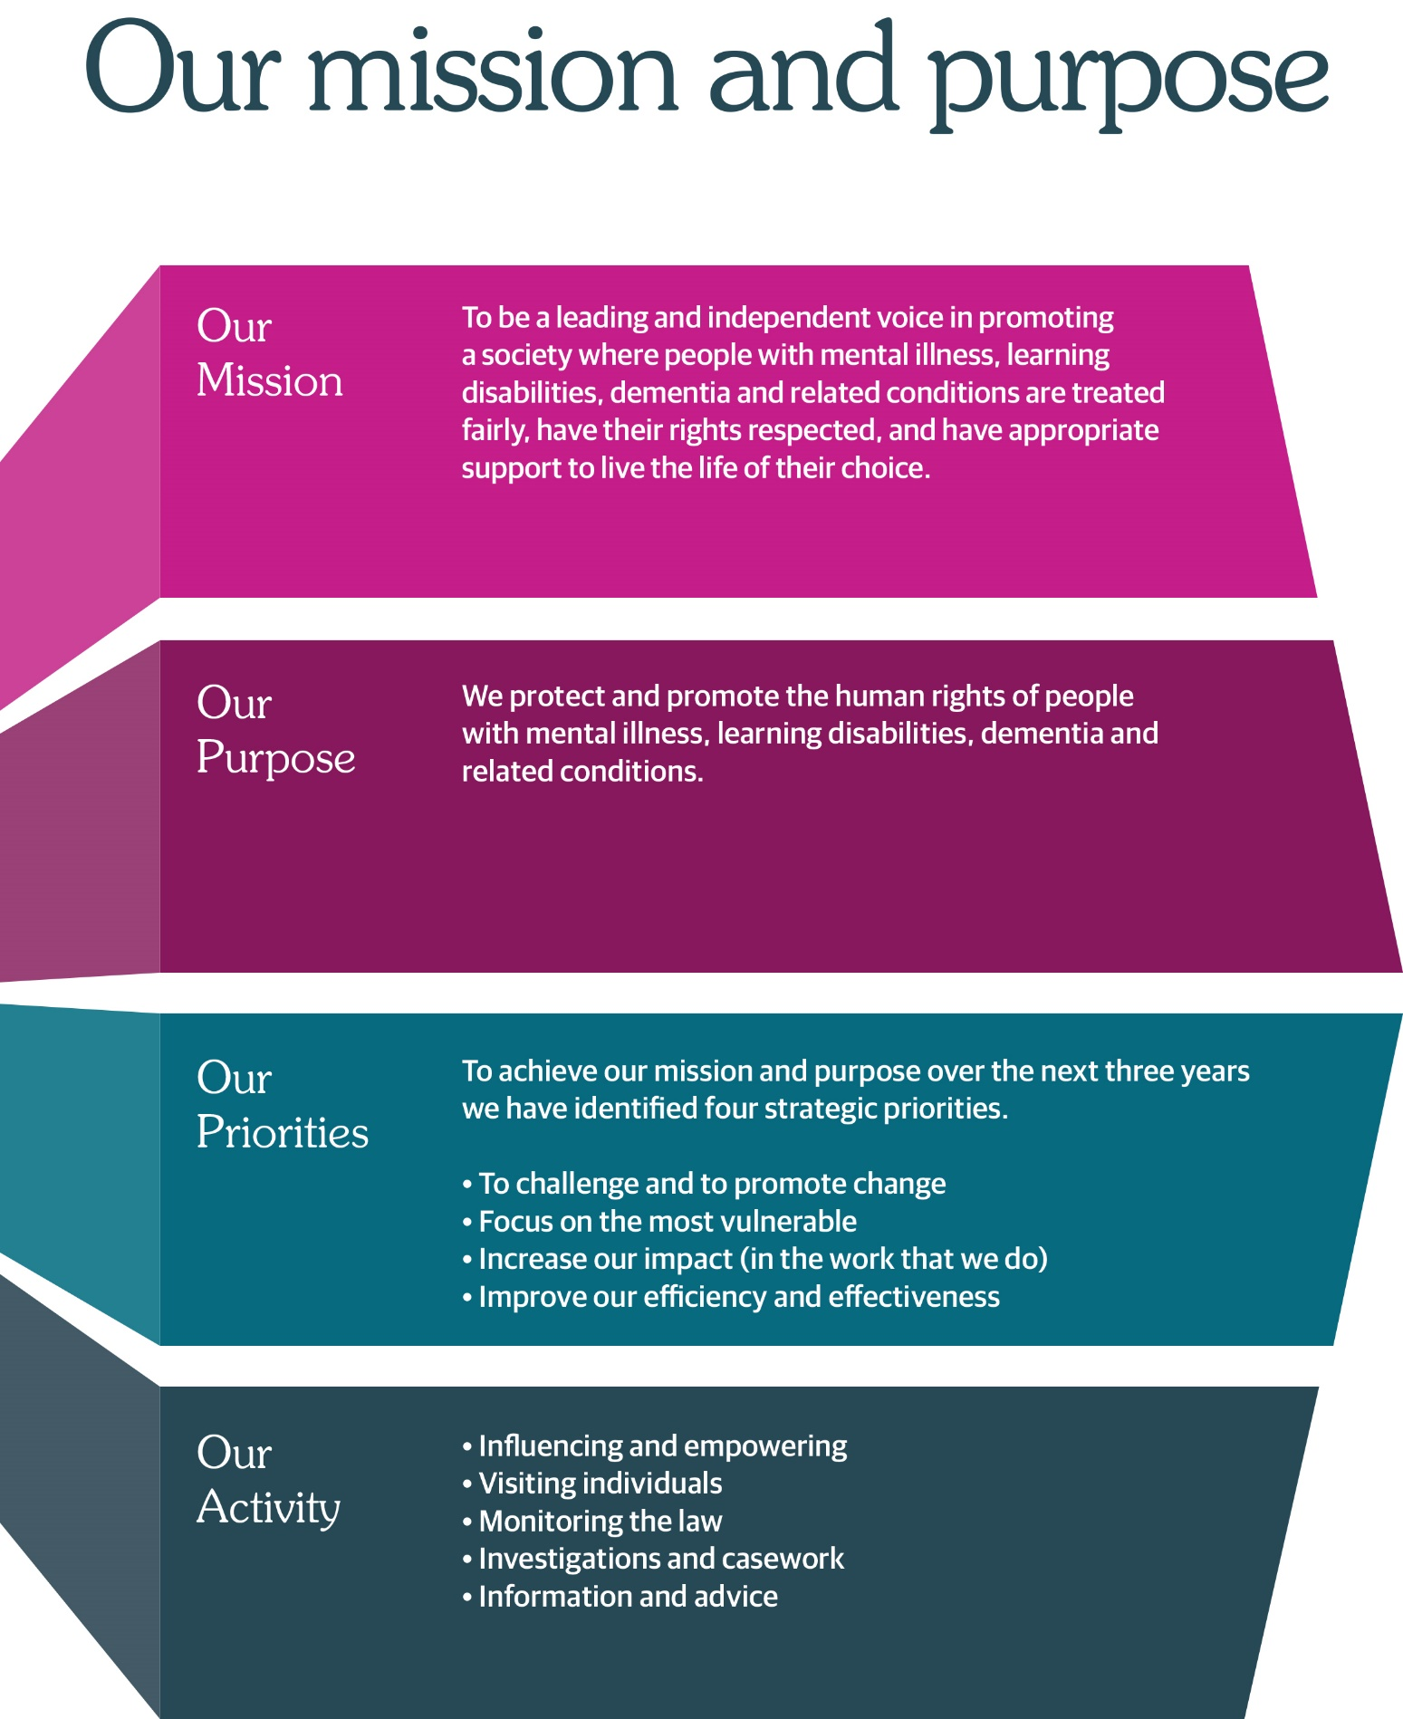



# Nursing Officer

**(full time or part time)**

**£62,572 to 69,525 pro rata per annum pay award pending**

**35 hours a week**

**Based in Edinburgh (Haymarket), hybrid working options**

We protect and promote the human rights of people with mental illness, learning disabilities, dementia and related conditions.

We are currently recruiting for a full time or part time post for experienced nursing practitioner to join our team. Your role will require you to have direct contact with service users, their relatives and carers in respect of their concerns about their mental health and/or the care and treatment they receive. You will also be required to carry out investigation work and deal with casework pertaining to your allocated area. While the role is based in Edinburgh, you will be attached to a team covering a particular geographical area of Scotland and will be required to visit services across the whole of Scotland. You must be able to communicate effectively with service users, carers, advocates and service providers and have exceptional influencing skills.

You must be qualified as a

* Registered Mental Health Nurse or
* Registered Learning Disability Nurse

In addition, you should have experience of operating at senior practitioner level and involvement in the practical application of mental health and incapacity legislation and rights based care.

Supervisory / management experience is also essential.

As an employer, we offer excellent terms and conditions of service including a generous pension scheme, a commitment to learning and development and access to an Employee Assistance Programme and comprehensive staff benefits.

We also offer a comprehensive range of HR policies including policies to help balance commitments at work and home and flexible working arrangements.

At the Commission we champion diversity, inclusion and wellbeing. We pride ourselves on being an employer of choice, cultivating a sense of belonging and providing a workplace where everyone feels valued. We aim to have a workforce which represents the wider society that we serve and therefore encourage applications from people of all backgrounds and under-represented groups.

Our office environment is modern, light, bright and green with superb views and is very close to Haymarket Railway station and transport links.

For more information on applying, please phone 0131 313 8772 or visit the website at <https://www.mwcscot.org.uk/about-us/work-us/nursing-officer>

For an informal discussion about this vacancy, please contact one of our Senior Managers by telephoning 0131 313 8777.

Closing date for applications is **noon, 11 August, 2025** and interview dates will be **21 and 22 August 2025**. Interviews will either be in the office or via Microsoft Teams.

# Nursing Officer – Job Description

|  |  |
| --- | --- |
| **Job Title:** | Nursing Officer |
| **Reports To:** | Senior Manager (Practitioners) |

|  |
| --- |
| 1. **Job Purpose** |
| To carry out practitioner responsibilities to support the Commission in achieving its strategic aims and objectives |

| 1. **Dimensions** |
| --- |
| This post has a Scotland wide remit. This includes influencing and negotiating with key people within, NHS bodies, local authorities, health and social care partnerships, Scottish Government and other stakeholders in order to influence change in services to better ensure the protection of people with mental illness, learning disability and related conditions. A key role is direct contact with individuals, their relatives and carers as well as other members of the public in respect of their concerns about either their mental health and the care and treatment they receive or that of others. Much of the Commission’s work is at the complex interface between the individual’s rights, the law and ethics and the care the person is receiving. The Commission works across the continuum of health and social care. |

| 1. **Role of the Mental Welfare Commission for Scotland** |
| --- |
| We protect and promote the human rights of people with mental illness, learning disabilities, dementia and related conditions    We do this by:   * Checking if individual care and treatment is lawful and in line with good practice * Empowering individuals and their carers through advice, guidance and information * Promoting best practice in applying mental health and incapacity law   Influencing legislation, policy and service development |

| 1. **Key Result Areas** |
| --- |
| 1. To co-ordinate Commission activity in a specified region of Scotland. This includes planning, coordinating and reporting on the visiting programme, ensuring visits are organised according to procedures and that follow up action and reports are dealt with appropriately and in a timely manner; planning and participating in formal annual meetings and other meetings with NHS boards, Health and Social Care Partnerships and local authorities; being the point of contact for professionals and individuals; managing correspondence and casework and holding primary responsibility for defining key issues arising; identifying and prioritising issues, determining what response should be made or further action taken and taking that forward. 2. To identify the need for and carry out informal investigations and inquiries and deal with all correspondence from a specified region of Scotland. This casework can involve legal and welfare issues, liaison with other agencies to resolve welfare issues and ensuring that relevant issues are brought to the attention of the Commission, ensuring that relevant issues are brought to the attention of Executive Directors, including identifying possible deficiencies in care and escalating as appropriate within the Commission. To participate in formal investigations as part of an inquiry team and contribute expert professional input to all forms of investigatory work. 3. To interview and review the care and treatment of individuals; and to interview their relatives, guardians or staff in hospital or the community as necessary; to report on their care and treatment, ensure that this is being delivered to a high standard and, where applicable, within the appropriate legal framework. To promote best practice in relation to operation of the Mental Health Acts and Adults with Incapacity Act. To take forward concerns raised by individuals as appropriate. 4. To contribute to the Commission’s national reports, good practice guidance and internal advice and guidance, and to undertake a lead role in producing these where appropriate. To contribute to the Commission’s role in influencing the national agenda on issues pertaining to the rights of individuals and ethics in professional practice. 5. To provide advice, guidance and consultation to all stakeholders on a wide range of legislative, practice and individual matters through a variety of forums. This includes participation in MWC’s telephone advice service, when advice must be provided in response to potentially very complex clinical, ethical and legal questions. To represent the Commission at and contribute to training events and conferences on relevant subject matters. 6. To provide expert professional nursing or social work advice across the Commission. To report to appropriate governance and management committees. To participate in MWC speciality working groups and project groups, and chair if requested. 7. To undertake individual continuing professional development to maintain and update skills and knowledge (particularly in relation to legislation and individuals’ rights/welfare). To represent the Commission at professional meetings, network and establish and maintain contacts. This provides an opportunity for clinical colleagues to seek informal advice and to promote best practice. |

|  |
| --- |
| 1. **Planning and Organising**   Within agreed performance objectives, the post holder has a high degree of autonomy in organising, managing and prioritising his or her own work.  Review of performance in the post is conducted by formal appraisal on an annual basis and regular review of progress and development throughout the year. |

|  |
| --- |
| 1. **Internal and External Relationships** |
| **Internal**  In addition to the internal working relationship with the senior manager, the following are key working relationships:  All staff - to discuss common areas of concern and to develop multidisciplinary and team working relationships.  **External**  Senior and other staff of the NHS bodies, local authorities, health and social care partnerships, other statutory bodies, Scottish Government, professional, voluntary and advocacy organisations – to influence policy and agendas and raise issues of concern about the protection of individuals and to follow up on individual cases. To use negotiating and influencing skills to improve the care and treatment delivered to people.  Users and Carers – to raise awareness of the role and function of the Commission and to follow up on individual cases arising from visits, correspondence or telephone duty. |
| 1. **Most Challenging Aspects of the Job** |
| The Commission aims to influence national policy development and local operational practices by focusing on its role with the individual. It needs to have credibility with a range of stakeholders in order to do this. There are major challenges for the post holder in balancing the remit of the protection of individuals with the need to influence organisational practices to ensure individual rights and protection are upheld. There are also challenges to influencing changes in behaviour and practices of organisations that provide services in the absence of any executive authority to enforce changes. |

|  |
| --- |
| 1. **Skills/Qualifications and Experience** |
| The post holder must be either a registered mental health nurse or learning disability nurse with extensive post registration experience.  The post holder must have recent experience of direct application or involvement in the practical application of mental health and incapacity legislation and rights based care.  The post holder should have considerable management or supervisory experience or, at the very least, operated at senior practitioner level. The post holder must have an excellent understanding of the mental health agenda in Scotland and the capacity to influence and negotiate with senior people in the health, social care and voluntary sectors.    The post holder must show evidence of continuing professional development. |

# Nursing Officer - Person Specification

It is important to note that to be considered for appointment you must meet all of the essential criteria for the role. You should be able to demonstrate both within your application, and at interview (if invited to attend), how your skills, knowledge, values, and personal qualities match those required.

|  |  |
| --- | --- |
| **Essential** | **Desirable** |
| * Registered Mental Health Nurse / Learning Disability Nurse * Extensive practice and post qualification experience * Able to influence and negotiate at all levels, in particular with senior people in local authorities, NHS boards, health and social care partnerships and the independent care sector * Excellent understanding of the mental health agenda for Scotland * Recent experience of direct application as an RMN/RLDN in the practical application of mental health and incapacity legislation and rights based care * Ability to communicate effectively with individuals, carers, advocates and service providers * Excellent written and verbal skills to help produce reports, present casework information and deliver presentations * Able to analyse and scrutinise casework reports and information * Ability to balance competing work priorities and to work to tight deadlines and timescales * Able to work as part of a multidisciplinary team * Proficient IT skills * Evidence of continuing professional development * Supervisory/management experience * Able to travel throughout Scotland | * Knowledge of statutory mental health services in Scotland |

# Employment Information – Nursing Officer

The following notes summarise the key points of the terms and conditions.

Full details will be provided with offers of employment.

|  |  |
| --- | --- |
| **Headquarters** | Thistle House, 91 Haymarket Terrace, Edinburgh, EH12 5HE  Options for hybrid working |
| **Pay** | £62,572 - £69,525 per annum pay award pending |
| **Type of Contract** | This post is offered as a substantive contract with the Commission |
| **Manager** | The post-holder reports to the Senior Manager of the team |
| **Hours of work** | Full-time posts are normally 5-days per week of 35 hours, exclusive of breaks but the hours of attendance may be varied, by agreement, to meet the needs of the work. |
| **Leave** | **Annual Holidays**  The annual entitlement for full time posts is 25 days per year, rising to 30 days after 10 years’ relevant service. (NHS and local authority service is counted as relevant service).  **General/Public Holidays**  Public and privilege holidays total 11.5 days per leave year, 6 of these are on set dates and the remainder can be taken as required.  For part time posts, the public/privilege holiday entitlement is pro-rata to full time equivalent.  The leave year runs from 1st April to 31st March. |
| **Superannuation** | [NHS Pension Scheme](https://pensions.gov.scot/nhs/your-membership/your-contributions) is available to all staff subject to scheme rules.  Please click [here](https://pensions.gov.scot/nhs/your-membership/your-contributions) for contributions details.  The employer currently contributes an amount equal to **22.5%** of pensionable pay into the scheme on members’ behalf. |
| **Staff Benefits** | Through the Commission Staff Benefits scheme there is access to a wide variety of offers and discounts from the UK’s most popular retailers and service providers. The current provider is EdenRed. There is also access to, [My Gyms discount site](https://www.mygymdiscounts.co.uk/?page=no-login), the UK's largest network of gyms, studios, fitness centres and sports clubs across the UK with discounted membership offers. A comprehensive Employee Assistance Programme is also available and access to a Cycle to Work Scheme.  (The Commission reserves the right to withdraw, amend the schemes and change providers as appropriate) |
| **Our values** | The Commission operates a set of internal values for staff. |
| **Performance,**  **Learning and Development** | There is a performance development system in operation within the Commission. Progression through the salary scale is subject to satisfactory performance. |
| **Data protection** | The information you provide on the application form and any supplementary forms will be used to assist in the process of recruitment and selection in accordance with the Policy of the Mental Welfare Commission.  If you are successful in your application the information you provide will be used for HR and Payroll purposes. By signing the declaration section of the application form it is understood that you consent to the use and storage of your personal information for the above stated purposes. |
| **Work outside the Commission** | It is important to identify and minimise any conflicts of interest that could prevent staff from making fair and objective judgements or could be perceived as doing so by people with lived experience and carers, practitioners, and the public. Details are contained in the Commission’s Conflict of Interest Policy. |
| **Probationary period** | The post requires a 6 months’ probationary period. |
| **Disclosure Scotland** | You will be required to submit an application for a PVG Certificate - Children and Adults. |
| **Occupational Health Screening** | Any offer of employment is subject to satisfactory Occupational Health clearance. The successful candidate will be asked to complete a Pre-Employment Health Questionnaire. NHS Lothian Occupational Health will make an assessment on your fitness to carry out the post based on the information contained within the questionnaire. In certain circumstances further information is required before clearance can be given, and Occupational Health may contact you by telephone or request that you attend for an appointment. Clearance may be subject to you attending for a post-employment appointment and it is vital that you attend this appointment if required |
| **Complaints** | The Commission has a Complaints Handling Procedure. All applicants have access to it if they feel they have been unfairly treated during the recruitment and selection process. External applicants should direct any concerns to the Human Resources department and internal applicants have recourse to the Commission’s Grievance Procedure. |
| **Equal opportunities** | The Commission is an equal opportunities employer. |
| **Feedback** | We do recognise the time and effort it takes to apply for a position. Following the short-listing process, you will be notified about the outcome of your application by email.  We are unable to offer any feedback to candidates at application stage. However, feedback will be given to any candidate requesting it following an interview at the Commission. |

# How to Apply

For more information on applying, please phone 0131 313 8772 or visit the website at <https://www.mwcscot.org.uk/about-us/work-us/nursing-officer>

For an informal discussion about this vacancy, please contact one of our Senior Managers by telephoning 0131 313 8777.

Closing date for applications is **noon, 11 August, 2025** and interview dates will be **21 and 22 August 2025**. Interviews will either be in the office or via Microsoft Teams.