Policy Manager

Community Energy Scotland
Recruitment Application Pack





Contents

Contents 1
1. Introduction 2
2. The Application process 3
2.1. Timetable 3
2.2. How to apply 3
2.3. Data & Privacy 3
3. Working for CES 5
3.1. Community Energy Scotland 5
3.1.1. Working for Community Energy Scotland 5
3.1.2. Community Energy Scotland Staff Benefits 6
4. Job description 8
4.1. Overall Purpose 8
4.2. Main Tasks 8
4.2.1. Update and implement Policy and Advocacy Strategy: 8
4.2.2. Maintain Relationships with Key Stakeholders 8
4.2.3. Delivery Policy Interventions 9
4.2.5. Communicate with staff, members and the public 9
4.2.6. Management Duties 10
4.2.7. Administration 10
4.2.8. Other Tasks 10
5. Person Specification 11
5.1. Essential Knowledge, Skills & Attributes 11
5.2. Essential Experience 11
5.3. Desirable Knowledge, Skills & Attributes 11

Introduction

Community Energy Scotland is recruiting for a Policy Manager based in Scotland. We are looking to recruit an energetic, well-organised and self-motivated individual to lead on CES’s policy and advocacy work. Training as required, personal development opportunities, and support will be provided by Community Energy Scotland.

This application pack introduces you to the application process and timetable, and the Policy Manager role. If you have any queries, please contact Rona at: Rona.mackay@communityenergy.scot

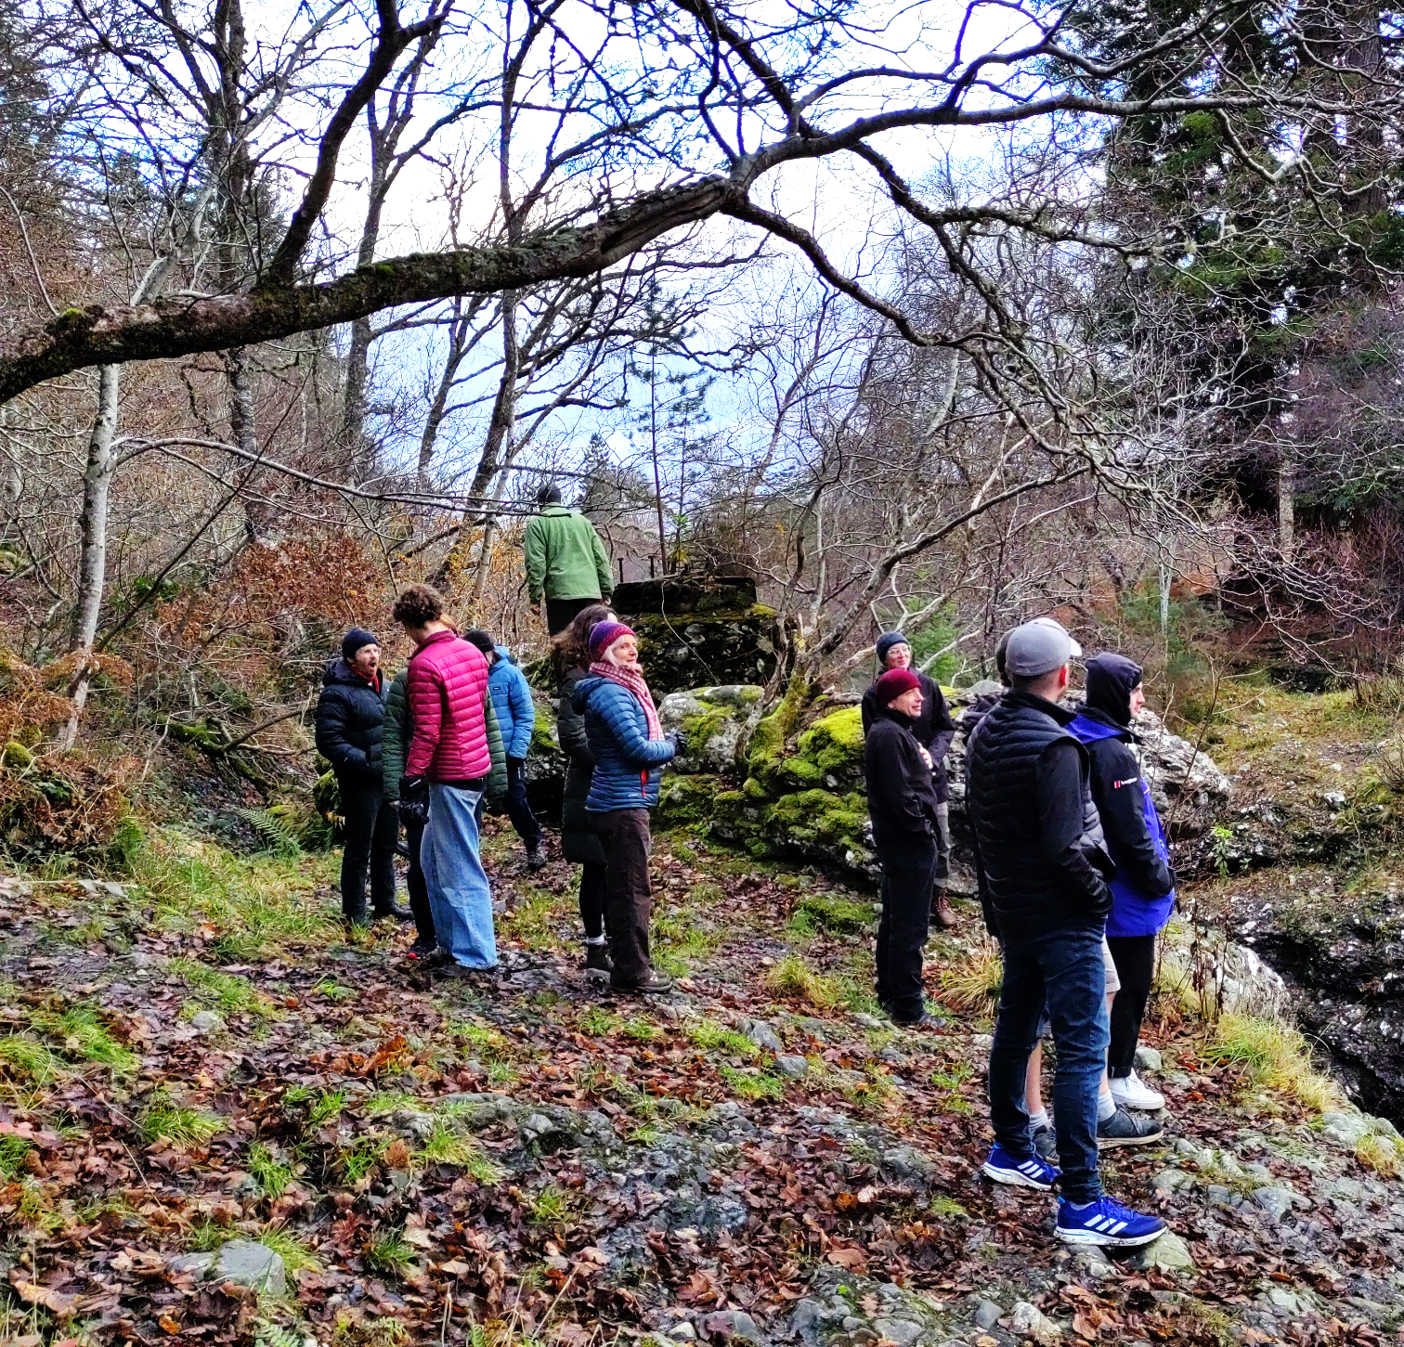

The Application process

  - Timetable

The timetable for the application process is as follows:
Tuesday 2nd September | Deadline for receipt of application by email to  jobs@communityenergyscotland.org.uk
Thursday 4th September | Applicants informed whether they have been short-listed for interview and about the interview format
Week of the 8th September | Interviews conducted via MS Teams
Friday 12th September | Applicants informed whether they are successful

  - How to apply

Applicants should submit a cover letter and CV to jobs@communityenergyscotland.org.uk by 5pm on Tuesday 2nd September 2025. The cover letter should provide the following information:
- Personal & contact details
- A brief explanation of your interest in CES and the post
- A brief explanation of how you meet the person specification.
- A completed copy of our CES Diversity Monitoring Form. We collect this information to monitor our diversity and inclusion within our organisation. The information is kept confidential and not used in candidate selection.

Referees will only be contacted once the successful candidate has been offered the job subject to references. At least one of the two referees should be your current or most recent employer.

For enquiries about the vacancy please send an e-mail to jobs@communityenergyscotland.org.uk and we will get back to you as soon as possible.

  - Data & Privacy
We collect or use the following personal information as part of Community Energy Scotland staff recruitment, administration and management:
- Contact details (eg name, address, telephone number or personal email address)
- Date of birth
- Photographs (eg staff ID card)
- Copies of proof of address documents (eg bank statements or bills)
- Details of any criminal convictions (eg DBS checks)
- Political, conflict of interest or gift declarations
- We also collect the following information for Community Energy Scotland staff recruitment, administration and management:
- Racial or ethnic origin
- Sexual orientation information
- Our lawful bases for collecting or using personal information as part of staff recruitment, administration and management are:
- Consent
- Legal obligation

Please see our Privacy Notice for further information.

Working for CES

  - Community Energy Scotland

Incorporated in 2007, Community Energy Scotland’s charitable objects are community development, environmental protection and the prevention and relief of poverty. CES has been at the forefront of community energy development since then, supporting communities to take control of and benefit from their local renewable energy resources and help lower carbon emissions.

Community Energy Scotland is a membership based organisation with over 400 Members across Scotland and is open to non-profit-distributing community groups to join. CES’ core values are:
- Trust: Trust is fundamental to how staff and the volunteer Board work together as a team in pursuit of CES’ aims;
- Integrity: our members and the communities we work with recognise that we are reliable, impartial and deliver on our promises;
- Passion: Our Board and staff are committed to community development through a process of decarbonisation and democratisation of the energy system.

    - Working for Community Energy Scotland

Community Energy Scotland currently has 28 members of staff based all over Scotland.

In our Staff Satisfaction Survey in 2025 when asked what they liked best about working for Community Energy Scotland, staff gave the following feedback:
- “My values and CES' values align strongly and I feel like I have the opportunity to make a difference with my work.”
- “The culture of inclusion and care of the staff.”
- “The opportunities provided through my role to meet new people, learn new things, and work on meaningful issues.”
- “Fellow colleagues and opportunity to do worthwhile work benefiting communities.”
- “Kind and friendly colleagues and management team. The trust in staff to explore new work and light touch management giving the freedom to develop new areas.”
- “Flexibility of working allows me to maintain a work-life balance and pursue interests and have good relationships outside of work. I think there is a good sense of community and belonging within our team despite being based in different areas”
- “I really like the type of work, the team are all really driven and it feels like we are trying to make a positive change in the world.”

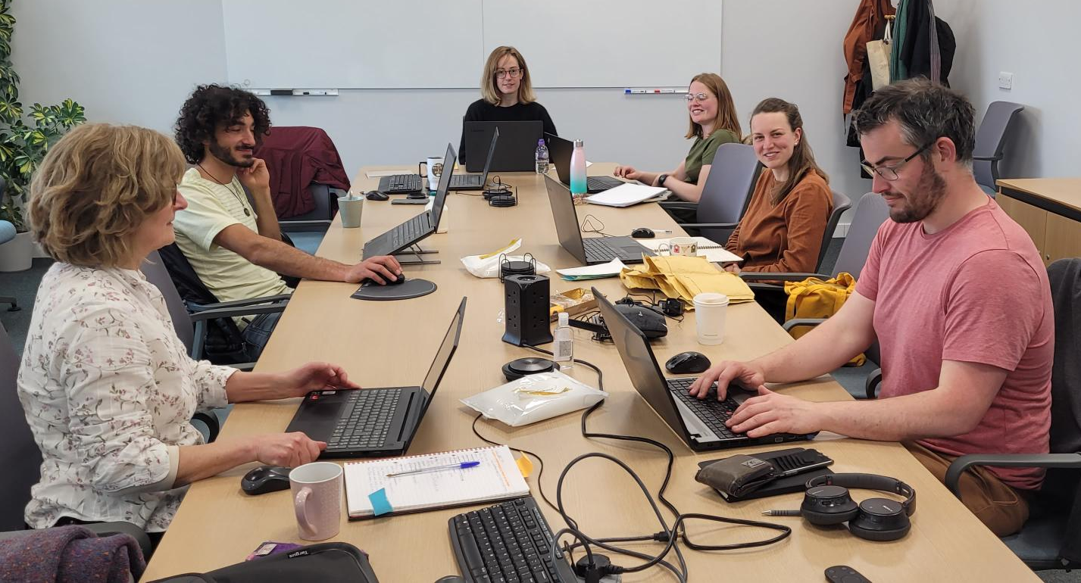

    - Community Energy Scotland Staff Benefits
- Employer’s monthly contribution to pension at a rate of 3% of monthly salary. If employment with Community Energy Scotland extends to over one year’s service, the contribution provided by Community Energy Scotland will at that stage rises to 6% of monthly salary.
- 36 days of leave per annum, comprising of 25 days flexible annual leave, plus 11 days of fixed and flexible bank holidays. Increasing to 27 days flexible leave after 2 years of service and 30 days after 5 years of service.
- Access to office space or £1044 per annum (pro rata) home working allowance
- Car journeys for work are reimbursed at £0.45 per mile.
- Generous Maternity Pay - employees may take up to 26 weeks ordinary maternity leave and 26 weeks additional maternity leave making a total of 52 weeks. This is irrespective of length of service or hours worked. An employee who has completed at least one year’s continuous service 11 weeks before the Expected Week of Childbirth will be entitled to 26 weeks salary, i.e. full pay together with any increases or bonuses due, during this period. The employee will also be entitled to a further 13 weeks Statutory Maternity Pay (SMP) at the standard rate in place at the time.
- Paternity/Adoption Leave, Miscarriage, Parental Bereavement and Compassionate Leave
- Flexible working which promotes a work life balance
- 5 days pro rata for a full time member of staff on a year’s contract can be spent on training or studying and each full-time staff member of Community Energy Scotland who has been with CES for six months, or has a year’s contract or more with CES, in principle has a budget of up to £350 per annum (pro rata to the Financial year) to spend on training.
- Two team in-person meetings and two online team events annually

- Sick pay entitlement:

Length of service | Full Pay Allowance | Half Pay Allowance
Less than 1 year | 4 weeks | 4 weeks
After 1 year | 4 weeks | 4 weeks
After 2 years | 9 weeks | 9 weeks
After 3 years | 14 weeks | 14 weeks
After 4 years | 19 weeks | 19 weeks
5 years or more | 26 weeks | 26 weeks

- Electric Vehicle Salary Sacrifice Scheme
- Staff are allowed up to 1 day of paid leave annually to participate in voluntary activities during working hours

Job description

- £35,156 per annum (pro rata). Progression from starting salary is reviewed annually from 1st April, and subject to satisfactory performance and Community Energy Scotland’s financial status
- Fixed-Term appointment for 1 year, with the view to forming a permanent post thereafter.
- Full Time/Part Time Post (we are open to discuss part-time hours from a minimum of 28 hours to full-time at 35 hours per week) with potential for flexible working as per the CES Flexible Working Policy.
- Some travel to other areas in Scotland is likely to be required, while keeping our carbon footprint down following Community Energy Scotland’s environmental policy
- The post holder will be expected to travel regularly to meetings and conferences in Edinburgh, Glasgow and around Scotland. Thus, a central belt location is preferable. The post is suitable for home working but office or co-working space for the post holder can be secured if required.

  - Overall Purpose

To lead in the development and delivery of CES’s Policy and Advocacy strategy.

  - Main Tasks
Your role will be to deliver the following tasks:

    - Update and implement Policy and Advocacy Strategy:
- Finalise our Policy and Advocacy Strategy and ensure it aligns with existing UK Scottish Government policies and strategies as well as other internal documents including CES's Strategy and Communications Strategy
- Engagement with political parties on manifesto development for Scottish elections in 2026
- Compile an evidence base to back up positions
- Develop one page policy briefings with recommendations on key issues
- Agree and sign off the strategy within three months of taking up post

    - Maintain Relationships with Key Stakeholders
(supported by CEO):
- Represent CES at key events, meetings and in the press. This will include preparing, delivering and facilitating presentations/open meetings and discussions when required. Some travel to meetings and site visits is anticipated
- Coordinate the Scottish Community Coalition on Energy (SCCE), including organising regular meetings, agreeing shared policy positions and working collaboratively with DTAS and Community Land Scotland to use the strengths of each organisation to push policy positions forward, in line with the SCCE strategy
- Holding regular meetings with policy teams from Community Energy England and Community Energy Wales, identifying common policy priorities and collaborating on advocacy work and consultation responses.
- Identify sympathetic MPs, MSPs, policy makers and influencers and build relationships with them and their team
- Maintain a database of contacts and keep supporters informed and involved to create an active network
- Investigate the potential for collaboration and partnership with other aligned organisations
    - Delivery Policy Interventions
(supported by appropriate team members):
- Intervene both (a) reactively in response to arising opportunities, and (b) proactively in pursuit of a policy priorities, in line with the policy and advocacy strategy and the Scottish Community Coalition on Energy strategy
- Facilitate members to participate in the policy arena and speak out directly; gather member input for consultations, briefings and other opportunities to shape policy.
- Co-ordinate and/or draft responses to regulatory and legislative consultations of relevance to members
- Work with the Communications Officer and CEO to write press releases and other responses to key news stories and policy developments.
- Organise events where appropriate, such as Parliamentary receptions or roundtables.

    - State of the Sector
- Work with the Head of Projects Operations to deliver the State of the Sector Report and use the data collected to have the greatest possible impact. This includes input into:
  - Design of State of the Sector (SOTS) survey questions, and stakeholder engagement
  - Regular liaison with Community Energy England and Community Energy Wales and working together to analyse survey responses and identify implications for policy development.
  - Providing creative and practical input into the future of SOTS, its development, and its potential benefits to the sector.

    - Communicate with staff, members and the public
(supported by Membership & Comms Officer):
- Build relationships with CES’s member community groups to inform, consult and involve CES members in policy work. This includes leading a policy working group comprised of representatives of Community Energy Scotland’s members (community energy organisations) to input into, develop and groundtruth policy positions.
- Work with the Membership and Communications Officer to effectively disseminate information and ensure good public profile is achieved on CESpolicy and advocacy activities
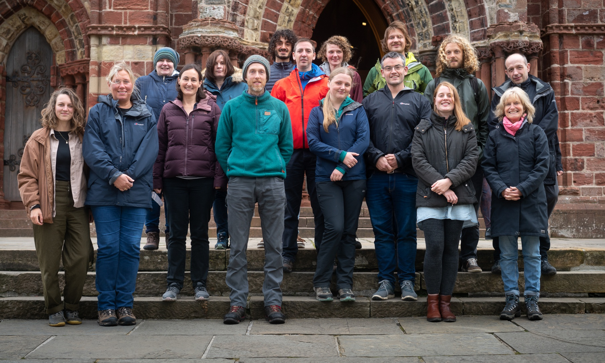



- Embed knowledge and use of the policy and advocacy strategy within CES
- Ensure that CES staff and board members are kept fully up to date on key developments and CES’ position on them through the management of an effective policy briefing system.

    - Management Duties
(The post is not initially expected to include line management responsibilities initially, however this may change.)
- Inspire, manage and develop staff in a way that brings out their full potential, ensuring that all staff line managed are effectively deployed and supported, have clear time and work plans linked with Annual Reviews and are fully engaged in delivering Community Energy Scotland’s priorities.

    - Administration
- To keep all personal work records up to date such as annual leave requests, My Hours and Monday.com

    - Other Tasks
- Support the CES development team to secure increased funding and support for policy work
- Play a full role in the evolution and operation of the team at Community Energy Scotland, and support the success of Community Energy Scotland as a whole
- Undertake other duties as may be required from time to time by the CEO
- Maintain a safe working environment ensuring your own personal safety and the safety of others.
- Ensure relevant consistent branding across all CES communications.
- Provide regular appraisal of project deliverables to CES, attend project team meeting and full team meetings, preparing feedback.

Person Specification

The post holder will be expected to work on their own initiative, be self-motivated and well organised, in order to meet the deadlines and funding requirements of this project.

  - Essential Knowledge, Skills & Attributes
- A high level of self-motivation and strong commitment to Community Energy Scotland, its ethos and purpose
- A sound understanding of UK and/or Scottish Government parliamentary functions and the process of national policy, regulation and legislative development.
- Knowledge of the process of and challenges for communities in deploying sustainable energy projects.
- Nuanced social skills, including the ability to engage effectively with individuals, community groups, government agencies and large corporate utilities
- Strong negotiation skills, and an ability to adapt quickly to new requirements and opportunities
- Effective partnership-building skills and practical and experience of partnership working, especially with community groups
- High quality communication, representation, and co-ordination skills
- Demonstrable ability to understand and interpret complex technical & financial information
- Ability to build, maintain and work effectively in high-performing teams

  - Essential Experience
- Degree level qualification in a relevant subject or equivalent relevant experience
- At least three years of relevant experience working in a similar sector such as policy, research or practical experience within the community energy sector
- Previous experience of engaging on policy and advocacy issues and developing relationships with key stakeholders
- Demonstrable relationships with decision makers or those who work closely with them, and ready-formed network for policy engagement.
- Experience of engaging in expert stakeholder forums.
- Public speaking and presentation

  - Desirable Knowledge, Skills & Attributes
In addition to the above, it may be desirable for candidates to possess some or all of the following:
- Detailed knowledge and demonstrable practical experience of community (energy) development
- A track record of working in and in partnership with development trusts and/or other grassroots community member-based development organisations.
- Experience of working with civil servants and politicians in Holyrood and/or Westminster
- Understanding of energy market regulations



Community Energy Scotland Page 12

