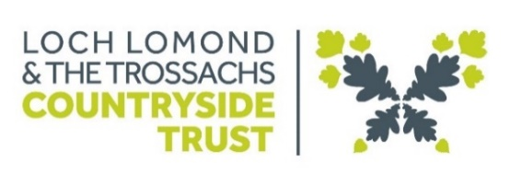
Diversity Monitoring
(updated April 2024)
Loch Lomond and the Trossachs Countryside Trust is committed to being an equal opportunity employer under the Discrimination and the Equality Act 2010 and recognise the value that a diverse workforce can bring. The information requested on this form will be used to monitor the effectiveness of our equality and diversity practices and will remain separate from your application form. The information requested counts as special category data under the Data Protection Act 2018. It will be retained in anonymised form for three years, unless your recruitment is successful, we then use this information to populate the equality and diversity information on your HR record which you will have full access to. Please let us know if you have any questions about our use of your personal data or your rights under the legislation.

Please tick the relevant box in each section, or complete details as appropriate and return the completed form along with your application form to info@trustinthepark.org

What gender do you identify as?
Man | ☐
Woman | ☐
Non- binary | ☐
Trans- gender | ☐
Prefer to self-describe | ☐
Prefer not to say | ☐
Are you trans, or do you have trans experience? | Yes | ☐
Are you trans, or do you have trans experience? | No | ☐
Are you trans, or do you have trans experience? | Don’t know | ☐
Are you trans, or do you have trans experience? | Prefer not to say | ☐

Age
16-24 | ☐
25-34 | ☐
35-44 | ☐
45-54 | ☐
55-64 | ☐
65+ | ☐
Prefer not to say | ☐

Do you consider yourself to have a disability or health condition?
Yes | ☐
No | ☐
Prefer not to say | ☐

Which of the following best describes your ethnic group?

Ethnic origin is not about nationality, place of birth or citizenship. It is about the group to which you perceive you belong. Please tick the appropriate box.

White |  | Mixed/multiple ethnic groups
Scottish | ☐ | White and Black Caribbean | ☐
Irish | ☐ | White and Black African | ☐
Other British | ☐ | White and Asian | ☐
British Gypsy or Irish Traveller | ☐ |  | ☐
European | ☐ |  | ☐
Any other white background please write here: |  | Any other mixed background please write here:
Asian/Asian British |  | Caribbean or Black
Pakistani, Pakistani Scottish or Pakistani British | ☐ | Caribbean, Caribbean Scottish or Caribbean British | ☐
Indian, Indian Scottish or Indian British | ☐ | Black, Black Scottish or Black British | ☐
Bangladeshi, Bangladeshi Scottish or Bangladeshi British | ☐ |  | ☐
Chinese, Chinese Scottish or Chinese British | ☐ |  | ☐
Any other Asian background please write here: |  | Any other Black/African/Caribbean background please write here:
African |  | Arabic
African, African Scottish or African British | ☐ | Arab, Arab Scottish or Arab British | ☐
Any other African background please write here: |  | Any other Arabic background please write here:
Other ethnic group
Any other ethnic group please write here:
Prefer not to say | ☐

Do you have caring responsibilities?
If yes, please tick all that apply
None | ☐
Primary carer of a child/children (under 18) | ☐
Primary carer of disabled child/children | ☐
Primary carer of disabled adult (18 and over) | ☐
Primary carer of older person | ☐
Secondary carer (another person carries out the main caring role) | ☐
Prefer not to say

Thank you for completing this form. Your answers will help us monitor the effectiveness of our equality and diversity practices.

