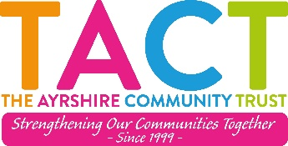

Self-Disclosure Form

Self-Disclosure Form for Declaring Convictions – Scotland

Unspent Convictions

You must complete this section:
Yes
No

Do you have any unspent convictions?
If you have crossed yes, please provide details below.

All unspent convictions must be disclosed. Please provide details of any unspent convictions here:
Date | Court | Offence | Disposal

Spent Convictions

Date | Court | Offence | Disposal

Barred List

This section should only be completed if you will be applying for PVG disclosure or enhanced disclosure with list checks. Do not complete this section if you are applying for a basic, standard or enhanced disclosure without list checks.

I understand that my role involves regulated work and confirm that I am not barred from the relevant regulated work group(s):

Signed | Date:

Declaration
I certify that the information contained in this form is true and complete to the best of my knowledge and belief. I understand that any false information or omission in the information I have given may lead to the immediate suspension or termination of my volunteering or employment with the organisation.

I confirm that I have read and understood this declaration.
Full name
Address
Signed
Date

Please return this form to info@tact.scot or post to:

Kaileigh Brown
Executive Director
The Ayrshire Community Trust
27 Vernon Street
Saltcoats
KA22 5HE

Please mark envelope ‘Private and Confidential’.

