

Chief Executive Officer

Job Description
June 2025

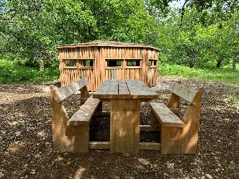
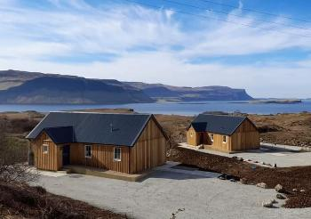
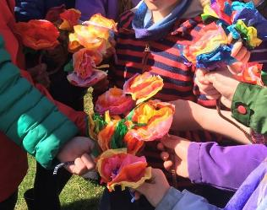

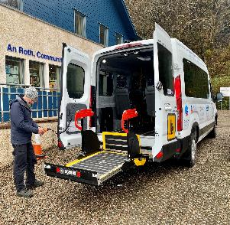
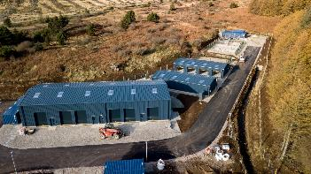
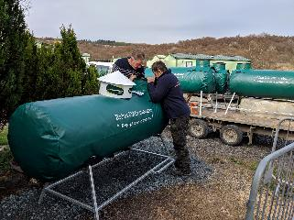

Mull, Iona and Surrounding Islands
The Mull archipelago is part of the Inner Hebrides, lying off the west coast of Scotland. Accessible from the mainland, by three separate ferry routes, the main island Mull is just under 400 square miles in size with an estimated population in 2020 of 3000.
Mull has six primary schools with Iona having its own primary school, and a High School based in the north of the island in the main population centre, Tobermory.
Medical provision is provided through three surgeries across the island, and a Community Hospital in Craignure providing Accident and Emergency service.
Mull boasts a diverse range of scenery, wildlife and leisure activities which bring large numbers of visitors throughout the year. The island also hosts a number of music and arts festivals plus the annual Tour of Mull car rally.
Mull and Iona Community Trust – The Organisation
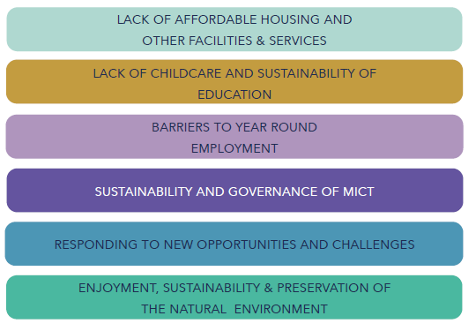
Mull and Iona Community Trust was established in 1997 and is one of the best known and successful development trusts in Scotland. Set up to improve the quality of life on Mull, Iona and surrounding islands, diversification has been key to the Trust’s longevity. While grant funding still plays an important role, most of the Trust’s income is generated through its own operational activities, which in turn provide much needed services and facilities within the community. The work of the Trust is led by our five year strategy with the following key strategic areas –

The Trust currently employs 23 staff (approx. 13 full time equivalent), with an annual turnover of around £1 million. Our staff and numerous volunteers allow us to provide a range of services and initiatives including recycling and re-use workshops, charity shops, countryside ranger service, community transport and providing support to many other third sector groups on the islands.
During the last 15 years, the Trust has grown it’s asset portfolio, including purpose-built office and meeting rooms in Craignure, eight houses for affordable rent, small business park, storage facilities, community forest, helipad and community pontoons with shore facilities.
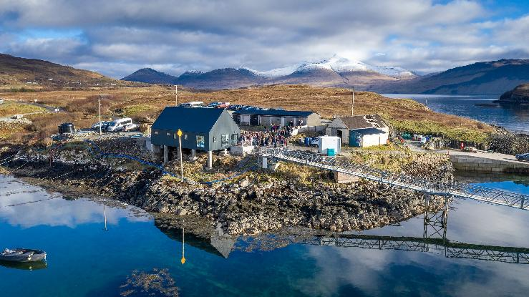

The Role of the Chief Executive Officer
To ensure the sustainability of Mull and Iona Community Trust by developing new, and nurturing existing, income generating activities, and to provide leadership for the staff team.
The Trust has grown to offer a number of services and activities for the benefit of the communities it serves. This role will provide direction and leadership for the staff team to maintain and grow these services, while seeking further opportunities to benefit our communities and generate income for the Trust to sustain its activities.
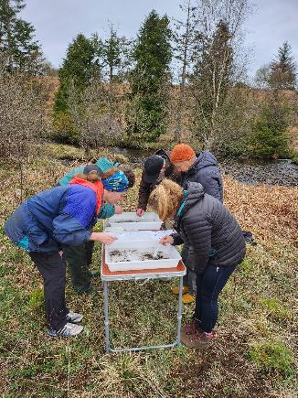
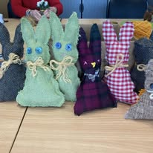

Key Tasks and Responsibilities
Strategy –
- Provide strong, clear, effective and visible leadership and drive in the delivery of MICT’s strategic objectives
- Translating strategy into operational plans and support staff to review or put these plans in place
- Work with the convenor to ensure that the Board of Trustees continues to evolve and has the appropriate mix of skills and experience to oversee the performance of the Charity’s operation and to deliver its strategic objectives.
- Work with senior staff and board to retain relationships with stakeholders and maintaining strategic alignment with sponsors, key partners and supporters
- Work with the Board and key staff to review the strategy annually.
Finance, Governance and Compliance –
- Provide leadership and good governance to ensure MICT’s assets and financial resources are managed effectively, promoting a culture of financial transparency, identifying risks and taking appropriate action so that MICT remains in good financial health, updating the Board on a regular basis.
- Support the Board in the exercise of its legal, financial and other responsibilities, following the requirements of the Office of the Scottish Charity Regulator, Companies House and any other current legislation
- Attend Board Meetings and provide written reports to the Board on a regular and timely manner, ensuring they have the information they require for the good governance of the organisation.
- Work with relevant staff to ensure the risk register is updated regularly and shared with the Board.
Management of Resources –
- Responsibility for ensuring the management and welfare of staff and volunteers, their development and support and supervision in line with the organisational structure.
- Oversee the scheme of delegation and ensure that staff are supported and empowered to achieve best results for tenants, service users, customers and the organisation
- Create a positive and trusting culture within the organisation staff team
- Deliver supervision and other line management support to the senior management team and complete performance appraisals, setting an example for this approach to filter down to all staff to ensure they feel valued within the MICT team
- Ensure policies and procedures are regularly reviewed, updated, understood and adhered to by all staff and volunteers.

Terms and Conditions
Reporting to: Mull and Iona Community Trust Board of Directors
Salary: Grade 9 £38,000 - £45,000 per annum, (depending on experience) paid monthly by BACS
Length of Contract: Permanent contract
Probationary period: 3 months
Annual Leave: 33 days per annum, including public holidays
Pension: Workplace pension with employer contribution of 6%
Hours of Work: 37.5 hours per week, but these are highly flexible. Monthly timesheets are completed and Time Off In Lieu is logged and taken.
Nature of Work: Occasional evening and weekend work required, therefore time off in lieu is given.
Training: Three monthly progress reviews given, at which training needs are reviewed. An Annual Appraisal will take place every 12 months.
Place of Work: An Roth Community Enterprise Centre, Craignure with home working available.
Conditions: This post will be offered subject to satisfactory references.

