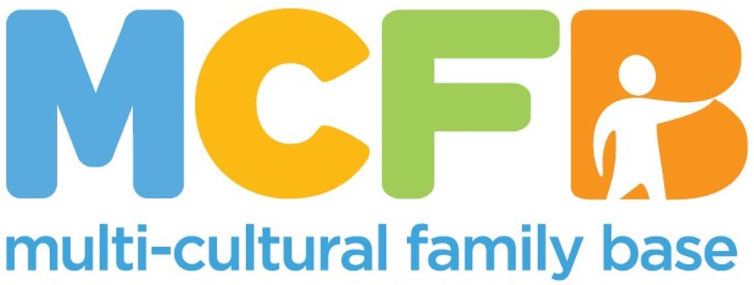

ROLE PACK
This is a pack that gives the role descriptions and other information about our organisation.

ABOUT THE MULTI-CULTURAL FAMILY BASE
Founded with a commitment to social justice and inclusion in 1998, the Multi-Cultural Family Base (MCFB) is a leading organisation in Edinburgh dedicated to supporting diverse communities and enhancing the well-being of infants, children and families from all cultural backgrounds. MCFB provides essential community-based services, such as therapeutic group work, direct work, advocacy, and support to minoritised groups.

Our Values
Multi-Cultural Family Base is an anti-racist and anti-oppressive organisation. We are passionate about promoting human rights, valuing diversity, providing equitable opportunities, and working in a way which is compassionate, responsive, respectful, and re-empowering. Multi-Cultural Family Base is committed to involving service users and stakeholders in co-production of service planning and provision.
We believe that community-based services for diverse families should be easy to access and able to respond to a wide range of needs. Our services include therapeutic groupwork, one-to-one casework, and advocacy work. For more information go to: www.mcfb.org.uk
We are seeking a dedicated and committed person to take up the role of Chair on our Board. To learn more about the role, please look at the description below.

ABOUT THE ROLE
POST TITLE: Board Chair
We’re looking for someone who shares our mission and values to lead our Board of Directors from October 2025. As Chair, you will facilitate Board discussions, ensure effective governance of our decision-making, and provide support and strategic direction to our CEO and Business Operations manager. You will be supported in the role by a Deputy Chair, a Treasurer, a Company Secretary and a dedicated, friendly, and collaborative group of Directors.
The role could also be performed on a Co-Chair basis.
Core responsibilities:
- Board meetings (held four times per year on a hybrid basis) plus AGM – you will prepare the agendas and chair the discussions.
- Board sub-committees - you will be expected to join at least one Board sub-committee (Finance, HR or Risk & Audit)
- Annual Report & Accounts – working with the CEO, Treasurer and external auditor, you will draft the Directors’ Report for the financial year and sign off the accounts once audited.
- Financial transactions / formal documentation – you may be required to authorise financial transactions and sign formal documentation on MCFB’s behalf.
We work predominantly with BME/BAME children and young people and we are a social work practice learning centre. We particularly welcome applications from people from ethnically diverse backgrounds as well as those with a social work background.
An updated PVG is required for the role. We will support the transition of the PVG to MCFB.
Please download the application form and submit to hello@mcfb.org.uk
