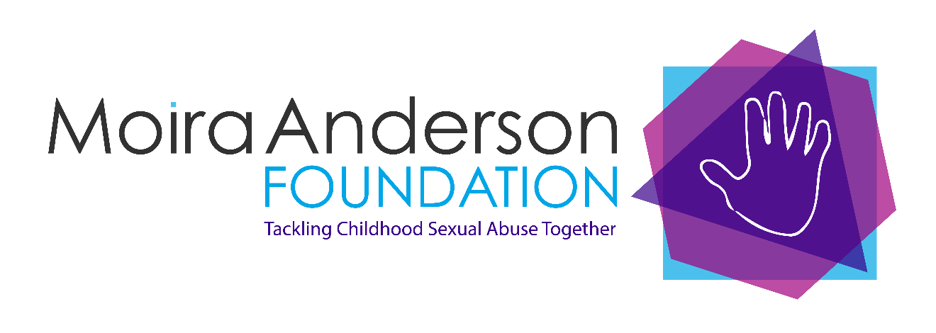

JOB DESCRIPTION AND PERSON SPECIFICATION

Job Title: Client Support Officer
Service: Moira Anderson Foundation
Terms of employment: Fixed term for 12 months
35 hours per week. Monday to Friday (9am to 5pm, with the exception of Wednesday which will be 11am – 7pm)
Salary: £26,380 per annum
Pension: Excellent terms – After a postponement period of 3 months, dependent on eligibility, we will pay 8% of basic salary, employee contribution of minimum 1%. Opt out available
Annual Leave: 23 days per annum, rising one per year (after first year) to a maximum of 26, plus 12 public holidays

Main purpose:

We are seeking an enthusiastic and committed person to assist the Service Delivery Manager in the development and provision of a highly person-centered support service for children, young people and adults who have been affected by Childhood Sexual Abuse.

Main duties and responsibilities:

To uphold and integrate the MAF values of Trust, Integrity, Compassion and Resilience into your work with clients, communications with colleagues and relationship building with external agencies.

To assist the Service Delivery Manager by managing a client case load and providing a customised package of support for clients relevant to their needs and situation. Gathering and collating data; completing assessments and evaluations using tools such as Warwick Edinburgh Mental Wellbeing Scale.
To provide on-going support/pre-therapy work with clients, build trusting relationships with them, prior to the client moving on to therapy.

To assist in the development and implementation of additional interventions to support the wellbeing and care of children, young people and adults affected by CSA; e.g. peer support, education and development opportunities.

To liaise with like-minded organisations to collaborate on joint initiatives which would be mutually beneficial in addressing the Scottish Government Survivors’ strategy.

To develop appropriate responses to the needs of clients.

To facilitate the integration and sharing of appropriate information to support effective person-focused care for clients.

To work in partnership with statutory and non-statutory bodies e.g. NHS Boards, Social Work, LAMH, SAMH, to provide specific services related to supporting clients.

To assist the Service Delivery Manager to develop and maintain partnerships that are essential to the integrated provision of care to clients affected by CSA. For example, connecting GPs/primary care, non-statutory services and specialist mental health services.

To deliver a warm, open and empathetic service response when it is needed (including family members/significant others).

To work with clients to create quality assurance systems and undertakes continuous monitoring of performance.

To keep abreast of current legislation, particularly within Safeguarding and UNCRC.

To assist the Service Delivery Manager to develop and maintain partnerships with other voluntary organisations and statutory agencies.

To keep accurate records and update information systems as required.

To work collaboratively with clients and others to develop quality service; work with policies and procedures and align with a model of monitoring and improving performance that reflects the quality assurance developments in MAF.

Person specification:

Qualifications
- SVQ Level 3/HNC or equivalent in Child Care or a related area, or other relevant qualification at SCQF level 7, or COSCA Counselling Skills or equivalent relevant experience in a mental health or trauma environment

Experience
- Experience of working with people affected by trauma and/or mental health issues
- Sound knowledge of issues affecting people affected by CSA

Skills and Abilities
- Excellent interpersonal, communication and networking skills.
- Good organisational and planning skills.
- Working knowledge of Microsoft Office applications.
- Ability to work on own initiative and also work collegiately as part of a team.
- Ability to remain calm in challenging situations and have a solution focused outlook.

