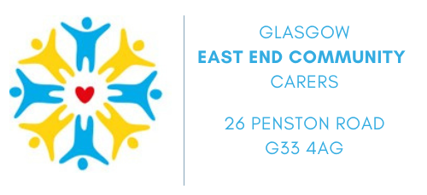

Glasgow East End Community Carers - Organisation Profile:
Glasgow East End Community Carers has been working to relieve the needs of individuals resident in the east end of Glasgow and suffering from any mental or physical disability, illness, or impairment (which may include age associated problems) and their carers since 1991. The organisation was originally formed by a group of local people who had experience of having to care for someone and they recognised that many individual carers needed support, advice and information to allow them to continue in their caring responsibilities.
The organisation is made up of the Carers Hub and the Home Care Service.
The Carers Hub seeks to empower carers by providing them with support and resources to improve their quality of life and develop the skills necessary to become more confident in their caring role.
The Home Carer Service provides a paid service of care in the home to people with a wide range of needs.

