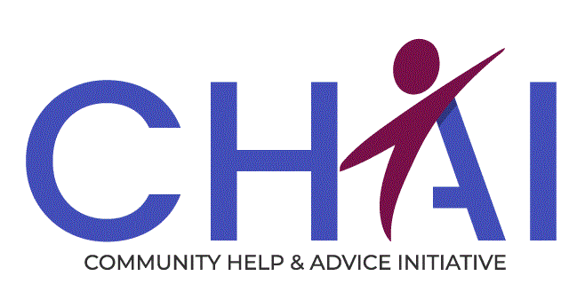
Job Description
Job Title: Energy Adviser
Location: Edinburgh (with some hybrid working and community outreach)
Reporting to: Service Manager – Financial Wellbeing Team
Position Type: Full-time (35.75 hours per week), permanent
Salary Range: £26,497 – £28,381 per annum

Job Purpose
To provide high-quality, confidential energy advice and practical support to individuals and families experiencing fuel poverty or energy-related hardship. The role will help clients reduce energy costs, manage energy debt, and create warmer, healthier homes. Advice will be delivered face-to-face, by telephone, and digitally, embedded within CHAI’s holistic advice model alongside welfare rights, housing, and debt services.
By joining our team, you will help alleviate fuel poverty, improve wellbeing, and strengthen financial resilience, ensuring that no one in our communities endures hardship.

Role and Responsibilities

Energy Advice
- Deliver tailored energy advice, including tariff checks, energy efficiency tips, and support with billing issues.
- Assist clients with fuel debt, Fuel direct issues, fuel vouchers, crisis grants, supplier hardship funds and promote Warm Homes Discount.
- Negotiate with energy suppliers to resolve disputes and agree affordable repayment plans.
- Support applications for energy efficiency measures and home improvements.
- Maintain accurate case records using Advice Pro and comply with data protection legislation.
- Provide light-touch and in-depth advice and interventions based on client needs.

Service Development
- Promote Energy Advice service across CHAI teams and partner networks.
- Build strong relationships with external partners such as Home Energy Scotland, Fuel Bank Foundation, and Changeworks.
- Contribute to outreach activities and awareness campaigns.
- Prepare reports on outcomes and impact for the Service Manager and funders.

Personal Development
- Complete City & Guilds Level 3 Energy Awareness training (or equivalent).
- Maintain up-to-date knowledge of energy advice, fuel poverty issues, and relevant legislation.

Organisational
- Adhere to the policies and procedures of CHAI.
- Actively participate in Team and Organisational meetings
- Participate in the development of CHAI services.
- Feedback on the review of organisational policies and procedures.
- Promote and represent CHAI services positively.
- Perform other reasonable related duties as required.
We offer the following
- Flexible working
- Access to Simply Health benefit plan
- 32 days annual leave (inclusive of public holidays)
- Enrolment to NOW Pension Scheme
- Extensive training programme
- Full and part time opportunities
- Supportive work environment
- Opportunities to improve services and make a difference

CHAI (Community Help & Advice Initiative
28 Westfield Avenue Edinburgh EH11 2QH
Tel: 0131 442 2100
Fax: 0131 443 5891
Email: chai@chaiedinburgh.org.uk
Web: www.chaiedinburgh.org.uk

Person Specification
Adviser
Essential | Desirable
Qualification
- Ability to quickly learn complex energy advice processes and regulations.  - Willingness to train City & Guilds Level 3 Energy Awareness | - Educated to Diploma / Degree level / SCQF 7  - City & Guilds Level 3 Energy Awareness
Knowledge, Skills & Experience
- Experience of developing trusting relationships in a formal setting.  - Ability to work independently and use own initiative and work collectively as part of a team.  - Experience of managing a caseload whilst working with vulnerable groups.  - Ability to prioritise caseload, review & update cases, and work to agreed time scales.  - Excellent communication and networking skills.  - Ability to follow policies, procedures and processes.  - Excellent literacy and numeracy skills, and the ability to write clear and comprehensive case notes.  - High level of computer literacy.  - Understanding of common energy issues.  - Ability to research problems and find solutions.  - Ability to interact positively with colleagues and networks across a range of levels. | - Experience of providing high quality accurate advice, information and representation in line with the Scottish National Standards for Information and Advice Providers.  - Experience providing energy advice or working in a related advice role  - Knowledge of energy efficiency measures and fuel poverty issues  - Awareness of legislation in safeguarding, health & safety and data protection.  - Advocacy skills.  - Knowledge of using a case management system e.g. Advice Pro.  - Good knowledge of support agencies in Edinburgh.  - Understanding of trauma informed practice.
Personal Qualities
- Passionate and committed to making a meaningful difference for individuals, families and children.
- Understanding of people's journeys and the challenges they have had in their lives, and how poverty can have an impact on them.
- Demonstrate commitment to a person-centred approach.
- Pro-active approach to identifying client needs and accommodating them.
- Flexible approach to the working environment.
- Ability to work under pressure.
- Ability to keep knowledge and skills up to date and be motivated to do so.
Other
Will be required to obtain a Protection of Vulnerable Groups Scheme Record Disclosure

