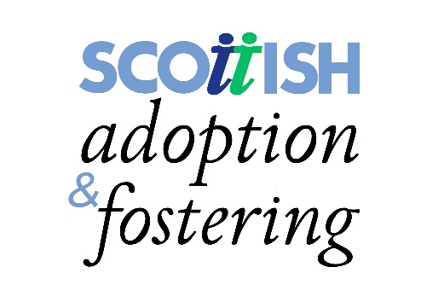
JOB DESCRIPTION

JOB TITLE Permanent and Freelance Therapists

HOURS Permanent Role – 18 Hours per week
Freelance Role – around 4 hours per week

SALARY £45,047 pro rata (18 hours - £22,368) permanent role
£43.64 per hour – freelance

BENEFITS We offer a generous staff benefit package and permanent staff members are enrolled in Lothian Pension Scheme

JOB LOCATION Within 60 mile radius of our office 111 Oxgangs Road N, Edinburgh EH14 1ED

ACCOUNTABLE TO Practice Manager – Adoption Support

1 CORE TASK AND RESPONSIBILITY

To provide a comprehensive Therapy Support Service to care experienced children and their families/carers on behalf of Scottish Adoption and Fostering.

2 JOB ACTIVITIES

- Provide Therapy to individual children and families at our offices at 111 Oxgangs Road North, in families’ homes or at a suitable venue within a 60 mile radius of the office.

- Run a variety of Therapy groups for care experienced children and their families/carers.

- Undertake assessments and develop therapeutic treatment plans for children who are referred for a Therapy service.

- Work with children taking account of issues of safer caring and confidentiality – referring any issues of concern to your own Manager or another Manager within the Agency.

- Maintain close liaison and communication with the adoptive parents/carers of children receiving a service – getting and giving appropriate feedback prior to and following each session.

- Provide review reports and attend review meetings involving adoptive parents/carers and the professional network involved with the child (permanent role only).

- Keep attendance records and summary reports for each child, which will be shared with adoptive parents/carers on request and destroyed within 1 year of therapy being completed.

- Work in close partnership and collaboration with agency colleagues and those within the wider statutory and voluntary sector to support and sustain families in their adoptive/caring task.

- Work within the laid down policies and procedures of Scottish Adoption and Fostering.

3 OTHER DUTIES AND EXPECTATIONS

- Access and make use of clinical supervision in line with Regulatory Body requirements.

- Be committed to maintaining your own professional development – undertaking relevant training and keeping up to date with research.

- Promote and represent the Agency in a way which upholds the values and ethos of Scottish Adoption and Fostering.

- Value diversity and demonstrate a commitment to anti-discriminatory practice in accordance with the agency’s equality policy.

- Remain a member of the Protecting Vulnerable Groups Scheme (PVG) in relation to working with children.

