Introducing Recyke-a-bike
People into work and bikes into the community. That’s our goal at Recyke-a-bike. We are a registered charity based in Causewayhead, Stirling who are passionate about cycling and hope to spread that passion into the local community.
Our well stocked shop sells modestly priced bikes, giving everyone the opportunity to own a bike which can be used for pleasure, commuting, exercise or as a vital mode of transport. Our trained and experienced workshop mechanics also provide extensive servicing and repairs for all types of bikes.
In addition to our Workshop Staff, we have an Outreach Team who deliver Bikeability Scotland Level 1 and Level 2 training in primary schools throughout Stirling and Clackmannanshire. The team also provides cycle training for people of all ages and abilities, from both adults and children keen to learn how to ride bikes through to those looking to develop their on-road or mountain biking skills. Our Outreach Team also run the highly successful InspiRide course. This 6-week fully-funded Employability, Training and Wellness Program not only improves people’s technical skills in terms of bike mechanics and riding, it also allows them to develop interpersonal and communicational skills, improving their self-confidence and preparing them for future employment.
In addition to our staff, our volunteers are an essential asset to the day-to-day running of our charitable organisation. Giving time generously supports all our functions whilst in return volunteers learn new skills, grow in confidence, and feel included as members of our Recyke-a-bike family.
Here at Recyke-a-bike we also offer a successful free-to-hire e-bike/e-trike library. Our Active Travel program supports our aim to help more people to choose to cycle more regularly.
We are excited to meet candidates who are enthusiastic about contributing to our charity’s good work at a time when cycling as a mode of transport is more important than ever before. We want and need more people on bikes and hope you can help us achieve that!

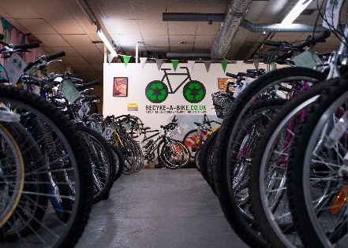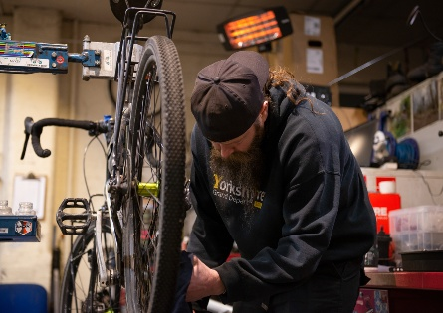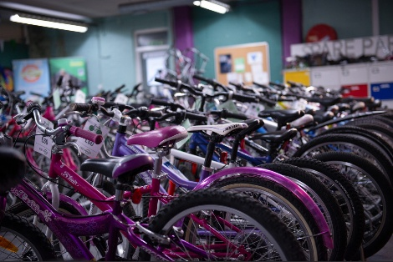

About Us
Our History
Recyke-a-bike (part of Fallin Community Enterprises) has been in operation since 2005. We began as a small recycling social enterprise that quickly grew into a job club, using bike recycling as work experience for our members. Over the years we’ve seen a lot of growth and now offer training services and cycling outreach work, in addition to our bike recycling and sales through our well stocked and modestly priced shop.
More information can be found on our website linked below:
Recyke-a-bike | Cycle Repairs, Training and Outreach in Stirling
Our Aims
Are to help people, our local community and environment by:
- Supporting people into employment, education, training and volunteering;
- Helping more people to choose cycling for low carbon transport, better health and wellbeing, and of course for fun; and
- Stopping bikes ending up in landfill.
Our Vision
Is a healthy, economically and environmentally sustainable Scotland where vibrant communities work together making them great places to live, work and relax.
Our Mission
Is to use cycling, bikes and social inclusion to change and improve lives across Scotland. We will improve sustainability, poverty, health and wellbeing, social isolation, employability and cycling within the Scotland region.

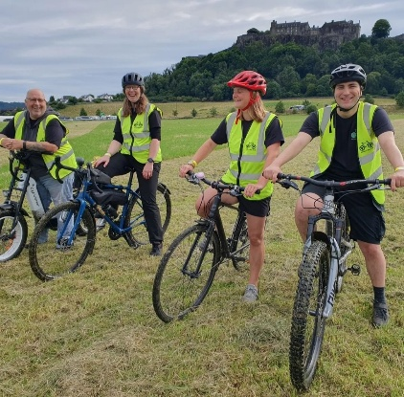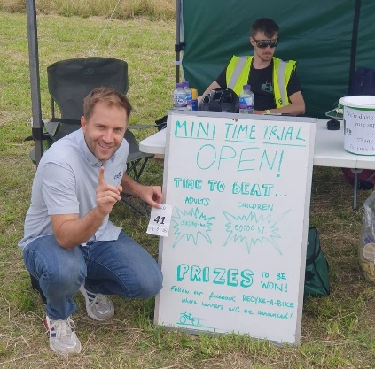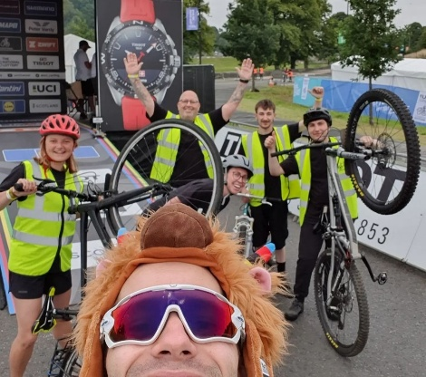

Our Values
- People are our greatest asset, everyone is part of the team, valued and respected whether paid, placement, volunteer, or customer.
- Anyone who wants to cycle should have access to a bike, cycle training and safe cycle infrastructure.
- Equality of opportunity should be a human right and we will work to improve people’s opportunities for work, life and cycling.
- Vocational jobs and qualifications are just as important to individuals and society, and we will support their achievement.
We only have one planet and our work must be done in an environmentally responsible manner.

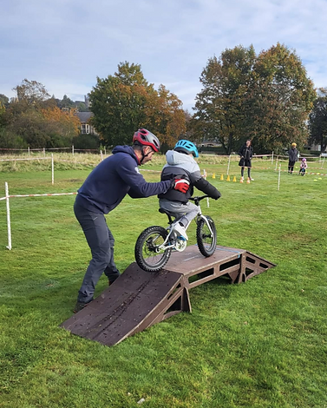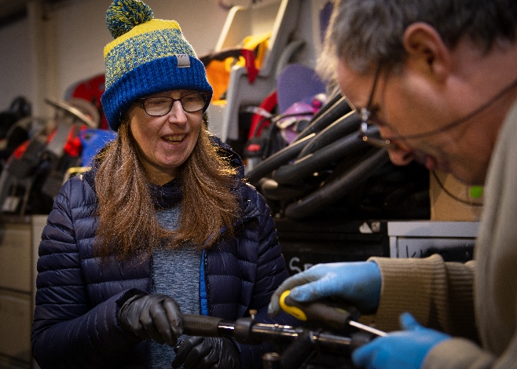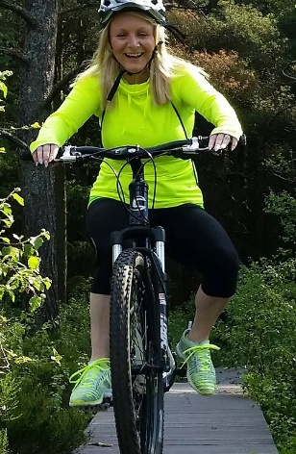
Our Benefits and Rewards
Pension Scheme – Employees are automatically enrolled in Scottish Widows’ Recyke-a-bike pension scheme within 3 months from their start date. Recyke-a-bike contributes 5%, with employees contributing 3%, with the opportunity to add a higher percentage.
Annual Leave – 32 days per annum (pro rata for part time staff).
Staff Discounts – Yearly 50% reduction in price for shop bikes worth £100 or under. All other staff purchases are at a 20% reduction.
Death in Service – This benefit pays out a fixed amount on death up to a determined value to the beneficiaries. This is usually free of tax. Why provide this benefit? - It gives our employees the security that in the event of their death their family and dependants are left with a lump sum to help during this very difficult time.
Long Service Recognition – 1 day additional annual leave for every 5 years of service.
Real Living Wage Provider – Recyke-a-bike is a Real Living Wage provider and is committed to paying fair wages.
Job Description
Job Title – Outreach Worker and Cycle Trainer
Reports To – Recyke-a-bike Outreach and Development Manager
Location – Recyke-a-bike, Causewayhead, Stirling
Contract – 35 hours per week (would consider part time for the right candidate but working hours would be 8am until 4pm)
Contract Term – Permanent
Salary – £24,897 p/a
Purpose
To support the delivery of the Bikeability programme in partnership with Cycling Scotland and Stirling and Clackmannanshire local authorities. The Outreach Worker and Cycle Trainer will also support the delivery of all cycling-based activities delivered by Recyke-a-bike.
Responsibilities
- Main:
  - Delivery of Bikeability Training to Children.
  - Delivery of Adult Cycle Training.
  - Maintenance of bikes and equipment for each of the following fleets: Stirling, Clackmannanshire, EBike, Practical Cycle Awareness Training (PCAT) and Adult Cycle Training Fleets.
  - Managing health and safety within area of responsibility.
  - Carrying out risk assessments for Bikeability sessions.
  - Planning, risk assessing and delivering other cycle related sessions, events and activities.
  - External liason with third parties including schools, local councils, community groups and organisations, as well as charities and businesses.
  - Attending team meetings.
  - Attending continuous professional development (CPD) training.
- Additional:
  - Building bikes for the shop when not busy.
  - Collecting bike donations for the shop.
  - Deliver Doctor Bike services across the Forth Valley when required.
  - Assisting other departments where needed.
  - Any other reasonable duties consistent with working for a small charitable organisation.
Person Specification
- Essential:
  - Have a passion for cycling.
  - Be a competent cyclist, comfortable riding in road and shared use path settings.
  - Be computer literate with a working knowledge of Microsoft Office and use of the internet.
  - Have tact, diplomacy and skills in handling children and adults, including those with additional support needs.
  - Can work independently (without supervision), as part of a team and take initiative where necessary.
  - Be committed to continual learning, improvement and development.
  - Have a desire to mentor and support members of the Outreach team.
  - Have a willingness to be flexible in approach.
  - Have a friendly and welcoming manner.
- Desirable:
  - Be a qualified Cycle Trainer and National Standards Instructor.
  - Have experience delivering Bikeability.
  - Have experience working with children.
  - Have a full, clean driving license.
  - Be committed to recycling and working within the Third Sector.
  - Have experience of collection and maintenance of data and reporting.
  - Have bike mechanic and/or other cycle training qualifications (if you do not have the relevant qualification, training can be provided for the right candidate.)
  - Have a current two-day outdoor first aid certificate.

Additional Information
The post holder will normally be operating from Recyke-a-bike in Causewayhead, Stirling. However, they will also be required to undertake outreach duties in the Stirling and Clackmannanshire local authority areas also.
The post holder will be required to work outside of the normal working hours (08:00-16:00, Monday to Friday) as either flexible hours or where circumstances dictate as Time Off In Lieu (TOIL) that will be agreed in advance with the post holder’s line manager.
The post holder will be required to work most public holidays.
Due to the nature of this role, we expect Outreach Workers to take the majority of their Annual Leave outside of termtime during our busiest periods.
Recyke-a-bike activities include working with children and vulnerable adults. As such, the post holder must be willing to undertake a Disclosure Scotland Protecting Vulnerable Group (PVG) check as a requirement for the role.
Recyke-a-bike is a welcoming organisation, and we encourage applications from people with a wide range of backgrounds, experiences and perspectives.
Application Process
Please submit a CV and cover letter to info@recyke-a-bike.co.uk
Please note that we would aim to appoint this position as soon as possible, early submissions would be appreciated. The closing date for applications is 31/1/2025, although an appointment may be made before then, should the right candidate apply.

