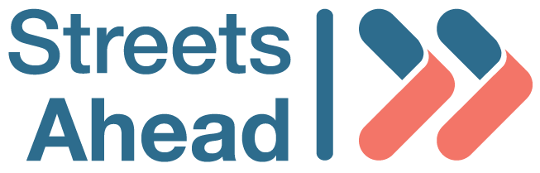
Diversity Monitoring Form

Streets Ahead wants to meet the aims and commitments set out in our equality policy. This includes not discriminating under the Equality Act 2010.

Please complete this form to help us understand the diversity of our job applicants.

Completing this form is voluntary and all information will be treated in confidence and used solely by the Human Resources department for the purpose of providing statistics for equality, diversity and inclusion monitoring.

None of the information you provide will be linked to your application and you can send this to us separately if you prefer.

If you have any questions about the form, contact Rhona McLeod on recruitment@streets-ahead.org.uk

Position applied for
In each section listed below, please choose one option by marking ‘X’ in the appropriate box.

Agon
Under 18 |  | 18-24 |  | 25-29 |  | 30-34
35-39 |  | 40-44 |  | 45-49 |  | 50-54
55-59 |  | 60-64 |  | 65-69 |  | 70 and over
Prefer not to say

DISABILITY

The Equality Act 2010 defines a disability as a physical or mental impairment that has a substantial and long-term adverse effect on an individual’s ability to carry out normal day-to-day activities. This could include long-term or progressive health conditions.
Do you consider that you have a disability?
Yes |  | No |  | Prefer not to say

GENDER REASSIGNMENT
Is your gender the same as your sex that you were registered at birth? If your gender is not the same as the sex recorded on your birth certificate when you were born, (for example, you are transgender or non-binary), select ‘No’. If you answered ‘No’ please enter the term you use to describe your gender.
Yes
No
Term used to describe my gender
Prefer not to say

MARITAL OR CIVIL PARTNERSHIP STATUS
Co-habiting |  | Divorced
Married |  | Registered civil partnership
Separated |  | Single
Widowed |  | Prefer not to say

RACE (ETHNIC GROUP)

Asian Scottish |  | Asian British/Other British
Asian Other |  | Black Scottish
Black British/Other British |  | Black Other
Mixed Ethnicity Scottish |  | Mixed Ethnicity British/Other British
Mixed Ethnicity Other |  | White Scottish
White British/Other British |  | White Other
Any other ethnic group |  | Prefer not to say
If your ethnic group was not specified, please specify if you wish

RELIGION OR BELIEF
Buddhist |  | Christian
Hindu |  | Jewish
Muslim |  | No religion
Sikh |  | Prefer not to say
Other religion or belief (please specify)

SEX
Female |  | Male
Other |  | Prefer not to say

SEXUAL ORIENTATION
Asexual |  | Bisexual
Gay |  | Heterosexual or straight
Lesbian |  | Pansexual
Other sexual orientation, please specify |  | Prefer not to say

Date

Please do not sign this form so we can keep this information anonymous

