
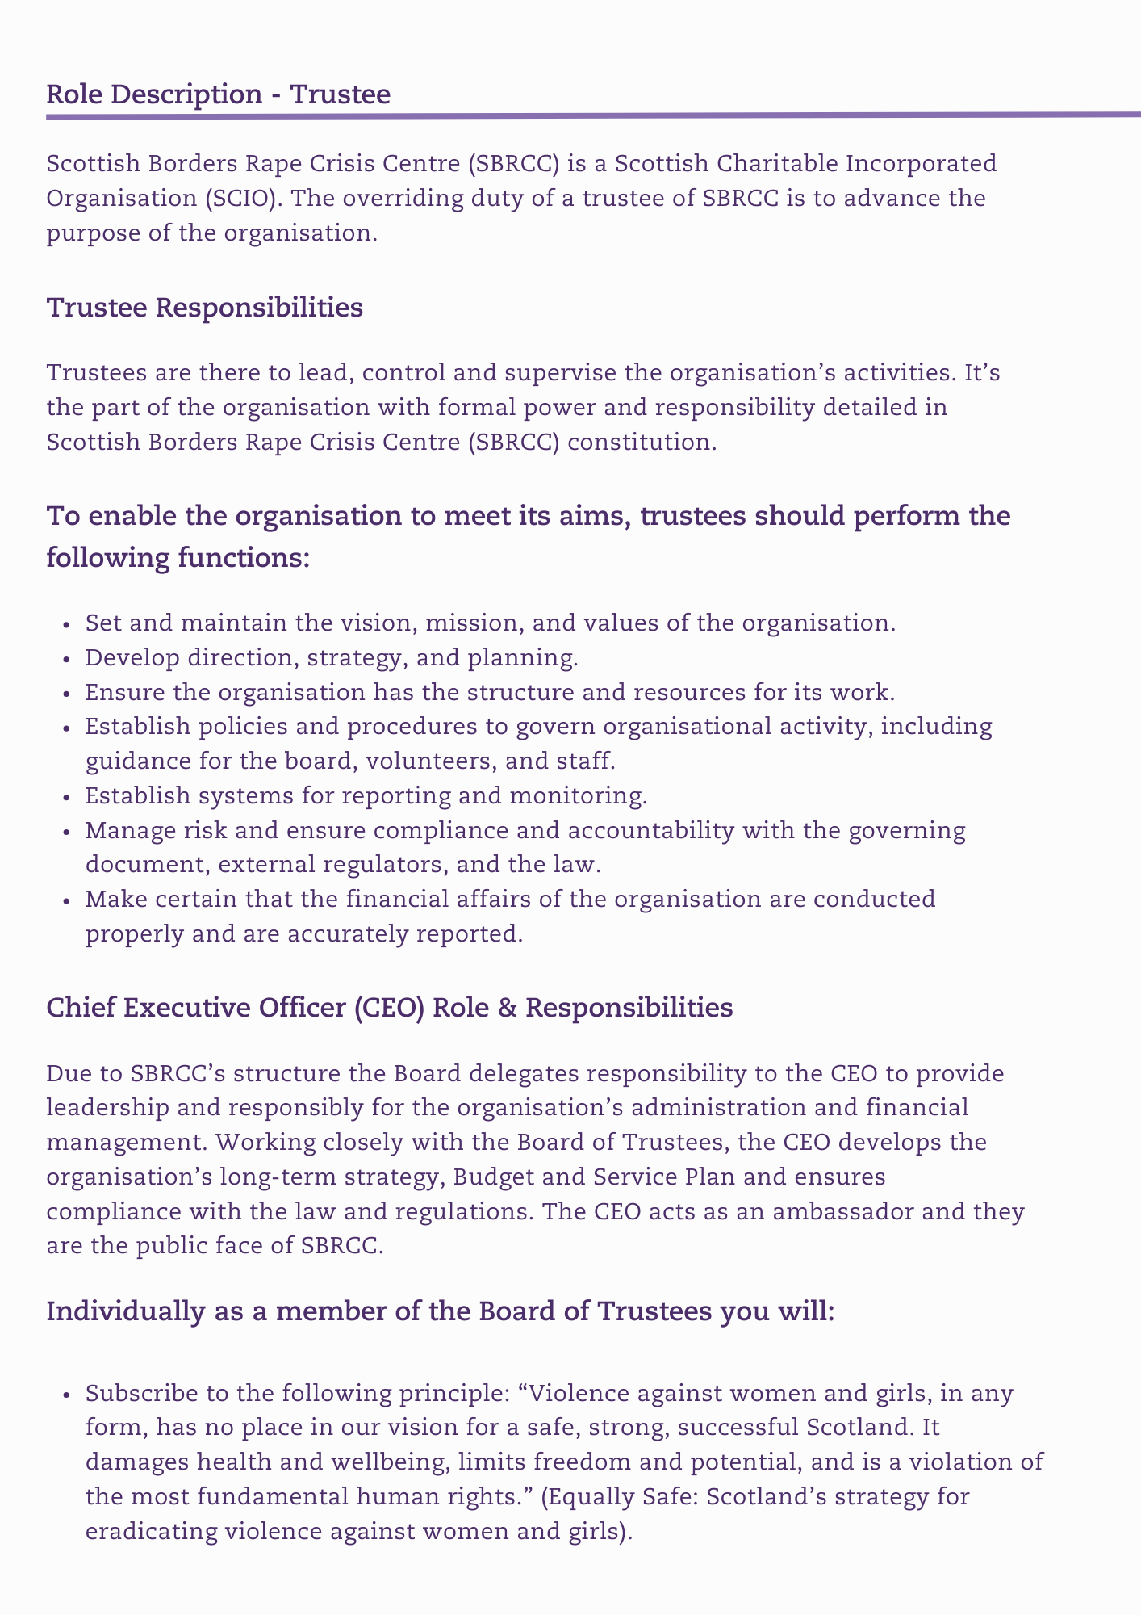
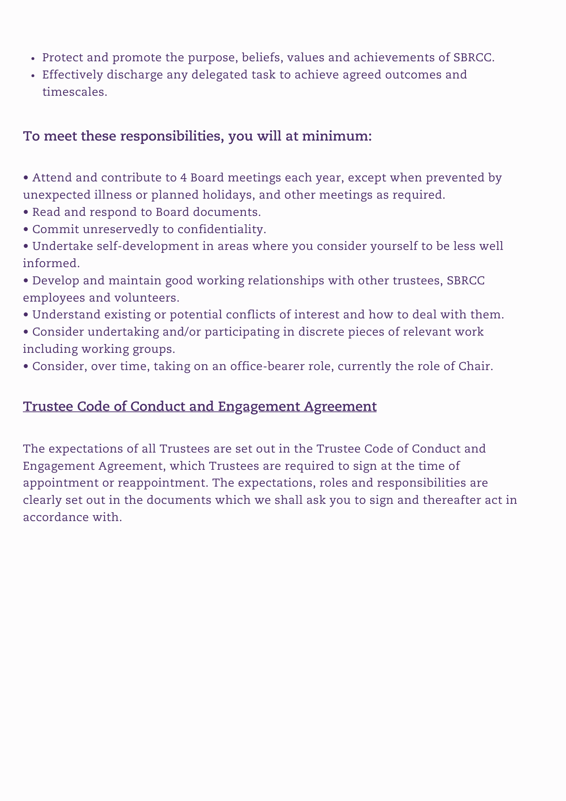
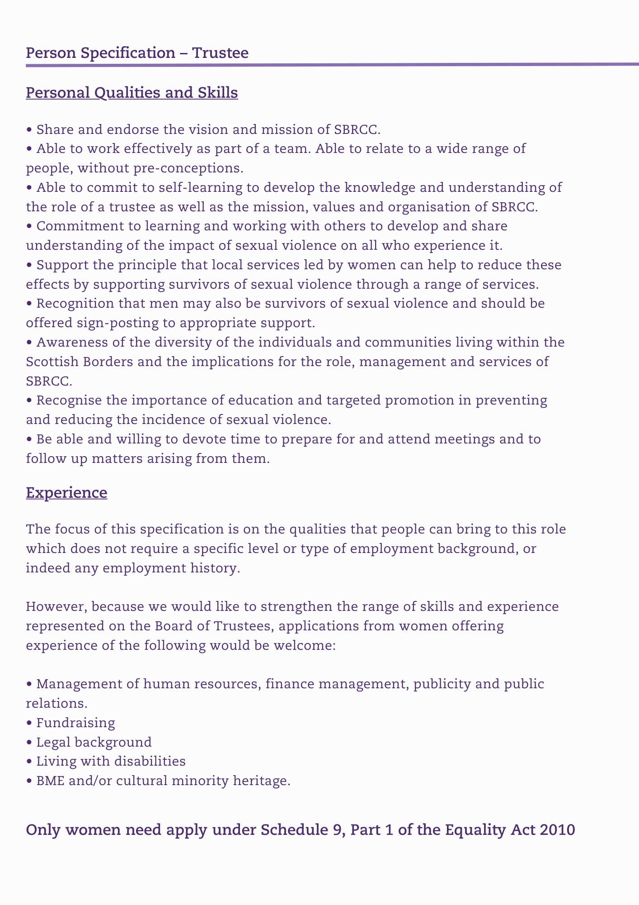
Application Form – Trustee

Section 1. Personal Information
Name (in full)

Address
(including postcode)

Contact phone number

Email address

Section 2. Skills / Knowledge / Experience Overview - Please tick/mark those which apply to you. There is not an expectation that you will have all of these skills.
Feminist/Gendered Analysis of violence |  | Third sector knowledge
Board/ Committee participation |  | Marketing
Accountancy / Financial |  | Media / PR
Fundraising |  | Organisational Development
Governance |  | Change Management
Human Resources |  | Policy Development
Information Technology |  | Risk Management
Campaigning |  | Health & Safety
Legal |  | Strategic Planning
Management Systems |  | Social Media
Website Development & Management |  | Training
Business Development |  | Audit Quality
Partnership & Networking |  | Service User Participation
OTHER(S) - please list below
Section 3. Please tell us what interests you about the role of Trustee at SBRCC.

Section 4. Experience, skills and knowledge - Please describe how your experience, skills and knowledge are relevant and would enable you to fulfil this role.
Section 5. Employment History – please list any relevant previous employment starting with the most recent.
From | To | Employer | Title and main duties | Reason for Leaving

From | To | Employer | Title and main duties | Reason for Leaving

From | To | Employer | Title and main duties | Reason for Leaving

Professional Qualifications: If Applicable

Name of awarding body | Date awarded | Qualifications obtained, Membership of Professional Institution etc.

Training – Please provide details of any courses or training undertaken relevant to this role.
Course / Training | Provider(s)

Section 6. Referees – Please give details of two referees.

One of your referees should be your current employer if you are employed, or your last employer if you are unemployed.

References will only be sought for successful applicants.

Reference 1.
Name:
Job title:
Address:
Relationship to you:
Telephone number:
Email:

Reference 2.
Name:
Job title:
Address:
Relationship to you:
Telephone number:
Email:

Declaration
Rehabilitation of Offenders

Do you have any criminal convictions other than those spent under the Rehabilitation of Offenders Act?
Disqualification

Section 69 of the Charities and Trustees Investment (Scotland) Act 2005 disqualifies the following from acting as charity trustees:

• Someone with an unspent conviction for dishonesty under the Act
• An undischarged bankrupt
• Someone who has been removed under either Scottish or English Law by the courts or by the charity commission from being a charity trustee
• A person disqualified from being a company director
• Someone who has granted a Protected trust Deed (PTD)

I declare that I am not disqualified from being a Charities Trustee or Company Director and that the information given on this application form is correct and complete.

Signed:

Print Name:

Date:

Please note all personal information will be kept and used in line with our Data Protection I GDPR policy. For more details please contact SBRCC directly.

Disability
Do you consider yourself to have a disability which we require to take account of to assist you in attending an interview or carrying out this role? | Yes / No

Please email your completed application form to recruitment@sbrcc.org.uk
Or post your completed application to:

Susie Stein
Chief Executive Officer
Scottish Borders Rape Crisis Centre
1A Wilderhaugh
Galashiels
TD1 1PW

