Job Description Peer Advocacy Worker

The Job Details
Job Title: | Peer Advocacy Worker
Salary: | Starting £25,264
Pension: | 5% of salary subject to Staff Policy Conditions (see Staff Handbook)
Conditions: | Refer to Staff Handbook for full details
Holidays: | 32 days for full year April - March comprising 28 days + 4 fixed public holidays (as per contract). All holiday allowances pro-rata for part years and part-time posts.
Hours of work: | 35 hours per week. A Time-Off-In-Lieu system operates for any additional hours worked or the normal working day is altered.
Probationary Period | As per Contract
Notice Period: | As per Contract
Responsible to: | Carer Support Manager
Responsibilities: | Project Volunteers
Screening: | In working with Carers as part of your normal duties, you may be having one-to-one unsupervised access with a child or an adult at risk in a variety of settings including the individual’s own home. In addition, as part of your normal duties you may be working with Volunteers and Carers with their own Additional Support Needs. This post is therefore subject to satisfactory references and membership of the Protecting Vulnerable Groups Scheme (PVG Scheme).
Location: | Carers Link provides staff opportunity to work on a hybrid basis, however the amount of homeworking will very much depend on the nature of the role involved, length of service, and whether it is preferred by the staff member.  Hybrid working for full time staff is therefore offered on the basis of:  Please note that there is no requirement for you to work at home and you may choose to always be in the office if you prefer.
  Initial probation (weeks 1-12) | One day per week (Friday) for homeworking  (additional days by discretion of management)
  Weeks 13-26 | Maximum of two days per week working at home (Friday and one other)
  Weeks 27 and beyond (assuming successful completion of probation) | Minimum two days per week in office. However remaining days may not necessarily always be at home as it is expected that this role will involve support within the community (meeting carers and/or volunteers).

The Organisation
Carers Link wants to see carers of East Dunbartonshire have the best possible quality of life, through help and support for their caring role and the opportunity to pursue their own needs, interests or work.
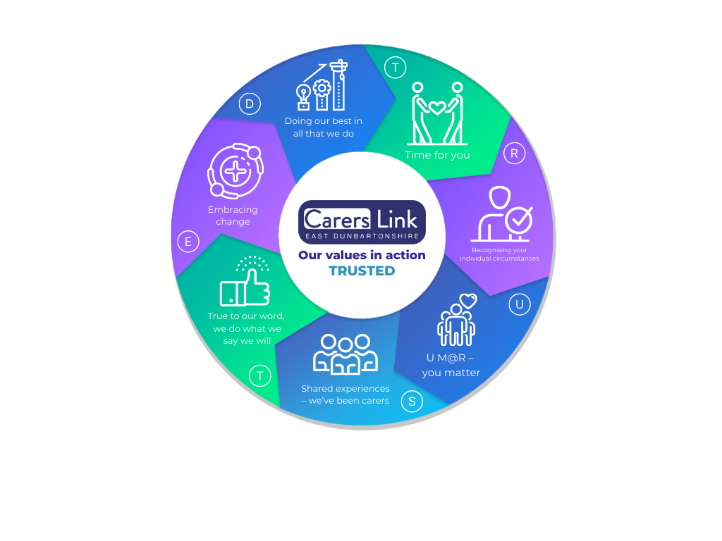

We are passionate about supporting carers because as staff, we’ve been there. Some of us are carers now, whilst the others have been carers in the past. Quite simply, we get it. We know the tiredness, the guilt, the frustration, the loneliness, the sadness that can all come with caring responsibilities. But we have also seen a community of carers grow locally over the last 15+ years, sharing in their support of one another, sharing in their laughter, in their tears and sometimes both at the same time.

This shared experience is one of the things that makes Carers Link TRUSTED. Carers share so much of themselves with us because they trust us – not just to keep information confidential but to be there for them and to do what we say we will.

The Job

Our project – Challenges to Changes – will provide Peer Advocacy to unpaid, family carers within the local authority of East Dunbartonshire. This will be a new project and – by involving Peer Advocates – a new way of providing support to carers.

The nature of advocacy provided by Peer Advocates (i.e. volunteers who have personal experience of caring for a family member) will focus on their caring role and/or the impact caring is having on their lives. It will include advocating to access respite and social care support services as well as supporting the carer’s own voice. From experience, we know carers need advocacy - sometimes through lack of confidence or knowledge but often through lack of energy or time. They are exhausted by caring and have no energy to take on more forms or meetings or in challenging ‘the system.’ However, until this new project, paid staff has delivered this advocacy.

This project will now harness the immense knowledge and experiences of carers to help others in making changes for themselves, whether small steps that might make a difference to how they feel or to access formal social care support to make bigger changes in their caring role. Peer advocates will either act directly as a voice or support a carer to find their own voice, supporting carers to express themselves and to ensure their needs are being heard within East Dunbartonshire’s social care provisions

The Challenges to Changes project is being funded for one year through the Scottish Government Independent Advocacy Social Care Fund. During work on the Care Reform (Scotland) Bill, independent advocacy was highlighted and this fund will test how the less common types of independent advocacy – collective, peer or citizen – can support people who need social care support. Monitoring and evaluation from these pilot projects will help inform the approach to future independent advocacy provision for people accessing social care support.

The job description will be supported by objectives as agreed with the CEO and within the funding application and partnership agreement.
The Tasks

Aim – Recruit volunteers with current or previous caring experiences to act as Peer Advocates by:
- Working collaboratively with colleagues in other volunteer-involving projects (Carers Call & NODA) to ensure a coordinated and shared approach to developing volunteer recruitment pathways through all recruitment stages.
- As above, liaising to promote volunteering for project and wider organisation through EDVA, websites, social media, publicity materials and outreach talks/events.
- Having a shared approach to initial enquiry responses before matching potential volunteers to appropriate projects or interests.
- Carry out appropriate screening, reference, Disclosure/PVG checks as required.

Aim – Ensure Volunteers involved in the project are supported by:
- Working collaboratively with colleagues as above, to ensure a coordinated and shared approach to volunteer induction training.
- Developing and delivering training required for the specific role of Peer Advocate
- Be responsible for the day-day organisation and support of project volunteers, including guidance, policies, procedures and practical resources or instruction.
- Working collaboratively within the team to organise and deliver social get-togethers e.g. Christmas, Volunteers Week, Carers Week.
- Organising and delivering project specific support and supervision sessions.

Aim - Bring your lived experience, personal expertise, and local knowledge to support carers and peer advocates by:
- Participating in the organisation’s ‘duty’ system to ensure adequate cover to respond to queries.
- Participating in the screening of new Carers to the organisation as required, identifying their needs and signposting and/or referring as appropriate.
- Maintain a small personal caseload ranging from information enquiries to complex and ongoing emotional support and/or advocacy needs.
- Work with the Peer Advocates, Advocacy Team and Carer Support Manager to provide advocacy and support to carers. This will include allocating cases to Peer Advocates, monitoring outcomes and casework direction and risk management.
- Support Peer Advocates in using the Outcomes Star with carers to determine ‘journeys of change’ and then supporting them to facilitate agreed changes.
- Supporting Peer Advocates to share their experiences as case studies and reflections IF they CHOOSE to do so, as support to other Carers and to contribute to influencing health and social care systems in East Dunbartonshire.
- Ensure that accurate and up-to-date files for Carers are maintained by yourself and Peer Advocates
- Work collaboratively with the Advocacy Team to develop an array of templates (that can be adapted for individual carer needs) and resources for use by Peer Advocates. These should reflect the National Performance Framework and take a Human Rights approach to carer support.

Aim – Ensure service development is to a high standard that meets funding requirements
- Implement such administrative processes as necessary to deliver the project. This will include recording systems and outcome evaluations using Outcome Stars.
- Utilise the organisation’s database to its maximum potential in the planning, co-ordination and recording of activities. Ensure that accurate and up-to-date files (for activities and Carers as applicable) are maintained
- Ensure evaluation processes are in place for all aspects of the project to ensure monitoring and reporting on each area to Board Members and funders. Provide timely and accurate reports and statistics as required.
- Be responsible for all aspects of administration, co-ordination and facilitation of any groups including arranging of speakers, venue, catering, risk assessment etc.

Aim – Be part of the wider organisational team responsibilities by:
- Being led by the Carer Support Manager and CEO in the delivery of the projects aims & objectives.
- Be aware of the Vision, Mission, Values and Objectives and work in a manner to reflect these.
- Adhere to agreed budgets and timescales.
- Work within the policies, principles and good practice of Carers Link, in particular adhering to confidentiality at all times in relation to information accessed through role involvement.
- Attend support and supervision to monitor workload, reflect on work and identify learning opportunities
- Make effective use of training opportunities made available.
- Any other task that may be reasonably requested of the posts.

Person Specification

Shared Experiences | Essential | Desirable
Personal experience of being a Carer or Young Carer AND the ability to use your lived experience in a positive and appropriate way to help others
An understanding of the issues faced by carers
Values | Essential | Desirable
Be true to your word - Be honest and act with integrity, deliver what you say you will do (but don’t promise what you can’t)
Recognising individual circumstances – Treat people with dignity and respect, whether carers, staff, volunteers or partner organisations
Time for you – Be willing to have a cup of coffee with someone (virtual or otherwise), chat and importantly, listen
Embracing change - Have a positive, energetic and ‘can do’ approach. Be creative at problem solving. A sense of humour helps too!
Do your best in all that you do – Have high standards in the quality of your work whether supporting carers or typing up notes on the database. Always seek to continually improve what you do and contribute to the improvement of the organisation
Be a team player and support your colleagues to ensure goals are met
Behave in a way which builds a strong reputation for Carers Link
Specific Experience or Skills | Essential | Desirable
Experience of working with and/or supporting volunteers
Experience of delivering advocacy, information, or support
Experience of facilitating or working with groups
Excellent communication skills & ability to relate to a wide range of people
The ability to empathise with others and build positive relationships
Excellent organisation, administration and IT skills
Computer literacy in all aspects of Office i.e. Word and Excel.
Good understanding of outcomes, monitoring & data collation/reporting
Excellent attention to detail and methodical approach to work
Ability to travel across East Dunbartonshire

