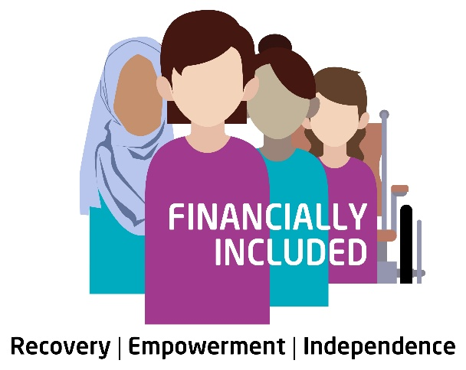

Job Description: Administrator
Hours: 21 hours per week
Salary: £27,000 per annum (pro rata)
Annual Leave: 20 days plus 12 public holidays (pro rata)

Location & Working Pattern

This role will be primarily office-based. However, we are open to discussion regarding flexible working arrangements, including some home working and flexibility around working days and hours across the week.

Financially Included is a specialist welfare rights project supporting women who have experienced economic abuse and other forms of gender-based violence, which have impacted their ability to achieve financial independence and stability.
As the project enters an exciting new phase of growth and development, we are seeking to recruit a dedicated and experienced Administrator to join our team.
This is a key role within a dynamic and innovative project. We are looking for someone who is passionate about social justice, thrives in a fast-paced and collaborative environment, and has a strong understanding of the feminist analysis of gender-based violence.
The successful candidate will play an important role in supporting the delivery of our work and ensuring the smooth running of our services. You will be required to work across a number of functions within the project, so the ability to operate effectively in a fast-paced and multi-layered environment is essential.
By joining Financially Included, you will become part of a passionate and committed team with a shared vision and values, working to improve outcomes for women affected by economic abuse.
GEMAP Scotland is committed to Fair Work First principles, including providing a supportive working environment, promoting equality, and investing in staff wellbeing and development.

Key Responsibilities

1. Administrative Support
- Provide day-to-day administrative support to the Financially Included team
- Maintain accurate records
- Support scheduling of meetings, events, and internal activities
- Prepare documents, reports, and correspondence as required

2. Training & Events Coordination
- Coordinate training sessions, including bookings, invitations, and attendee management
- Act as a first point of contact for training enquiries
- Support preparation of training materials and resources
- Assist with organising events, workshops, and roadshows (including logistics and venue coordination)

3. Helpline & Second-Tier Advice Support
- Support the administration of the Economic Abuse Helpline (“Purple Phone”), including:
  - Managing inboxes and logging enquiries
  - Ensuring enquiries are allocated and responded to within agreed timescales
- Assist with coordination of second-tier advice requests from professionals
- Maintain accurate records on systems such as AdvicePro

4. Data & Reporting
- Input and maintain accurate data on case management and monitoring systems
- Support the production of routine reports for funders and internal use
- Assist in tracking outputs such as training numbers, helpline contacts, and engagement activity

5. Communications & Engagement
- Support communications activity, including:
  - Drafting and scheduling social media content
  - Updating website content (where required)
- Respond to general enquiries and direct them appropriately
- Support stakeholder engagement activities and partnership working

6. General Duties
- Work in line with trauma-informed principles and organisational values
- Maintain confidentiality and adhere to data protection requirements
- Contribute to team meetings and wider project development
- Undertake any other duties appropriate to the role

Additional Information
- The role may involve occasional travel for events or training delivery
- A commitment to equality, diversity, and inclusion is essential
- The postholder will be expected to work in a trauma-informed and survivor-centred way

Person Specification
Category | Criteria | Essential / Desirable
Experience | Experience in an administrative or support role | Essential
 | Experience of organising meetings, events, or training | Essential
 | Experience of managing data and maintaining accurate records | Essential
 | Experience working in the third sector, advice sector, or public sector | Desirable
Skills & Abilities | Strong organisational skills with the ability to manage multiple tasks | Essential
 | Excellent communication skills (written and verbal) | Essential
 | Good IT skills, including Microsoft Office (Word, Excel, Outlook) | Essential
 | Ability to work independently and as part of a team | Essential
 | Attention to detail and accuracy | Essential
 | Experience supporting communications or social media | Desirable
Knowledge & Understanding | Understanding of confidentiality and data protection | Essential
 | Awareness of working in a professional, client-focused environment | Essential
 | Knowledge or understanding of economic abuse and/or gender-based violence | Desirable
 | Experience using case management systems (e.g. AdvicePro) | Desirable
 | Understanding of trauma-informed practice | Desirable

Please complete the application form and return to amberc@gemap.co.uk by Wednesday 15th April 2026 by 5pm.
When completing the section “why are you applying” it is important that you refer to how you meet the essential and desirable criteria in the table.
Shortlisting is planned for 16th April with invite to interview being email out that afternoon.
Interviews will take place on Tuesday 21st April at Wright Business Centre, 1 Lonmay Road, Glasgow, G33 4EL.

