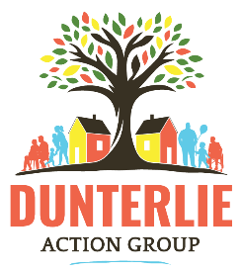
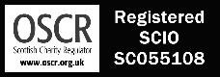
Community Development Worker
Application Form
Personal Detail
Name
Address
Postcode
Email
Phone Number

Equality Act 2010
We are committed to being an equal opportunities employer. If you have a disability as defined in the Equality Act 2010, are there any reasonable arrangements that could be made to assist you in attending an interview? Please give details.

Referees
Referees will not be approached prior to a condition offer being made.
 | Reference 1 | Reference 2
Name
Position
Organisation
Email Address
Telephone Number

Guaranteed Interview Scheme
Dunterlie Action Group are committed to interviewing applicants who meet the essential criteria for the role as shown in the person specification (full details can be found in the Job Description) if they fall under one of three categories: Disabled, Care Experienced, Living within G78 postal area. If you think this applies to you, please mark the appropriate box.
Disabled | Care Experience | G78 Postal Area

Education
Please only list your qualifications and training that are relevant to this post. Start with most recent.
Institution or Awarding Body | Date | Subject and Qualification Gained

Employment History
Please give a brief history of your last five years employment, including any gaps and volunteering/unpaid work.
Company | Position | Responsibilities and Achievements | Dates

Commentary
Please use this section to explain how your experience meets the job description and person specification. Feel free to use examples from your work, volunteering, and life experience to show your skills and abilities and how you would meet the needs of this role.

