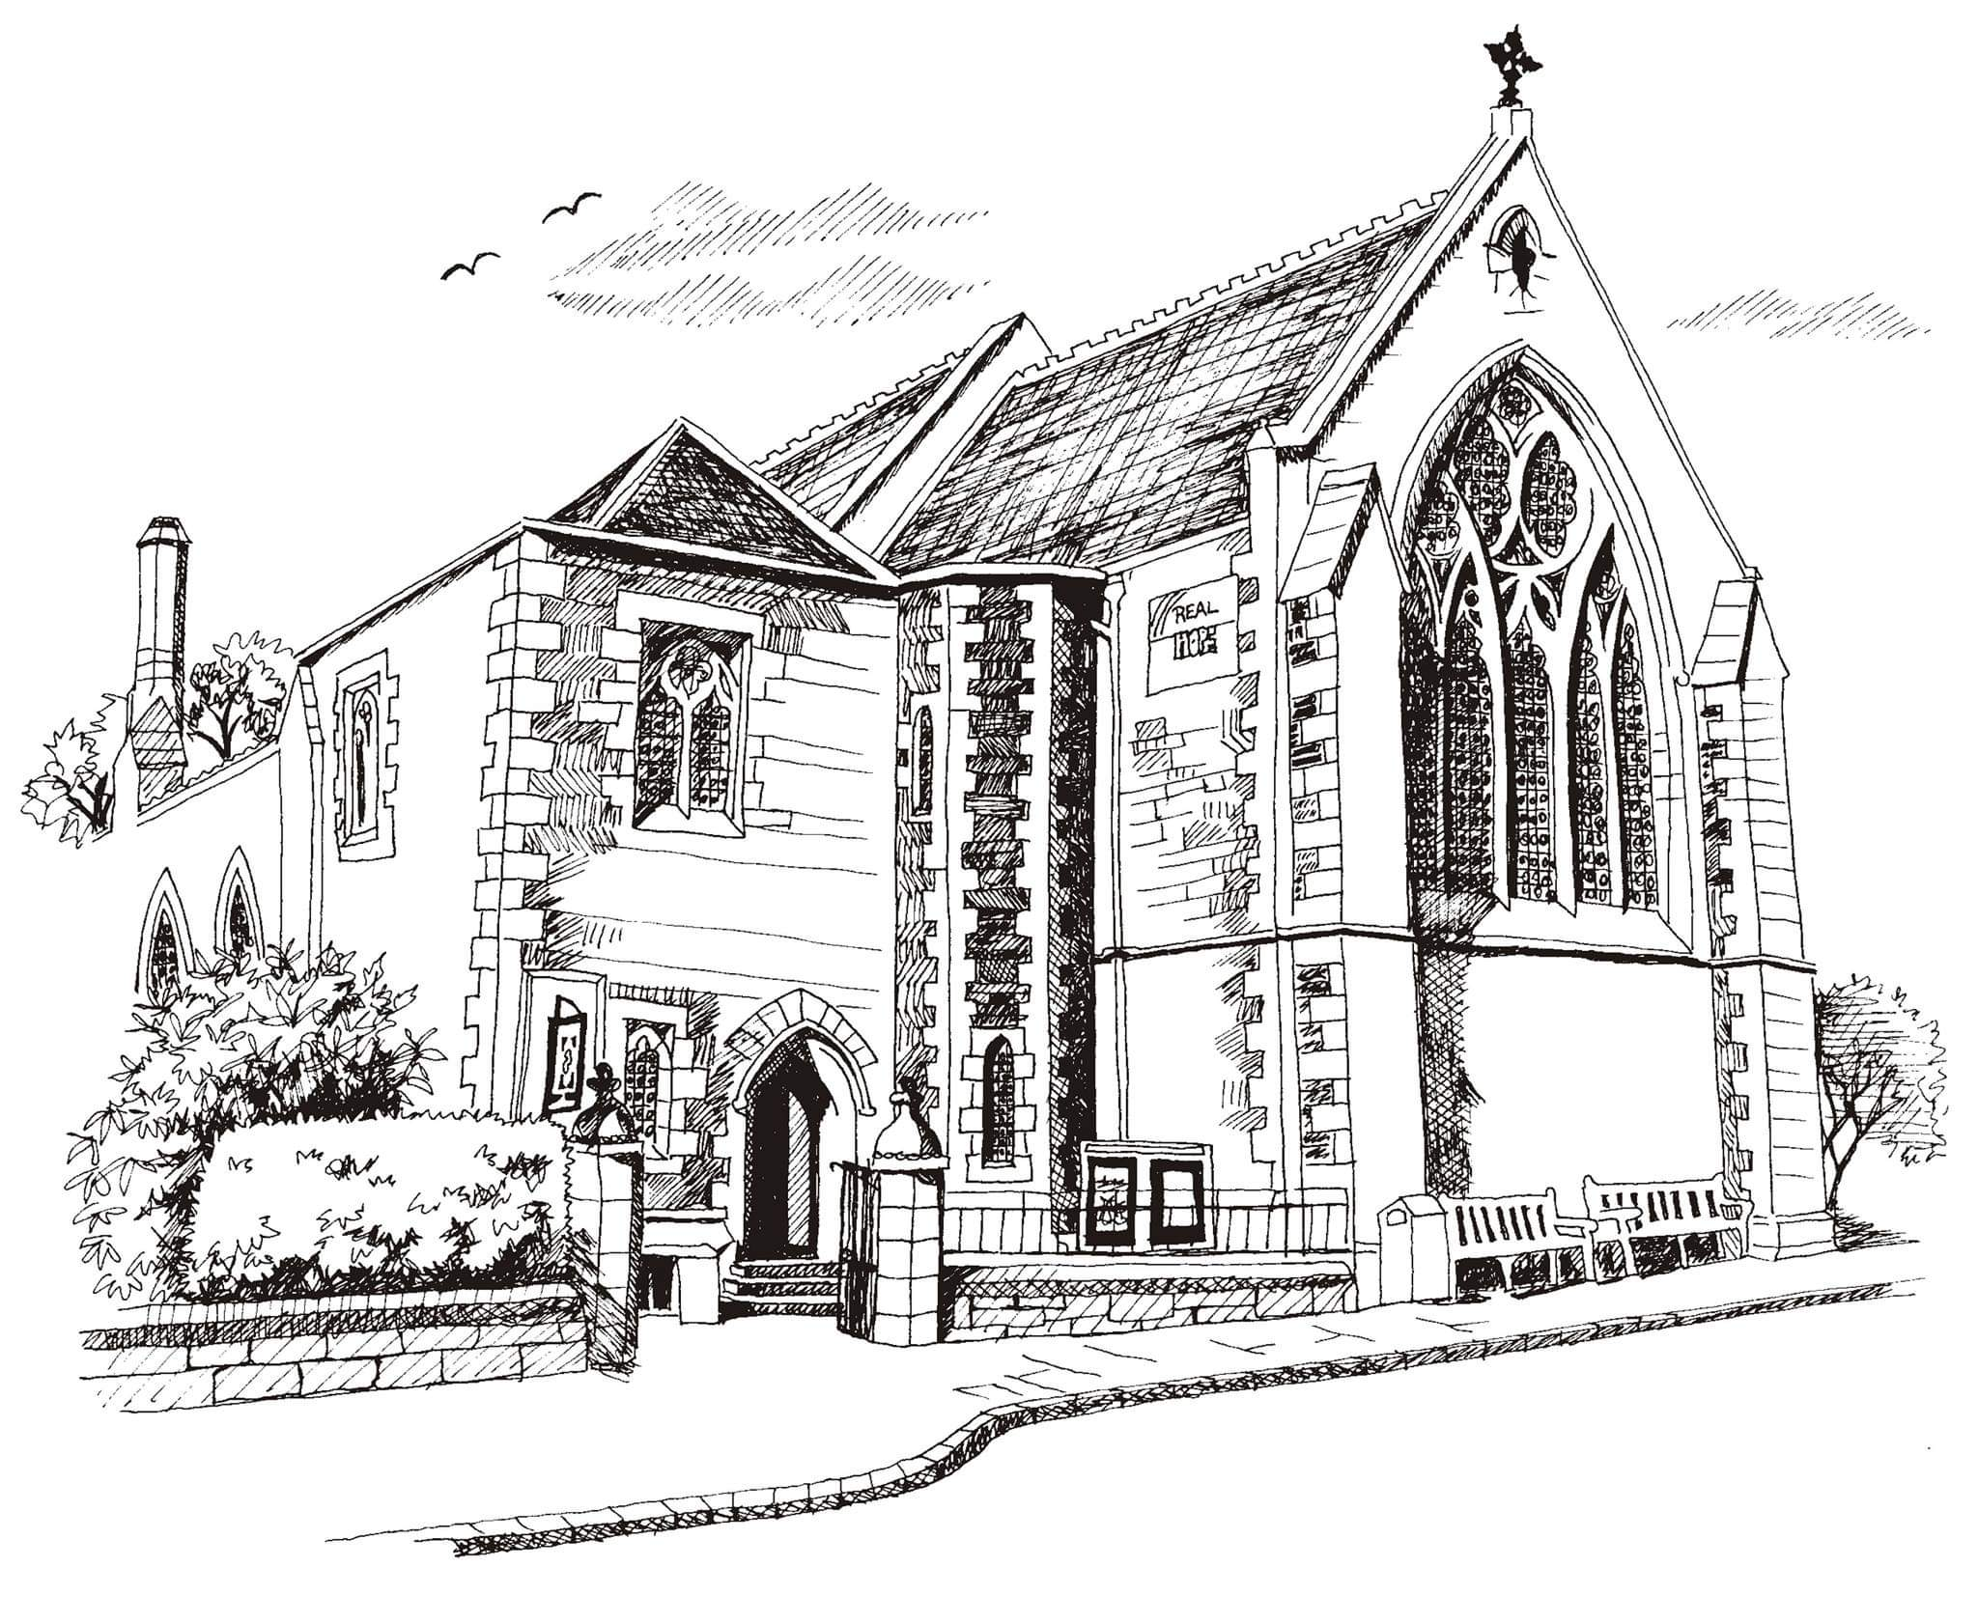
St James’ Church Goldenacre

57B Inverleith Row
Edinburgh EH3 5PX
www.stpj.org.uk

Application form: Church Administrator
Please type your answers in this form, using the expandable boxes as necessary.

Your details

Name:

Address:

Postcode:

Phone:

Email:

Education and training
Please give details:

Qualifications
Please give details:

Employment history

Your current or most recent employer

Name of employer:

Address:

Postcode:

Job title:

Pay:

Length of time with employer:

Reason for leaving:

Duties:

Previous employers
Please tell us about other jobs you have done and about the relevant skills you used or learned in those jobs.

Supporting statement
Please tell us why you are applying for this job and why you think you are the best person for the job.

Interview arrangements and availability

Interviews will be held on Tuesday 20th October 2026
Please let us know if you are unable to be available on this date.
If you are invited to interview we will let you know by Thursday 15th October at the latest. If you do not hear by then, your application has been unsuccessful.

If you have a disability, please tell us if there are any reasonable adjustments we can make to help you in your application or with our recruitment process.

How soon could you start working for us?

Right to work in the UK
Do you need a work permit to work in the UK? Yes / No

References
Please give the names and contact details of 2 people who we can ask to give you a reference. We may ask them before an employment offer is made. We will not ask your current employer until we get your permission.

Referee 1
In what capacity do you know this person?

Referee 2
In what capacity do you know this person?

Declaration
I confirm that to the best of my knowledge the information I have provided on this form is correct and I accept that providing deliberately false information could result in my dismissal.

Name:

Signature:

Date:

Please return this form to Revd. Ruth Green revruthstjames@hotmail.com
no later than midday on Monday 12th October 2026.

