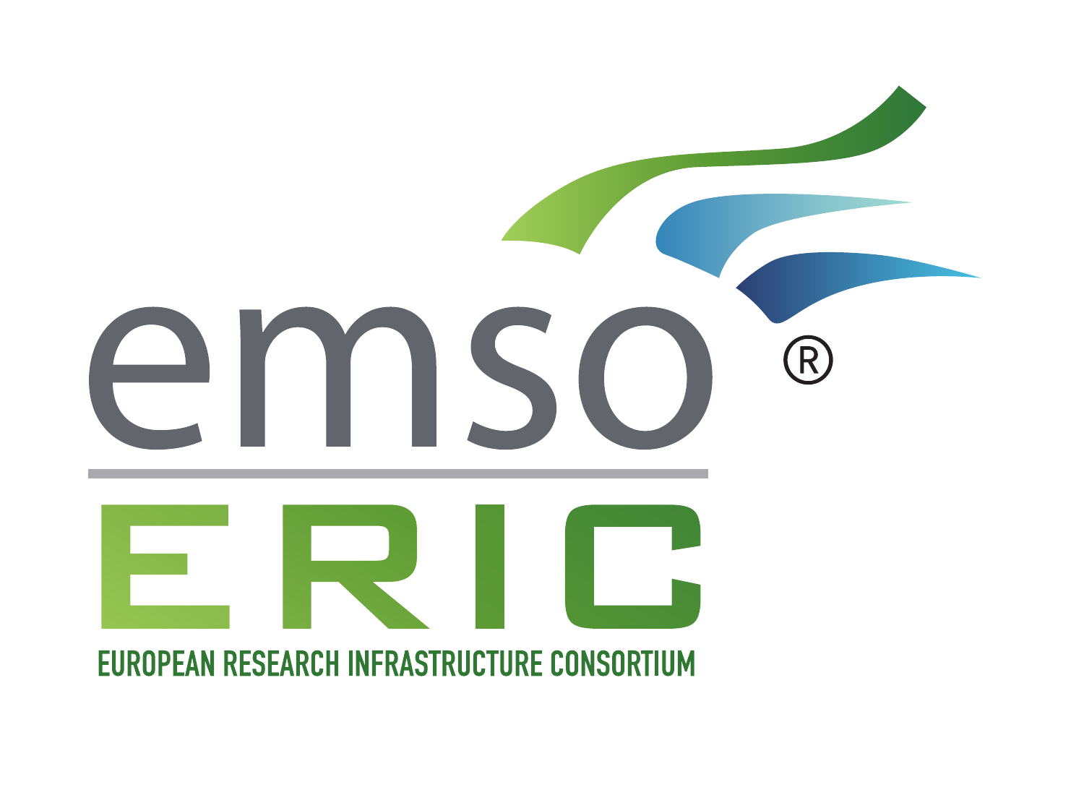 EMSO ERIC | 10TH ANNIVERSARY

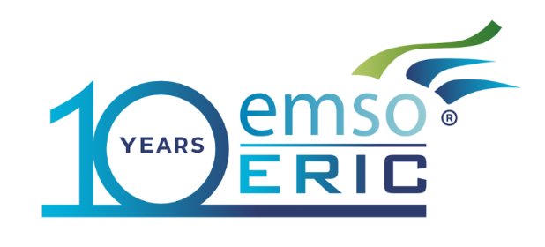

A DECADE IN THE DEEP
CELEBRATING 10th ANNIVERSARY OF EMSO ERIC
Rome, Italy | 15-16 December 2026

Introduction & Event Overview
EMSO ERIC, the European Research Infrastructure Consortium that operates the European Multidisciplinary Seafloor and water column Observatory, celebrates its 10th anniversary as an ERIC this year. EMSO ERIC has operated the observatory infrastructure since 2016 through a distributed system spanning 14 Regional Facilities across 21 sites—from the Nordic Seas to the Black Sea and out into the Atlantic—run by more than two dozen institutions and delivering around 125 in-situ variables from the seabed to the sea surface. Over the last decade, EMSO has anchored Europe’s marine research capabilities by providing uninterrupted, high-quality data from the ocean surface to the abyss, serving as an essential foundation for global environmental science and climate change research.
The infrastructure comprises cabled observatories, seafloor stations, mooring lines, surface buoys, and autonomous moving systems as well as shallow-water test sites. These facilities are open to the research community, allowing scientists and industry partners across Europe and beyond to freely access EMSO data online and apply for physical access to the observatories through the EMSO Physical Access programme. Today, EMSO stands as more than an infrastructure: it is a thriving ecosystem of researchers, engineers, and cutting-edge regional facilities dedicated to understanding our ocean’s future.
To mark and celebrate this decade of scientific and operational achievement while discussing strategic priorities for the future of European ocean observation, EMSO ERIC will bring together key scientific, policy, and institutional stakeholders on 15 and 16 December 2026 in Rome, Italy, at the Hotel Barceló Roma.

Below is the provisional agenda for the event; further details are already accessible on our official website, where the final program will also be published in due course.

DAY 1 | SCIENCE PROGRAMME

Science Day

10 Years of EMSO Science: Observing the Changing Ocean
Tuesday, 15 December 2026 | Location: Barceló Roma |

TIME | PROGRAMME
08:30-09:00 | Welcome and registration
09:00-09:30 | Opening and vision  EMSO's mission, science themes and the value of sustained deep-ocean observation  Ingrid PUILLAT, EMSO ERIC Director General  Dominique LEFEVRE, CNRS and Science Service Group Leader
09:30-10:00 | Keynote lecture  The Future of Ocean Observing Systems  Henry RUHL, MBARI, Director of Central and Northern California Ocean Observing System
10:00-11:15 | Ocean Dynamics Challenge  Keynote, Sabrina SPEICH, CNRS-IPSL  EMSO perspectives, Nadia LO BUE, INGV  EMSO case study and discussion
11:15-11:45 | Coffee break
11:45-13:00 | Biodiversity Challenge  Keynote, Nicolas PADE, CEO of EMBRC ERIC  EMSO perspectives, Silvana NEVES, PLOCAN  EMSO case study and discussion
13:00-14:30 | Lunch
14:30-15:35 | Geophysical Challenge  Keynote, Roberta IVALDI, Istituto Idrografico della Marina (IIM)  EMSO perspectives, Davide EMBRIACO, INGV  EMSO case study and discussion
15:35-16:05 | Coffee break
16:05-16:50 | Cross-cutting panel discussion
16:50-17:40 | Poster pitches
17:40-18:40 | Poster session and icebreaker
Programme timings and contributors may be updated as the event is finalised.

EMSO ERIC | 10TH ANNIVERSARY
DAY 2 | MORNING

Information Session

Wednesday, 16 December 2026 | Location: Barceló Roma | Morning - 08:30-14:00

TIME | PROGRAMME
08:30-09:00 | Welcome and registration
09:00-09:30 | Opening: ten years of EMSO  Ingrid PUILLAT, EMSO ERIC Director General
09:30-10:00 | How does technology serve science and industry in EMSO  Dominique LEFEVRE, CNRS and Science Service Group Leader  Alfredo MARTINS, INESC TEC and Engineering and Logistics Service Group Leader
10:00-10:20 | Physical Access: achievements and impact  Simo CUSI, EMSO ERIC Engineering and Logistics Officer  Joaquin Del Rio, EMSO OBSEA Regional Facility Leader
10:20-10:45 | Coffee break
10:45-11:30 | The Digital Sea: Virtual Access and Data Funneling in the portal  Enoc MARTINEZ, UPC, Data Service Group Leader  Aljaz MASLO, EMSO ERIC Science and Data Officer  Towards the OcenEye initiative, the importance of EMSO data and its interoperability towards EMODnet Physics  Antonio NOVELLINO, EMODnet Physics Coordinator  The importance of EMSO data for the Copernicus marine service  Dominique OBATON, Copernicus Marine In Situ TAC Lead Coordinator
11:30-12:15 | A Decade of Discovery: EMSO’s Scientific Achievements and Societal Impact, Scaling Subsea Innovation and Skills through EMSO  Dominique LEFEVRE, CNRS, Science Service Group Leader,  Bridging the Deep: Scaling Subsea Innovation and Skills through EMSO  Sara PERO, EMSO ERIC Communication Officer  Panel discussion
12:15-12:30 | Towards the future and international collaborations from Marine Research Infrastructures collaborations  Ingrid PUILLAT, EMSO ERIC Director General
12:30-14:00 | Lunch

EMSO ERIC | 10TH ANNIVERSARY
DAY 2 | AFTERNOON AND EVENING

10th Anniversary Ceremony

Wednesday, 16 December 2026 | Location: Barceló Roma | Afternoon - From 14:00

TIME | PROGRAMME
14:00-14:30 | Opening welcome  Ingrid PUILLAT, EMSO ERIC Director General  Host-country and host-institution representatives
14:30-14:45 | Assembly of Members address  Ana ARICHA, Chair of the EMSO-ERIC Assembly of Members
14:50-15:10 | Research Infrastructures in European marine strategy  High-level European and Research-Infrastructure perspectives
15:10-15:20 | EMSO corporate video
15:20-15:45 | Scientific keynote  Henry RUHL, MBARI, Director of Central and Northern California Ocean Observing System
15:45-16:15 | Networking break
16:15-16:25 | Access success story  Clara MANNO, British Antarctic Survey
16:25-17:00 | Celebrating achievements and looking to the future  Closing speech: Ingrid PUILLAT, EMSO ERIC Director General
The final line-up of institutional representatives will be announced following confirmation.

