**Welcome to Epiphany!**

**The Twenty-First Sunday After Pentecost**

**October 25th, 2020**

**8:00 am & 10:30 am**

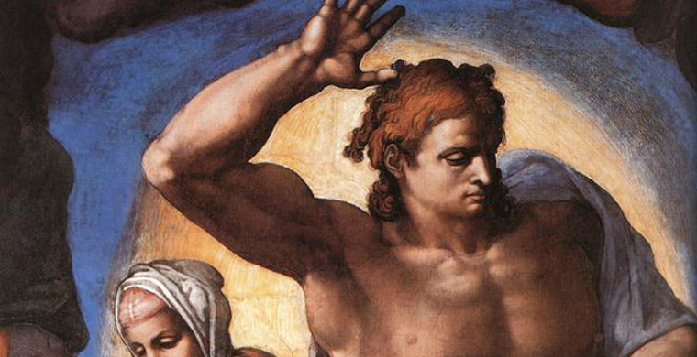

**Sharing Truth Cross Grounding Lives Cross Igniting Joy**

We believe God has called us to share the compelling

Truth of Jesus Christ through:

Celebratory Worship

**First Reading 1 John 3: 4-10**

**Psalm 119: 9-16**

**9** How shall a young man cleanse his way? *

**By ruling himself according to your word.**

**10** With my whole heart I have sought you; *

**O let me not go astray from your commandments.**

**11** Your words have I hidden within my heart, *

**that I may not sin against you.**

**12** Blessed are you, O Lord; *

**teach me your statutes.**

**13** With my lips have I been telling *

**of all the judgments of your mouth.**

**14** I have had greater delight in the way of your testimonies *

**than in all manner of riches.**

**15** I will meditate on your commandments *

**and have respect for all your ways.**

**16** My delight will be in your statutes, *

**and I will not forget your word.**

**People: Glory to the Father, and to the Son, and to the Holy Spirit, as it was in the beginning, is now, and will be forever. Amen**

**The Gospel John 8: 31-47**

**Sermon The Rev. Steve Victory**

|  |  |  |  |
| --- | --- | --- | --- |
|  | **Altar Guild** | **Readers/Chalice** | **Vestry** |
| **8:00** | Debbie Wieland |  | Dwight Anneaux |
| **10:30** | Carol Gregory |  | Joelle Davis |

Caring Relationship

**Home Communion** If you know someone in need of home communion, please call the office so we can make the appropriate arrangements.

**Confidential Prayer** If you are in need of prayer we have a team of intercessors that will pray for you. To be added to their list of those in need please call Maribeth Race at (352) 383-3383. Your call and the nature of your request will be kept confidential.

**Happy Birthday this week to our Epiphany Family!**

Nancy Volland & Barbara Garrett-Wilcox

**Happy Anniversary this week to our Epiphany Family!**

Henry & Joyce Ankenmann

Biblical Teaching

**Sunday Discipleship Class:**   Join us at **9:30 am on Sundays.**  Studying Genesis, Faith, and Science foundational chapters 1-11 of the Book of Genesis, primarily using the video series, “The Genesis Academy."  "Is Genesis History?"  Join this study and learn the solid historical and scientific groundwork of human civilization provided in Genesis 1-11.

**Men’s Wednesday Bible Study: Wednesdays at** **9:00am** in the Parish Hall. David is the Old Testament fore bearer of the Messiah. We are now in 2 Samuel, as we work our way through the story of David. Come see who he was and what makes his life so special - interesting - and full of surprises!

**Theology On Tap:** every other **Monday,** **October 26th, at 7:00 pm** in the Parish Hall. We will be discussing John Piper’s Book *Desiring God*. Please read chapter 3.

**Youth Group:** **Wednesdays 7:00 pm – 8:30 pm** in the Chapel. For students entering 6th grade to recently graduated from High School. There will be food, fellowship and a study of Paul’s Epistle to the Romans.

**Ladies' Bible Study:** **concluded on 10/21/2020** begins again in January TBA.

**Men’s & Women’s Thursday Night Bible Study:** **Thursdays at 7-8:30 pm** in the Parish Hall studying the Acts of the Apostles. "Come and see the beginnings of Christianity - first in Jerusalem - then throughout the Roman and Greek nations. See what made them different - and what *should*make us different!"

Announcements

**A Call to prayer:** Join several parishioners who have covenanted together to stop what they're doing **every Tuesday at 7:30** to pray that the Holy Spirit would break into the lives and ministries of  Epiphany. Joining them would be a powerful thing for each of us to do.

**The 1st Sunday loose offering** next Sunday, **November 1st**, will be given to the Rev. Steve Victory Discretionary Fund. If you write a check for it, please put it in the memo line.

**Pledge Cards**: You can turn in your pledge cards at **any time** in the offering plate, in office or by mail. We request they are in no later than Sunday November 22th.  If you need another pledge card we have some in the Narthex.

**Thanksgiving Meal Boxes:** All Food and/or donations are due in by Sunday, **November 15th**. Food list is in the office or Parish Hall.

**Ladies Fellowship Dinner**: End of the year Holiday Party! At the Squires Tri-City Adult Daycare, Inc. at **6:00 pm November 15th**. We will have a potluck dinner with a sign-up sheet in the Parish Hall. There will be crafts and we will hear all about this wonderful resource for our local area. 2046 Classique Lane Tavares, FL 32778 (Epiphany’s old Fellowship Hall/ Sunday School Room when we were at Classique)

Spiritual Healing

**Mid-Week Eucharist Service with Healing Prayer:** We are excited to announce that we have opened our Chapel for weekly Services. **Wednesdays at 11:00.**

**For Healing…** *indicates hospital stay

Jack Walstad

Justin Mills

Micah S.

Amanda S.

Amanda Disman

Bob Reich

Ken Rhodes

Bill Sanford

Janet Jones

Justin Flamm

Yvonne Hutchison

Bryce Berran

Ted Berran Carol Fuller Dave Dixon

Fran Harris

Mary

Ricky Daniel

Pat Cury

Deborah Barnes

Adalynn

Dave & Susan P.

Nino

Cathy Anderson

**For those in the Armed Forces…**

Drew Moser

Brandon Peters

Rachel Parkison

Carolyn Johnson

Adam Hile

Gene Imrich Jr.

Ed Kupchick

Uriah Lennox

David Scott

Sean E Marshall

Rayan Barnes

Chase Cook

Josh Schweidert

Brent Shinkle

Chris Barker

Shaye Hayer

Brian Volland

Beau Cook

Cameron Horn

J. Nelson Brown

Thomas McDuffie

Paul Hamilton