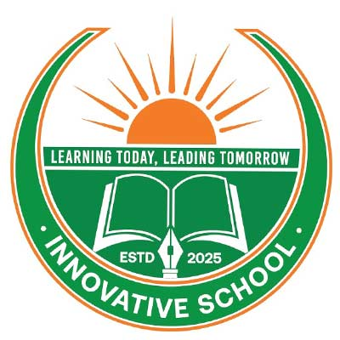
INNOVATIVE SCHOOL
NOTICE

Date: 28 June 2026
Subject: Fruit Festival 2026
Dear Students and Respected Parents/Guardians,
We are delighted to announce that Innovative School is organizing a Fruit Festival to promote healthy eating habits, nutrition awareness, and joyful learning among our students.
Date: Tuesday, 30 June 2026
Time: 10:00 AM – 1:00 PM
Venue: Innovative School Campus
All students are requested to participate in the festival with enthusiasm. Parents/Guardians are cordially invited to attend and encourage their children to take part in this enjoyable and educational event.
For any further information regarding the program, every student is requested to contact his/her respective class teacher before the event.
Your kind cooperation and presence will make the program a great success.
We look forward to welcoming you all.
Authority of
Innovative School

INNOVATIVE SCHOOL

📢 NOTICE

Subject: Food Festival 2026 – Assigned Fruits for Students
Dear Students & Respected Guardians,
This is to inform you that Innovative School will organize a Food Festival on 30 June 2026 (Tuesday) from 10:00 AM to 1:00 PM.
The following students are requested to bring the assigned fruits:
Student Name
Assigned Fruits
Sl | Students Name | Fruits name
1 | Zabeer Awab | Green Coconut & Mango
2 | Bishnu Das | Mango & Jackfruit
3 | Mohammad Arfan | Litchi & Dragon Fruit
4 | Naguib Sadaf | Black Plum & Litchi
5 | Saad Bin Zahed (Marzuk) | Pineapple & Papaya
6 | Dhruvo Barmon | Lotkon & Black Plum
7 | Tanjim Eshan | Banana & Guava
8 | Umayer Bayan | Green Coconut & Wood Apple
9 | Sirat Nazari | Sapodilla (Sofeda) & Watermelon
10 | Abdullah Al-Jishan | Banana & Guava
11 | Sondhi | Black Plum & Lemon
12 | Gopinath  Rizwan | Lotkon & Dragon Fruit  Watermelon & Pineapple
13 | Md. Estekamat | Mango & Litchi
14 | S. M. Fardin | Hog Plum (Amra) & Guava

Instructions:
Please bring fresh and clean fruits as assigned.
Each student will introduce themselves and the fruits they have brought.
Students should arrive on time with their assigned fruits.
For any further information, please contact your respective class teacher before the program.

We look forward to welcoming you all.
Authority of
Innovative School

