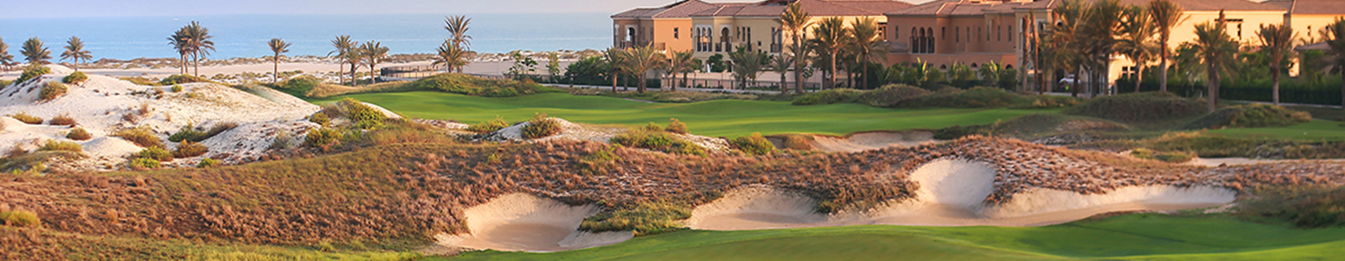

‘Battle of the Business Groups Abu Dhabi Golf Day’
Partnership Opportunities

Thursday 14th October 2021
Saadiyat Beach Golf Club

We are delighted to announce the next ‘Battle of the Business Groups Abu Dhabi Golf Day’ will take place on Thursday 14th October 2021 at Saadiyat Beach Golf Club. This will be a first return to this unparalleled corporate tournament across the international business network of Abu Dhabi, since 2019!

The competition this year will see players representing a massive 6 Abu Dhabi Business Groups – BBG Abu Dhabi, AmCham Abu Dhabi, Irish Business Council, French Business Group, Canadian Business Council and Australian Business Group.

This unique corporate tournament will provide unbeatable networking opportunities across the Abu Dhabi business community and will be followed by a fantastic evening event. At sunset, colleagues, friends and family will join players for prize presentations and to enjoy further networking, BBQ buffet and a raffle draw. The cost per player including the 18-hole tournament and BBQ buffet plus 2 house beverages is 795AED; but there are various opportunities for add on packages to get more involved in this event, and benefit as a corporate:

Sponsor a Hole!
- 1 prime sponsored hole to brand on the day as you wish (flags & collateral must be provided by hole sponsors; personnel are not allowed to man holes due to COVID-19 regulations.)
- Activation of your choice to be run at your sponsored hole. Hole sponsors must provide a prize for the activation at a minimum value of AED500.
- Event sponsor company logo to be displayed on event invitation shared to all 6 Abu Dhabi Business Groups’ databases and external invitees.
- Event sponsor company logo to be displayed on websites of all 6 Abu Dhabi Business Groups.
- Event sponsor company to be mentioned in social posts of all 6 Abu Dhabi Business Groups.

- Event sponsor company logo to be displayed on event sponsor board visible at course entrance and during prize presentations.
- Opportunity to display promotional branding (roll up banner) in Clubhouse registration area (event sponsor company must provide roll up banner.)
- Event sponsor company logo will be displayed in the digital prize booklet during evening presentation.
- Receive all event images taken by event photographer.
Cost of this package is AED 2,000*
*Excluding hole activation prize of AED500 which must be provided

Corporate Sponsored Hole plus Team of 2!
- Includes all benefits of ‘Sponsor a Hole’ package plus 2 players to participate in the competition on the day.
Cost of this package is AED 3,500*
*Excluding hole activation prize of AED500 which must be provided

Corporate Sponsored Hole plus Team of 4!
- Includes all benefits of ‘Sponsor a Hole’ package plus 2 players to participate in the competition on the day.
Cost of this package is AED 5,100*
*Excluding hole activation prize of AED500 which must be provided

Sponsor Merchandise for players & winners
- Packages can be worked out for sponsoring items such as branded golf balls, branded caps, prize winners’ trophies.
Please contact Sinead at BBG Abu Dhabi to discuss these opportunities.

To discuss any of the above sponsorship packages please get in touch with the FBG Abu Dhabi office.

In light of the on-going restrictions due to the COVID-19 pandemic, we will be following full precautions during this corporate outing to comply with social distancing guidelines in the interests of our players health and safety and in accordance with Saadiyat Beach Golf Club as guided by the Department of Culture and Tourism.

We look forward to a safe and enjoyable day out!

Kind regards,

Helene Daniel
Executive Director
FBG Abu Dhabi

