# Agriculture, land and emissions

Discussion paper

© Commonwealth of Australia 2023

**Ownership of intellectual property rights**

Unless otherwise noted, copyright (and any other intellectual property rights) in this publication is owned by the Commonwealth of Australia (referred to as the Commonwealth).

**Creative Commons licence**

All material in this publication is licensed under a [Creative Commons Attribution 4.0 International Licence](https://creativecommons.org/licenses/by/4.0/legalcode) except content supplied by third parties, logos and the Commonwealth Coat of Arms.



**Cataloguing data**

This publication (and any material sourced from it) should be attributed as: DAFF 2023, Agriculture, land and emissions: discussion paper, Department of Agriculture, Fisheries and Forestry, Canberra, October. CC BY 4.0.

This publication is available at [haveyoursay.agriculture.gov.au/agriculture-and-land-sectoral-plan.](https://haveyoursay.agriculture.gov.au/agriculture-and-land-sectoral-plan)

Department of Agriculture, Fisheries and Forestry

GPO Box 858 Canberra ACT 2601

Telephone 1800 900 090

Web [agriculture.gov.au](https://www.agriculture.gov.au/)

**Disclaimer**

The Australian Government acting through the Department of Agriculture, Fisheries and Forestry has exercised due care and skill in preparing and compiling the information and data in this publication. Notwithstanding, the Department of Agriculture, Fisheries and Forestry, its employees and advisers disclaim all liability, including liability for negligence and for any loss, damage, injury, expense or cost incurred by any person as a result of accessing, using or relying on any of the information or data in this publication to the maximum extent permitted by law.

**Acknowledgement of Country**

We acknowledge the Traditional Custodians of Australia and their continuing connection to land and sea, waters, environment and community. We pay our respects to the Traditional Custodians of the lands we live and work on, their culture, and their Elders past and present.

**Cover:** photo credit for front image of basil farmer, Kerry Trapnell.

Contents

Introduction 1

The agriculture and land sector plan 1

Why agriculture and land? 2

This discussion paper 3

1 The need for higher ambition 6

1.1 Reducing future climate risk 6

1.2 Securing access to markets, capital and supply chains 6

1.3 Biodiversity as part of the solution 7

1.4 Global food security, with lower emissions 8

1.5 Opportunities for First Nations peoples 8

2 Building on existing effort and knowledge 9

2.1 Industry leadership 9

2.2 Traditional knowledge 9

2.3 Local and regional initiatives 10

2.4 State and territory goals and programs 10

2.5 Commonwealth initiatives 10

3 Opportunities to reduce emissions 12

3.1 Livestock 12

3.2 Cropping and horticulture 13

3.3 Fuel and energy 14

3.4 Carbon storage in the land 15

4 Developing emissions pathways 18

4.1 Medium-term outlook 18

4.2 Towards 2050 19

4.3 Interim goals or indicators 20

5 Supporting and enabling change 21

5.1 Driving innovation 21

5.2 Building capacity 22

5.3 Ensuring the system enables emission reductions 24

6 Have your say 27

Glossary 28

References 30

**Tables**

Table 1 Livestock technologies and practices 13

Table 2 Cropping and horticulture technologies and practices 14

Table 3 Fuel and energy technologies and practices 15

Table 4 Carbon storage technologies and practices 16

**Figures**

Figure 1 Australia's national greenhouse gas emissions from 2004-05 to 2020-21 (CO2-e) 3

Figure 2 Agriculture's greenhouse gas emissions by source, 2004–05 to 2020–21 (CO2-e) 13

Figure 3 Land use, land use change and forestry's greenhouse gas emissions by source, 2004–05 to 2020–21 (CO2-e) 16

Figure 4 Australia's net zero emissions projections in the baseline scenario, 2021–22 to 2034–35 19

Figure 5 Three themes of potential actions 21

## Introduction

### The agriculture and land sector plan

Australia’s agriculture and land sectors are already feeling the effects of climate change. More frequent and extreme weather events, together with changing seasonal conditions, are putting pressure on productivity, farm performance and landscape health. Australian producers and land managers are innovative and are adapting and will continue to do so. But the size of the future adaptation challenge can be significantly reduced through strong global action to reduce emissions.

That’s why the Australian Government signed up to the Paris Agreement and committed to ambitious emission reductions goals, including reaching net zero emissions by 2050. Achieving those goals is in Australia’s long-term interests, including ensuring a profitable, sustainable and internationally competitive future for our producers and land managers.

Many agriculture industry groups have already committed to playing their part, endorsing Australia’s economy-wide goal or setting their own specific emissions reduction targets. Meeting these commitments and our net zero goal will help position Australia’s export-oriented agriculture sector to take advantage of shifts in markets that are expected to flow from the global transition towards lower emissions.

The government is now developing a [net zero plan](https://www.dcceew.gov.au/climate-change/emissions-reduction/net-zero#:~:text=The%20Australian%20Government%20is%20developing,reach%20Net%20Zero%20by%202050.) to describe how Australia can reach that 2050 goal. As part of that work, sectoral decarbonisation plans are being prepared to identify opportunities in:

* electricity and energy
* transport
* industry
* agriculture and land
* resources
* the built environment.

The plans will consider ways to reduce emissions in each sector and opportunities for collective action that support decarbonisation. This information will provide industry, governments and the community with certainty needed to invest in Australia’s low emissions future.

The Agriculture and Land Sector Plan is being developed by the Minister for Agriculture, Fisheries and Forestry, Senator the Hon Murray Watt; with the Minister for the Environment and Water, the Hon Tanya Plibersek MP; and the Minister for Climate Change and Energy, the Hon Chris Bowen MP.

The plan will focus on the emissions that come directly from activities in agriculture and on the land (known as scope 1 emissions), as well as emissions associated with energy, fuel and electricity use (scope 1 and 2, refer to Glossary). In terms of land, the plan will consider options associated with forestry, as well as activity on conservation lands, Indigenous Protected Areas, and other types of public and privately held land. Opportunities for First Nations people will be an important part of the policy discussion.

Indirect emissions such as those from manufacturing of inputs (scope 3) will not be addressed by the plan. However, there will be close links to other plans where related issues are considered, including the Electricity and Energy, Industry and the Transport sectoral plans. Community views regarding electricity transmission infrastructure will be considered in the Electricity and Energy plan.

The government is also exploring opportunities to reduce emissions from Australia’s important fisheries industries and will work closely with them including through conversations associated with other sectoral plans.

### Why agriculture and land?

The emissions and sequestration associated with activity in agriculture and the land make up a significant part of Australia’s, and the world’s, greenhouse gas emissions. As noted by the Intergovernmental Panel on Climate Change (IPCC) (2018) reducing those emissions and increasing carbon stored in the land is an important part of stabilising global temperatures.

#### Agriculture

Agriculture, as a sector in the National Greenhouse Account (NGA), made up 16.8% of national greenhouse gas emissions in 2020–21 (Figure 1). This share is relatively significant and is also expected to increase as other parts of the economy, such as the electricity sector, take up more readily available and lower cost abatement options.

Around two-thirds of agriculture’s emissions are methane produced during digestion by ruminant livestock, like cattle and sheep. The next largest sources are agricultural soils and manure management, as further explored in section 3. Electricity, energy and fuel use in agriculture is accounted for in other parts of the NGA. That contribution was around 9 Mt CO2 e in 2020–21, or 2% of Australia’s emissions, noting that this figure includes emissions from forestry and fishing industries (DCCEEW 2022).

#### Land use, land use change and forestry

Emissions and sequestration associated with the management of land, including agricultural land, are accounted for under the land use, land use change, and forestry (LULUCF) sector of the NGA.

LULUCF is currently a net carbon sink in Australia, contributing 13.7% of the national total in 2020–21 (Figure 1). The main drivers of this net sink are declines in land clearing for agricultural uses and native forest harvesting and associated natural regeneration of previously cleared land. This is further discussed in section 3.4.

Figure Australia's national greenhouse gas emissions from 2004-05 to 2020-21 (CO2-e)

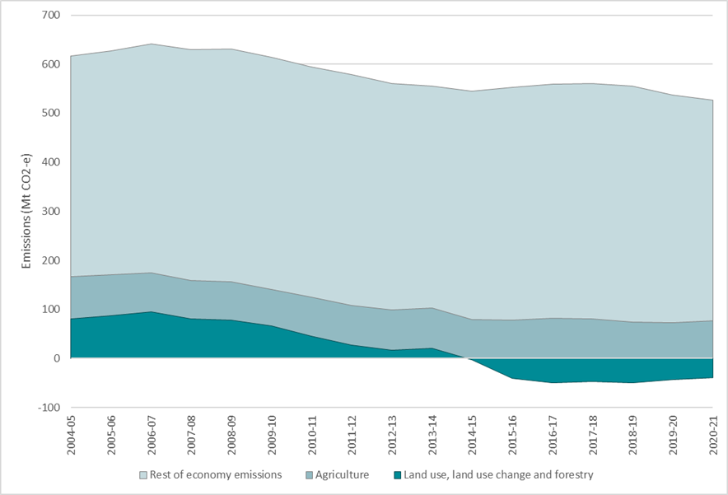

Source: DCCEEW 2022a

### This discussion paper

The development of sector plans is being informed by engagement with industry, the community, experts and governments to ensure the plans are robust, ambitious, achievable and accepted. This discussion paper is part of that engagement. It seeks views on opportunities for agriculture and land to contribute to the whole-of-economy goals, in a way that supports industry growth, productivity, sustainability and resilience.

This discussion paper explores:

* the need for higher levels of ambition (section 1)
* the existing effort and initiatives underway to reduce emissions from agriculture and land (section 2)
* the technical potential to reduce emissions and increase carbon storage (section 3)
* what the emission reduction pathways might look like for the sector to 2035, and longer-term (section 4)
* areas where action could be taken to help lower emissions (section 5).

There are questions posed throughout the paper to help guide stakeholder discussion. Questions follow each relevant section of the paper. Broader comments and views are also welcome. We invite you to write a submission or complete the [Have Your Say survey](https://haveyoursay.agriculture.gov.au/agriculture-and-land-sectoral-plan).

The department recognises the considerable value and meaning of First Nations knowledge, culture and expertise in land management. First Nations experiences and insights on all aspects of this discussion paper and the questions that follow are particularly welcomed.

#### Seeking your views: summary of questions in this discussion paper

##### The need for higher ambition

Climate change is already affecting Australia’s producers and the environment. Reducing emissions is critical for reducing future climate risks for the agriculture and land sectors, as well as ensuring our industries are well-placed to compete in global markets. Australia is committed to taking action on emissions and both the agriculture and land sectors have an important role to play in supporting our national contribution to global efforts. This is explored in section 1.

1. What are the opportunities to reduce emissions and build carbon stores in agriculture and the land? What are the main barriers to action?
2. How can we progress emission reduction efforts whilst also building resilience and adapting to climate change?

##### Building on existing effort and knowledge

There has already been significant action taken by industry, governments, First Nations peoples, local and regional communities to address climate change. This is explored in section 2.

1. Are there initiatives or innovative programs underway that could be applied or expanded on at a national scale?
2. How can the Australian Government bring together existing effort and new initiatives into one coordinated plan?

##### Opportunities to reduce emissions

Looking in more detail, there are technologies, practices and other measures that can reduce emissions and increase carbon stores. Some are established and others are still emerging. This is explored in section 3.

1. What are the most important options to be further adopted or supported, looking in the short and the longer-term?
2. What are the practical solutions to increase uptake?

##### Developing emissions pathways

The plan will explore different ways for agriculture and land to contribute to whole-of-economy emission goals, whilst also delivering on national priorities that include a profitable and productive future for agriculture, and sustainable management of Australian landscapes. This is considered in section 4.

1. How do you see the agriculture and land sectors contributing over the medium and longer-term? What are the opportunities to deliver emission reductions in parallel with wider goals?

##### Supporting and enabling change

The plan will explore ways in which the Australian Government can help to accelerate emissions reduction in agriculture and increase carbon storage in the land. This is considered in section 5.

1. How can the Australian Government better support agriculture and land sectors to:
   1. drive innovation,
   2. build capacity,
   3. ensure the system enables emissions reductions?
2. What new initiatives could the Australian Government design that would support emissions reduction and carbon storage in agriculture and land and help ensure a productive, profitable, resilient and sustainable future for the sectors?
3. A consistent and trusted approach for assessing and reporting emissions is often raised as a barrier to reducing emissions. Is there a role for the Australian Government in addressing this concern, and how can producers and land managers be supported?
4. What skills, knowledge and capabilities do you think producers and land managers need to implement change? What information and data would help them make decisions about emissions reductions and sustainable land management in the short and longer-term?

## The need for higher ambition

This section explores the rationale for an ambitious approach to developing the plan for agriculture and the land sector. It discusses the ways in which global efforts to reduce emissions could flow through domestically, and how a proactive and ambitious approach to reducing emissions and building carbon in the land will benefit industry and the environment in the long-term.

Several key themes are explored, with questions posed at the end of the section about how to effectively harness changes occurring domestically and overseas.

### Reducing future climate risk

According to the IPCC (2023), climate change has slowed the growth of agricultural productivity globally over the past 50 years, with further warming projected to increase food insecurity and supply instability. Australian producers are already experiencing some effects. Modelling from the Australian Bureau of Agricultural and Resource Economics and Sciences (ABARES 2021) shows that recent seasonal conditions (2001 to 2020) reduced the profitability of Australian broadacre farms by an average of 23%, or around $29,200 per farm.

Producers and land managers are adapting and building resilience to climate impacts and will continue to do so. But there are limits to what can be achieved through adaptation alone. There is a risk that despite advances in innovation, agricultural productivity growth may be outpaced by the impacts of climate change, including more frequent and severe natural disasters, localised changes to growing regions, and heightened biosecurity risks (IPCC 2023; ABARES 2022a).

Strong global action on emissions, including in Australia, is needed to mitigate future physical climate risk and reduce the adaptation challenge. Reducing those risks will benefit agriculture. For example, analysis of different scenarios by ABARES (2021) suggests that the worst impacts of climate change could, in the absence of adaptation, up to halve average farm profits by 2050.

### Securing access to markets, capital and supply chains

Governments overseas are developing emissions policies to deliver on the goals of the Paris Agreement. While policy in relation to agriculture and the land is still developing, it is reasonable to expect that over time, new requirements will flow through to Australia’s export-oriented agricultural industry.

Producers are already experiencing growing expectations from consumers, retailers and governments for products that demonstrate sustainable sourcing. While Australian agriculture is already relatively well placed in terms of sustainability (ABARES 2023a), further effort could enable producers to leverage this position and capitalise on the increasing expectations in relation to sustainability, carbon and nature outcomes.

Expectations around sustainability and emissions are also building in capital markets and supply chains. For example, many of Australia’s major banks have signed up to the [Net Zero Banking Alliance](https://www.unepfi.org/net-zero-banking/), which will drive expectations around emission reductions in all parts of the economy, including agriculture. Many large agri-food corporations are setting their emissions reduction targets and reporting requirements, which will flow right through supply chains. Being ready to respond with verifiable low-emissions production systems will ensure Australian producers can maintain access to capital and global markets.

National emission reporting initiatives are also underway. For example, the government is aligning with international requirements for [standardised disclosure of climate‑related financial risks and opportunities.](https://treasury.gov.au/consultation/c2022-314397) This will ensure Australia’s financial reporting system is appropriately positioned for the expansion of international standard‑setting priorities on climate and sustainability reporting.

#### Examples of supply chain and banking climate commitments

* Rabobank – Net zero financed emissions in their portfolio by 2050
* NAB – Net zero emissions by 2050
* JBS – Net zero greenhouse gas emissions by 2040 throughout the company’s global operations
* Heineken – Ambition of net zero emissions across its value chain by 2040
* GrainCorp – Net zero by 2050
* Viterra – Carbon net zero by 2050
* Bega Group – Reduce scope 1 and 2 emissions by 40% by 2030 (from a 2021 base year) and reach net zero carbon emissions by 2050
* SunRice – Net zero emissions across value chain by 2050, toward zero waste products and packaging and supporting the industry towards the most water efficient rice paddies globally.

### Biodiversity as part of the solution

As investors and corporates progress plans for managing their emissions, they are also turning their attention to equivalent ways to demonstrate environmental credentials and achieve positive outcomes for nature. For example, similar to arrangements for climate-related financial disclosures, the [Taskforce on Nature-related Financial Disclosures](https://www.dcceew.gov.au/climate-change/policy/nature-based-solutions-for-climate/financing-solutions) is leading on reporting frameworks for broader environmental impacts. This approach will see ‘nature positive’ investment progressed hand-in-hand with responses to climate change.

There are opportunities for producers and private land managers to deliver carbon storage together with nature outcomes; contributing to Australia’s commitment to address biodiversity decline, while also improving soil quality, water retention and building climate resilience. Similar opportunities also exist on publicly managed land, including land managed for conservation purposes. Work currently underway to update Australia’s National Biodiversity Strategy and Action Plan under the Convention on Biological Diversity may also provide future opportunities for sequestration and biodiversity including for example, through efforts to protect and conserve 30% of Australia’s landmass and marine areas by 2030 or to work towards restoring degraded ecosystems.

The government is developing a [Nature Repair Market](https://www.dcceew.gov.au/environment/environmental-markets/nature-repair-market) that will help producers and land managers access income for delivering carbon and biodiversity together. The market will also support environmental improvements across Australia by encouraging businesses, organisations, governments and individuals to invest in projects to protect, manage and restore nature. Addressing emissions and biodiversity will be an increasing opportunity for producers and land managers.

### Global food security, with lower emissions

Australian agriculture plays an important role in regional Australia and in the national economy, as well as globally as part of the international supply of food. As climate change intensifies, impacts on populations and food supply will vary, with more challenges in areas of poor food security. Trade in food will become increasingly important for ensuring regional and global food security.

As an export-oriented sector, Australian agriculture can play an important role as a supplier of lower-emissions food and fibre, meeting growing food demand while contributing to global emissions goals. Australian cattle and grains producers already operate with a relatively low-emissions intensity compared to other major agricultural exporter countries (ABARES 2023a). With further improvements, our producers would be well placed to displace higher-emissions intensive production in other countries.

### Opportunities for First Nations peoples

First Nations peoples have custodianship, knowledge and understanding of Australia’s lands and waters that extends over 60,000 years. Over thousands of generations, First Nations peoples have cared for and protected Country, lived sustainably with the land, and traded domestically and internationally.

The cultural, social and environmental assets which First Nations communities possess span many areas. They include traditional knowledge; cultural and communal responsibilities that involve caring for and protecting Country; a fast-growing population (especially resident population in Northern Australia); and the competitive advantage and value proposition they bring to the agriculture and land-based industries through thousands of years of sustainable land management. There is also an opportunity to further support the biodiversity conservation work already underway on Indigenous Protected Areas.

Inclusion of First Nations peoples will be central to delivering on the plan as it aims to grow capacity across agriculture and the land sector to respond to climate change (see section 5.2). It will support existing and emerging First Nations agricultural and other land management interests and businesses and align with First Nations communities’ goals for prospering into the future.

#### Seeking your views: the need for higher ambition

Climate change is already affecting Australia’s producers, land managers and the environment. Being proactive in addressing emissions is essential for reducing future climate risk and maintaining competitiveness in global markets. Australia is committed to acting on emissions, and the agriculture and land sectors have an important role to play.

1. What are the opportunities to reduce emissions and build carbon stores in agriculture and the land? What are the main barriers to action?
2. How can we progress emission reduction efforts whilst also building resilience and adapting to climate change?

## Building on existing effort and knowledge

A range of actions have been taken by industry, governments, First Nations peoples, and local and regional communities to address climate change. This plan will aim to recognise, build upon and uplift this collective effort. This section acknowledges some examples of the actions being taken across the country and prompts you to consider other initiatives that may be well suited for development at a national level.

### Industry leadership

Significant progress on emissions has already been made by the agricultural industry through its focus on productivity, its investment in technology and innovation, its response to market drivers and its implementation of improved land management practices. Australian agriculture has below-average emissions intensities for beef and grains production compared to major developed nation producers and exporters, and our use of pesticides and fertilisers is amongst the lowest in the world (ABARES 2023a). The agricultural industry also has a goal to reach $100 billion in farmgate value by 2030 (NFF 2018). Achieving this, while reducing emissions, will likely require greater efficiency and productivity improvements.

Australian agricultural industry bodies are aware there is work to be done, with ambitious commitments being made towards sustainability, emissions reduction and environmental outcomes. Those commitments are underpinned by significant investments into developing innovative, commercial-scale solutions. The plan should recognise and build on this existing effort.

#### Examples of industry climate commitments

* Dairy – [30% reduction in emissions intensity by 2030 from a 2015 baseline](https://sustainableozcontent-prod.dairyaustralia.com.au/reducing-environmental-impact).
* Red meat – [carbon neutral by 2030](https://www.mla.com.au/research-and-development/Environment-sustainability/carbon-neutral-2030-rd/).
* Wine – [net zero emissions and zero waste by 2050](https://www.agw.org.au/about-australian-grape-and-wine/the-grape-and-wine-sector/vision-2050/).
* Grains – [15% reduction in grains emissions intensity by 2030](https://www.graingrowers.com.au/policy/carbon-and-climate/climate-change-policy-graingrowers).
* National Farmers’ Federation – [economy wide net zero emissions by 2050](https://nff.org.au/key-issue/climate-change/), provided it is economically viable, there are no unnecessary regulatory impediments or sector specific targets, and global food security is taken into consideration.
* Australian Forest Products Association – [reduction of 18 megatonnes of CO2-e by 2030](https://ausfpa.com.au/publications/18-by-2030-forest-industries-help-tackle-australias-climate-change-challenges/).

### Traditional knowledge

Incorporating the traditional knowledge of our First Nations peoples into our national toolkit for addressing climate change is critically important. For example, strategic fire management using traditional knowledge is a proven technique for reducing emissions. The plan provides an opportunity to continue to partner constructively with, and learn from, the traditional knowledge and expertise of First Nations peoples to ensure they have a leading voice in the agriculture and land sectors’ response to climate change.

### Local and regional initiatives

Across the country, local governments, community groups and farmer organisations have been working with producers and land managers to reduce emissions. For example, Hepburn Shire Council developed [an agricultural emissions reduction guide](https://hepburnznet.org.au/action/farm/) to support producers in reaching the shire’s 2030 zero net emissions goal. Local groups, such as natural resource management regional bodies and Landcare groups, also deliver programs that help producers respond to climate change and restore nature. These local and regional initiatives will be critical for delivering trusted, place-based information and support to producers and land managers.

### State and territory goals and programs

State and territory governments are advancing their own targets with respect to climate and agriculture, both through on-ground initiatives and overarching strategies such as Victoria’s [Agriculture Sector Pledge](https://agriculture.vic.gov.au/climate-and-weather/policy-programs-action#h2-1), Queensland’s [Low Emissions Agriculture Roadmap 2022-2032](https://www.daf.qld.gov.au/news-media/campaigns/low-emissions-roadmap/about-the-roadmap), Western Australia’s [Sectoral Emissions Reduction Strategy](https://www.agric.wa.gov.au/climate-land-water/sectoral-emissions-reduction-strategies-sers-and-agricultural-sector) and other significant state-based sectoral emission reduction plans.

#### National Statement on Climate Change and Agriculture

The recent [National Statement on Climate Change and Agriculture](https://www.agriculture.gov.au/agriculture-land/farm-food-drought/climatechange/national-statement-on-climate-change-and-agriculture), endorsed on 13 July 2023, demonstrates the commitment of all Commonwealth, state and territory agriculture ministers to establish strong national leadership and direction on climate change and agriculture. The national statement commits to working with the sector to ensure it achieves its full potential as a world-leading, climate-smart producer and exporter of food and fibre. This includes advocating for agriculture’s interests in the whole-of-economy transition to net zero and seeking out opportunities presented by a low-emissions future.

### Commonwealth initiatives

The Commonwealth has also been investing in the development and extension of low emissions technologies and practices, as well as supporting producers to access and incorporate new practices into their businesses. Current investment includes:

* Funding for the [Rural Research and Development Corporations](https://www.agriculture.gov.au/agriculture-land/farm-food-drought/innovation/research_and_development_corporations_and_companies#principlesbased-statutory-funding-agreements)
* [Climate-smart sustainable agriculture](https://www.agriculture.gov.au/agriculture-land/farm-food-drought/natural-resources/landcare/climate-smart) under the Natural Heritage Trust
* The [Support Plantation Establishment Grants](https://www.grants.gov.au/Go/Show?GoUuid=ce740da9-68ef-4c4d-a8c7-cedef5098b64)
* The [Methane Emissions Reduction in Livestock (MERiL) program](https://www.dcceew.gov.au/climate-change/emissions-reduction/agricultural-land-sectors/livestock)
* [Climate Active](https://www.climateactive.org.au/)
* The [Carbon Farming Outreach Program](https://www.dcceew.gov.au/climate-change/emissions-reduction/agricultural-land-sectors/livestock)
* [Clean Energy Finance Corporation](https://www.cefc.com.au/where-we-invest/decarbonisation/natural-capital/) natural capital investments
* [Australian Agricultural Sustainability Framework](https://www.agriculture.gov.au/agriculture-land/farm-food-drought/natural-resources/landcare/sustaining-future-australian-farming)
* Supporting the [development of an Australian seaweed farming industry](https://www.frdc.com.au/growing-seaweed-reduce-emissions-livestock) to produce methane reducing livestock feed.

Strengthening Australia’s environmental laws to deliver better environment and heritage outcomes, supporting private landholders to invest in their natural capital, and implementing approaches that expand protected and conserved areas can support carbon storage outcomes and help to reduce pressure on the agricultural sector.

Current measures include:

* establishing a [Nature Positive Plan](https://www.dcceew.gov.au/environment/epbc/publications/nature-positive-plan)
* updating [Australia’s Strategy for Nature 2019-2030](https://www.australiasnaturehub.gov.au/national-strategy) to demonstrate how we will contribute to the [Global Biodiversity Framework](https://www.dcceew.gov.au/environment/biodiversity/international/un-convention-biological-diversity/global-biodiversity-framework), which references a global restoration target
* committing to protect and conserve 30% of Australia’s landmass by 2030
* establishing the [Nature Repair Market](https://www.dcceew.gov.au/environment/environmental-markets/nature-repair-market).

There is also significant work underway that will be linked to the plan, including:

* implementing recommendations from the [Australian Carbon Credit Unit (ACCU) Review](https://www.dcceew.gov.au/climate-change/emissions-reduction/independent-review-accus/implementation)
* implementing the [National Traceability Strategy](https://www.agriculture.gov.au/biosecurity-trade/market-access-trade/national-traceability)
* investing in the [Future Drought Fund](https://www.agriculture.gov.au/agriculture-land/farm-food-drought/drought/future-drought-fund)
* work on [Climate-related financial disclosures](https://treasury.gov.au/consultation/c2022-314397)
* participating in relevant international initiatives such as the [Glasgow Breakthrough Agenda on Agriculture](https://minister.agriculture.gov.au/Watt/media-releases/glasgow-breakthrough-agenda-on-agriculture), the [Forests and Climate Leaders Partnership](https://minister.agriculture.gov.au/watt/media-releases/forests-and-climate-leaders-partnership) and the [Global Methane Pledge](https://minister.dcceew.gov.au/bowen/media-releases/australia-joins-global-methane-pledge).

#### Seeking views: building on existing effort and knowledge

A range of initiatives and programs addressing climate change are underway across all levels of government, industry and the community. These programs may be leveraged, learned from, uplifted or expanded through the plan.

1. Are there initiatives or innovative programs underway that could be applied or expanded on at a national scale?
2. How can the Australian Government bring together existing effort and new initiatives into one coordinated plan?

## Opportunities to reduce emissions

A range of established and emerging technologies and practices could help reduce emissions or increase the storage of carbon in soils and vegetation. Some of these are being implemented, but adoption of others is impeded by cost, doubt about abatement and productivity outcomes, and limited technical understanding or skills.

This section explores the potential technologies and practices by sub-sector. It then asks which of these are the key options to be further adopted or supported, and what are practical ways in which uptake can be increased.

### Livestock

The largest source of agricultural emissions is methane from enteric fermentation in ruminant animals, such as cattle and sheep, accounting for around 69.3% of the sector’s emissions in 2020–2021 (CO2-e) (Figure 2). Livestock waste is also a significant source of methane and nitrous oxide emissions, at approximately 9.2% of the sector total.

Deployment of methane-inhibiting feed supplements has the potential to significantly reduce livestock emissions. There has been considerable investment in exploring the abatement potential offered by these supplements globally. More work is needed to make this option viable for widespread adoption. Australia’s expansive pasture-based production systems present a particular challenge in terms of delivering supplements to grazing livestock.

There are also options to improve the emissions intensity of livestock (kg CO2-e/kg of product) by implementing management practices that improve the efficiency of production. Practices that can lead to lower-emissions intensity include genetics and improved herd management.

Table Livestock technologies and practices

| Established and scalable technologies and practices | Emerging technologies and practices |
| --- | --- |
| * Improved herd management | * Methane reducing feed supplements and forage feeds |
| * Improved pasture management | * Methane vaccines |
| * Genetics | * Early life programming |
| * Biogas capture and use systems | * Selecting for anti-methanogenic bioactives in forage and pasture species |
| * Application of urease inhibitors to manure | – |
| * Manure stockpile aeration, composting and pelletising | – |

Figure Agriculture's greenhouse gas emissions by source, 2004–05 to 2020–21 (CO2-e)

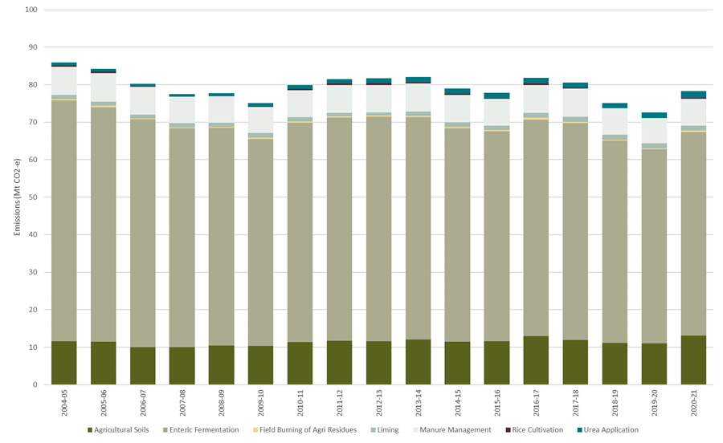

Source: DCCEEW 2022a

### Cropping and horticulture

The cropping and horticulture sectors contribute nitrous oxide and carbon dioxide emissions. Nitrous oxide from agricultural soils accounted for 16.7% of agriculture’s total emissions in 2021 (CO2-e) (Figure 2). Most of these emissions were from fertiliser application and crop residues, though livestock waste was also responsible for a portion of emissions from agricultural soils. Carbon dioxide from application of urea and lime accounted for another 3.9% of agriculture’s emissions.

The Australian grains industry already has low-emissions intensity compared to other cereal growing nations (CSIRO, 2022). There are several established technologies and practices that can be used to reduce nitrous oxide emissions, with some already being adopted as best practice where technically and financially viable. These include the use of precision agriculture and increased legumes in crop rotations. Use of nitrification inhibitor coated fertiliser could reduce nitrous oxide emissions by 79% in grains system (Migliorati et al. 2014, 2016; Scheer et al. 2016; Schwenke et al. 2019a, 2019b), but it's not common due to higher costs in comparison with conventional fertilisers.

Other emerging technologies and practices include advances in plant genetics and green nitrogen fertilisers from green hydrogen and ammonia production. The manufacture of nitrogen fertiliser from renewable energy would significantly lower pre-farm (scope 3) emissions. Domestic manufacturing of nitrogen fertiliser will be captured under the industry sector plan.

Table Cropping and horticulture technologies and practices

| Established and scalable technologies and practices | Emerging technologies and practices |
| --- | --- |
| * Slow-release and nitrification inhibitor coated fertilisers | * Plant genetics |
| * Optimised application in inputs including use of precision agriculture | * Low or zero carbon nitrogen fertilisers (from low or zero hydrogen and ammonia production) |
| * Increased legumes in crop rotations | – |
| * Minimising field burning | – |

### Fuel and energy

Electricity, energy and fuel use by agriculture represent a small, but not insignificant additional source of emissions (around 9 Mt CO2-e in 2020–21). The plan will explore options to address these emissions on-farm, including opportunities to increase renewable energy use, small-scale energy generation and energy efficiency. However, large-scale energy and fuel supply will be addressed by the Electricity and Energy and Transport sector plans.

The adoption of renewable energy is an opportunity for producers to build energy security and reduce both their emissions and input costs, which has already driven adoption in various forms across the sector. Peer-to-peer learning and building technical workforce capacity in the integration of renewable energy and agricultural production systems will help to grow confidence in these solutions.

Prospects for reducing emissions from fuel use in the sector are constrained by the high-torque and intense duty cycle requirements of on-farm machinery and vehicles. Technological solutions, including switching to low or zero carbon fuels and gases, electrification, and the application of hydrogen fuel cells are progressing slowly and rely upon broader supply chain development.

Table Fuel and energy technologies and practices

| Established and scalable technologies and practices | Emerging technologies and practices |
| --- | --- |
| * On-farm renewable energy generation and integration with agricultural production systems, including solar grazing | * Other agrisolar applications, including with horticulture and apiculture |
| * Bioenergy generation, including manure bio-digestion and bagasse and wood cogeneration | * Battery electric and hydrogen fuel cells for on-farm machinery and vehicles |
| * Increased energy efficiency | * Greater utilisation of agricultural feedstocks for bioenergy and biofuel production |
| – | * Low or zero carbon fuel and gas production and use |

### Carbon storage in the land

As noted earlier, LULUCF is currently a net sink in the NGA (Figure 3). Finding ways to grow that sink will be important for addressing climate change. Agricultural producers manage over 50% of Australia’s land (ABARES 2023b) and the Indigenous Estate covers 57% of the land (ABARES 2022b), it will be critical to engage proactively with producers and First Nations peoples on new opportunities, as well as with governments who manage public lands such as national parks, council reserves, public utilities with land assets and coastal reserves.

Sequestering carbon into vegetation and soils across all lands can reduce net emissions and provide wider co-benefits such as water and soil quality improvement, wind protection, drought resilience and more biodiverse landscapes (Climate Change Authority 2023). It can also provide new income streams for producers who choose to participate in carbon and emerging biodiversity markets. Wider adoption of new tree plantings and cropping practices may be promoted by establishing a greater understanding of these potential environmental and wider benefits. Ensuring producers have access to support and information needed to make decisions on how to optimise use of land for productive agriculture, carbon sequestration and biodiversity outcomes will be important.

Supplying into the Nature Repair Market and the carbon market with diverse native plantings is an emerging opportunity. Undertaking plantings based on locally adapted planting protocols will ensure that the right species are planted for that area. This will increase the likelihood of successful outcomes, supporting climate resilience and enhancing co-benefits.

Farm forestry and agroforestry are examples of how carbon, agriculture and timber production can work together – with trees established and managed on farmland with the intention of harvesting for commercial purposes. Tree plantings can also provide co-benefits including shade and shelter for livestock, reduced soil erosion and improved water quality (Net Zero Australia 2023). However, commercial viability is a constraint, including proximity to milling infrastructure.

On land managed for cultural, conservation or other purposes, including government-owned land and Indigenous Protected Areas, there are opportunities for increasing and maintaining carbon stores, where this is compatible with other land management goals. There is a need to further assess carbon storage potential on these lands to contribute to reaching net zero emissions.

There will be trade-offs at the landscape scale that need to be considered in determining which lands are most appropriate for carbon stores, including aggregate impacts on agricultural production, food security and water availability (see section 5.2.4). Questions are also being raised about the extent to which sequestration offsets should be used within agriculture or sold to other sectors of the economy to offset their emissions. Climate change also needs to be considered given risks it presents to the capacity of land to accumulate and maintain stored carbon. For example, reduced water availability and increased fire risk can affect plant growth or cause direct losses of carbon stored in vegetation.

By encouraging management activities in areas with high environmental value, there is potential to support sustainable management and restoration of land that delivers carbon and environmental outcomes, as well as benefits for landholders’ businesses and the resilience of regional economies.

Table Carbon storage technologies and practices

| Established and scalable technologies and practices | Emerging technologies and practices |
| --- | --- |
| * Planting and seeding native trees for carbon storage and other benefits | * Improving management of coastal (blue carbon) and freshwater (teal carbon) wetlands |
| * Farm forestry and plantation forestry for wood production | – |
| * Managing land to allow native forest to regenerate | – |
| * Cropping and pasture management practices including stubble retention, reduced or no tillage, cover cropping, pasture rejuvenation and use of green manures | – |
| * Strategic fire management in northern Australian savannas | – |

Figure Land use, land use change and forestry's greenhouse gas emissions by source, 2004–05 to 2020–21 (CO2-e)

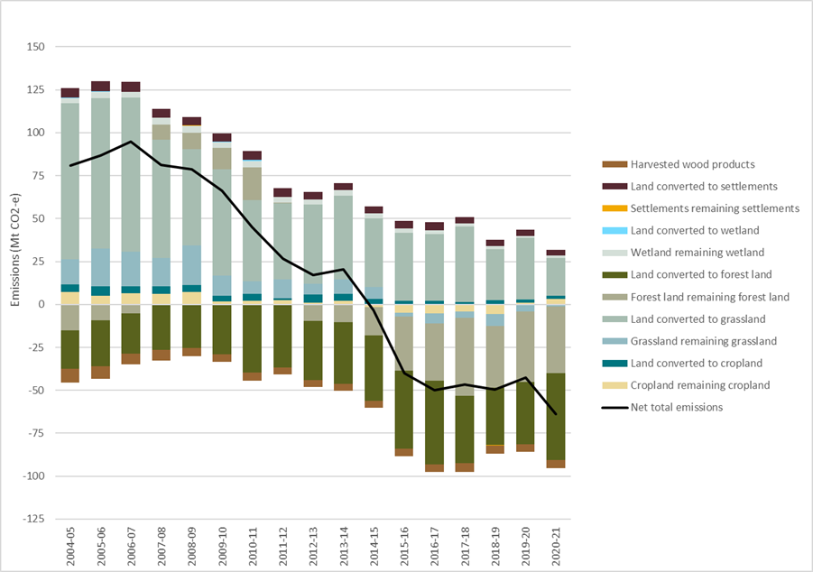

Source: DCCEEW 2022a

#### Circular economy and waste

There are unique opportunities and barriers for the agricultural sector in moving towards a circular economy. Circular economies aim to ‘close the loop’ on production systems. The 3 key principles are to reduce waste and pollution, circulate products and materials (at their highest value), and regenerate nature (DCCEEW 2023).

Agriculture and forestry produce a range of waste products, including organic wastes such as manure and product loss, plastic waste, and workshop wastes such as tyres and batteries (AgriFutures 2022a). Some of these waste sources are also direct sources of emissions, including animal manure and crop residues. Certain waste products can be readily utilised on farm – for example, manure as compost or product waste as animal feeds, whereas others require regulated recycling systems.

In agriculture, moving towards circular production systems may look like minimising demands on external inputs, reducing food waste and reusing waste as by-products or inputs (AFI 2022). Though many of these options are not new to the sector, there are barriers to reducing and utilising waste, including a lack of available information, alternatives, and few local solutions (AgriFutures 2022a). There are also opportunities for incorporating circular economy principles across the broader agri-food system (CSIRO 2023).

#### Seeking your views: Opportunities to reduce emissions

There are established and emerging technologies, practices and other measures to reduce emissions and increase carbon stores. Some of these technologies and practices are being adopted, whereas others require further support before widespread uptake can be achieved. Your views are sought on advancing the opportunities to reduce emissions.

1. What are the most important options to be further adopted or supported, looking in the short and the longer-term?
2. What are the practical solutions to increase uptake?

## Developing emissions pathways

The government’s [net zero plan](https://www.dcceew.gov.au/climate-change/emissions-reduction/net-zero#:~:text=The%20Australian%20Government%20is%20developing,reach%20Net%20Zero%20by%202050.) will outline how Australia can transition to a net zero economy. That plan will be economy-wide; looking to maximise benefits and support an economically efficient approach to decarbonisation. The sector level plans will underpin the economy-wide approach.

This section of the discussion paper explores the ways for agriculture and the land sector to contribute to economy-wide goals. The aim is to create a common understanding of what is possible and enable investment in opportunities to reduce emissions. This discussion will be informed by the sector’s abatement potential (discussed in section 3), as well as other factors, like financial, social and market influences.

The section poses a number of questions, including what might be possible to achieve in the medium to longer term, as well as interim goals or indicators to help measure success.

### Medium-term outlook

Historically agricultural emissions have fluctuated with the level of production; highly productive years tend to see an increase in emissions, whereas in less productive years emissions trend downwards. Looking forward, there are different views on what can and will be achieved in terms of emission reductions by 2030 and 2035. Those views are influenced by the outlook for different agricultural commodities and products, the industry’s own growth and emission goals, as well as the likelihood of limited or more widespread uptake of lower-emissions production technologies and practices.

The DCCEEW’s emissions projections see agriculture’s emissions remaining relatively stable to 2035 (Figure 4). That projection is based on current policy settings. For agriculture, it is largely driven by ABARES’ 5-year outlook on production as well as assumptions around the uptake of lower emissions technologies, such as livestock feed supplements. Over the same period, emissions from the national energy sector are projected to decrease, resulting in an increase in agriculture’s proportional share of national emissions, to around 20% (Figure 4).

LULUCF is projected to remain a net carbon sink to 2035 (Figure 4).

Figure Australia's net zero emissions projections in the baseline scenario, 2021–22 to 2034–35

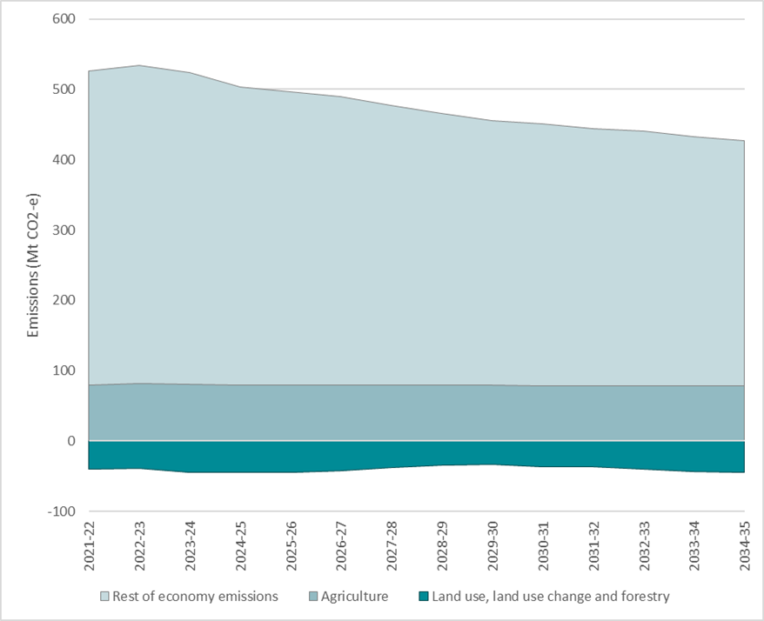

Source: DCCEEW 2022b

### Towards 2050

A wider view is needed when thinking about how agriculture and the land sector may be placed by 2050. The global transition to lower emissions is expected to drive a significant shift in the world’s economy, creating new opportunities and challenges at all levels. Changes of this scale are not new for the sector. Agriculture’s response to national competition reforms of the 1980s and 1990s demonstrated the industry’s capacity to adjust – embracing risk and being rewarded with productivity improvements and profitability.

Given Australian agriculture’s export focus, the global context is highly relevant. Reducing emissions is a global challenge, and in line with the Paris Agreement, needs to be tackled in a way that does not threaten food production. As discussed in section 1.4, Australia has comparatively low emissions intensity beef and grain production, and could play a role in supplying lower emissions intensive food into global markets (ABARES 2023a). Domestic and international opportunities and trade-offs around the use of land for carbon storage also need to be considered.

In the longer-term Australia could see more intensification in production systems in response to market demands, reducing emissions intensity but also potentially increasing or decreasing absolute emissions depending on other business decisions. Consumer-led choices could also encourage production of lower emissions products.

There will also be new opportunities associated with demand for carbon sequestration and restoration of nature. An expanded vision for the industry could include more mixed farming, where producers supply larger volumes of lower emissions food and fibre into global markets, integrated with the provision of carbon and biodiversity outcomes at the farm-scale.

### Interim goals or indicators

The emissions reduction targets set by the government are economy wide. There is no expectation there will be sector-specific emissions reduction targets. However, in considering the way forward it may be useful to consider goals or indicators, such as continuous improvements in emissions intensity, that can provide measures of progress.

There is also a strong interest from some parts of the industry in exploring alternative goals, as well as differentiated approaches to reporting on greenhouse gases, including methane. Reducing emissions of methane is important to limit peak warming scenarios and keep 1.5 degrees of warming within reach. Many countries, including the European Union and major agricultural commodity exporters such as the United States, Brazil and Indonesia, are prioritizing the reduction of methane. Agricultural methane makes up around 50% of Australia’s total methane emissions. Reducing agricultural methane would contribute to Australia’s commitment to the Global Methane Pledge, which aims to collectively reduce global methane emissions by 30% on 2020 levels by 2030.

The IPCC considers different approaches for individual greenhouse gases in its Sixth Assessment Report, which suggests that global methane emissions need to be reduced from 2019 levels by 34% by 2030 and by around 55% by 2050 to remain consistent with the goals of the 2015 Paris Agreement (IPCC 2023). There is no advice on the extent to which those reductions apply to different sources of methane.

It will be important that Australia’s approach to greenhouse gas reporting continues to remain aligned with international benchmarks and expectations.

#### Seeking your views: developing emissions pathways

The plan will explore different ways for the agriculture and land sectors to reduce emissions, store carbon and contribute to the economy-wide net zero goal. It will consider the sectors’ starting point, mitigation potential over coming decades and the global trends that may have an impact, as well as how to deliver on other national priorities. Your views are sought on what is possible to achieve and markers for success along the way, including:

1. How do you see the agriculture and land sectors contributing over the medium and longer-term? What are the opportunities to deliver emission reductions in parallel with wider goals?

## Supporting and enabling change

The emissions reduction potential of agriculture and land will be significantly influenced by a combination of technical, economic, social and market related factors. There are a number of areas where action could be taken to influence these factors and enable the industry to take advantage of the global transition to lower emissions.

Opportunities to support greater action may be grouped under 3 themes (Figure 5):

* driving innovation
* building capacity
* ensuring the system enables change.

This section explores these themes and opportunities within them to affect change. It then asks you to consider where attention should be focused to accelerate action, support effective responses to climate change and reduce emissions.

Figure Three themes of potential actions

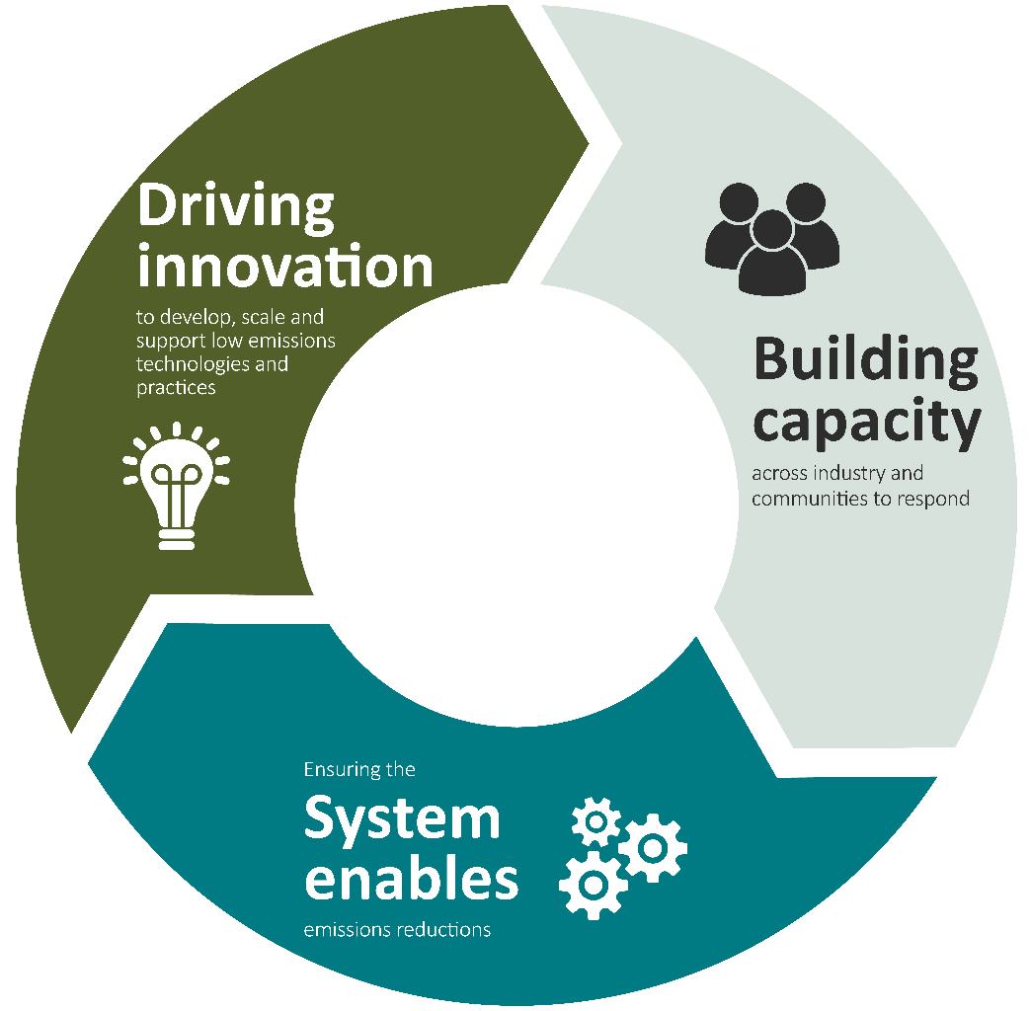

### Driving innovation

To drive significant emissions reduction in agriculture and the land sector a broad suite of commercially viable and scalable options will be needed. Research, development and extension (RD&E) of new technologies and practices will be critical (note, extension is considered specifically in section 5.2.2).

There is already significant investment in R&D underway, across governments, industry and academia, including through the agricultural Rural Research and Development Corporation (RDC) system. Private enterprise is playing a role, with agritech companies investing in research and providing a mechanism for producers and land managers to access commercial scale solutions. Current investments are returning promising results, with technologies and practices indicating potential to reduce emissions. However, there is a gap between promising solutions and commercial scale availability for adoption on farm.

The Commonwealth recently undertook an analysis of relevant research, development and deployment underway across agriculture and the land. Stakeholders engaged in the process suggested that investment should be increased, with better coordination and collaboration and a greater focus on long-term funding and whole farm solutions. Increasing the availability of qualified researchers, measurement infrastructure and trial sites were also identified as ways to help support R&D across the system.

A lack of sufficient local evidence can make it difficult to demonstrate the efficacy and viability of low emissions technologies and practices. While uncertainty is an inherent feature of innovation, adoption by producers may be slowed without proven success stories. Trialling solutions at scale and minimising risk for first movers may encourage uptake. It is also important to explore alternative and emerging practices, as well as learn from the original and continuing land management practices of Australia’s First Nations people.

### Building capacity

Implementation of new technologies and practices is ultimately driven by producers and land managers, supported by the capacity of their wider communities. There are examples of farm businesses working to understand their emissions and implement climate-smart practices, either with the support of existing government and industry programs, or by utilising private advisory services and tools. However, there is a common view that more is needed to build capacity across the farming community and among land managers, as well as across the system within which agriculture operates.

#### Knowledge, skills and capabilities for a low emissions future

Emissions reduction in agriculture and land will require new skills and roles, some of which are yet to exist. New training and career paths are likely to be needed. This challenge exists right across the economy. However, regional and commodity specific factors, as well as the diverse nature of the industry and businesses involved, create particular challenges. Additionally, agriculture is an industry projected to face labour productivity impacts as a result of climate change in coming decades (Treasury 2023).

Governments, industry and the private sector are already investing in workforce capability, including delivery of extension services. However, the scale and breadth of advice needed across the country gives rise to questions about whether there is sufficient workforce capacity across different commodities, regions and businesses. There will also be new skills and expertise required throughout the supply chain, including understanding how production decisions can affect emissions. These new requirements will place additional pressures on a sector with existing workforce challenges. Notwithstanding this, research into perspectives on agriculture and rural industries suggests that new and younger workers can be attracted by the opportunity to contribute to sustainable production (AgriFutures 2022b, 2023).

Growing the capacity in existing and emerging First Nations agriculture and land interests is also a priority. The First Nations population is younger and growing faster than the non-First Nations population with much of that growth in rural and regional Australia (ABS 2022; NIAA 2021). Increasing the participation of this growing population in agriculture and activating the value of their knowledge and land in the emission reduction challenge, may improve outcomes for the sector, communities and First Nations peoples, while contributing to Australia’s national goals.

#### Extension of information and knowledge sharing

The range of potential management options can be difficult for producers to navigate, with volumes of information available from different sources. Producers may not be clear where to turn for trustworthy and independent advice. Existing networks of trusted agricultural extension and service providers could play a strong role in helping producers make decisions on-farm. However, provision of that advice requires existing providers to have skills and knowledge in emerging practices and technologies, as well as general adaptive techniques.

Commercial-scale demonstration sites could also assist in communicating successful technologies and practices. Research suggest that producers are most motivated by peer-to peer learning. Demonstration sites and learning networks could therefore be a means of accelerating the R&D to adoption pipeline.

#### Understanding on-farm emissions

For producers, understanding the emissions profile of their business is a fundamental first step. There are a wide range of carbon calculators that can help, available through industry bodies, private providers and universities. But there is uncertainty about which to use, as each caters to different circumstances, can generate different results and may not necessarily be designed for Australian agriculture systems. They also cater to different reporting frameworks which require different levels and types of data to meet the requisite standards.

There is currently little incentive for producers to track their emissions. However, as demand for supplier information increases, access to trusted calculators will become more important. Those calculators will need to meet certain standards and be adaptable to different production systems, including for land management. In this context, it has been suggested that the government could play a stronger role in assuring the performance of calculators available to Australian producers.

#### Supporting broader decisions on land use and management

Decisions on changing use or management of land to reduce emissions and store carbon involve consideration of benefits and trade-offs – for example, agricultural production, biodiversity, water availability, compatibility with traditional land management practices, and management of pests, weeds and fire risk. These considerations apply at landscape and property scales. Where decisions involve establishing and managing vegetation, considerations include vegetation types, location, scale and management approaches. Careful design can optimise benefits while minimising trade-offs.

Modelling, mapping and data systems can support these decisions. Organisations, including regional natural resource management bodies have experience in landscape-scale planning and providing advice to land managers to assist with property-scale planning. There may be scope for further investment in support services, technology and data to assist with these land management decisions. There are also wider land use considerations related to the transition to net zero, such as using land for renewable energy infrastructure and as a source for low or zero carbon fuels and gas feedstocks.

### Ensuring the system enables emission reductions

Australian producers operate in supply chains and a global marketplace. Those external factors have a significant influence on production decisions at the farm level.

There are clear signals that global markets, supply chains and private capital are seeking product and investment options with lower emissions and climate risks. Similar interest is emerging for nature. However, these are yet to translate into widespread incentives for on-ground investment in new technologies and practices. Greater policy certainty and incentives may be needed to unlock private investment and action. In this context, the government is keen to explore ways in which it can influence the system to better accelerate adoption by producers and land managers.

#### Increased collaboration and coordination

The Commonwealth, states, territories, industry, academia, First Nations landholders and the private sector are all already investing in a range of initiatives aimed at reducing emissions. Given the breadth of activity, stakeholders are already calling for greater collaboration and coordination across existing work. In the recently released National Statement on Climate Change and Agriculture, all Australian agriculture ministers committed to working with the sector to establish strong leadership and direction. Taking that step is likely to be one of the most efficient ways to maximise outcomes from the collective investment and guide future policy direction.

#### Working internationally

Addressing emissions from agriculture and land is a global challenge. Australia must stay engaged internationally to draw on the international RD&E effort, learn from other countries’ experiences, and position itself as a trading partner of choice. Communicating the unique nature of Australia’s ecological and production systems, as well as areas of commonality, will help to secure international partnerships and agreements that are favourable to producers.

Both government and industry are already partnering with like-minded countries to address risks and opportunities arising from climate change. The government is increasing its international standing and collaboration in this area, including through involvement in the Global Research Alliance on Agricultural Greenhouse Gases, implementing its Global Agriculture Leadership Initiative through a Special Representative of Agriculture, integrating sustainable agriculture principles in free trade agreements and increased engagement in international fora and bilaterally with trading partners. Through the Australian Agricultural Sustainability Framework (AASF), agricultural industry is engaging with Global Forum on Farm Policy and Innovation to develop adaptive global sustainable credentials that fairly account for unique landscapes.

#### Recognising and valuing improvements

There is an increasing expectation that businesses will understand and report on their emissions. Standardised approaches may help to reduce the reporting burden and support interoperability across supply chains. Consideration of international market requirements will also help to facilitate trade. Getting these systems right may help ensure the value of lower emissions can be captured and shared at the farm gate.

Work is underway to establish measurement and verification systems. The development of the AASF is one example, providing a means for industry to demonstrate success against a standardised set of sustainability metrics. The National Agricultural Traceability Strategy is also relevant, along with other verification initiatives across states, industry, and independent providers. Greater coordination, consistency and harmonisation of programs may assist producers to navigate confusion. Importantly, systems need to be accessible and inclusive for First Nations producers and land managers.

At the national scale, Australia’s NGA uses a range of emission factors to determine greenhouse gases emitted per unit of specified activity. The accounts capture changes that occur at farm level to the extent that they result in changes in national statistics, for example, change in production or total fertiliser use. As a result, some actions to reduce emissions at the farm level may not be captured in the national data. There may be an opportunity to improve how emissions reductions are estimated, measured and presented to increase the recognition of action taken across industry.

#### Providing incentives for investment

Delivering emissions reductions and expanding carbon storage across agriculture and the land will require more than just investment from government and industry, it will also require significant investment by private actors. Reducing risk and lowering the cost of capital can help stimulate that investment, including on-farm, and in the research, development and commercialisation of low emissions technologies and practices. Existing and emerging bodies such as the Clean Energy Finance Corporation, the Regional Investment Corporation and the National Reconstruction Fund may have a role to play.

The ACCU Scheme is already supporting landholders to undertake approved activities that reduce emissions or store carbon. Participation could be scaled-up with more engagement and methodologies. For example, the government is developing an Integrated Farm and Land Management method and updated Savanna Fire Management methods.

However, the scheme does not suit all landholders and production systems. In addition, landholders considering participation need to assess implications for their own business emission goals in the longer-term; either selling ACCUs for use by other entities or using carbon storage to reduce their own net emissions. The government is keen to explore options both within and outside the ACCU Scheme to incentivise change and support producers who implement technologies and practices that reduce emissions. Through [implementation of the Independent Review of ACCUs](https://www.dcceew.gov.au/climate-change/emissions-reduction/independent-review-accus/implementation), the government is working on options to improve the ACCU Scheme’s transparency and to continue to support the capacity and capability of rural and remote communities, including First Nations Australians, to participate in and benefit from the ACCU Scheme.

There are also a range of other Australian Government initiatives directed at biodiversity, natural resource management and sustainable agriculture outcomes that could contribute to emissions reductions and carbon storage, such as the Natural Heritage Trust Climate-Smart Agriculture package.

The Independent Review of the Environment Protection and Biodiversity Conservation Act 1999 also noted the opportunities for government to facilitate mechanisms that encourage conservation activities on private lands. The review notes the importance of leveraging existing markets, including the carbon market, investing in technological improvements, and fostering innovation. The Nature Repair Market would increase the financial viability of carbon projects, including on agricultural land, by providing a legislated framework to give the private sector confidence in investing in biodiversity. The market will operate in parallel with the carbon market, so landholders can be recognised for carbon projects that create biodiversity. Pilots undertaken as part of the government’s Agricultural Stewardship program have demonstrated the potential of this approach.

#### Seeking your views: supporting and enabling change

The plan will be underpinned by a range of mechanisms that support and accelerate emissions reduction in agriculture and increase carbon storage in the land. The government is exploring ways to build on existing investments and fills gaps across the system to maximise outcomes for the sectors.

Your views are sought on what actions are needed to support agriculture and the land to contribute to the economy wide emissions reduction goal.

1. How can the Australian Government better support agriculture and the land sector to:
   1. drive innovation
   2. build capacity
   3. ensure the system enables emissions reductions?
2. **What new initiatives could the Australian Government design that would support emissions reduction and carbon storage in agriculture and land emissions reductions and help ensure a productive, profitable, resilient and sustainable future for agriculture and land sectors?**
3. **A consistent and trusted approach for assessing and reporting emissions is often raised as a barrier to reducing emissions. Is there a role for the Australian Government in addressing this concern, and how can producers and land managers be supported?**
4. **What skills, knowledge and capabilities do you think producers and land managers need to implement change? What information and data would help them make decisions about emissions reductions and sustainable land management in the short and longer-term?**

## Have your say

We invite industry, business and the community to provide views on ways that agriculture and land management can contribute to the whole-of-economy emissions reduction task.

For information on how to have your say please go to [haveyoursay.agriculture.gov.au/agriculture-and-land-sectoral-plan.](https://haveyoursay.agriculture.gov.au/agriculture-and-land-sectoral-plan)

Submissions will close on AEST 5pm 13 December 2023.

Further stakeholder engagement opportunities will be communicated through [haveyoursay.agriculture.gov.au/agriculture-and-land-sectoral-plan](https://haveyoursay.agriculture.gov.au/agriculture-and-land-sectoral-plan).

The feedback you provide may also be used to inform the development of the other five sectoral plans.

## Glossary

| Term | Definition |
| --- | --- |
| AASF | Australian Agriculture Sustainability Framework |
| ACCU | Australian Carbon Credit Unit. Each ACCU issued represents one tonne of carbon dioxide equivalent (tCO2-e) stored or avoided by a project |
| agricultural industry | The network of people and groups involved in agriculture, including producers, their representative bodies, support services, and supply chain actors. |
| agriculture sector | The National Greenhouse Accounts definition of agriculture, which covers sources of emissions such as enteric fermentation, manure management, agricultural soils, rice cultivation, field burning of agricultural residues, liming and urea application. |
| carbon neutral | When anthropogenic emissions of greenhouse gases to the atmosphere are balanced by anthropogenic removals over a specified period. Where multiple greenhouse gases are involved, the quantification of carbon neutral depends on the climate metric chosen to compare emissions of different gases (such as global warming potential, global temperature change potential, and others, as well as the chosen time horizon). |
| emissions | Greenhouse gas emissions, including carbon dioxide (CO2), methane (CH4), nitrous oxide (N2O). |
| emission factors | The quantity of greenhouse gases emitted per unit of some specified activity. Emission factors are used to convert a unit of activity into its emissions equivalent. E.g., a factor that specifies the kilograms of CO2-e emissions per unit of activity. |
| enteric fermentation | The process in animals by which gases, including methane, are produced as a by-product of microbial fermentation associated with digestion of feed. |
| land manager | Someone with a controlling interest over land. |
| land sector | The land uses, and the management of those lands, which fall within LULUCF. |
| LULUCF | Land use, land use change and forestry as defined in the National Greenhouse Accounts. |
| NGA | National Greenhouse Account |
| offset | Offsets are used to compensate for emissions an emitter produces, to help reduce their carbon footprint. Offsets are generated by projects that reduce, remove or capture emissions from the atmosphere. |
| producer | Includes farmers, graziers, pastoralists and foresters. |
| RDC | Rural Research & Development Corporation. There are 15 RDCs, including 5 Commonwealth statutory bodies and 10 industry-owned companies (IOCs). All RDCs manage R&D services. |
| RD&E | Research, development and extension. |
| scope 1 emissions | Scope 1 greenhouse gas emissions are the emissions released to the atmosphere as a direct result of an activity, or series of activities. Scope 1 emissions are sometimes referred to as direct emissions. For agricultural businesses they include, but are not limited to, emissions from enteric fermentation, agricultural soils, manure management, land management, fuel use and stationary energy. |
| scope 2 emissions | Scope 2 greenhouse gas emissions are the emissions released to the atmosphere from the indirect consumption of an energy commodity. For example, indirect emissions come from the use of electricity produced by the burning of coal to produce energy elsewhere. |
| scope 3 emissions | Scope 3 emissions are indirect greenhouse gas emissions other than scope 2 emissions that are generated in the wider economy. They occur as a consequence of business or natural activities, but from sources not owned or controlled by producers or land managers. For example, indirect emissions from the production of fertiliser. |
| sequestration | The process of storing carbon in a carbon pool. |
| sink | Any process, mechanism, or activity that removes a greenhouse gas, an aerosol or a precursor of a greenhouse gas from the atmosphere. |
| source | Any process or activity that releases a greenhouse gas, an aerosol or a precursor of a greenhouse gas into the atmosphere. |

## References

Axio, I, Lucas, D. Boland, A-M, Muller, C. Heinrich, K, Allan, M 2022a, [Options for improved waste management: Current practices and opportunities for improved pre-farm gate waste management in agriculture, fisheries and forestry](https://agrifutures.com.au/product/options-for-improved-waste-management/), AgriFutures, Wagga Wagga, accessed 9 August 2023.

AgriFutures 2022, [Community Perceptions and Worker Experiences Program: Quantitative research results](https://agrifutures.com.au/community-perceptions-and-worker-experiences/), Wagga Wagga, accessed 21 August 2023.

AgriFutures 2023, [Listen up: Young people’s perspective on the future of Australian agriculture and rural industries](https://agrifutures.com.au/news/listen-up-young-peoples-perspective-on-the-future-of-rural-industries/), Wagga Wagga, accessed 21 August 2023

ABARES 2018, [ABARES Insights: Snapshot of Australia’s Agricultural Workforce](https://www.agriculture.gov.au/abares/products/insights/snapshot-of-australias-agricultural-workforce#:%7E:text=Indigenous%20agricultural%20employees,as%20Indigenous%20(3%2C278%20people)), Australian Bureau of Agricultural and Resource Economics and Sciences, Canberra, accessed 2 August 2023.

ABARES 2021, [ABARES Insights: Analysis of Climate change impacts on adaptation on Australian farms](https://www.agriculture.gov.au/abares/products/insights/climate-change-impacts-and-adaptation#recent-changes-in-seasonal-conditions-have-affected-the-profitability-of-australian-farms), Australian Bureau of Agricultural and Resource Economics and Sciences, Canberra, accessed 2 August 2023.

ABARES 2022a, [Where to next for Australian agriculture?](https://www.agriculture.gov.au/abares/products/insights/australian-agriculture-on-a-roll-but-where-to-next#:~:text=This%20two%2Dpart%20ABARES%20Insights,matter%20in%20the%20near%2Dfuture.), Australian Bureau of Agricultural and Resource Economics and Sciences, Canberra, accessed 10 September 2023.

——2022b, [Australia’s Indigenous land and forest estate (2020)](https://www.agriculture.gov.au/abares/forestsaustralia/forest-data-maps-and-tools/spatial-data/indigenous-land-and-forest#daff-page-main), Australian Bureau of Agricultural and Resource Economics and Sciences, Canberra, accessed 8 August 2023.

ABARES 2023a, [Environmental sustainability and agri-environmental indicators – international comparisons](https://www.agriculture.gov.au/abares/products/insights/environmental-sustainability-and-agri-environmental-indicators), Australian Bureau of Agricultural and Resource Economics and Sciences, Canberra, accessed 2 August 2023.

——2023b, [Snapshot of Australian Agriculture 2023](https://www.agriculture.gov.au/abares/products/insights/snapshot-of-australian-agriculture), Australian Bureau of Agricultural and Resource Economics and Sciences, Canberra, accessed 8 August 2023.

ABS 2022, [Census of Population and Housing - Counts of Aboriginal and Torres Strait Islander Australians 2021](https://www.abs.gov.au/statistics/people/aboriginal-and-torres-strait-islander-peoples/census-population-and-housing-counts-aboriginal-and-torres-strait-islander-australians/2021), Australian Bureau of Statistics, Canberra, accessed 8 August 2023.

AFI 2022, [Spring 2022: Circular economies in agriculture](https://www.farminstitute.org.au/product/spring-2022/), Australian Farm Institute, Sydney, accessed 9 August 2023.

CCA 2023, [Reduce, remove and store: The role of carbon sequestration in accelerating Australia’s decarbonisation](https://www.climatechangeauthority.gov.au/publications/reduce-remove-and-store-role-carbon-sequestration-accelerating-australias-decarbonisation), Climate Change Authority, Canberra, accessed 15 August 2023.

CSIRO 2022, [Australian grains baseline and mitigation assessment](https://publications.csiro.au/publications/publication/PIcsiro:EP2022-0163), Commonwealth Scientific and Industrial Research Organisation, Canberra, accessed 3 August 2023.

CSIRO 2023, [Reshaping Australian food systems](https://www.csiro.au/en/work-with-us/services/consultancy-strategic-advice-services/CSIRO-futures/Agriculture-and-Food/Reshaping-Australian-Food-Systems), Commonwealth Scientific and Industrial Research Organisation, Canberra, accessed 17 August 2023.

DCCEEW 2022a, [Australia’s National Greenhouse Accounts](https://www.greenhouseaccounts.climatechange.gov.au/), Department of Climate Change, Energy, Environment and Water, Canberra, accessed 19 July 2023.

——2022b, [Australia’s emissions projections 2022](https://www.dcceew.gov.au/climate-change/publications/australias-emissions-projections-2022), Department of Climate Change, Energy, Environment and Water, Canberra, accessed 19 July 2023.

DCCEEW 2023, [National Inventory Report 2021 Volume 1](https://www.dcceew.gov.au/climate-change/publications/national-inventory-report-2021), Department of Climate Change, Energy, the Environment and Water Canberra, accessed 21 July 2023.

——2023, [Transitioning to a more circular economy](https://www.dcceew.gov.au/environment/protection/circular-economy), Department of Climate Change, Energy, Environment and Water, Canberra, accessed 9 August 2023.

IPCC 2018, [Summary for Policymakers. In: Global Warming of 1.5°C](https://www.ipcc.ch/sr15/chapter/spm/), Intergovernmental Panel on Climate Change, Cambridge, UK, accessed 24 July 2023.

IPCC 2023, [AR6 Synthesis Report Summary for Policymakers](https://www.ipcc.ch/report/sixth-assessment-report-cycle/), Intergovernmental Panel on Climate Change, Geneva, Switzerland, accessed 19 July 2023.

Migliorati M, Bell M, Lester D, Rowlings D, Scheer, C, de Rosa D, Grace P 2016, Comparison of grain yields and N2O emissions on Oxisol and Vertisol soils in response to fertiliser N applied as urea or urea coated with the nitrification inhibitor 3,4-dimethylpyrazolephosphate. Soil Research 54, 552-564, accessed 23 August 2023.

Migliorati M, Scheer C, Grace P, Rowlings D, Bell M, McGree J 2014, Influence of different nitrogen rates and DMPP nitrification inhibitor on annual N2O emissions from a subtropical wheat–maize cropping system. Agriculture, Ecosystems Environment 186, 33-43, accessed 23 August 2023.

NFF 2018, [2030 roadmap: Australian agriculture’s plan for $100 billion industry](https://nff.org.au/policies/roadmap/), National Farmers’ Federation, Canberra, accessed 3 August 2023.

NIAA 2021, [National Roadmap for Indigenous Skills, Jobs and Wealth Creation](https://www.niaa.gov.au/news-centre/indigenous-affairs/national-roadmap-indigenous-skills-jobs-and-wealth-creation), National Indigenous Australians Agency, Canberra, accessed 9 August 2023.

NZAu 2023, [Downscaling – The role of forestry in enhancing the Australian land CO2 sink](https://findanexpert.unimelb.edu.au/scholarlywork/1796071-downscaling-%E2%80%93-the-role-of-forestry-in-enhancing-the-australian-land-co2-sink), Net Zero Australia, Melbourne, accessed 24 July 2023.

Scheer C, Rowlings DW, De Antoni Migliorati M, Lester DW, Bell MJ, Grace PR 2016, Effect of enhanced efficiency fertilizers on nitrous oxide emissions in a sub-tropical cereal cropping system. Soil Research 54, 544-551, accessed 23 August 2023.

Schwenke, G, Haigh, M 2019a, Can split or delayed application of N fertiliser to grain sorghum reduce soil N2O emissions from sub-tropical Vertosols and maintain grain yields? Soil Research 57, 859-874, accessed 23 August 2023.

——2019b, Urea-induced nitrous oxide emissions under sub-tropical rainfed sorghum and sunflower were nullified by DMPP, partially mitigated by polymer-coated urea, or enhanced by a blend of urea and polymer-coated urea. Soil Research 57, 342-356, accessed 23 August 2023.

The Treasury 2023, [2023 Intergenerational Report](https://treasury.gov.au/publication/2023-intergenerational-report), Canberra, accessed 10 September 2023.

UNFCCC 2015, [Paris Agreement](https://unfccc.int/process-and-meetings/the-paris-agreement), United Nations Framework Convention on Climate Change, Paris, accessed 24 July 2023.