# National Bioenergy Feedstock Strategy: discussion paper

© Commonwealth of Australia 2025

**Ownership of intellectual property rights**

Unless otherwise noted, copyright (and any other intellectual property rights) in this publication is owned by the Commonwealth of Australia (referred to as the Commonwealth).

**Creative Commons licence.**

All material in this publication is licensed under a [Creative Commons Attribution 4.0 International Licence](https://creativecommons.org/licenses/by/4.0/legalcode) except content supplied by third parties, logos and the Commonwealth Coat of Arms.



**Cataloguing data**

This publication (and any material sourced from it) should be attributed as: DAFF 2025, *National Bioenergy Feedstock Strategy: discussion paper*, Department of Agriculture, Fisheries and Forestry, Canberra, October. CC BY 4.0.

This publication is available at [https://haveyoursay.agriculture.gov.au/national-bioenergy-feedstock-strategy](https://aus01.safelinks.protection.outlook.com/?url=https%3A%2F%2Fhaveyoursay.agriculture.gov.au%2Fnational-bioenergy-feedstock-strategy&data=05%7C02%7CStuart.Watt%40aff.gov.au%7C6748ef8ea7e94b7ae8d208ddfeffdf75%7C2be67eb7400c4b3fa5a11258c0da0696%7C0%7C0%7C638947097129550538%7CUnknown%7CTWFpbGZsb3d8eyJFbXB0eU1hcGkiOnRydWUsIlYiOiIwLjAuMDAwMCIsIlAiOiJXaW4zMiIsIkFOIjoiTWFpbCIsIldUIjoyfQ%3D%3D%7C0%7C%7C%7C&sdata=KuclmLkzjYf1UdmMh%2FJkcdBN98O2gfWEndIMnHN2Bj0%3D&reserved=0).

Department of Agriculture, Fisheries and Forestry

GPO Box 858 Canberra ACT 2601

Telephone 1800 900 090

Web [agriculture.gov.au](https://www.agriculture.gov.au/publications)

**Disclaimer**

The Australian Government acting through the Department of Agriculture, Fisheries and Forestry has exercised due care and skill in preparing and compiling the information and data in this publication. Notwithstanding, the Department of Agriculture, Fisheries and Forestry, its employees and advisers disclaim all liability, including liability for negligence and for any loss, damage, injury, expense or cost incurred by any person as a result of accessing, using or relying on any of the information or data in this publication to the maximum extent permitted by law.

**Acknowledgement of Country**

We acknowledge the continuous connection of First Nations Traditional Owners and Custodians to the lands, seas, and waters of Australia. We recognise their care for and cultivation of Country. We pay respect to Elders past and present, and recognise their knowledge and contribution to the productivity, innovation and sustainability of Australia’s agriculture, fisheries, and forestry industries.

Contents

Introduction 4

Context 4

Opportunities for agriculture and forestry 4

National Bioenergy Feedstock Strategy 6

Objectives 6

Scope 6

Discussion paper purpose 7

Discussion questions 7

Australian feedstocks – production potential and readiness 8

Feedstock production 8

Feedstock utilisation 9

Supply chain maturity 10

Other issues for consideration 12

Diversification vs prioritisation 12

Quantifying feedstocks and their characteristics 12

Infrastructure requirements 12

Addressing social license and sustainability 13

Research and development needs 14

Coordination across jurisdictions 14

Climate change and variable production 14

Biosecurity and traceability 15

Have your say 16

Contacts 16

Glossary 17

References 18

## Introduction

### Context

As the next step on the path to Australia’s long-term target of net zero by 2050, the Australian Government has announced a national target to reduce emissions by 62–70% below 2005 levels by 2035. The government also released the [Net Zero Plan](https://www.dcceew.gov.au/climate-change/publications/net-zero-plan), showing how Australia will achieve a fair, orderly and efficient transition to net zero.

Bioenergy – including renewable or low carbon liquid fuels (LCLF), low carbon gases and solid biofuels – is highlighted as a critical factor in Australia’s net zero transition. Expanding the use of these fossil fuel alternatives will enable the decarbonisation of aviation, heavy freight, maritime, mining and some industrial processes. The advantage of advanced biofuel products like sustainable aviation fuel, renewable diesel and biomethane is that they are ‘drop-in’ fuels that are fully compatible with existing infrastructure and technologies. Low carbon fuel alternatives can therefore provide a transition solution for the existing fleet to decarbonise while new low emissions technologies continue to develop.

That is why making the switch to low carbon fuels is one of five decarbonisation priorities in the Net Zero Plan, and is supported by actions across the sector plans. As noted in the [Electricity and Energy](https://www.dcceew.gov.au/climate-change/emissions-reduction/net-zero/electricity-and-energy-sector-plan), [Transport](https://www.infrastructure.gov.au/department/media/publications/transport-and-infrastructure-net-zero-roadmap-and-action-plan), [Industry](https://www.industry.gov.au/publications/industry-sector-plan) and [Resources](https://www.industry.gov.au/publications/resources-sector-plan) Sector Plans, establishing and scaling domestic LCLF and low carbon gas production will represent an increasingly cost-effective option for fuel users over time. The [Agriculture and Land Sector Plan](https://www.agriculture.gov.au/agriculture-land/farm-food-drought/climatechange/ag-and-land-sector-plan) recognises the significant opportunities this presents for primary producers to supply the necessary feedstocks and to decarbonise diesel use in agriculture.

Building a bioenergy industry in Australia will maximise the economic and industrial benefits of the shift to clean energy and net zero. The Clean Energy Finance Corporation (CEFC) estimates that a mature domestic LCLF industry in Australia could be worth $36 billion by 2050 and deliver 230 million tonnes of cumulative CO2-e abatement. It would also increase Australia’s national fuel security, with Bioenergy Australia estimating that scaling up domestic production of LCLFs, combined with continued electrification, could lead to a 60% reduction in reliance on fuel imports between 2040 and 2050.

To help realise these outcomes, the Australian Government is investing $1.1 billion to incentivise LCLF production in Australia through the [Cleaner Fuels Program](https://www.dcceew.gov.au/about/news/new-prod-incentive-low-carbon-liquid-fuels). The program will stimulate private investment in onshore LCLF refineries, backing local innovators and increasing fuel supply resilience. It builds on earlier investments in research and development including $250 million through the [Future Made in Australia Innovation Fund](https://arena.gov.au/funding/future-made-in-australia-innovation-fund/) and the Australian Renewable Energy Agency’s (ARENA) $33.5 million [Sustainable Aviation Fuel Funding Initiative](https://arena.gov.au/funding/sustainable-aviation-fuel-funding-initiative/). The Government is also expanding the [Guarantee of Origin (GO) Scheme](https://www.dcceew.gov.au/energy/renewable/guarantee-of-origin-scheme) to include LCLFs, and establishing the [Paraffinic Diesel Standard](https://consult.dcceew.gov.au/supply-of-renewable-diesel-australian-paraffinic-diesel-fuel-quality-standard).

### Opportunities for agriculture and forestry

Access to the necessary volume and quality of feedstocks is a fundamental component of developing a domestic bioenergy industry. LCLF and low carbon gases are mostly produced using biogenic materials from agriculture and forestry, including oilseeds and other lipids (e.g. canola and tallow), carbohydrates (e.g. sugar) and other lignocellulosic biomass (e.g. cropping and forestry residues).

Australia’s large land area and advanced agricultural practices mean we have significant feedstock potential. Our producers already participate in global bioenergy supply chains through the export of feedstocks like canola and tallow. There is now an opportunity for governments and industry to collaborate to maximise the value of Australian biogenic feedstocks by mobilising their use in domestic bioenergy production. Our ability to produce feedstocks underpins Australia's potential to become a major and diversified producer of bioenergy, which will have cascading benefits for our primary producers and regional economies.

Each one of Australia’s diverse feedstocks has commercial, technical, and logistical challenges and opportunities. Addressing barriers to supply chain development requires a clear and aligned policy direction that is coordinated with the energy industry, primary producers and across jurisdictions. The Australian Government is developing a National Bioenergy Feedstock Strategy (the strategy) to help provide that direction and coordination.

Development of the strategy is an opportunity to bring stakeholders together to explore key issues including feedstock availability, infrastructure and technology requirements, sustainability credentials and international considerations. Ensuring the strategy complements other Commonwealth, state and territories policies as well as private sector initiatives, will be important to fully realising the benefits of an Australian bioenergy industry.

## National Bioenergy Feedstock Strategy

### Objectives

The National Bioenergy Feedstock Strategy aims to establish a coordinated, national direction for the sustainable evolution of bioenergy feedstock production, in a way that maximises opportunities for agriculture and forestry producers and is complementary with Australia’s ongoing food and fibre security. It will explore opportunities for, and barriers to, the development of feedstock supply chains needed to support future domestic bioenergy production.

The strategy will aim to identify opportunities for industry and governments to support the growth of feedstock supply chains, including through policy settings, leadership and coordination across jurisdictions. It will complement government initiatives and industry investments to support bioenergy production in Australia and maximise the economic and industrial benefits of the shift to clean energy and net zero. The strategy will need to build on the achievements of existing collaborations, including the Jet Zero Council.

To ensure the ongoing sustainability and social license for these developing supply chains, the strategy will be developed in conjunction with the *National Food Security Strategy* to ensure feedstock production remains complementary to food and fibre production.

### Scope

The strategy is being led by the Department of Agriculture, Fisheries and Forestry and will focus on feedstocks produced in Australia’s agriculture and forestry sectors. These feedstocks are projected to account for the bulk of LCLF and low carbon gas production for the near future.

Non-biogenic feedstocks, such as green hydrogen and captured carbon dioxide that can be used to produce LCLF through ‘power-to-liquid’ technology, will not be directly addressed in this stream of work. Biogenic feedstocks not directly produced by primary industries, including used cooking oil and municipal solid waste, are also out-of-scope. The National Waste Policy Action Plan and Australia’s Circular Economy Framework seek to achieve an 80% average resource recovery rate from all waste streams by 2030, and a doubling of the circularity rate by 2035. While not directly focussed on bioenergy development, these initiatives provide indirect opportunities for the use of waste materials as bioenergy feedstocks.

As noted earlier in this discussion paper, the strategy is one part of a broader suite of Australian Government policies to support the domestic production of bioenergy (and in particular LCLF) as a key element of achieving our net zero target. These measures are all important for establishing the economic viability of this new industry. In parallel with discussions about the feedstock strategy, government will be consulting industry on the design of the Cleaner Fuels Program. Those consultations, together with further exploration of ways to incentivise LCLF uptake, is being led through the climate change, energy and transport portfolios and is not within scope of the feedstock strategy.

### Discussion paper purpose

This discussion paper seeks stakeholder views to inform the development of the strategy. It provides a high-level overview of Australian feedstocks, including production, current utilisation, and supply chain maturity. The paper then explores a range of further issues for consideration through strategy development. These include infrastructure requirements, social licence and sustainability, research and development needs, and coordination across jurisdictions.

### Discussion questions

We invite your responses to consider:

* What are the main barriers—commercial, logistical, regulatory, or environmental—to developing reliable and sustainable feedstock supply chains for domestic bioenergy production?
* What opportunities exist to improve feedstock supply chain efficiency and reduce costs?
* Is sufficient feedstock data available to support the development of the strategy and inform investment in new bioenergy industries?
* Which feedstocks, or mix of feedstocks, should be prioritised for immediate deployment, and which require further research and development across the short, medium, and long term?
* How can government and industry support the utilisation of a diverse range of feedstocks, including resources like residues, woody biomass and other novel feedstocks?
* What actions should government and industry take to ensure social licence and sustainability concerns are appropriately addressed?
* Besides those noted in the discussion paper, are there other key issues that should be considered in the development of a National Bioenergy Feedstock Strategy?

## Australian feedstocks – production potential and readiness

### Feedstock production

Australia has access to a wide range of biomass resources that could serve as feedstocks for domestic bioenergy production. These include oilseeds, lipids, carbohydrates, residues and other lignocellulosic biomass. In terms of potential production capacity, a recent report by the Commonwealth Scientific and Industrial Research Organisation (CSIRO) (2025) found that Australia could produce over 90 mega-tonnes of biomass as feedstock for LCLFs per year.

Much of this potential feedstock is in the form of crops which are currently exported in high volumes, like sugar cane, canola and sorghum (Table 1). The establishment of domestic processing would open up new market opportunities for these feedstocks, providing an opportunity to add value on-shore.

Table 1 Agricultural commodity output, 2024–25

| Commodity | 10-year production average (mt) | 10-year average  % exported | Total export value  ($m, 2024–25) |
| --- | --- | --- | --- |
| Canola | 4.81 | 76% | 4,909 |
| Cottonseed | 1.00 | 26% | 342 |
| Tallow^ | 0.46* | n/a | 848 |
| Sugar | 4.39 | 81% | 2,460 |
| Sorghum | 1.74 | 62% | 1,144 |

^Note – includes AHECC trade headings 1501, 1502, 1503, 1506.  
*Note – figure represents 10-year *export* average as total production data is not available. Exports based on financial year.  
Source: ABARES September 2025 Agricultural Commodities Report.

Ensuring consistent availability of feedstocks is an important consideration given that annual production of different commodities can vary depending on seasonal conditions. Even within the year, feedstock availability will peak around harvest time, meaning that some level of pre-processing into stable intermediary products (e.g. pellets, bio-oil) may be required to ensure year-round access. While there will be opportunities to expand feedstock production through deeper integration into existing cropping systems, there is a finite amount of land suitable for cropping, and that could change over time due to the impacts of climate change.

Greater utilisation of lower-value or byproduct materials may be necessary over time to support a sustainable and diversified industry. Residues and lignocellulosic biomass feedstocks – including by-products from cropping and other agriculture, sawmill residues, and short rotation forestry – are a large potential biomass resource. While these feedstocks have uses for maintaining soil and/or ecosystem health and as animal feed, they generally do not have existing market competition. However, estimates vary on production capacity, partly owing to their current under-utilisation (Table 2).

Table 2 Residue and lignocellulosic feedstock estimates based on CSIRO analysis (2025)

|  |  |  |
| --- | --- | --- |
| Biomass type | National estimate (low) | National estimate (high) |
| Crop stubble | 7 Mtpa | 30 Mtpa |
| Grasses | 13 Mtpa | 19.7 Mtpa |
| Wood (plantation forest) | 11 Mtpa | 14 Mtpa |
| Bagasse | 5.5 Mtpa | 10 Mtpa |
| Waste | 2 Mtpa | 11 Mtpa |
| Short-rotation tree crops | 0 | 29.3 Mtpa |
| Total (applying constraints) | 38.5 Mtpa | 114 Mtpa |

Source: CSIRO 2025

### Feedstock utilisation

Even with Australia’s significant feedstock production capacity, there is a difference between potential and practical utilisation as feedstocks. CSIRO (2025) found that ‘Australia has sufficient biomass production capacity to produce over 12 GL of LCLF per year… [which is] more than enough to meet our projected LCLF demand and abatement targets’. However, the report then goes on to note that realisation of this capacity is largely determined by price and that many feedstocks are subject to other existing market and non-market demands, including for:

* human and livestock consumption
* overseas bioenergy production
* retention of residues post-harvest to help maintain soil health, moisture, carbon-nitrogen balance and overall productivity.

Existing uses of agricultural feedstocks are illustrated in recent analysis undertaken by Deloitte for the Clean Energy Finance Corporation (2025) and shown in Figure 1. Oilseeds like canola and lipids such as tallow are already exported in significant volumes for biodiesel production in countries like the European Union, United States, and Singapore. Similarly high proportions of sugar and sorghum production are exported, largely to Asia.

The strategy will need to account for competing demands when considering how Australia can make best use of its diverse feedstock resources to practically service future demand for bioenergy. Australia’s current and future bioenergy demands go beyond just liquid fuels to include gaseous (e.g. biomethane) and solid energy carriers (e.g. wood chips and bagasse used for cogeneration). Since biomass resources are not unlimited, there will be trade-offs between economic, decarbonisation and environmental outcomes depending on how they are utilised. Additional utilisation may also emerge in the future as industries including plastics, chemicals and materials manufacturing look to switch from fossil-based feedstocks to bio-based alternatives.

Figure 1 Breakdown of agricultural feedstocks by end-use (in tonnes)

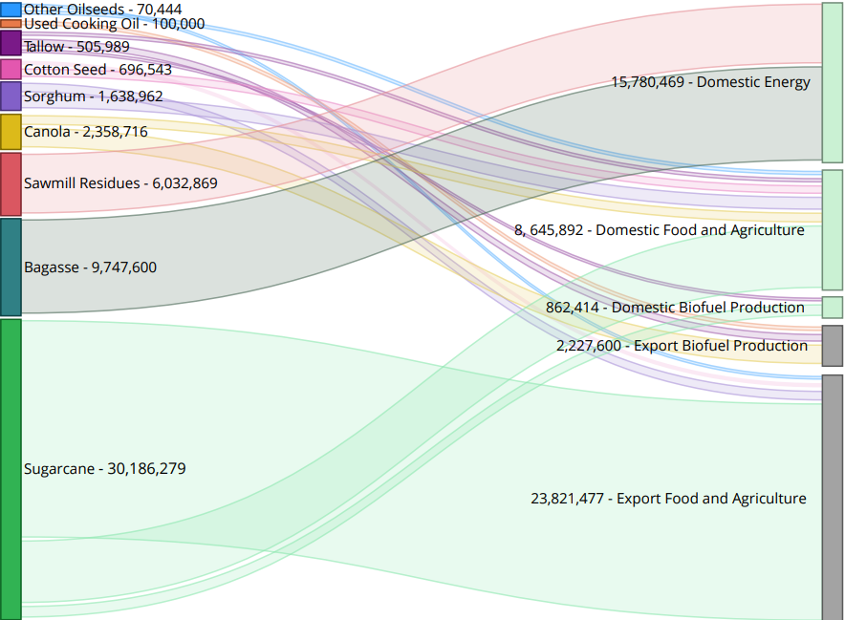

Source: CEFC 2025

Figure 1 outlines production figures for agricultural feedstocks (on the lefthand side, sorted from smallest mass to largest) and shows proportional flows of these volumes to their end uses (on the righthand side). The connecting flow from feedstock to end use varies in size based on the weight of each feedstock in tonnes. Sugarcane represents the largest share of feedstocks at 30,186,279 tonnes, with 23,821,477 tonnes being directed to export food and agriculture. The next largest feedstock sources – bagasse and sawmill residues – are entirely consumed by existing domestic bioenergy production (in the form of cogeneration). Other feedstock sources flow to domestic food and agriculture uses, and domestic and exported biofuel production.

### Supply chain maturity

The growth of domestic bioenergy industries will depend upon the development of feedstock supply chains and their respective infrastructure, technological and logistical requirements. A recent CEFC report (2025) proposed a hierarchy (Figure 2) to strategically assess the prospects of specific feedstock/processing combinations based on availability, competing market demand and technological readiness. This type of approach could be useful for considering ways in which to support progressive development of the feedstock industry.

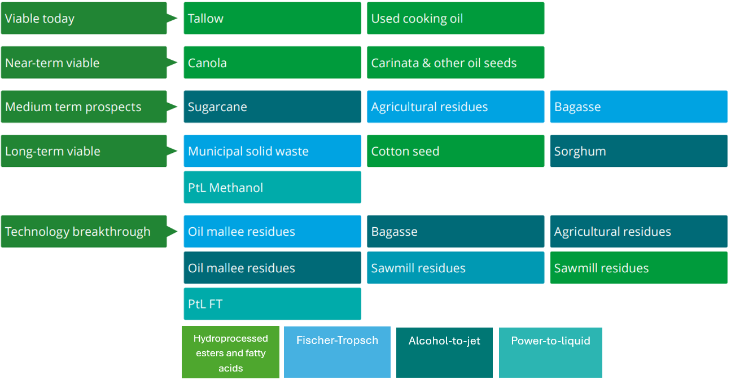Figure 2 Breakdown of feedstock-technology combinations and readiness

Source: CEFC 2025

In the absence of structured incentives focused on RD&E of emerging feedstocks and processing technologies, capital investment is likely to flow only into the most presently viable pathways noted above. Through the strategy, consideration might be given to how government and industry can align to ensure that we make best use of the widest pool of resources and avoid adverse consequences from overly relying on one production pathway – otherwise known as the risk of technology ‘lock in’.

The strategy could also explore options to promote market transparency, resilience in supply chains, reduced costs and improved efficiency, as well as ways for government, industry, and communities to build the required workforce capacity and skills. There may also be options for industry to consider the role of long-term contracts to provide certainty needed for feedstock producers to engage in development of the industry.

## Other issues for consideration

### Diversification vs prioritisation

Noting that feedstock supply chains vary in their commercial maturity and technical ability to service domestic bioenergy production, the strategy may outline different visions for a future mix of feedstocks and processing technologies. One example could focus on supporting the deployment of feedstocks and processing pathways with the best prospects of scaling up in the short term. An alternative approach could focus on a more diverse range of feedstock resources, including those whose commercial viability is a longer-term prospect. Identifying and pursuing a specified mix of feedstocks and processing pathways will have different implications for decarbonisation, economic and sustainability outcomes. Government and industry should be aligned on this vision and what steps will be required to enable it.

### Quantifying feedstocks and their characteristics

A level of clarity around feedstock production is fundamental for de-risking the significant capital investments required to underpin domestic bioenergy industries. Domestic processing facilities will depend on a reliable flow of accessible feedstocks to ensure consistency of production. Work has been undertaken in the past to quantify Australia’s biomass resources, including the Australian Biomass for Bioenergy Assessment. The strategy will explore whether additional effort is required to ensure ongoing accuracy and consistency of estimates.

A robust framework for carbon intensity measurement and certification will also be important to underpin the decarbonisation outcomes of using feedstocks for bioenergy purposes. The Commonwealth Government is expanding the Guarantee of Origin (GO) Scheme to certify the emissions intensity of low carbon liquid fuels across the fuel production lifecycle, including upstream emissions from feedstocks and inputs to their production.

Additional information may be sought by consumers of low carbon liquid fuels and gases regarding the sustainability of these energy carriers (and the feedstocks used in their production). While the GO scheme is an emissions intensity verification framework, it is considering options to allow fuel producers to include information on sustainability attributes on a GO certification. Inclusion of these attributes may assist consumer knowledge and market adoption but will be limited by practical access to high-quality, suitable data and the ability to trace and verify the information.

### Infrastructure requirements

Many feedstock commodities currently have mature, export-oriented supply chains with established infrastructure. Oilseeds and lipids have a commercially proven biofuel processing method which can leverage existing liquid fuel infrastructure. In these cases, more limited action may be required, such as establishing appropriate policy settings, to provide certainty for industry investment and to catalyse additional utilisation of this feedstock for domestic bioenergy purposes.

Geographically concentrated industries may face fewer logistical challenges in mobilising feedstocks for bioenergy than those which are produced across vast distances. For this reason, and due to the emerging nature of their processing technologies, residues and lignocellulosic biomass involve more complex supply chain considerations that require greater levels of de-risking and flexible infrastructure design. Localised aggregation and pre-processing methods like densification or torrefaction could help alleviate these issues but would require significant infrastructure investment and logistical coordination.

The movement of feedstock around remote and regional areas may also have impacts on local communities. Examples could include increased pressure on local infrastructure such as roads and bridges, particularly where bypass options are not available for heavy traffic. The strategy will explore the need for industry and government to work collaboratively to address these challenges.

### Addressing social license and sustainability

Efforts to scale up feedstock supply chains should be consistent with community values regarding sustainability and consider how these values are shaped by the socio-economic context of different regions across Australia. The strategy will explore policy settings aimed at ensuring an enduring social license for new bioenergy industries with respect to the sustainability of feedstock production. Australian agricultural and forestry industries are already obligated to meet environmental regulatory standards, which also impact the production of renewable energy. The scaling up of feedstock production could have additive impacts on land use, water and fertiliser demand, and biodiversity.

Standards or requirements could be considered at these preliminary stages to ensure the industry develops in a way that is consistent with social expectations. International examples of standards which regulate bioenergy (e.g. the EU Renewable Energy Directive III and the Carbon Offsetting and Reduction Scheme for International Aviation) offer guidance but may not fully account for Australia’s unique agricultural conditions. Consistency with these international standards may have important implications for market access and the ability to export low carbon liquid fuels and gases.

The distinction between feedstocks which are edible – either directly by humans, or indirectly through consumption by livestock – and those which are not, is another social license issue to consider. The strategy will explore the relevance of the ‘food vs fuel’ issue in an Australian context and ways to ensure that feedstock production remains complementary with food and fibre production. There is significant potential for agricultural production systems to generate diverse outputs and outcomes (including decarbonisation) required for a food-secure and low-emissions future. Appropriate planning and coordination will be needed to reduce transitional risks, balance multiple priorities and support benefits for communities.

Figure 3 Feedstock generations

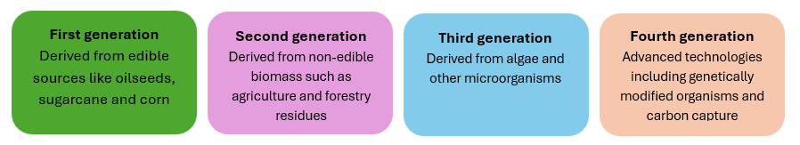

****The National Food Security Strategy****

The National Food Security Strategy will seek to collaborate with farmers and fishers, industry and the community to boost the productivity, resilience, and security of Australia’s food system. The use of edible feedstocks for bioenergy purposes may have some impact on the availability of a quantity and quality of sufficient food, which is a key dimension of food security.

Consultation on the Feeding Australia strategy opened via [Have Your Say](https://haveyoursay.agriculture.gov.au/food-security-strategy) on 13 August 2025 and closed on 1 October 2025.

### Research and development needs

Identifying and targeting research and development (R&D) opportunities could make an important contribution to maximising feedstock production, reducing carbon intensity and improving efficiencies across supply chains. The strategy could explore opportunities to boost production of feedstocks through new and novel feedstocks (such as carinata or pongamia), identifying ways to capture byproducts and residues in production systems, improving feedstock yields, optimising production practices, and developing sustainable harvesting techniques that preserve ecosystem services.

Other opportunities could include testing and de-risking farming and land management practices such agroforestry, coppicing of short-rotation trees and more productive use of marginal lands. These novel systems could widen the array of benefits provided by the agriculture and forestry sectors and improve complementarity of food, fibre and fuel production.

ARENA, CSIRO, CEFC and the Rural Research and Development Corporations are making important contributions regarding innovation, research, early-stage deployment and commercial scaling of feedstocks and renewable energy technologies. The strategy could explore respective roles for government and industry in this space.

### Coordination across jurisdictions

State and territory governments are advancing their own strategies with respect to bioenergy. For example, Western Australia has committed to developing an Advanced Biofuels Strategy, New South Wales is developing a Renewable Fuels Strategy, Tasmania is developing a Future Clean Fuels Strategy, and South Australia has an existing Bioenergy Roadmap. Significant work is also underway in Queensland and Victoria to understand feedstock availability at a regional level. A national strategy can build on and complement this existing and emerging work and explore ways to establish greater alignment and coordination across jurisdictions.

### Climate change and variable production

The effects of climate change will impact the production and availability of all agricultural and forestry-derived products. Increased seasonal variability and drying conditions will impact production from broadacre cropping, increased severe weather events may impact geographically-concentrated industries like sugar, and more frequent and intense fire events may impact forestry production. Climatic changes may also unlock opportunities for production of different commodities in certain regions. Bioenergy feedstocks may not be subject to the same aesthetic and/or other physical quality criteria as other agricultural and forestry products, which could make them a robust commodity in the context of climate variability and increasing severe weather events. The strategy could explore how to account for the impacts and opportunities of seasonal variability and climate change on feedstock availability, and to ensure supply chains remain resilient in the face of climate-related disruption.

### Biosecurity and traceability

Development of feedstock supply chains should include appropriate management of biosecurity risks as feedstock volumes and movements increase. Importation of feedstocks produced overseas could involve amplified risk in the form of exotic pests, weeds and diseases, and potentially less transparency regarding providence and chain of custody. As per the above section, climate change may also impact the prevalence and reach of disease and pest outbreaks. It is important that supply chains remain resilient and flexible in the face of potential disruptions due to biosecurity incursions.

Supply chain traceability practices and technology will play a role in mitigating these risks and will also likely be required to underpin the certification of feedstock characteristics (through verification of providence and chain of custody) referenced in an earlier section. Views are sought on how developing feedstock supply chains can deploy existing and innovative solutions to reduce these risks.

## Have your say

We invite stakeholders to provide views on the development of a bioenergy feedstock strategy.

Questions raised in this discussion paper are intended as a guide only. Respondents are welcome to provide more general comments in their submission.

Submissions longer than 10 pages need to include a summary of key points.

You can lodge a submission through the Have Your Say portal at [https://haveyoursay.agriculture.gov.au/national-bioenergy-feedstock-strategy](https://aus01.safelinks.protection.outlook.com/?url=https%3A%2F%2Fhaveyoursay.agriculture.gov.au%2Fnational-bioenergy-feedstock-strategy&data=05%7C02%7CStuart.Watt%40aff.gov.au%7C6748ef8ea7e94b7ae8d208ddfeffdf75%7C2be67eb7400c4b3fa5a11258c0da0696%7C0%7C0%7C638947097129550538%7CUnknown%7CTWFpbGZsb3d8eyJFbXB0eU1hcGkiOnRydWUsIlYiOiIwLjAuMDAwMCIsIlAiOiJXaW4zMiIsIkFOIjoiTWFpbCIsIldUIjoyfQ%3D%3D%7C0%7C%7C%7C&sdata=KuclmLkzjYf1UdmMh%2FJkcdBN98O2gfWEndIMnHN2Bj0%3D&reserved=0)

Submissions will close at 5 pm AEST on 7 November 2025.

Further stakeholder engagement opportunities will be communicated through [National Bioenergy Feedstocks Strategy - DAFF](https://www.agriculture.gov.au/agriculture-land/farm-food-drought/climatechange/bioenergy-feedstocks).

### Contacts

For further information please contact [feedstocks@aff.gov.au](mailto:feedstocks@aff.gov.au).

## Glossary

| Term | Definition |
| --- | --- |
| ABARES | Australian Bureau of Agricultural and Resource Economics and Sciences |
| alcohol-to-jet (AtJ) | The process of converting alcohol (typically ethanol) to jet fuel through a series of catalytic reactions. |
| bioenergy | A form of renewable energy generated from the conversion of biomass resources into heat, electricity, gas, and/or liquid fuels. |
| biofuel | Biogenic alternative to fossil fuels, used to produce bioenergy. Biofuel commonly refers to liquid fuels (e.g. biodiesel) but can also include gaseous and solid forms. |
| byproducts and residues | Biogenic materials that remain after the primary processing of agricultural and forestry biomass, such as bagasse from sugarcane or wood chips from forestry. |
| carinata | A non-edible oilseed crop, grown between main crop rotations and used as a lower carbon liquid fuel feedstock |
| CEFC | Clean Energy Finance Corporation |
| CSIRO | Commonwealth Scientific and Industrial Research Organisation |
| DAFF | Department of Agriculture, Fisheries and Forestry (Commonwealth) |
| densification | The use of heating and pressure to increase the density and energy of biomass, resulting in products such as pellets or briquettes. |
| feedstock, biogenic | Biological materials that are used as input to process energy carriers including liquid fuels and gases. These materials can come from agricultural crops (such as oilseeds), agricultural and forestry residues, livestock waste, or even municipal solid waste. |
| feedstock, non-biogenic | Materials that are not from biological sources, used as input to process energy carriers including liquid fuels and gases. These can include hydrogen and captured carbon dioxide. |
| generations (feedstock) | Categorisation of biomass, used to create bioenergy, as first (from edible sources), second (non-edible sources), and third (algae and other microorganisms). |
| Hydroprocessed Esters and Fatty Acids (HEFA) | The use of hydrogen and a catalyst to process of high-fat content feedstocks (such as oilseeds) to create liquid biofuels, including biodiesel and sustainable aviation fuel. |
| low carbon liquid fuel (LCLF) | A liquid fuel with lower carbon intensity involved in its production and combustion compared with fossil fuel equivalents. Commonly (but not exclusively) produced with biogenic feedstocks. |
| lignocellulosic | Biomass derived from dry plant matter, including agricultural residues, forestry residues, and short rotation trees. |
| pongamia | A drought-tolerant oilseed crop that can be grown on marginal land and used as low carbon liquid fuel feedstock |
| sustainable aviation fuel (SAF) | A renewable and low carbon fuel replacement to traditional jet fuels, produced from a range of feedstocks |
| torrefaction | The heating of biomass in an oxygen-limited environment, to improve energy density and reduce water content. |

## References

ARENA 2021. [Australia’s Bioenergy Roadmap](https://arena.gov.au/assets/2021/11/australia-bioenergy-roadmap-report.pdf), Australian Renewable Energy Agency, Canberra, accessed 14 August 2025.

Bioenergy Australia 2025. [Securing Our Fuel Future: Resilience Through Low Carbon Liquid Fuels,](https://cdn.revolutionise.com.au/cups/bioenergy/files/nyydxvvoi7belg4m.pdf) Bioenergy Australia, Canberra.

Cavelius, P., Engelhart-Straub, S., Mehlmer, N., Lercher, J., Awad, D., Bruck, T 2023. “The potential of biofuels from first to fourth generation” PLOS Biology 21.

CEFC 2025. [Refined Ambitions: Exploring Australia’s Low Carbon Liquid Fuel Potential,](https://www.cefc.com.au/document?file=/media/jh3gvm14/refined-ambitions-exploring-australia-s-low-carbon-liquid-fuel-potential.pdf)  Clean Energy Finance Corporation.

CSIRO 2023. Sustainable Aviation Roadmap, Commonwealth Scientific and Industrial Research Organisation, Canberra.

——, 2025. [Opportunities and Priorities for a Low Carbon Liquid Fuel Industry in Australia,](https://research.csiro.au/tnz/wp-content/uploads/sites/454/2025/03/EXT-Opportunities-and-priorities-for-a-Low-Carbon-Liquid-Fuel-Industry.pdf) Commonwealth Scientific and Industrial Research Organisation, Canberra.

Dimitriou, I., Berndes, G., Englund, O., Brown, M., Busch, G., Dale, V., Devlin, G., English, B., Goss, K., Jackson, S., Kline, K. L., McDonnell, K., McGrath, J., Mola-Yudego, B., Murphy, F., Negri, MC., Parish, E. S., Sesame, H., Tyler, D 2018. [Lignocellulosic crops in agricultural landscapes: Production systems for biomass and other environmental benefits – examples, incentives and barriers,](https://www.ieabioenergy.com/wp-content/uploads/2019/01/TR2018-05.pdf) International Energy Agency.

Mabee, W., Walker, B 2025. [Review of feedstock supply for bioenergy in IEA Bioenergy,](https://task43.ieabioenergy.com/wp-content/uploads/sites/38/2025/05/Review-of-feedstock-supply-for-bioenergy-in-IEA-Bioenergy.pdf) International Energy Agency.

NSW Department of Primary Industries and Regional Development 2024. [Cropping: Sorghum.](https://www.dpi.nsw.gov.au/about-us/publications/pdi/2024/sorghum) New South Wales Department of Primary Industries and Regional Development, Sydney.