Review of devitalisation requirements for fresh cut flower and foliage imports: draft report
October 2025
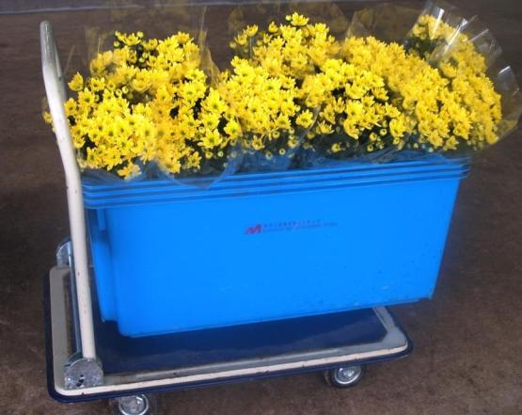

© Commonwealth of Australia 2025
Ownership of intellectual property rights
Unless otherwise noted, copyright (and any other intellectual property rights) in this publication is owned by the Commonwealth of Australia (referred to as the Commonwealth).
Creative Commons licence
All material in this publication is licensed under a Creative Commons Attribution 4.0 International Licence except content supplied by third parties, logos and the Commonwealth Coat of Arms.

Cataloguing data
This publication (and any material sourced from it) should be attributed as: DAFF 2025, Review of devitalisation requirements for fresh cut flower and foliage imports: draft report, Department of Agriculture, Fisheries and Forestry, Canberra, CC BY 4.0.
This publication is available at agriculture.gov.au/about/publications.
Department of Agriculture, Fisheries and Forestry
GPO Box 858 Canberra ACT 2601
Telephone 1800 900 090
Web agriculture.gov.au
Email: plantstakeholders@aff.gov.au
Disclaimer
The Australian Government acting through the Department of Agriculture, Fisheries and Forestry has exercised due care and skill in preparing and compiling the information and data in this publication. Notwithstanding, the Department of Agriculture, Fisheries and Forestry, its employees and advisers disclaim all liability, including liability for negligence and for any loss, damage, injury, expense or cost incurred by any person as a result of accessing, using or relying on any of the information or data in this publication to the maximum extent permitted by law.
Acknowledgement of Country
We acknowledge the continuous connection of First Nations Traditional Owners and Custodians to the lands, seas and waters of Australia. We recognise their care for and cultivation of Country. We pay respect to Elders past and present, and recognise their knowledge and contribution to the productivity, innovation and sustainability of Australia’s agriculture, fisheries and forestry industries.
Stakeholder submissions on draft reports
This draft report has been issued to give all interested parties an opportunity to comment on relevant technical biosecurity issues, with supporting rationale. A final report will then be produced taking into consideration any comments received.
Submissions should be sent to the Department of Agriculture, Fisheries and Forestry following the conditions specified within the related Biosecurity Advice, which is available at: agriculture.gov.au/biosecurity/risk-analysis/memos.

Contents
Summary v
1 Introduction 1
1.1 Background 1
1.2 Scope 1
1.3 Existing policy 2
1.4 Consultation 4
1.5 Next steps 4
2 Imported cut flower pathway 5
2.1 Cut flowers - harvest to point of sale 5
2.2 Use of imported cut flowers 5
3 Diversion from intended use of imported cut flowers to propagation 7
3.1 Motives and categories of DFIU 7
3.2 Examination and evaluation of DFIU of imported cut flowers to propagation 7
3.3 Evaluation of potential success of DFIU of imported cut flowers to propagation 10
3.4 Biosecurity risk of personal DFIU of imported cut flowers to propagation 15
3.5 Biosecurity risk of commercial DFIU of imported cut flowers to propagation 18
4 Proposals 20
4.1 Proposals on Australia’s existing devitalisation requirements for imported propagable cut flowers 20
4.2 Important notes associated with the proposals 20
4.3 Review of processes 21
5 Conclusion 22
Appendix A: Method for pest risk assessment of pathogens associated with diversion of intended use of imported cut flowers to propagation 23
Appendix B: Examples of Reddit posts 33
Glossary, acronyms and abbreviations 36
References 38
Figures
Figure 3.1 Species of cut flowers on the 31 posts discussed in Reddit between October 2022 and April 2023 that might be related to DFIU of cut flowers to propagation 11
Figure 3.2 Three different flower bouquets with reduced number of leaf nodes from left to right. 13
Figure 3.3 Three different grades of roses with increased number of leaf nodes from left to right. 13
Figure A.1 Decision rules for determining the impact score for each direct and indirect criterion, based on the level of impact and the magnitude of impact 34

Tables
Table 1.1 Current devitalisation requirements for specific cut flowers imported into Australia 2
Table A.1 Nomenclature of likelihoods 30
Table A.2 Matrix of rules for combining likelihoods 31
Table A.3 Decision rules for determining the overall consequence rating for each pest 35
Table A.4 Risk estimation matrix 36

Summary
The Australian Government Department of Agriculture, Fisheries and Forestry (the department) has prepared this draft report to review current devitalisation requirements for fresh cut flowers and foliage (hereafter referred to as cut flowers) imported into Australia. This review is part of a broader Pest Risk Analysis (PRA) package assessing biosecurity risks associated with imported cut flowers in accordance with the Biosecurity Act 2015, to ensure import measures provide an Appropriate Level of Protection (ALOP).
This review examines and evaluates the biosecurity risk associated with diversion from intended use (DFIU) of imported cut flowers from time-limited decorative purposes to propagation (hereafter referred to as DFIU of imported cut flowers to propagation) and provides proposals with regards to devitalisation requirements in the context of achieving ALOP.
The review identifies that there is no evidence or information to indicate that commercial DFIU of imported cut flowers to propagation is occurring in Australia. However, there is information to suggest that personal DFIU may be occurring globally at or below very low levels. It is not known what proportion of the global DFIU is occurring in Australia, if any, and what proportion of the DFIU involved imported cut flowers as differentiated from locally produced cut flowers. Due to uncertainty of the information on personal DFIU occurrence, the review assumes that personal DFIU may be occurring in Australia at or below very low levels. The success of personal DFIU in producing a viable and healthy plant to serve as a host of quarantine pathogens that may be present in imported cut flowers (that are diverted to propagation) is likely limited.
These findings result in the overall unrestricted risk estimate of quarantine pathogens associated with commercial DFIU and personal DFIU of imported cut flowers to propagation being assessed as achieving the ALOP for Australia. As such, specific risk management measures to manage DFIU of imported cut flowers to propagation are not required for either commercial DFIU or personal DFIU.
This means that Australia’s current devitalisation requirements for imported cut flowers do not meet the key principles of the SPS Agreement, which state that phytosanitary measures should only be required where necessary, should have minimal impact, and should be justified by an appropriate pest risk analysis (PRA). Therefore, this draft report proposes that the devitalisation requirements be removed from the following pathways:
- More than 6 small boxes, bouquets or equivalent from all permitted countries:
Glyphosate dip for Brunia spp., Calathea insignis, Calathea lancifolia, Callistephus chinensis, Chrysanthemum spp., Cordyline spp., Dianthus spp., Oxypetalum spp., Hypericum spp., Rhapis spp., Rosa spp., Viburnum spp., Viola spp., Codiaeum variegatum and Dracaena spp.
- More than 6 small boxes, bouquets or equivalent from Vietnam:
Metsulfuron-methyl dip for Chrysanthemum spp.
- 6 or less small boxes, bouquets or equivalent from all permitted countries:
Manual removal of the auxiliary buds of all the nodes on stems; or cutting the stems to 5 cm below the flower heads.
The phytosanitary measures determined to be effective to manage biosecurity risk to achieve the ALOP for Australia are based on the biosecurity risk associated with specific intended use of the commodity. It is important to note that DFIU of imported cut flowers potentially increases the biosecurity risk associated with the goods and is not permitted by the department. The department has powers under the Biosecurity Act 2015 (hereafter referred to as the Act) to investigate suspected DFIU, undertake an assessment of the biosecurity risk, and take action where required. Action can include education and warnings, significant fines, revocation of permits and/or other approvals from the department, criminal prosecution or civil litigation.
This draft report has been published on the department website to allow interested parties to provide comments and submissions within the 60-day consultation period.

Introduction

Background
Since 1963 Australia has permitted the importation of commercially produced cut flowers from many countries for time-limited decorative purposes in Australia. Some cut flowers such as roses, chrysanthemums and carnations are considered propagable. Using imported cut flowers for propagation poses potential biosecurity risk because, if there are pathogens associated with the imported cut flowers and the propagation is successful, the associated pathogens could establish, spread and cause consequences in Australia. Therefore, Australia currently requires specific cut flower species to be devitalised to make them non-propagable prior to export to Australia.
The Biosecurity Act 2015 and its subordinate legislation provides the legal basis for preventing and managing the introduction into Australia of pests and diseases that may cause harm to human, animal or plant health or the environment.
Australia is a signatory to the World Trade Organization (WTO) and, like other WTO members, has rights and obligations under the Agreement on the Application of Sanitary and Phytosanitary Measures (SPS Agreement). The key principles of the SPS Agreement regarding phytosanitary measures are that phytosanitary measures should only be required where necessary, should have minimal impact, and should be justified by an appropriate pest risk analysis or, where applicable, another comparable examination and evaluation of available scientific information.
The department has conducted this review to examine and evaluate the occurrence of diversion from intended use of imported cut flowers to propagation and the associated biosecurity risk. The review makes proposals with regards to devitalisation requirements in the context of achieving the ALOP for Australia and meeting the key principles of the SPS Agreement.

Scope
The scope of this review is to:
- Investigate the occurrence of diversion from intended use (DFIU) of imported cut flowers to propagation and assess the associated unrestricted biosecurity risk (i.e., with no application of devitalisation requirements) to determine whether specific risk management measures are required. This is undertaken for all cut flowers the department has determined to be propagable.
- Where risk management measures are required, evaluate whether current devitalisation requirements are effective and, if not, determine the devitalisation requirements that could be applied.
In this review, cut flowers are defined as stems with flowers and foliage, without propagules (for example, bulbils, fruit and seeds), consistent with current import conditions.
This review includes:
- Australia’s existing policy for DFIU of imported cut flowers and international guidance on DFIU of imported plant produce (Chapter 1, Section 1.3),
- an overview of the imported cut flower pathway (Chapter 2),
- examination and evaluation of the DFIU activity of imported cut flowers to propagation, the factors that influence successful propagation, and the associated biosecurity risk (Chapter 3), and
- proposals on Australia’s devitalisation requirements for imported cut flowers (Chapter 4).
This review excludes:
- a review of the definition of cut flowers in current import conditions, i.e. stems with flowers and foliage, without propagules (for example, bulbils, fruit and seeds),
- assessments of biosecurity risk of arthropods as they have been assessed previously in the final pest risk analysis (PRA) for cut flower and foliage imports—Part 1 (thrips, aphids and mites) and Part 2 (other arthropod pests), and
- assessments of biosecurity risk of pathogens associated with imported cut flowers that are used in accordance with the intended use of time-limited decorative purposes in Australia, as this will be undertaken in cut flower PRA – part 3. The department will engage with stakeholders regarding cut flower PRA – part 3 upon finalisation of this review of devitalisation requirements.

Existing policy

Australia’s existing policy on devitalisation of imported cut flowers
The department has historically required imported propagable cut flowers to be devitalised to make them non-propagable. This was in order to manage any potential biosecurity risk associated with DFIU of these cut flowers to propagation. The department’s devitalisation requirements have evolved over time. The current requirements are summarised in Table 1.1 and further details can be found on the Australian Government’s Biosecurity Import Conditions (BICON) database, bicon.agriculture.gov.au/BiconWeb4.0.
Table 1.1 Current devitalisation requirements for specific cut flowers imported into Australia
Cut flower species | Devitalisation requirements
Commercial quantities (more than 6 small boxes, bouquets or equivalent) from all permitted countries
Brunia spp.  Calathea insignis  Calathea lancifolia | 20-minute immersion of stems to at least 35 cm from the cut end (OR to within 5 cm of the flower head) in a solution of glyphosate at concentration of 0.9 g/L.
Callistephus chinensis  Chrysanthemum spp.  Cordyline spp.  Dianthus spp.  Oxypetalum spp. (syn. Tweedia spp.) | 20-minute immersion of stems to at least 35 cm from the cut end (OR to within 5 cm of the flower head) in a solution of glyphosate at concentration of 1.8 g/L.
Hypericum spp.  Rhapis spp. (leaves and fronds with basal stem attached)  Rosa spp.  Viburnum spp.  Viola spp. | 20-minute immersion of stems to at least 35 cm from the cut end (OR to within 5 cm of the flower head) in a solution of glyphosate at concentration of 5.4 g/L
Codiaeum variegatum (syn. Croton variegatus) (stems with leaves)  Dracaena spp. (stems with leaves) | 20-minute immersion of stems to within to 15 cm of apex in a solution of glyphosate at concentration of 5.4 g/L
Commercial quantities (more than 6 small boxes, bouquets or equivalent) from Vietnam
Chrysanthemum spp. | 20-minute immersion of stems to at least 35 cm from the cut end in a solution of metsulfuron-methyl at concentration of 0.1333 g/L.
Non-commercial quantities (6 or less small boxes, bouquets or equivalent)
All species as listed for commercial quantities | Devitalised manually through removal of the auxiliary buds of all the nodes on stems; or cutting the stems to 5 cm below the flower heads.

International policy on devitalisation of imported cut flowers
Australia and New Zealand are the only countries known to have devitalisation requirements for imported cut flowers.
In 2021, Biosecurity New Zealand commissioned Lincoln University researchers to carry out a comprehensive literature review of devitalisation and its efficacy, as well as to identify potential methods for compliance testing to effectively determine whether devitalisation requirements have been met. Key findings from this review (Stark & Moot 2022) include:
- The devitalisation effect of glyphosate, the main chemical used for devitalisation, can be reversed by supplementing the plants with amino acids to overcome the effects of devitalisation.
- There are limited efficient and reliable tests to determine whether devitalisation treatments have been carried out. Testing for devitalisation either involves lengthy grow-out tests, or an ELISA for glyphosate.
- Glyphosate is ineffective at eliminating pathogens on a plant. Any disease control benefits of devitalisation are indirect due to the decreased vase-life caused by devitalisation.
New Zealand Ministry for Primary Industry has reviewed its devitalisation requirements as part of its review of the import health standard for imported cut flowers and released its consultation paper in November 2024. The paper proposes that a devitalisation treatment for imported cut flowers is no longer required.

International guidance on DFIU of imported plant produce
Intended use is defined as the declared purpose for which plants, plant products or other articles are imported, produced or used (FAO 2024). The intended use of a commodity may be for planting, consumption, processing and in the case of cut flowers, time-limited decorative purposes. The effect of intended use on a commodity’s pest risk and the application of different phytosanitary measures for a commodity based on its intended use are recognised by ISPM 32 (FAO 2016). Any phytosanitary measure applied should be proportional to the pest risk identified (FAO 2016) .
There are currently no International Standards for Phytosanitary Measures (ISPM) or official guidance on how to conduct a PRA to specifically assess biosecurity risk associated with DFIU. The International Plant Protection Convention (IPPC) paper, Diversion from Intended Use (FAO 2016) (hereafter referred to as the IPPC DFIU paper) provides an overview of the current issues of managing biosecurity risk associated with DFIU. The purpose of the IPPC DFIU paper was to estimate the extent of the DFIU issue and to evaluate the need for further guidance or support from the IPPC.
In brief, the IPPC DFIU paper (FAO 2016) states that:
- There are limited options available to a country to prevent DFIU of goods post-import and DFIU activities are rarely documented or reported.
- Various countries apply measures to manage DFIU to import pathways such as cut flowers, avocado, potato and grains. However, the risk of DFIU is derived from anecdotal evidence, with no PRA conducted to assess the risk and support the measures.
- The efficacy of devitalization measures is not considered to be proven. There is insufficient literature on the efficacy of some treatments routinely used if the objective is entirely to prevent sprouting.
- While National Plant Protection Organisations (NPPOs) have a sovereign right to impose phytosanitary measures on imported goods to manage biosecurity risk, the lack of an appropriate PRA or clear scientific evidence (or equivalent) to justify the application of measures for DFIU is inconsistent with the principles of the SPS Agreement.
- Greater clarity around information and evidence for DFIU is required to support the measures for DFIU.
- A PRA or, where applicable, another comparable examination and evaluation of available scientific information should be conducted to support the measures for DFIU.
- Measures for DFIU that are not supported by a PRA are not in line with the IPPC or the SPS agreement and should be removed.
In line with the IPPC DFIU paper, this review examines and evaluates information and evidence on the occurrence in Australia of DFIU of imported cut flowers to propagation. This review then assesses unrestricted biosecurity risks (i.e., without devitalisation requirements being applied) associated with the DFIU occurrence. This is to determine whether devitalisation requirements are technically justified.

Consultation
The department has an extensive program of consultation with international and domestic stakeholders regarding the importation of cut flowers into Australia.
On 30 August 2024, the department notified registered stakeholders, via email and the department website, of the commencement of the review of devitalisation requirements for specific cut flowers imported into Australia.

Next steps
The department has notified registered stakeholders, and the WTO-Secretariat about the release of this draft report.
This draft report gives stakeholders an opportunity to comment on the department’s review and proposals, and to draw attention to any scientific, technical or other gaps in the data, or misinterpretations or errors.
The department will consider submissions received on the draft report and may consult further with stakeholders. The department will revise the report as appropriate and then prepare a final report, taking into account stakeholder comments.
The final report will be published on the department’s website along with a notice advising stakeholders of the release. The department will also notify registered stakeholders and the WTO Secretariat about the release of the final report.
The biosecurity requirements recommended in the final report will form the basis of the conditions published on BICON, and for any import permits subsequently issued.

Imported cut flower pathway
This chapter provides a brief overview of the imported cut flower pathway, from harvest to point of sale, and consumer usage patterns.

Cut flowers - harvest to point of sale
Cut flowers are one of the most perishable plant commodities traded globally as they lose quality and vase life rapidly, with most cut flowers lasting no more than 1–2 weeks from point of sale (IIGB 2015; Jones 1959). Therefore, commercial processes are optimised to reduce time between harvest and sale to ensure quality products are delivered to consumers.
For cut flowers imported into Australia, the time between harvest and being sold to customers can be anywhere from 9 to 42 days (for air freighted goods) or from 27 to 77 days (for sea freighted goods). Roses, carnations and chrysanthemums accounted for 83% of cut flowers imported into Australia in 2023. According to the information provided by the Australian Flower Traders Association (Sabine Perrone, personal communication, 5 October 2023), the typical steps and timelines for roses, carnations and chrysanthemums from harvest to customers include:
- Harvest to pre-export (4-9 days) — includes key steps such as harvest, quality checks/grading, cold storage, chemical treatments to ensure quality, phytosanitary treatments (where required), packing, local-transport and inspections by exporting country’s NPPO
- Transport to Australia — airfreight (2-5 days) or sea-freight (20-40 days)
- Biosecurity clearance (1-7 days, depending on compliance) — all consignments of cut flowers are inspected upon arrival in Australia
- If consignments meet Australia’s import conditions, they are released to importers (1 day)
- If consignments are found to be non-compliant, remedial action is applied to the consignments prior to release, adding remediation time (1 - 7 days). It is important to note that where the department assesses that the risk cannot be practically treated or managed onshore, remedial action will involve export or destruction of the whole or part of the consignment.
- Domestic distribution (1-7 days) — cut flowers are stored at importer/wholesaler premises for further distribution around Australia
- Final sale process — supermarket (1-6 days), or florists (1-14 days)
- In Australia, retail sales of most cut flowers occur at supermarkets or florists, with a small proportion being sold through markets or roadside stalls. Due to methods of storage and display, supermarkets can generally display cut flowers for a limited time (e.g., approximately 4 days for roses and 6 days for chrysanthemums), whereas florists can display cut flowers for up to 2 weeks.

Use of imported cut flowers
The use of imported cut flowers for time-limited decorative purposes can be separated into 3 categories: gift, personal use and event. Cut flowers in the gift and personal use categories contribute to the majority of cut flower sales, with a peak in sales occurring during special occasions such as Valentine’s Day, Mother’s Day, Christmas and other culturally significant occasions such as Chinese New Year (Yue & Hall 2010). Most cut flowers in the gift and personal use categories are used indoors and only a small proportion are used outdoors (< 2.4%) (Yue & Hall 2010) such as at cemeteries, however this trend is decreasing due to the use of artificial or preserved flowers (Kostecka et al. 2024). Cut flowers in the event category, such as a wedding, may be used indoors or outdoors. Weddings in Australia remain predominantly indoors, with only 18% held outdoors (Easy Weddings 2023).

Diversion from intended use of imported cut flowers to propagation
This chapter examines and evaluates the activity of DFIU of imported cut flowers to propagation, the factors affecting successful propagation, and the associated biosecurity risk.

Motives and categories of DFIU
DFIU is likely to be driven by the potential benefit when compared to the cost, effort and potential consequences of the diversion. If the benefit is perceived to outweigh the effort and consequences, DFIU could potentially occur. In contrast, if the cost, effort and potential consequences appear to outweigh the benefit, DFIU is unlikely to occur and other avenues for the desired outcome are likely to be used.
For the purpose of this review, DFIU of imported cut flowers to propagation can be divided into 2 categories: commercial and personal. Commercial DFIU of cut flowers to propagation is likely to be driven by economic advantage to gain access to cut flower varieties not available in Australia, or to bypass Plant Breeders’ Rights (PBR, see Section 3.2.1). Personal DFIU of cut flowers to propagation is likely to be motivated by various factors including cultural or sentimental reasons, availability of cut flower types and/or curiosity.

Examination and evaluation of DFIU of imported cut flowers to propagation
A review of published literature found no primary reference relating to DFIU of imported cut flowers to propagation.
Alternative sources of information that could provide insight on DFIU of imported cut flowers to propagation were examined. These are outlined in Section 3.2.1 for commercial DFIU and Section 3.2.2 for personal DFIU.

Commercial DFIU
Information examined included infringement of plant variety rights (PVR) occurring in the European Union (EU) and biosecurity compliance on the imported cut flowers in Australia.
Infringement of PVR in the EU
Plant variety rights (PVR) infringements in the EU were examined to determine if DFIU of cut flower to propagation is used as a means to circumvent PVR. This information could provide insight on the potential for DFIU of cut flowers to propagation to be used as a means to circumvent PBR in Australia should Australia remove devitalisation requirements for imported cut flowers.
Like PBR in Australia, PVR in the EU gives growers exclusive commercial rights over a new plant variety providing protection against unauthorised production or sale of plant varieties covered under the PVR (CPVO 2025; IP Australia 2025). The EU is the world’s largest market for both cut flowers and ornamental plants and does not require devitalisation treatment for cut flowers imported into the EU (Darras 2021).
Examination of case law within the Community Plant Variety Office (CPVO) database found over 500 PVR infringement cases from 1957 to 2023. None of these cases related to DFIU of cut flowers to propagation, despite over 50% of the case decisions (from 1995 onwards) being related to ornamental plant species (available at online.plantvarieties.eu/pvrcaselaw) such as:
- illegal procurement, growing and sale of chrysanthemums (Case 22/2012, Sixth Penal Division of Sevilla, Spain; GESLIVE vs X)
- illegal propagation via cuttings and sale of commercial rose varieties (Case IV 1 WAZ 34106, Poland)
- illegal procurement, growing and sale of carnations (Case 331/2012 Fourth Penal Division of Cadiz, Spain).
Records within the CPVO database showed that infringement of PVR predominantly involved the direct propagation from propagative materials, including whole plants, seeds, bulbs and fresh cuttings.
Biosecurity compliance on imported cut flowers in Australia
There are no departmental records documenting instances of commercial DFIU of imported cut flowers to propagation.
Information received by the department as part of the Flower Industry Australia’s submission on the draft Pest Risk Analysis for Cut Flowers and Foliage – Part 2 states that “Anecdotal evidence within the Australian flower community suggests that cases of ineffective devitalisation and subsequent propagation of cut flowers do occasionally occur.” It is unclear whether the anecdotal evidence in the statement was drawn from DFIU conducted by the Australian flower community in an effort to show that devitalisation treatments do not work.
It is important to note that, regardless of the intention, DFIU of any commodities imported into Australia is a breach of Australia’s import regulation and the Act. This is because the biosecurity risk associated with an imported commodity differs significantly for different intended uses of the commodity. As a result, phytosanitary measures required to manage the biosecurity risk also differ significantly for different intended uses of the commodity.
The genetic characteristics and pre-harvest factors of the plant from which a cut flower stem originated are not precisely known. This means it may not be possible to confirm if a cut flower stem is worthy to be propagated for commercial production and sale, hence there may not be sufficient incentive for commercial DFIU of imported cut flowers to propagation. In addition, the Australian cut flower industry is aware of Australia’s strong biosecurity protections and the strength of legislative and potential non-compliance actions taken by the department. The Australian cut flower industry is also aware of existing import processes for nursery stock, which facilitates an efficient way to import new varieties of cut flowers into Australia (DAFF 2020; Hegarty, Thomson & Webster 2022; Smith 2022). This may explain the lack of evidence for commercial DFIU of imported cut flowers to propagation occurring in Australia.

Personal DFIU
There are a number of websites and videos providing advice on how to propagate plants from cut flowers. Some of these sites feature unsound propagation practices, for example using petals or flower buds for direct planting (Fraser Valley Rose Farm 2024). These websites do not indicate the occurrence of DFIU. It is possible that they may be viewed for entertainment and/or educational purposes.
To better understand the prevalence of personal DFIU of cut flowers to propagation, an analysis of online gardening forum posts was undertaken. The analysis used an Application Programming Interface script to collect posts from gardening subforums from Reddit between October 2022 and April 2023. Reddit is one of the world’s largest social forum platforms with over 55 million daily users which provides a unique, data-rich resource for behavioural studies (Medvedev, Lambiotte & Delvenne 2017). According to Similarweb (2025), more than half of the website’s traffic comes from the United States, and approximately 4% from Australia. The gardening forums used within this analysis included over 5.8 million subscribers and thus provides an enormous dataset for the study. The time period of the Reddit posts collected for analysis coincided with peak import periods of cut flowers, Christmas and Valentine’s Day.
Analysis of 6066 posts collected from relevant gardening subreddits or forums between October 2022 and April 2023 showed that out of all propagation-type posts, 31 related to propagation from cut flowers (Figure 3.1). It is important to note that these represent global figures and are not specific to Australia; some of these 31 posts were questions that did not identify whether DFIU occurred; and the posts did not identify whether they were regarding imported cut flowers and/or locally produced cut flowers. Of the 31 posts:
- Only 4 posts noted successful propagation of brassica (1 post) and pittosporum (3 posts). However, neither brassica nor pittosporum is permitted to be imported into Australia as cut flowers.
- Other posters often commented that the attempt to propagate was likely to fail and/or that dedicated rooting hormone would be needed for success, and that the resulting plants were not likely to thrive unless they were placed onto specialised rootstocks.
- More than half (19 posts) were questioning if propagation of cut flowers is possible, and included no information on whether an attempt to propagate was made.
- The majority of posts were afterthoughts by the posters, who wanted to save the cut flowers once they had wilted or thought of propagating if by chance they observed shoots forming on the cut flowers.
- All attempts of propagation were performed via stem cuttings. Grafting techniques were mentioned within the comments as requiring specialist skills and knowledge.
According to the department’s method for PRA, likelihoods are assigned to each step of pest risk assessments. Six qualitative likelihood descriptors are used: High; Moderate; Low; Very Low; Extremely Low; and Negligible. Indicative ranges, on a scale of 0 to 1, are provided to illustrate the boundaries of the qualitative likelihood descriptors (Table A.1 in Appendix A).
If DFIU to propagation occurred in all the 31 Reddit posts, this equates to approximately 0.005 on a scale of 0 to 1, which is within the indicative range of the likelihood of very low (Table A.1 in Appendix A). However, the level of DFIU occurring globally could be lower than very low levels because more than half of the 31 posts were questioning if propagation of cut flowers is possible, and it is not known whether an attempt to propagate was made.
The analysis of the Reddit posts showed that personal DFIU of cut flowers to propagation may be occurring globally at or below very low levels, that attempts are usually an afterthought by the owner who wanted to ‘save’ a spent flower, and that propagation was rarely successful. In addition, it is not known what proportion of the global DFIU is occurring in Australia, if any, and what proportion of the DFIU involved imported cut flowers as differentiated from locally produced cut flowers.
Examples of individual reddit posts are provided in Appendix B.
Figure 3.1 Species of cut flowers on the 31 posts discussed in Reddit between October 2022 and April 2023 that might be related to DFIU of cut flowers to propagation

Evaluation of potential success of DFIU of imported cut flowers to propagation
There is limited literature available on the success or effectiveness of propagation from cut flowers.
Should DFIU of imported cut flowers to propagation occur, it would most likely involve stem cuttings. Global trade in unrooted cuttings as propagative materials of various ornamental species suggests that viability for propagation of harvested plant stems could be maintained for variable duration. Studies on storability and quality of ornamental cuttings indicated that the duration the cuttings remain viable for propagation is dependent on species, cultivar and conditions of transportation and storage (Christiaens et al. 2019; Faust, Lewis & Rapaka 2010; Hussein 2007; Khan 1983; Leatherwood 2008).
The preparation, type and characteristics of the stems and conditions during storage and transportation are expected to differ between traded unrooted cuttings as propagative material and traded cut flowers. Therefore, information on the success or failure of propagation for traded unrooted cuttings cannot be equally applied to traded cut flowers.
This section evaluates potential success of DFIU of cut flowers to propagation, taking into consideration the physiological and metabolic characteristics of imported cut flowers against key factors affecting the success of propagation. These include plant material used in propagation (i.e., cut flower stems compared to cuttings selected and prepared as propagative material) (Section 3.3.1), time between harvest and point of propagation (Section 3.3.2) and environmental conditions and practices during propagation (Section 3.3.3).

Plant material used in propagation (cut flower stems vs cuttings selected and prepared as propagative material)
Vegetative propagation by stem cuttings is one of the commonly used methods of producing genetically identical plants. Three main types of stem cuttings used in propagation are: hardwood, semi-hardwood and softwood cuttings. Hardwood cuttings are generally harvested during the dormant season from mature, quiescent, lignified shoots after the leaves have abscised (Costa & Van de Pol 2003). Semi-hardwood cuttings are partly lignified, harvested late in the growing season, mostly mid-summer after flowering when the plant is putting on new growth and starting to harden. Softwood cuttings have little lignification, are soft and fleshy with high water content and are generally harvested early in the growing season, usually in spring and early summer when the plant is actively growing (Costa & Van de Pol 2003).
Some ornamental plants such as roses can be propagated from all types of cuttings depending on species and cultivars. For example, hardwood cuttings are used for field propagation of rose rootstocks of Rosa multiflora and Rosa chinensis var Indica Major; semi-hardwood cuttings are used for propagating garden roses and cut roses; and softwood cuttings are used for miniature pot roses (Costa & Van de Pol 2003). Carnations and chrysanthemums are vegetatively propagated from terminal or shoot tip cuttings (stem cuttings with a terminal bud and are usually young semi- or non-lignified stems) (Larson 1980). In the context of this review, DFIU of cut flowers to propagation will involve stem cuttings that are young, soft, succulent and non-lignified stem with leaves which are considered comparable to either semi-hardwood or softwood cuttings.
Commercial propagation of roses often uses grafting techniques which attach the bud-eye or cutting of a desired rose cultivar to a more vigorous growing variety of root stock (Izadi, Zarei & Alizadeh 2014); however, this is not a requirement as many roses will grow well on their own roots (Thomson 2009).
Successful propagation of a stem cutting depends on the formation of adventitious roots at the base of the cutting and the development of shoot(s) via axillary bud(s) within leaf node(s) on the cutting (Justamante et al. 2019).
There is variance in the ability to propagate between different species, as well as cultivars within a species (Dubois & de Vries 1991; Justamante et al. 2019; Nguyen, Winkelmann & Debener 2020). While some cultivars of rose, carnations and chrysanthemums can be propagated relatively easily, others depend on specific plant material to be used and/or specialist techniques (Glady, Lang & Runkle 2007; Izadi, Zarei & Alizadeh 2014; Momin et al. 2015; Nazari, Khosh-Khui & Salehi 2009; Zheng, Xiao & Song 2020).
In general, a healthy vigorous stem cutting is important to the success of propagation. Other characteristics which contribute to propagation success include:
- leaf area and thickness and photosynthetic capacity (as affected by e.g. stomatal density and chlorophyll content);
- internode length and stem diameter;
- starch, soluble carbohydrate and nutrient contents in the leaf and stem;
- concentration of endogenous growth substances; and
- position along the stem from which the cutting was taken and position of the stem within the plant’s canopy also influence rooting potential (Leakey, Newton & Dick 1994).
In a rose stem, axillary buds higher up the stem typically form more flowers and less vegetative growth; whereas axillary buds further down the stem form vegetative growth. Cuttings generated from higher up on the stem produce plantlets of poor quality and are generally avoided in commercial rose propagation (Marcelis-van Acker 1994).
The presence and number of leaf nodes on cut flowers depend on the arrangement or bouquet as well as the size or grade of the cut flowers. For example, number of leaf nodes may be fewer in a small cut flower gift box (far right in Figure 3.2) or in mini grade (far left in Figure 3.3).
Figure 3.2 Three different flower bouquets with reduced number of leaf nodes from left to right.
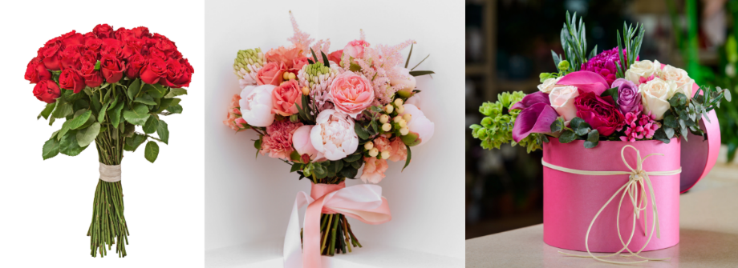
Source: Photos adapted from adobe express under licence.
Figure 3.3 Three different grades of roses with increased number of leaf nodes from left to right.
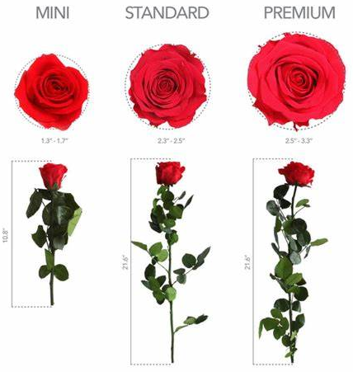
Source: www.verdissimousa.com
Flowers are active sink organs that require a continuous supply of carbohydrates as an energy source, as building blocks for cell wall synthesis and to maintain osmotic potential (Ranwala & Miller 2009). They primarily receive carbohydrates and amino acids from other organs such as leaves, sepals, stem and roots, where these metabolites are synthesised (Borghi & Fernie 2021).
Once harvested from the plant, a cut flower depends on metabolites synthesised and/or stored within a cut flower stem. Photosynthesis in leaves of cut flowers is very limited and does not provide enough carbohydrate (Ranwala & Miller 2009) and therefore postharvest quality and longevity of cut flowers are significantly shorter than those intact on a plant (Kondo et al. 2020). This is expected to subsequently reduce their viability for propagation.
The process of flowering can also lead to senescence and death of the plant parts involved for some species. These changes in plant physiology and metabolic pathways lead to reduced availability of essential nutrient and phytohormones (da Costa et al. 2021; da Silva 2006; Fanourakis et al. 2013), the elements that are pivotal to plant propagation (da Costa et al. 2021; Justamante et al. 2019; Kim et al. 2018; Leakey 2004; Otiende et al. 2021).
The information outlined in Section 3.3.1 means that cut flower stems, even at harvest, are generally less suitable (physically or metabolically) for plant propagation to produce viable and healthy plants, compared to cuttings selected and prepared as propagative material.

Time between harvest and point of propagation
The time between harvest and propagation of plant material is critical to propagation success because following harvest, all plant materials, including cut flowers, have limited longevity, which varies among species and cultivars (da Costa et al. 2021).
Various factors associated with pre-harvest (such as genotype, growing conditions), during harvest (such as maturity stage, harvest method and time) and postharvest (such as pre-cooling, sorting, leaf removal, conditioning, and conditions during storage, transport and retail sale) affect postharvest quality and longevity of cut flowers (Aydin 2023) and subsequently their viability for propagation. About two-thirds of the shelf life of cut flowers depends on postharvest factors (Gast 1997).
Harvest and distribution of cut flowers often have a negative effect on the status of carbohydrate (and other metabolites) of cut flowers.
- At harvest, cut flowers are excised from organs that are the source of carbohydrates (and other metabolites) such as bulbs, tubers, roots, and the bulk of leaves and stems. This generally results in the depletion of carbohydrates (Verdonk et al. 2023) and increased respiration rates in cut flowers (da Costa et al. 2021; da Silva 2006; Liu, Luo & Liao 2024).
- Once harvested from the plant, a cut flower undergoes several physiological changes such as disturbed water balance, alteration in carbohydrate metabolism, chlorophyll and chloroplast degradation and changes in antioxidant activity (Jhanji, Kaur & Chumber 2025).
- During transportation and storage, cut flowers are usually kept in the dark where photosynthesis is restricted, and the carbohydrate reserves are depleted by metabolic processes.
- During vase life, limited light, nutrient and water availability strongly impair photosynthesis, and carbohydrate availability is further reduced (Verdonk et al. 2023). Limited photosynthetic activity and increased respiration rate also result in increased transpiration rate, water stress, temperature rise and ethylene accumulation leading to deterioration and reduced longevity (da Costa et al. 2021; Gupta & Dubey 2018; Verma & Singh 2021).
- In addition, through the process of senescence, physiological changes within the stem slowly and progressively inhibit the uptake of water and nutrients (da Costa et al. 2021; da Silva 2006; Fanourakis et al. 2013).
These negative circumstances for maintaining carbohydrate reserves can strongly reduce the quality and longevity of cut flowers (Verdonk et al. 2023). This is expected to subsequently reduce their viability for propagation.
In addition to carbohydrates, macro and micronutrients, and plant hormones are also needed for plant propagation (da Costa et al. 2021; Kim et al. 2018; Leakey 2004). Reserves of these elements are rapidly consumed in a cut flower as it ages (da Costa et al. 2021; da Silva 2006; Fanourakis et al. 2013).
The longevity of cut flowers can be increased through the use of floral preservatives that include various elements to provide carbohydrates (sugar), prevent the growth of microorganisms (biocides), and prevent vascular blockage, inhibit ethylene biosynthesis and improve water and sugar uptake (various growth regulators) (Verma & Singh 2021).
It is likely that relevant commercial sectors in the supply chain would apply various practices to optimise the longevity of the traded cut flowers. Nevertheless, in general, the physiological and metabolic status of imported cut flowers are expected to have changed significantly over the time from harvest to retail sale, which will likely reduce their viability for propagation to produce viable and healthy plants. Cuttings selected and prepared as propagative material are without flowers, are not expected to undergo the same metabolic and physiological changes as cut flowers and are expected to remain viable for propagation for a longer period.

Environmental conditions and practices during propagation
As outlined in Section 3.3.2, after harvest cut flowers have limited longevity and the changes in physiological and metabolic status over the period from harvest to retail sale likely reduce the viability of imported cut flowers for propagation. Optimum environmental conditions and practices during propagation are essential to produce viable and healthy plants from imported cut flowers.
Specific environmental parameters influencing the success of propagation from stem cuttings vary based on the species and cultivars. In general, environmental conditions such as temperature, light, humidity, water and nutrients are vital in supporting plant growth, rooting and establishment of plants propagated from stem cuttings (Chen & Stamps 2006; Faust, Dole & Lopez 2016; Luna 2009; Owen & Maynard 2007). Practices such as wounding, rooting hormone application, and control of the environmental conditions increase rooting percentages and root quality (Chen & Stamps 2006; Luna 2009; Owen & Maynard 2007; Susaj et al. 2020). Applying mist irrigation or shade cloth or enclosing the propagules in polyethylene to increase relative humidity, decrease light, and lower air and leaf temperatures help maintain cell turgor in the absence of functional roots, retaining cell competence to form root initials (Chen & Stamps 2006; Faust, Dole & Lopez 2016; Luna 2009; Owen & Maynard 2007).
Achieving optimum environmental conditions and practices during propagation require some specialist knowledge, experience and equipment. In addition, successful propagation from imported cut flowers would require high numbers of cuttings to increase the probability of success. These are unlikely to be readily available for personal DFIU. Therefore, the success in producing viable and healthy plants from personal DFIU of imported cut flowers is expected to be much lower compared to cuttings specifically selected and prepared as propagative material.

Biosecurity risk of DFIU of imported cut flowers to propagation
It is important to note that ISPM 1: Phytosanitary principles for the protection of plants and the application of phytosanitary measures in international trade states that phytosanitary measures shall be technically justified on the basis of conclusions reached by using an appropriate PRA or, where applicable, another comparable examination and evaluation of available scientific information (FAO 2006).
The biosecurity risk of pathogens establishing and spreading in Australia is expected to be higher for imported cut flowers that are diverted from the intended use (which is time-limited decorative purposes) to propagation. This is because, if quarantine pathogens are present in the imported cut flowers that are diverted to propagation and the propagation is successful in producing viable and healthy plants, the resulting plant will serve as a host for the pathogens, allowing them to establish and potentially spread in Australia.
For imported cut flowers that are used according to the intended purpose, the pathogens will need to be transferred from the imported cut flowers (e.g. from cut flower waste that are discarded in the environment) to a suitable host in Australia. This is, in general, very unlikely and therefore significantly limit the likelihood of their establishing and spreading in Australia.
The IPPC DFIU paper states that greater clarity around information and evidence for DFIU is required to support the measures.
As outlined in Section 3.2, there is no primary reference regarding DFIU of imported cut flowers to propagation, either commercial DFIU or personal DFIU, and there is no evidence from other sources of information to indicate that commercial DFIU of cut flowers to propagation is occurring. However, personal DFIU of cut flowers to propagation may be occurring globally at or below very low levels.
This section assesses the unrestricted biosecurity risk (i.e., with no application of devitalisation requirements) of pathogens associated with personal DFIU (Section 3.4.1) and commercial DFIU (Section 3.4.2) of imported cut flowers to propagation. Evidence of and information to indicate or suggest the occurrence of personal DFIU and commercial DFIU are taken into consideration in the assessments.

Biosecurity risk of personal DFIU of imported cut flowers to propagation

Likelihood of entry
The likelihood of entry is considered in 2 parts, the likelihood of importation and likelihood of distribution, which consider pre-border and post-border issues, respectively.
Likelihood of importation
The likelihood that quarantine pathogens will arrive in Australia in a viable state with the importation of cut flowers is assessed as: Extremely low to High.
The likelihood of importation is assessed as ranging from Extremely low to High because the likelihood of importation varies among different pathogens, commodity type, prevalence of the pest and commercial production practices in the exporting country. Various pathogens, including quarantine pathogens, are associated with plant species produced and traded as cut flowers. Various steps used in production and export of cut flowers such as sourcing clean propagative material; in-field, harvest and post-harvest procedures; and pre-export inspection will likely reduce, but not eliminate, the likelihood of infected cut flowers being exported to Australia.
The following information supports the assigned likelihood range.
- Various pathogens, including quarantine pathogens, are associated with plant species produced and traded as cut flowers. Some pathogens can infect a wide range of hosts and some are very specific.
- Imported cut flowers undergo various independent steps of quality control and inspections, which contribute to reducing likelihood of quarantine pathogens being imported into Australia. These steps include:
- sourcing clean propagative material,
- in-field monitoring of disease symptoms and vectors and apply integrated pest management controls (such as removing plants showing symptoms, applying chemical sprays and/or biological control agents, and maintaining hygiene) to reduce pest prevalence,
- harvest and post-harvest procedures, and
- pre-export phytosanitary inspection.
- However, most of these steps rely on symptom expression of the diseases caused by the pathogens and hence infected cut flowers showing no or mild symptoms may not be detected and may be exported.
- Viability of pathogens is not expected to be affected by packaging, storage or transport used for the exported cut flowers.
- Therefore, this report concludes that it is possible that some cut flowers imported into Australia may be infected with quarantine pathogens for Australia and these pathogens may still be viable when the imported cut flowers arrive in Australia.
For the reasons outlined, the likelihood that quarantine pathogens will arrive in Australia in a viable state with the importation of cut flowers is assessed ranging from ‘Extremely low’ to ‘High’.
Likelihood of distribution
The likelihood that quarantine pathogens associated with imported cut flowers (that are diverted to propagation) will be distributed within Australia and subsequently transfer to a susceptible part of a host in a viable state (in this case, be in a viable and healthy host plant as a result of personal DFIU of the imported cut flowers to propagation) is assessed as: Extremely low.
The likelihood of distribution is assessed as Extremely low because although there is information to suggest that personal DFIU of cut flowers to propagation may be occurring at or below very low levels, the likelihood of distribution is further reduced because not all personal DFIU of cut flowers will be successful in obtaining viable and healthy plants to serve as a host for quarantine pathogens.
The following information supports the assigned likelihood range.
- It is expected that cut flowers imported into Australia could be distributed throughout Australia through wholesalers and retailers and be displayed for sale to customers, with the majority likely to be in florists and supermarkets and a small proportion in markets or roadside stalls.
- If imported cut flowers are diverted to propagation and the propagation is successful in producing viable and healthy plants, the plants will serve as a host of quarantine pathogens, if present and remain viable in the newly established plants.
- A review of published literature found no primary reference relating to personal DFIU of imported cut flowers to propagation occurring in Australia.
- From examination of alternative sources of information, personal DFIU of cut flowers to propagation may be occurring globally at or below very low levels, with the majority of information being ‘afterthoughts’ of people wanting to save a spent flower (Section 3.2.2). However, there is uncertainty in information on DFIU occurrence.
- It is not known if and what proportion of these occurred in Australia or if and what proportion of these involved imported cut flowers, i.e., not locally produced cut flowers.
- Some DFIU activities may not be documented or reported.
- If devitalisation requirements on imported cut flowers were removed, there may be an increase in DFIU to propagation. However, the increase is likely to be minor and temporary. This is because the level of DFIU of cut flowers to propagation that may be occurring globally is at or below very low levels even though all other countries, except Australia and New Zealand, do not require devitalisation treatment on their imported cut flowers. Noting that, in November 2024, New Zealand has proposed to remove devitalisation requirements for their imported cut flowers.
- To address the uncertainty, this report assumes that personal DFIU of imported cut flowers may be occurring in Australia at or below very low levels.
- From examination of an alternative source of information, personal DFIU of cut flowers to propagation was rarely successful and on species that is not permitted to be imported into Australia as cut flowers (Section 3.2.2).
- The success of personal DFIU of imported cut flowers to propagation, i.e. in producing viable and healthy plants can vary, for example, among species, cultivars, duration from the point of harvest to the point of DFIU, and environmental conditions and practices during propagation.
- Overall, the success of obtaining viable and healthy plants from personal DFIU is expected to be much reduced due to the following reasons:
- cut flower stems are generally not considered physically or metabolically suitable for plant propagation even at harvest (Section 3.3.1)
- the physiological and metabolic status of imported cut flowers are expected to have changed significantly over the period from harvest to retail sale, which will likely reduce their viability for propagation to produce viable and healthy plants (Section 3.3.2)
- with reduced viability of imported cut flowers for propagation, optimum environmental conditions and practices during propagation are essential to produce viable and healthy plants (Section 3.3.3). Achieving optimum environmental conditions and practices during propagation require some specialist knowledge, experience and equipment. In addition, successful propagation from imported cut flowers would likely involve high numbers of cuttings. These are unlikely to be readily available for personal DFIU.
For the reasons outlined, the likelihood that quarantine pathogens associated with imported cut flowers (that are diverted to propagation) will be distributed within Australia and subsequently be in viable and healthy host plants as a result of personal DFIU of the imported cut flowers to propagation is assessed as ‘Extremely Low’
Overall likelihood of entry
The overall likelihood of entry [En] is determined by combining the likelihood of importation [I] with the likelihood of distribution [D] using the matrix of rules shown in Table A.1 in Appendix A.
[I] = Extremely low to High
[D] = Extremely low
[En] = [I] x [D]
[En] = Extremely low to High x Extremely low = Negligible to Extremely low
That is the overall likelihood of entry is Negligible to Extremely low.

Likelihoods of establishment and spread
Likelihood of establishment varies for different pathogens. For example, likelihood of establishment was previously assessed by the department as Low for Tomato ringspot virus (Biosecurity Australia 2011), Moderate, for several orthotospoviruses (DAWR 2017) and High for Erwinia amylovora (DAFF 2022b), ‘Candidatus Phytoplasma asteris’ (Biosecurity Australia 2010) and Xylella fastidiosa (DAFF 2022a).
Similarly, likelihood of spread varies for different pathogens. For example, likelihood of spread was previously assessed by the department as Moderate for Tomato ringspot virus (Biosecurity Australia 2011) and ‘Candidatus Phytoplasma asteris’ (Biosecurity Australia 2010) and High for several orthotospoviruses (DAWR 2017), Erwinia amylovora (DAFF 2022b), and Xylella fastidiosa (DAFF 2022a).
Likelihoods of establishment and spread will be comparable between risk assessments, regardless of the import pathway through which the pest has entered the PRA area. This is because these likelihoods relate specifically to conditions and events that occur in the PRA area and are independent of the import pathway.

Overall likelihood of entry, establishment and spread
The overall likelihood of entry, establishment and spread [EES] is determined by combining the overall likelihood of entry [En] with the likelihood of establishment [Es] and likelihood of spread [S] using the matrix of rules shown in Table A.1 in Appendix A.
[En] = Negligible to Extremely low
[Es] = Low to High
[En] x [Es] = Negligible to Extremely low x Low to High = Negligible to Extremely low
[S] = Moderate to High
[EES] = [En]x[Es]x[S] = Negligible to Extremely low x Moderate to High = Negligible to Extremely low
That is the overall likelihood of entry, establishment and spread is Negligible to Extremely low.

Overall consequences
Overall consequences also vary for different pathogens. Overall consequences were previously assessed by the department as Low for ‘Candidatus Phytoplasma asteris’ (Biosecurity Australia 2010), Moderate for Tomato ringspot virus (Biosecurity Australia 2011) and several orthotospoviruses (DAWR 2017) and High for Erwinia amylovora (DAFF 2022b) and Xylella fastidiosa (DAFF 2022a).
Similar to likelihoods of establishment and spread, overall consequences of a pathogen are also independent of the import pathway.

Unrestricted risk estimate
Unrestricted risk estimate of pathogens associated with personal DFIU of cut flowers to propagation is determined by using a risk estimation matrix (Table A.2 in Appendix A) to combine the overall likelihood of entry, establishment and spread and the overall consequences of the pests.
Unrestricted risk estimate for pathogens associated with personal DFIU of imported cut flowers to propagation
Overall likelihood of entry, establishment and spread | Negligible to Extremely Low
Consequences | Low to High
Unrestricted risk estimate | Negligible to Very low
The unrestricted risk estimate of pathogens associated with personal DFIU of imported cut flowers to propagation is Negligible to Very low, which achieve the appropriate level of protection (ALOP) for Australia. Therefore, specific risk management measures for personal DFIU are not required for the importation of cut flowers into Australia.

Biosecurity risk of commercial DFIU of imported cut flowers to propagation

Likelihood of entry
The likelihood of entry is considered in 2 parts, the likelihood of importation and likelihood of distribution, which consider pre-border and post-border issues, respectively.
Likelihood of importation
As indicated in Section 3.4.1, the likelihood that quarantine pathogens will arrive in Australia in a viable state with the importation of cut flowers is assessed as: Extremely low to High.
Likelihood of distribution
The likelihood that quarantine pathogens associated with imported cut flowers (that are diverted to propagation) will be distributed within Australia and subsequently transfer to a susceptible part of a host in a viable state (in this case, be in a viable and healthy host plant as a result of commercial DFIU of the imported cut flowers to propagation) is assessed as: Negligible.
The likelihood of distribution is assessed as Negligible because there is no evidence or any information to indicate that commercial DFIU of cut flowers to propagation may be occurring in Australia.
The following information supports the assigned likelihood range.
- It is expected that cut flowers imported into Australia could be distributed throughout Australia through wholesalers and retailers and be displayed for sale to customers, with the majority likely to be in florists and supermarkets and a small proportion in markets or roadside stalls.
- If imported cut flowers are diverted to propagation and the propagation is successful in producing viable and healthy plants, the plants will serve as a host of quarantine pathogens, if present and remain viable in the newly established plants.
- A review of published literature found no primary reference relating to commercial DFIU of imported cut flowers to propagation occurring in Australia.
- From examination of biosecurity compliance on the imported cut flowers in Australia, there are no departmental records documenting instances of commercial DFIU of imported cut flowers to propagation.
- From examination of PVR infringement in the EU, no records of PVR infringement related to DFIU of cut flowers to propagation, despite more than half of the case decisions being related to ornamental plant species. Records of PVR infringement involve direct propagation from propagative materials, including whole plants, seeds, bulbs and fresh cuttings.
- PVR infringement in the EU has been examined because the EU is the world’s largest market for both cut flowers and ornamental plants and does not require devitalisation treatment for cut flowers imported into the EU.
- PVR infringement could provide insight on whether DFIU of cut flowers to propagation has been used as a means to circumvent plant variety right in the EU.
- PVR infringement could also provide insight whether DFIU of imported cut flowers may be used as a means to circumvent plant breeder right in Australia should Australia remove devitalisation treatment for imported cut flowers.
- Commercial DFIU of imported cut flowers to propagation in Australia is considered highly unlikely because:
- there may not be sufficient incentive as it may not be possible to confirm if a cut flower stem is worthy to be propagated for commercial production and sale,
- the Australian cut flower industry is aware of the importance of biosecurity on plant, animal, human and the environment and Australia’s strong biosecurity protections and the strength of legislative and potential non-compliance actions taken by the department,
- the Australian cut flower industry is also aware of existing import processes for nursery stock, which facilitates an efficient way to import new varieties of cut flowers into Australia, and
- the lack of records of PVR infringement related to DFIU of cut flowers to propagation, while there are records of infringement involving propagative materials, support that DFIU of cut flowers to propagation is unlikely to be worthy for commercial production and sale.
For the reasons outlined, the likelihood that quarantine pathogens associated with imported cut flowers (that are diverted to propagation) will be distributed within Australia and subsequently be in viable and healthy host plants as a result of commercial DFIU of the imported cut flowers to propagation is assessed as ‘Negligible’
Overall likelihood of entry
The overall likelihood of entry [En] is determined by combining the likelihood of importation [I] with the likelihood of distribution [D] using the matrix of rules shown in Table A.1 in Appendix A.
[I] = Extremely low to High
[D] = Negligible
[En] = [I] x [D]
[En] = Extremely low to High x Negligible = Negligible
That is the overall likelihood of entry is Negligible.

Likelihoods of establishment and spread
As indicated in Section 3.4.1, likelihood of establishment and likelihood of spread vary for different pathogens. The likelihoods of establishment and spread will be comparable between risk assessments, regardless of the import pathway through which the pest has entered the PRA area. This is because these likelihoods relate specifically to conditions and events that occur in the PRA area and are independent of the import pathway.
That is the likelihood of establishment is Low to High, and the likelihood of spread is Moderate to High.

Overall likelihood of entry, establishment and spread
The overall likelihood of entry, establishment and spread [EES] is determined by combining the overall likelihood of entry [En] with the likelihood of establishment [Es] and likelihood of spread [S] using the matrix of rules shown in Table A.1 in Appendix A.
[En] = Negligible
[Es] = Low to High
[En] x [Es] = Negligible x Low to High = Negligible
[S] = Moderate to High
[EES] = [En]x[Es]x[S] = Negligible x Moderate to High = Negligible
That is the overall likelihood of entry, establishment and spread is Negligible.

Overall consequences
As indicated in Section 3.4.1, overall consequences also vary for different pathogens and similar to likelihoods of establishment and spread, overall consequences of a pathogen are also independent of the import pathway.
That is the overall consequences is Low to High.

Unrestricted risk estimate
Unrestricted risk estimate of pathogens associated with commercial DFIU of cut flowers to propagation is determined by using a risk estimation matrix (Table A.2 in Appendix A) to combine the overall likelihood of entry, establishment and spread and the overall consequences of the pests.
Unrestricted risk estimate for pathogens associated with commercial DFIU of imported cut flowers to propagation
Overall likelihood of entry, establishment and spread | Negligible
Consequences | Low to High
Unrestricted risk estimate | Negligible
The unrestricted risk estimate of pathogens associated with commercial DFIU of imported cut flowers to propagation is Negligible, which achieve the appropriate level of protection (ALOP) for Australia. Therefore, specific risk management measures for commercial DFIU are not required for the importation of cut flowers into Australia.

Important bases and notes relating to pest risk assessments of personal DFIU and commercial DFIU
It is important to note the following:
- The unrestricted risk estimate of achieving the ALOP for personal DFIU and commercial DFIU assessed here is based on the information that:
- personal DFIU of imported cut flowers to propagation may be occurring in Australia at or below very low levels
- commercial DFIU of imported cut flowers to propagation does not occur in Australia.
- The unrestricted risk estimate will be applicable to all imported propagable cut flowers because:
- the highest possible rating of High for likelihoods of importation, establishment and spread have been taken into consideration in the assessments, and
- although the highest possible rating of Extreme for overall consequences has not been taken into consideration in the assessment, only Phytophthora ramorum (pathogen causing sudden oak death, SOD) is assessed as having Extreme consequences and cut flower species that are SOD hosts are not permitted to be imported from countries known to have SOD. The next highest possible rating of High for overall consequences has been taken into consideration in the assessments.
- In accordance with Australia’s method for pest risk analysis (Appendix A), where unrestricted risk estimate achieves the ALOP for Australia, specific risk management measures are not required for the imported commodity.
- Commercial DFIU of imported cut flowers to propagation, if it occurs, has the potential to pose a biosecurity risk of pathogens that do not achieve the ALOP for Australia. This is because commercial DFIU of imported cut flowers to propagation is expected to be more successful in producing viable and healthy plants than personal DFIU for the following reasons:
- commercial DFIU can commence sooner than personal DFIU, reducing the time between harvest and point of propagation,
- commercial DFIU can involve high numbers of cuttings, and
- achieving optimum environmental conditions and practices during propagation is possible with the availability of specialist knowledge, experience and equipment.
- Any biosecurity risk identified following the entry into Australia of the imported commodity, including DFIU, will be managed in accordance with the Act.
- DFIU is a breach of Australia’s import regulation and the Act.
- The department has powers under the Act to investigate suspected DFIU, undertake an assessment of biosecurity risk, and take action where required. Action can include education and warnings, significant fines, revocation of permits and/or other approvals from the department, criminal prosecution or civil litigation.

Proposals
This chapter provides proposals on Australia’s existing devitalisation requirements (Section 4.1) and important notes associated with the proposals (Section 4.2).

Proposals on Australia’s existing devitalisation requirements for imported propagable cut flowers
This draft report concludes that biosecurity risks associated with personal DFIU (Section 3.4.1) and commercial DFIU (Section 3.4.2) achieves the ALOP for Australia. Important bases and notes relating the pest risk assessments are outlined in Section 3.4.3. Therefore, specific risk management measures are not required for either personal DFIU or commercial DFIU for the importation of cut flowers into Australia. As such, current devitalisation requirements to manage biosecurity risks of DFIU of imported cut flowers to propagation are not technically justified.
As a signatory to the WTO, Australia is obligated under the SPS Agreement to ensure that phytosanitary measures are only required where necessary, have minimal impact on trade and are technically justified.
Australia’s current devitalisation requirements for imported cut flowers are not align with the SPS Agreement. Therefore, this draft report proposes that the devitalisation requirements be removed from the following import pathways:
- More than 6 small boxes, bouquets or equivalent from all permitted countries:
Glyphosate dip of the Brunia spp., Calathea insignis, Calathea lancifolia, Callistephus chinensis, Chrysanthemum spp., Cordyline spp., Dianthus spp., Oxypetalum spp., Hypericum spp., Rhapis spp., Rosa spp., Viburnum spp., Viola spp., Codiaeum variegatum and Dracaena spp.
- More than 6 small boxes, bouquets or equivalent from Vietnam:
Metsulfuron-methyl dip of the Chrysanthemum spp.
- 6 or less small boxes, bouquets or equivalent from all permitted countries:
Manual removal of the auxiliary buds of all the nodes on stems; or cutting the stems to 5 cm below the flower heads.

Important notes associated with the proposals
It is important to note that DFIU of imported cut flowers to propagation, particularly commercial DFIU, has the potential to introduce exotic pathogens into Australia, causing harm to human, animal or plant health, the environment, economic or community activities.
The biosecurity risk associated with an imported commodity differs significantly for different intended uses of the commodity. As a result, phytosanitary measures to manage the biosecurity risk also differ significantly for different intended uses of the commodity.
For example, imported nursery stock is intended for planting and is associated with a higher likelihood of a pathogen establishing than the intended use of time-limited decorative purposes for imported cut flowers. This is because the plants imported for planting (or the plants produced from imported cuttings, budwoods or tissue culture, etc.) will serve as a host of quarantine pathogens that may be present in the imported nursery stock, allowing the pathogens to establish and potentially spread in Australia. As such, imported nursery stock, with the exception of tissue culture for some plant species, are required to undergo post entry quarantine for disease screening and if quarantine pathogens are not detected, they are released from biosecurity control.
In contrast, pathogens that may be present in imported cut flowers will need to be transferred from the imported cut flowers to a suitable host in Australia, which is very unlikely, hence significantly limiting the likelihood of the pathogens establishing and spreading in Australia. As such, risk management measures required for imported cut flowers are very different from those for imported nursery stock.
The phytosanitary measures determined to be effective to manage biosecurity risk to achieve the ALOP for Australia are based on the biosecurity risk associated with specific intended use. DFIU of any imported commodity, including imported cut flowers, is a breach of Australia’s import regulation and the Act. The department has powers under the Act to investigate suspected DFIU, undertake an assessment of biosecurity risk, and take action where required. Action can include education and warnings, significant fines, revocation of permits and/or other approvals from the department, criminal prosecution or civil litigation.
It is also important to note that Australia’s national biosecurity system is built on shared responsibility whereby all stakeholders, including Australian governments, industry and the broader community, have important roles and responsibilities in the management of biosecurity risks in Australia (Craik, Palmer & Sheldrake 2017). The term ‘shared responsibility’, was created in the 1996 Nairn review ‘Australian Quarantine, a shared responsibility’ (Nairn et al. 1996). The term ‘shared responsibility’ is defined to mean everyone takes responsibility for biosecurity matters, whether under their direct control or not. Everyone has an obligation to take action to protect Australia from pests and diseases (Craik, Palmer & Sheldrake 2017).

Review of processes
The department reserves the right to review the import policy as deemed necessary, including if there is reason to believe that the occurrence of either commercial or personal DFIU of imported cut flowers to propagation and/or associated biosecurity risk has changed.

Conclusion
This draft report to review current devitalisation requirements for cut flowers imported into Australia was conducted in accordance with the Biosecurity Act 2015 to identify if the requirements align with the key principles of the SPS Agreement in the context of achieving Australia’s ALOP.
This draft report proposes that the current devitalisation requirements for imported cut flowers be removed.
The findings of this draft report are based on the analysis of scientific literature and other relevant information.
The department considers that the proposals provided in this draft report meet Australia’s international obligations and will manage biosecurity risk associated with DFIU of cut flowers to an acceptable level.
All cut flowers have been determined by the Director of Biosecurity to be conditionally non-prohibited goods under s174 of the Act. Conditionally non-prohibited goods cannot be brought or imported into Australia unless they meet specific import conditions. This report, upon its finalisation, provides the basis for changing current import conditions for cut flowers. The changes in import conditions will be communicated on BICON.

Appendix A: Method for pest risk assessment of pathogens associated with diversion of intended use of imported cut flowers to propagation
This section sets out the method for the pest risk assessment used by the Department of Agriculture, Fisheries and Forestry (the department). This method is consistent with the International Standards for Phytosanitary Measures (ISPMs), including ISPM 2: Framework for pest risk analysis (FAO 2019a) and ISPM 11: Pest risk analysis for quarantine pests (FAO 2019b) and the WTO Agreement on the Application of Sanitary and Phytosanitary Measures (WTO 1995).
Biosecurity risk consists of 2 major components: the likelihood of a pest entering, establishing and spreading in Australia for a defined import pathway; and the consequences should this happen. These 2 components are combined to give an overall estimate of the pest risk for the defined import pathway.
Unrestricted risk is estimated taking into account, where applicable, the existing commercial production practices of the exporting country and procedures that occur on arrival in Australia. These procedures include verification by the department that the consignment received is as described on the commercial documents and its integrity has been maintained.
- Initiation
The department initiated this review to examine and evaluate the currently required devitalisation for specific imported cut flowers species. This is to fulfill Australia’s obligation, as a signatory to the WTO, under the SPS Agreement in that phytosanitary measures should be justified by an appropriate pest risk analysis.
For this review, the ‘PRA area’ is defined as Australia for pests that are absent, or of limited distribution and under official control. For areas with regional freedom from a pest, the ‘PRA area’ may be defined based on a state or territory of Australia or may be defined as a region of Australia consisting of parts of a state or territory or several states or territories.
- Assessment of the likelihood of entry, establishment and spread
ISPM 11 (FAO 2019b) provides details of how to assess the ‘probability of entry’, ‘probability of establishment’ and ‘probability of spread’ of a pest. The SPS Agreement (WTO 1995) uses the term ‘likelihood’ rather than ‘probability’ for these estimates. In qualitative PRAs, the department uses the term ‘likelihood’ as the descriptor. The use of the term ‘probability’ is limited to the direct quotation of ISPM definitions.
A summary of the assessment process is given here, followed by a description of the qualitative methodology used in this review.
- Likelihood of entry
The likelihood of entry describes the likelihood that a quarantine pest will enter Australia when a given commodity is imported, be distributed in a viable state in the PRA area and subsequently be transferred to a suitable host.
For the purpose of considering the likelihood of entry, the department divides this step into 2 components:
- Likelihood of importation – the likelihood that a pest will arrive in Australia in a viable state when a given commodity is imported
- Likelihood of distribution – the likelihood that the pest will be distributed in a viable state, as a result of the processing, sale, use, or disposal of the commodity, in the PRA area and subsequently transfer to a susceptible part of a host.
- In this review, the likelihood of distribution is considered as the likelihood that the pest will be distributed in a viable state, as a result of the processing, sale and diversion of the intended use of the imported cut flowers to propagation, in the PRA area and the likelihood that the propagation will be successful in producing a viable and healthy plant to serve as a host.
- Likelihood of establishment
Establishment is defined as the ‘perpetuation, for the foreseeable future, of a pest within an area after entry’ (FAO 2024). In order to estimate the likelihood of establishment of a pest, reliable biological information of the pest such as availability of suitable hosts, alternate hosts and vectors, suitability of environment in the PRA area, cultural practices and control measures in the PRA area, reproductive strategies and adaptation mechanisms will be considered in comparison to the country/area origin of the pest.
Factors to be considered in the likelihood of establishment in the PRA area may include:
- availability of suitable hosts, alternate hosts and vectors in the PRA areas
  - prevalence of hosts and alternate hosts in the PRA area
  - whether hosts and alternate hosts occur within sufficient geographic proximity to allow the pest to complete its life cycle
  - whether there are other plant species, which could prove to be suitable hosts in the absence of usual host species
  - whether a vector, if needed for dispersal of the pest, is already present in the PRA area or likely to be introduced
- suitability of environment in the PRA area
  - factors in the environment in the PRA area (for example, suitability of climate, soil, pest and host competition) that are critical to the development of the pest, its host and if applicable its vector, and to their ability to survive periods of climatic stress and complete their life cycles
- cultural practices and control measures in the PRA area that may influence the ability of the pest to establish
- other characteristics of the pest
  - reproductive strategy of the pest and method of pest survival
  - potential for adaptation of the pest
  - minimum population needed for establishment.
- Likelihood of spread
Spread is defined as ‘the expansion of the geographical distribution of a pest within an area’ (FAO 2024). The likelihood of spread considers the factors relevant to the movement of the pest, after establishment on a host plant or plants, to other susceptible host plants of the same or different species in other areas. To estimate the likelihood of spread of the pest, reliable biological information is obtained from areas where the pest currently occurs. The situation in the PRA area is then carefully compared with that in the areas where the pest currently occurs and expert judgement used to assess the likelihood of spread.
Factors to be considered in the likelihood of spread may include:
- suitability of the natural and/or managed environment for natural spread of the pest
- presence of natural barriers
- potential for movement with commodities, conveyances or by vectors
- intended use of the commodity
- potential vectors of the pest in the PRA area
- potential natural enemies of the pest in the PRA area.
- Assigning likelihoods for entry, establishment and spread
Likelihoods are assigned to each step of entry, establishment and spread. Six qualitative likelihood descriptors are used: High; Moderate; Low; Very Low; Extremely Low; and Negligible. Definitions for these descriptors and their indicative ranges are given in Table A.1. The indicative ranges are only provided to illustrate the boundaries of the descriptors and are not used beyond this purpose in qualitative PRAs. These indicative ranges provide guidance to the risk analyst and promote consistency between different pest risk assessments.
Table A.1 Nomenclature of likelihoods
Likelihood | Descriptive definition | Indicative range
High | The event would be very likely to occur | 0.7 < to ≤ 1
Moderate | The event would occur with an even likelihood | 0.3 < to ≤ 0.7
Low | The event would be unlikely to occur | 0.05 < to ≤ 0.3
Very Low | The event would be very unlikely to occur | 0.001 < to ≤ 0.05
Extremely Low | The event would be extremely unlikely to occur | 0.000001 < to ≤ 0.001
Negligible | The event would almost certainly not occur | 0 < to ≤ 0.000001
- Combining likelihoods
The likelihood of entry is determined by combining the likelihood that the pest will be imported into the PRA area and the likelihood that the pest will be distributed within the PRA area, using a matrix of rules (Table A.2). This matrix is then used to combine the likelihood of entry and the likelihood of establishment, and the likelihood of entry and establishment is then combined with the likelihood of spread to determine the overall likelihood of entry, establishment and spread.
For example, if a descriptor of Low is assigned for the likelihood of importation, Moderate for the likelihood of distribution, High for the likelihood of establishment and Very Low for the likelihood of spread, then the likelihood of importation of Low and the likelihood of distribution of Moderate are combined to give a likelihood of Low for entry. The likelihood for entry is then combined with the likelihood assigned for establishment of High to give a likelihood for entry and establishment of Low. The likelihood for entry and establishment is then combined with the likelihood assigned for spread of Very Low to give the overall likelihood for entry, establishment and spread of Very Low. This can be summarised as:
importation x distribution = entry [E] Low x Moderate = Low
entry x establishment = [EE] Low x High = Low
[EE] x spread = [EES] Low x Very Low = Very Low
Table A.2 Matrix of rules for combining likelihoods
 | High | Moderate | Low | Very Low | Extremely Low | Negligible
High | High | Moderate | Low | Very Low | Extremely Low | Negligible
Moderate | – | Low | Low | Very Low | Extremely Low | Negligible
Low | – | – | Very Low | Very Low | Extremely Low | Negligible
Very Low | – | – | – | Extremely Low | Extremely Low | Negligible
Extremely Low | – | – | – | – | Negligible | Negligible
Negligible | – | – | – | – | – | Negligible

Time and volume of trade

One factor affecting the likelihood of entry is the volume and duration of trade. If all other conditions remain the same, the overall likelihood of entry will increase as time passes and the overall volume of trade increases.
The department normally considers the likelihood of entry on the basis of the estimated volume of one year’s trade. This is a convenient value for the analysis that is relatively easy to estimate and allows for expert consideration of seasonal variations in pest presence, incidence and behaviour to be taken into account. The consideration of the likelihood of entry, establishment and spread and subsequent consequences takes into account events that might happen over a number of years even though only one year’s volume of trade is being considered. This difference reflects biological and ecological facts, for example where a pest or disease may establish in the year of import but spread may take many years.
The use of a one year volume of trade has been taken into account when setting up the matrix that is used to estimate the risk and therefore any policy based on this analysis does not simply apply to one year of trade. Policy decisions that are based on the department’s method that uses the estimated volume of one year’s trade are consistent with Australia’s policy on appropriate level of protection and meet the Australian Government’s requirement for ongoing quarantine protection. If there are substantial changes in the volume and nature of the trade in specific commodities then the department will review the risk analysis and, if necessary, provide updated policy advice.

In assessing the volume of trade in this risk analysis, the department assumed that a substantial volume of trade will occur.
- Assessment of potential consequences
In estimating the potential consequences of a pest if the pest were to enter, establish and spread in Australia, the department uses a 2-step process. In the first step, a qualitative descriptor of the impact is assigned to each of the direct and indirect criteria in terms of the level of impact and the magnitude of impact. The second step involves combining the impacts for each of the criteria to obtain an ‘overall consequences’ estimation.
Step 1: Assessing direct and indirect impacts
Direct pest impacts are considered in the context of the impacts on:
- the life or health of plants and plant products
- This may include pest impacts on the life or health of the plants and production effects (yield or quality) either at harvest or during storage.
  - Where applicable, pest impacts on the life or health of humans or of animals and animal products may also be considered.
- other aspects of the environment.
Indirect pest impacts are considered in the context of the impacts on:
- eradication and control
- This may include pest impacts on new or modified eradication, control, surveillance or monitoring and compensation strategies or programs.
- domestic trade
- This may include pest impacts on domestic trade or industry, including changes in domestic consumer demand for a product resulting from quality changes and effects on other industries supplying inputs to, or using outputs from, directly affected industries.
- international trade
- This may include pest impacts on international trade, including loss of markets, meeting new technical requirements to enter or maintain markets and changes in international consumer demand for a product resulting from quality changes.
- non-commercial and environment
- This may include pest impacts on the community and environment, including reduced tourism, reduced rural and regional economic viability, loss of social amenity, and any ‘side effects’ of control measures.
For each of these direct and indirect criteria, the level of impact is estimated over 4 geographic levels, defined as:
- Local–an aggregate of households or enterprises (a rural community, a town or a local government area)
- District–a geographically or geopolitically associated collection of aggregates (generally a recognised section of a state or territory, such as ‘Far North Queensland’)
- Regional–a geographically or geopolitically associated collection of districts in a geographic area (generally a state or territory, although there may be exceptions with larger states such as Western Australia)
- National–Australia wide (Australian mainland states and territories and Tasmania).
For each criterion, the magnitude of impact at each of these geographic levels is described using 4 categories, defined as:
- Unlikely to be discernible–pest impact is not usually distinguishable from normal day-to-day variation in the criterion
- Minor significance–expected to lead to a minor increase in mortality/morbidity of hosts or a minor decrease in production but not expected to threaten the economic viability of production. Expected to decrease the value of non-commercial criteria but not threaten the criterion’s intrinsic value. Effects would generally be reversible.
- Significant–expected to threaten the economic viability of production through a moderate increase in mortality/morbidity of hosts, or a moderate decrease in production. Expected to significantly diminish or threaten the intrinsic value of non-commercial criteria. Effects may not be reversible.
- Major significance–expected to threaten the economic viability through a large increase in mortality/morbidity of hosts, or a large decrease in production. Expected to severely or irreversibly damage the intrinsic ‘value’ of non-commercial criteria.
Each individual direct or indirect impact is given an impact score (A–G) using the decision rules in Figure A.1. This is done by determining which of the shaded cells with bold font in Figure A.1 correspond to the level and magnitude of the particular impact.
The following are considered during this process:
- At each geographic level below 'National', an impact more serious than ‘Minor significance’ is considered at least 'Minor significance' at the level above. For example, a ‘Significant’ impact at the state or territory level is considered equivalent to at least a ‘Minor significance’ impact at the national level.
- If the impact of a pest at a given level is in multiple states or territories, districts or regions or local areas, it is considered to represent at least the same magnitude of impact at the next highest geographic level. For example, a ‘Minor significance’ impact in multiple states or territories represents a ‘Minor significance’ impact at the national level.
- The geographic distribution of an impact does not necessarily determine the impact. For example, an outbreak could occur on one orchard/farm, but the impact could potentially still be considered at a state or national level.
Figure A.1 Decision rules for determining the impact score for each direct and indirect criterion, based on the level of impact and the magnitude of impact
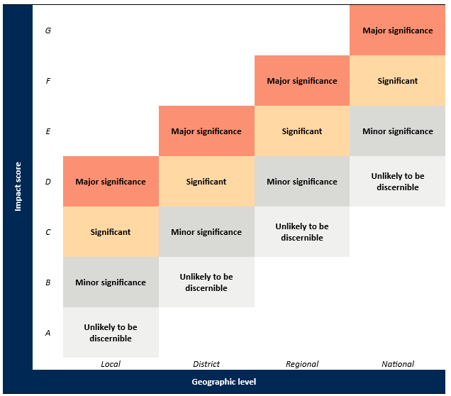
For each criterion:
- the level of impact is estimated over 4 geographic levels: local, district, regional and national
- the magnitude of impact at each of the 4 geographic levels is described using 4 categories: unlikely to be discernible, minor significance, significant and major significance
- an impact score (A–G) is assigned by determining which of the shaded cells with bold font correspond to the level and magnitude of impact.
Step 2: Combining direct and indirect impacts
The overall consequence for each pest or each group of pests is achieved by combining the impact scores (A–G) for each direct and indirect criterion using the decision rules in Table A.3. These rules are mutually exclusive, and are assessed in numerical order until one applies. For example, if the first rule does not apply, the second rule is considered, and so on.
Table A.3 Decision rules for determining the overall consequence rating for each pest
Rule | The impact scores for consequences of direct and indirect criteria | Overall consequence rating
1 | Any criterion has an impact of ‘G’; or  more than one criterion has an impact of ‘F’; or  a single criterion has an impact of ‘F’ and each remaining criterion an ‘E’. | Extreme
2 | A single criterion has an impact of ‘F’; or  all criteria have an impact of ‘E’. | High
3 | One or more criteria have an impact of ‘E’; or  all criteria have an impact of ‘D’. | Moderate
4 | One or more criteria have an impact of ‘D’; or  all criteria have an impact of ‘C’. | Low
5 | One or more criteria have an impact of ‘C’; or  all criteria have an impact of ‘B’. | Very Low
6 | One or more but not all criteria have an impact of ‘B’, and all remaining criteria have an impact of ‘A’; or  all criteria have an impact of ‘A’. | Negligible
- Estimation of the unrestricted risk
Once the assessment of the likelihood of entry, establishment and spread and for potential consequences are completed, the unrestricted risk can be determined for each pest or each group of pests. This is determined by using a risk estimation matrix (Table A.4) to combine the estimates of the likelihood of entry, establishment and spread and the overall consequences of pest establishment and spread.
When interpreting the risk estimation matrix, note the descriptors for each axis are similar (for example, Low, Moderate, High) but the vertical axis refers to likelihood and the horizontal axis refers to consequences. Accordingly, a Low likelihood combined with High consequences, is not the same as a High likelihood combined with Low consequences—the matrix is not symmetrical. For example, the former combination would give an unrestricted risk rating of Moderate, whereas the latter would give a Low rating.
Table A.4 Risk estimation matrix
Likelihood of pest entry, establishment and spread | Consequences of pest entry, establishment and spread
Likelihood of pest entry, establishment and spread | Negligible | Very Low | Low | Moderate | High | Extreme
High | Negligible risk | Very Low risk | Low risk | Moderate risk | High risk | Extreme risk
Moderate | Negligible risk | Very Low risk | Low risk | Moderate risk | High risk | Extreme risk
Low | Negligible risk | Negligible risk | Very Low risk | Low risk | Moderate risk | High risk
Very Low | Negligible risk | Negligible risk | Negligible risk | Very Low risk | Low risk | Moderate risk
Extremely Low | Negligible risk | Negligible risk | Negligible risk | Negligible risk | Very Low risk | Low risk
Negligible | Negligible risk | Negligible risk | Negligible risk | Negligible risk | Negligible risk | Very Low risk
- The appropriate level of protection (ALOP) for Australia
The SPS Agreement defines the concept of an ‘appropriate level of sanitary or phytosanitary protection (ALOP)’ as the level of protection deemed appropriate by the WTO Member establishing a sanitary or phytosanitary measure to protect human, animal or plant life or health within its territory.
Like many other countries, Australia expresses its ALOP in qualitative terms. The ALOP for Australia, which reflects community expectations through government policy, is currently expressed as providing a high level of sanitary or phytosanitary protection aimed at reducing risk to a very low level, but not to zero. The band of cells in Table A.4 marked ‘Very Low risk’ represents the ALOP for Australia.
- Adoption of outcomes from previous assessments
Outcomes of previous risk assessments have been adopted in this assessment for pests for which the risk profile is assessed as comparable to previously assessed situations.
The prospective adoption of previous risk assessment ratings for the likelihood of importation and the likelihood of distribution is considered on a case-by-case basis by comparing factors relevant to the pathway being assessed with those assessed previously. For assessment of the likelihood of importation, factors considered/compared include the commodity type, the prevalence of the pest and commercial production practices in the exporting country/region. For assessment of the likelihood of distribution of a pest the factors considered/compared include the commodity type, the ways the imported produce will be distributed within Australia as a result of the processing, sale or disposal of the imported produce, and the time of year when importation occurs and the availability and susceptibility of hosts at that time. After comparing these factors and reviewing the latest literature, previously determined ratings may be adopted if the department considers the likelihoods for the pathway being assessed to be comparable to those assigned in the previous assessment(s), and there is no new information to suggest that the ratings assigned in the previous assessment(s) have changed.
In this review, likelihood of importation is assessed for pathogens that have the potential to be associated with imported cut flowers, taking into consideration the differences in commodity type, prevalence of the pest and commercial production practices in the exporting country/region.
- In this review, likelihood of distribution is assessed for pathogens that have the potential to be associated with imported cut flowers, taking into consideration the ways the imported produce will be distributed within Australia, the occurrence (or lack of) and level (if occurred) of diversion of the intended use of the imported cut flowers to propagation in the PRA area, and the likelihood that the propagation will be successful in producing a viable and healthy plant to serve as a host.
The likelihoods of establishment and of spread of a pest species in the PRA area will be comparable between risk assessments, regardless of the import pathway through which the pest has entered the PRA area. This is because these likelihoods relate specifically to conditions and events that occur in the PRA area, and are independent of the import pathway. Similarly, the estimate of potential consequences associated with a pest species is also independent of the import pathway. Therefore, the likelihoods of establishment and of spread of a pest, and the estimate of potential consequences, are directly comparable between assessments. If there is no new information available that would significantly change the ratings for establishment or spread or the consequences the pests may cause, the ratings assigned in the previous assessments for these components may be adopted with confidence.

Appendix B: Examples of Reddit posts
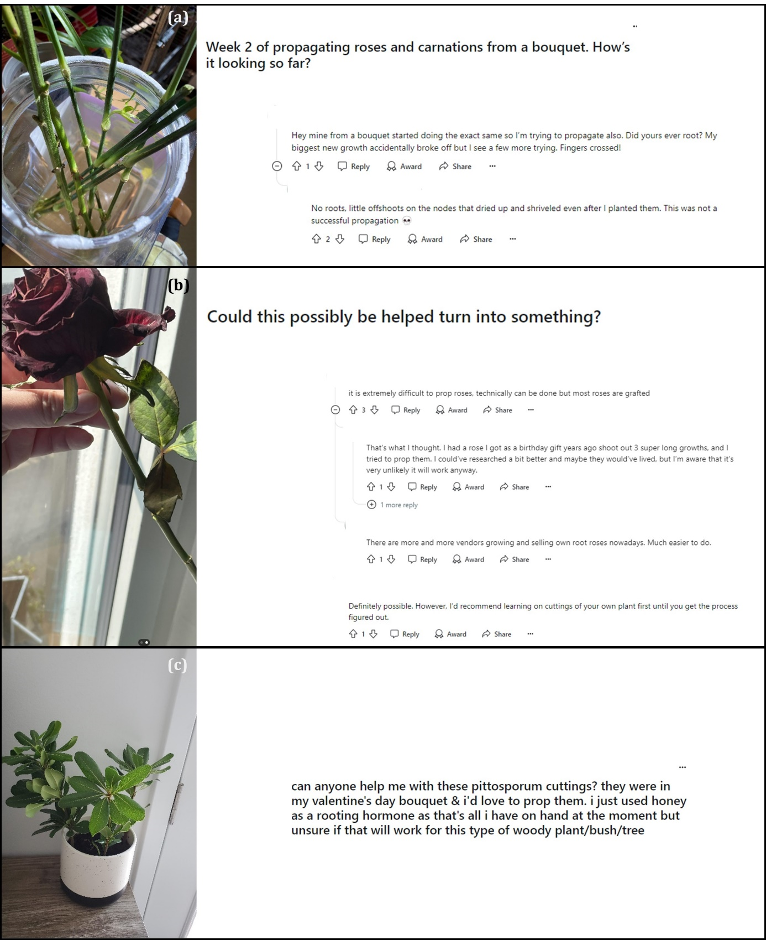

(a)
(b)
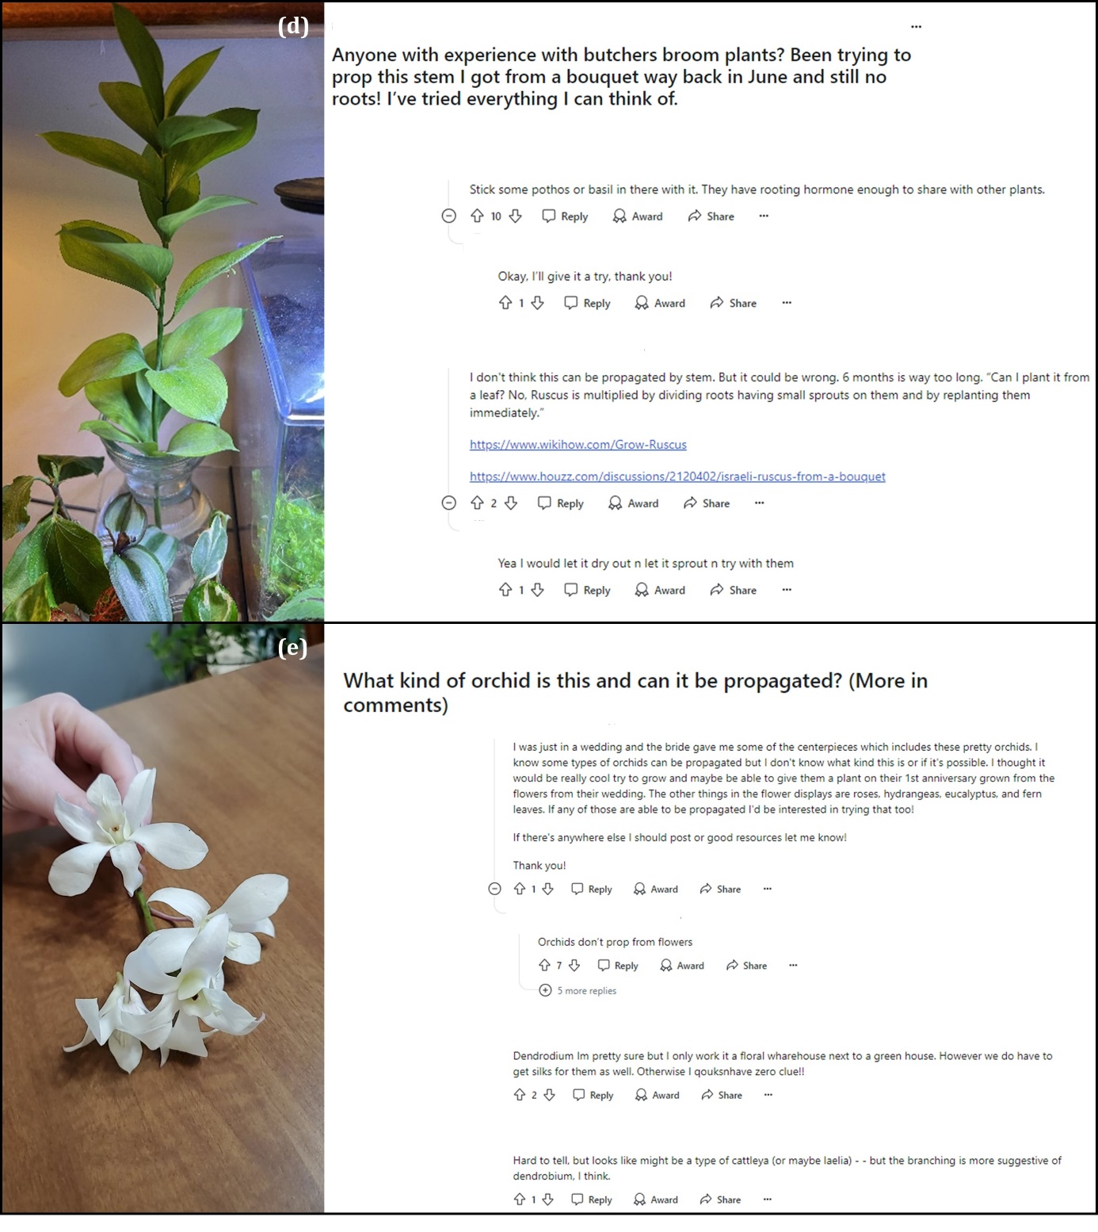

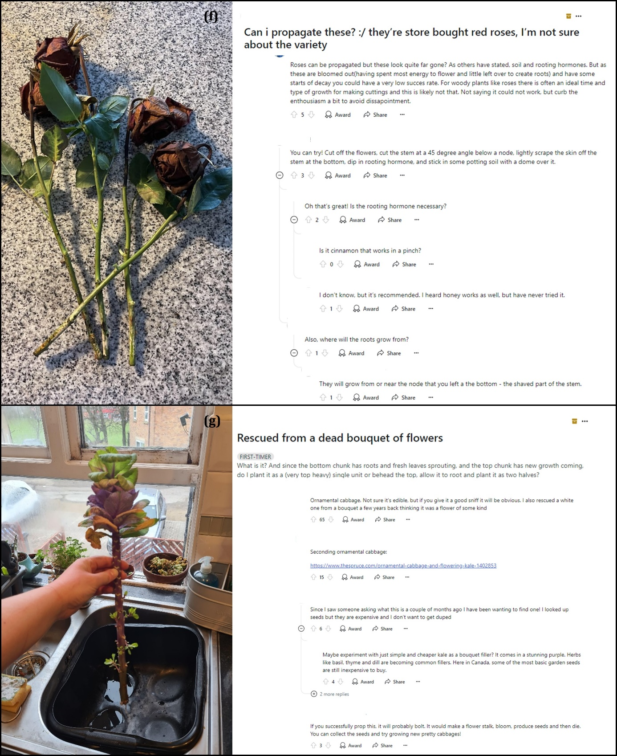
Source: (a) https://www.reddit.com/r/propagation/comments/11i23p5/week_2_of_propagating_roses_and_carnations_from_a/ (b) https://www.reddit.com/gallery/11h0ker (c)https://www.reddit.com/media?url=https%3A%2F%2Fi.redd.it%2F8scf0yg5imka1.jpg (d)https://www.reddit.com/r/propagation/comments/zudgwx/anyone_with_experience_with_butchers_broom_plants/ (e)https://www.reddit.com/r/propagation/comments/zbr6zn/what_kind_of_orchid_is_this_and_can_it_be/ (f)https://www.reddit.com/r/proplifting/comments/11gj3te/can_i_propagate_these_theyre_store_bought_red/ (g)https://www.reddit.com/gallery/110cqz3

Glossary, acronyms and abbreviations
Term or abbreviation | Definition
(the) Act | The Biosecurity Act 2015
Appropriate level of protection (ALOP) for Australia | The Biosecurity Act 2015 defines the appropriate level of protection (or ALOP) for Australia as a high level of sanitary and phytosanitary protection aimed at reducing biosecurity risks to very low, but not to zero.
Biosecurity risk | The Biosecurity Act 2015 refers to biosecurity risk as the likelihood of a disease or pest entering, establishing or spreading in Australian territory, and the potential for the disease or pest causing harm to human, animal or plant health, the environment, economic or community activities.
Consignment | A quantity of plants, plant products or other articles being moved from one country to another and covered, when required, by a single phytosanitary certificate (a consignment may be composed of one or more commodities or lots) (FAO 2022).
(the) department | (the) Department of Agriculture, Fisheries and Forestry.
Devitalisation | The application of a treatment which renders plant material incapable of propagation
Diversion from intended use (DFIU) | The practice of diversion from intended use (declared purpose for which plants, plant products, or other articles are imported, produced or used), for example, time-limited decorative purposes in the case of imported cut flowers
Establishment (of a pest) | Perpetuation, for the foreseeable future, of a pest within an area after entry (FAO 2022).
Fresh | Living; not dried, deep-frozen or otherwise conserved (FAO 2022).
Goods | The Biosecurity Act 2015 defines goods as an animal, a plant (whether moveable or not), a sample or specimen of a disease agent, a pest, mail or any other article, substance or thing (including, but not limited to, any kind of moveable property).
Imported cut flowers | (for the purpose of this report) Commercially produced fresh cut flowers and foliage without propagules (for example, bulbils, fruit and seed), imported for time-limited decorative purposes in Australia.
Import permit | Official document authorising importation of a commodity in accordance with specified phytosanitary import requirements (FAO 2022).
Inspection | Official visual examination of plants, plant products or other regulated articles to determine if pests are present or to determine compliance with phytosanitary regulations (FAO 2022).
Intended use | Declared purpose for which plants, plant products, or other articles are imported, produced or used (FAO 2022).
International Plant Protection Convention (IPPC) | The IPPC is an international plant health agreement, established in 1952, that aims to protect cultivated and wild plants by preventing the introduction and spread of pests. The IPPC provides an international framework for plant protection that includes developing International Standards for Phytosanitary Measures (ISPMs) for safeguarding plant resources.
International Standard for Phytosanitary Measures (ISPM) | An international standard adopted by the Conference of the Food and Agriculture Organization, the Interim Commission on Phytosanitary Measures or the Commission on Phytosanitary Measures, established under the IPPC (FAO 2022).
National Plant Protection Organization (NPPO) | Official service established by a government to discharge the functions specified by the IPPC (FAO 2022).
Pathogen | A biological agent that can cause disease to its host.
Pathway | Any means that allows the entry or spread of a pest (FAO 2022).
Pest | Any species, strain or biotype of plant, animal, or pathogenic agent injurious to plants or plant products (FAO 2022).
Pest risk analysis (PRA) | The process of evaluating biological or other scientific and economic evidence to determine whether an organism is a pest, whether it should be regulated, and the strength of any phytosanitary measures to be taken against it (FAO 2022).
Phytosanitary measure | Phytosanitary relates to the health of plants. Any legislation, regulation or official procedure having the purpose to prevent the introduction or spread of quarantine pests, or to limit the economic impact of regulated non-quarantine pests (FAO 2022). In this risk analysis the term ‘phytosanitary measure’ and ‘risk management measure’ may be used interchangeably.
Propagation (for plants) | The process of creating new plant(s)
Propagable | Capable of being propagated.
SPS Agreement | WTO Agreement on the Application of Sanitary and Phytosanitary Measures.
Treatment (as a phytosanitary measure) | Official procedure for killing, inactivating, removing, rendering infertile or devitalising regulated pests (FAO 2022).
Viable | Alive, able to germinate or capable of growth.

References
All web links in references were accessible and active on week of July 2025.
Aydin, V 2023, ‘Factors affecting the post-harvest quality of cut flowers’, in Advances in plant research and agriculture, Tas, A (ed), IKSAD Publishing House, Turkey.
Biosecurity Australia 2010, Final review of policy: importation of hop (Humulus species) propagative material into Australia, Department of Agriculture, Fisheries and Forestry, Canberra, Australia, available at https://www.agriculture.gov.au/biosecurity-trade/policy/risk-analysis/plant/hops.
-- -- 2011, Final review of policy: Importation of hazelnut (Corylus species) propagative material from Chile, Department of Agriculture, Fisheries and Forestry, Canberra, Australia, available at https://www.agriculture.gov.au/sites/default/files/sitecollectiondocuments/ba/plant/2011/Finalforrelease.pdf.
Borghi, M & Fernie, AR 2021, ‘From flowers to seeds: how the metabolism of flowers frames plant production’, The Biochemist, vol. 43, no. 3, pp. 14-18.
Chen, J & Stamps, RH 2006, ‘Cutting propagation of foliage plants’, in Cutting propagation: a guide to propagating and producing floriculture crops, Ball Publishing, Batavia (IL) USA.
Christiaens, A, van Huylenbroeck, J, Gobin, B & van Labeke, MC 2019, ‘Postharvest quality of ornamental cuttings evaluated by chlorophyll fluorescence’, Acta Horticulturae, vol. 1263, pp. 413-20.
Costa, JM & Van de Pol, PA 2003, ‘Propagation: own-rooted cuttings’, in Encyclopedia of rose science, Roberts, AV (ed), Elsevier.
CPVO 2025, Our mission, Community Plant Variety Office, https://cpvo.europa.eu/en/about-us/what-we-do/our-mission.
Craik, W, Palmer, D & Sheldrake, R 2017, Priorities for Australia’s biosecurity system, An independent review of the capacity of the national biosecurity system and its underpinning Intergovernmental Agreement, Department of Agriculture and Water Resources, Commonwealth of Australia, Canberra.
da Costa, LC, de Araujo, FF, Ribeiro, WS, de Sousa Santos, MN & Finger, FL 2021, ‘Postharvest physiology of cut flowers’, Ornamental Horticulture, vol. 27, no. 3, pp. 374-85.
da Silva, JAT 2006, ‘Ornamental cut flowers: physiology in practice’, in Floriculture, ornamental and plant biotechnology: advances and topical issues, da Silva, JAT (ed), Global Science Books.
DAFF 2020, ‘Importing cut flowers and foliage’, Department of Agriculture, Fisheries and Forestry, Canberra, ACT, available at https://www.agriculture.gov.au/biosecurity-trade/import/goods/plant-products/cut-flowers-foliage.
-- -- 2022a, Draft pest risk analysis for bacterial pathogens in the genus Xylella, Department of Agriculture, Fisheries and Forestry, Canberra, available at https://www.agriculture.gov.au/biosecurity-trade/policy/risk-analysis/plant/Xylella.
-- -- 2022b, Final report for the review of biosecurity import requirements for fresh apple fruit from the Pacific Northwest states of the United States of America, Department of Agriculture, Fisheries and Forestry, Canberra, available at https://www.agriculture.gov.au/biosecurity-trade/policy/risk-analysis/plant/apples-usa-2018.
Darras, A 2021, ‘Overview of the dynamic role of specialty cut flowers in the international cut flower market’, Horticulturae, vol. 7, no. 3, 51, https://doi.org/10.3390/horticulturae7030051.
DAWR 2017, Final group pest risk analysis for thrips and orthotospoviruses on fresh fruit, vegetable, cut-flower and foliage imports, Department of Agriculture and Water Resources, Canberra, available at https://www.agriculture.gov.au/biosecurity-trade/policy/risk-analysis/group-pest-risk-analyses/group-pra-thrips-orthotospoviruses/final-report.
Dubois, LAM & de Vries, DP 1991, ‘Variation in adventitious root formation of softwood cuttings of Rosa chinensis minima (Sims) Voss cultures’, Scientia Horticulturae, vol. 47, pp. 345-49.
Easy Weddings 2023, Wedding Industry Report, Issue 8, Easy Weddings, Mulgrave (Vic.) Australia.
Fanourakis, D, Pieruschka, R, Savvides, A, Macnish, AJ, Sarlikioti, V & Woltering, EJ 2013, ‘Sources of vase life variation in cut roses: a review’, Postharvest Biology and Technology, vol. 78, pp. 1-15.
FAO 2006, International Standards for Phytosanitary Measures (ISPM) no 1: Phytosanitary principles for the protection of plants and the application of phytosanitary measures in international trade, Food and Agriculture Organization of the United Nations, Rome, available at https://www.ippc.int/en/core-activities/standards-setting/ispms/.
-- -- 2016, Diversion from intended use: consideration of the extent of the issue, Secretariat of the International Plant Protection Convention, Food and Agriculture Organization of the United Nations, Rome, Italy, available at https://www.ippc.int/en/core-activities/standards-setting/ispms/.
-- -- 2019a, International Standards for Phytosanitary Measures (ISPM) no. 2: Framework for pest risk analysis, Secretariat of the International Plant Protection Convention, Food and Agriculture Organization of the United Nations, Rome, Italy, available at https://www.ippc.int/en/core-activities/standards-setting/ispms/.
-- -- 2019b, International Standards for Phytosanitary Measures (ISPM) no. 11: Pest risk analysis for quarantine pests, Secretariat of the International Plant Protection Convention, Food and Agriculture Organization (FAO) of the United Nations, Rome, Italy, available at https://www.ippc.int/en/core-activities/standards-setting/ispms/.
-- -- 2022, International Standards for Phytosanitary Measures (ISPM) no. 5: Glossary of phytosanitary terms, Secretariat of the International Plant Protection Convention, Food and Agriculture Organization of the United Nations, Rome, Italy, available at https://www.ippc.int/en/core-activities/standards-setting/ispms/.
-- -- 2024, International Standards for Phytosanitary Measures (ISPM) no. 5: Glossary of phytosanitary terms, Secretariat of the International Plant Protection Convention, Food and Agriculture Organization of the United Nations, Rome, Italy, available at https://www.ippc.int/en/core-activities/standards-setting/ispms/.
Faust, JE, Dole, JM & Lopez, RG 2016, ‘The floriculture vegetative cutting industry’, Horticultural Reviews, vol. 44, pp. 121-72.
Faust, JE, Lewis, KP & Rapaka, VK 2010, ‘Identifying the storage potential of unrooted shoot-tip cuttings of eight ornamental species’, Acta Horticulturae, vol. 877, pp. 1771-76.
Fraser Valley Rose Farm 2024, ‘Propagate roses from a bouquet’, YouTube, available at https://www.youtube.com/watch?v=imc56lhxhGQ.
Gast, KLB 1997, Postharvest and handling of fresh cut flowers and plant material, Agricultural Experiment Station and Cooperative Extension Service, Kansas State University, Manhattan, Kansas, USA.
Glady, JE, Lang, NS & Runkle, ES 2007, ‘Effects of ethephon on stock plant management of Coreopsis verticillata, Dianthus caryophyllus, and Veronica longifolia’, HortScience, vol. 42, no. 7, pp. 1616-21.
Gupta, J & Dubey, RK 2018, ‘Factors affecting post-harvest life of flower crops’, International Journal of Cuttent Microbiology and Applied Sciences, vol. 7, no. 1, pp. 548-57.
Hegarty, S, Thomson, R & Webster, E 2022, The economic impact of plant breeder's rights in Australia, IP Australia.
Hussein, HAA 2007, ‘Influence of cold storage of unrooted cuttings on some vegetative, rooting and flowering characters of Dianthus caryophyllus L. cvs.’, Journal of Plant Production, vol. 32, no. 4, pp. 2881-94.
IIGB 2015, Effectiveness of biosecurity controls for imported fresh cut flowers, Interim Inspector-General of Biosecurity, Australia.
IP Australia 2025, Plant breeder's rights, IP Australia, https://www.ipaustralia.gov.au/plant-breeders-rights.
Izadi, Z, Zarei, H & Alizadeh, M 2014, ‘Effect of time, cultivar and rootstock on success of rose propagation through stenting technique’, American Journal of Plant Sciences, vol. 5, pp. 1644-50.
Jhanji, S, Kaur, G & Chumber, M 2025, ‘Deciphering flower senescence physiology: advancements in post-harvest storage and preservation techniques for enhancing longevity’, The Journal of Horticultural Science and Biotechnology, vol. 100, no. 2, pp. 164-95.
Jones, R 1959, Caring for cut flowers, 2nd edn, Landlinks, Australia.
Justamante, MS, Acosta-Motos, JR, Cano, A, Villanova, J, Birlanga, V, Albacete, A, Cano, EA, Acosta, M & Pérez-Pérez, JM 2019, ‘Integration of phenotype and hormone data during adventitious rooting in carnation (Dianthus caryophyllus L.) stem cuttings’, Plants, vol. 8, 226, DOI 10.3390/plants8070226.
Khan, MA 1983, ‘Preservation of scion wood of Rosa’, Scientia Horticulturae, vol. 2, no. 3, pp. 261-66.
Kim, S, Abinaya, M, Park, YG & Jeong, BR 2018, ‘Physiological and biochemical modulations upon root induction in rose cuttings as affected by growing medium’, Horticultural Plant Journal, vol. 4, no. 6, pp. 257-64.
Kondo, M, Nakajima, T, Shibuya, K & Ichimura, K 2020, ‘Comparison of petal senescence between cut and intact carnation flowers using potted plants’, Scientia Horticulturae, vol. 272, 109564, https://doi.org/10.1016/j.scienta.2020.109564.
Kostecka, J, Pieczonka, A, Mazur-Pączka, A, Garczyńska, M, Pączka, G, Szura, R & Butt, KR 2024, ‘Waste from cemetery adornment of graves - management and minimization’, Journal of Ecological Engineering, vol. 25, no. 4, pp. 80-95.
Larson, RA 1980, Introduction to floriculture, Academic Press, New York (NY) USA.
Leakey, RRB 2004, ‘Physiology of vegetative reproduction’, in Encyclopedia of forest sciences, Burley, J, Evans, J & Youngquist, JA (eds), Academic Press, London, UK.
Leakey, RRB, Newton, AC & Dick, JM 1994, ‘Capture of genetic variation by vegetative propagation: processes determining success’, Tropical trees: the potential for domestication and the rebuilding of forest resources, HMSO, London, pp. 72-83.
Leatherwood, WR 2008, ‘Managing the postharvest physiology of unrooted cuttings to enhance shipping and postharvest quality’, Phd Dissertation, North Carolina State University.
Liu, Z, Luo, Y & Liao, W 2024, ‘Postharvest physiology of fresh-cut flowers’, in Oxygen, nitrogen and sulfur species in post-harvest physiology of horticultural crops, Ziogas, V & Corpas, FJ (eds), Academic Press.
Luna, T 2009, ‘Vegetative propagation’, in Nursery manual for native plants: a guide for tribal nurseries, Dumroese, RK, Luna, T & Landis, TD (eds), United States Department of Agriculture, Forest Service, Washington DC, USA.
Marcelis-van Acker, CAM 1994, ‘Axillary bud development in rose’, PhD Thesis, Wageningen Agricultural University.
Medvedev, AN, Lambiotte, R & Delvenne, JC 2017, ‘The anatomy of Reddit: an overview of academic research’, paper presented at Dynamics on and of Complex Networks III, IN, USA.
Momin, KCH, Dhiman, SR, Gupta, YC, Bharadwaj, SK & Kumar, S 2015, ‘Nutrient management for cutting production in carnation (Dianthus caryophyllus)’, Indian Journal of Agricultural Sciences, vol. 85, no. 4, pp. 509-14.
Nairn, ME, Allen, PG, Inglis, AR & Tanner, C 1996, Australian quarantine: a shared responsibility, Department of Primary Industries and Energy, Commonwealth of Australia, Canberra.
Nazari, F, Khosh-Khui, M & Salehi, H 2009, ‘Growth and flower quality of four Rosa hybrida L. cultivars in response to propagation by stenting or cutting in soilless culture’, Scientia Horticulturae, vol. 119, pp. 302-05.
Nguyen, THN, Winkelmann, T & Debener, T 2020, ‘Genetic analysis of callus formation in a diversity panel of 96 rose genotypes’, Plant Cell, Tissue and Organ Culture (PCTOC), vol. 142, no. 3, pp. 505-17.
Otiende, MA, Fricke, K, Nyabundi, JO, Ngamau, K, Hajirezaei, MR & Druege, U 2021, ‘Involvement of the auxin–cytokinin homeostasis in adventitious root formation of rose cuttings as affected by their nodal position in the stock plant’, Planta, vol. 254, no. 65, https://doi.org/10.1007/s00425-021-03709-x.
Owen, JS, Jr & Maynard, BK 2007, ‘Environmental effects on stem-cutting propagation: a brief review’, Combined Proceedings International Plant Propagators' Society, vol. 57, pp. 558-64.
Ranwala, AP & Miller, WB 2009, ‘Comparison of the dynamics of non-structural carbohydrate pools in cut tulip stems supplied with sucrose or trehalose’, Postharvest Biology and Technology, vol. 52, no. 1, pp. 91-96.
Similarweb 2025, ‘reddit.com Traffic Analytics, Ranking & Audience’, Similarweb LTD, New York, NY, available at https://www.similarweb.com/website/reddit.com/#overview.
Smith, L 2022, ‘French stamp on Tasmanian rose production paying dividends in cut flower market’, ABC News, 14 November 2025, available at https://www.abc.net.au/news/rural/2022-11-14/growing-french-bred-roses-in-tasmania/101629530, accessed 22 April 2025.
Stark, CH & Moot, DJ 2022, ‘Are the devitalisation requirements for imported cut flowers and foliage fit for purpose?’, New Zealand Journal of Crop and Horticultural Science, vol. 50, https://doi.org/10.1080/01140671.2022.2150235.
Susaj, E, Nikolla, M, Bekolli, A, Vuksani, G, Gashi, A & Susaj, L 2020, ‘Influence of shoots type and light intensity on carnation seedlings production’, Baltica, vol. 33, no. 1, pp. 91-100.
Thomson, S 2009, ‘Rose Rustling’, Gardening Australia, 25 July 2009, available at https://www.abc.net.au/gardening/how-to/rose-rustling/9430144, accessed 17 April 2025.
Verdonk, JC, van Ieperen, W, Carvalho, DRA, van Geest, G & Schouten, RE 2023, ‘Effect of preharvest conditions on cut-flower quality’, Frontiers in Plant Science, vol. 14, 1281456, DOI 10.3389/fpls.2023.1281456.
Verma, J & Singh, P 2021, ‘Post-harvest handling and senescence in flower crops: an overview’, Agricultural Reviews, vol. 42, no. 2, pp. 145-55.
WTO 1995, Agreement on the application of sanitary and phytosanitary measures, World Trade Organization, Geneva, available at https://www.wto.org/english/docs_e/legal_e/15-sps.pdf (pdf 91 kb).
Yue, C & Hall, C 2010, ‘Traditional or specialty cut flowers? Estimating U.S. consumers’ choice of cut flowers at noncalendar occasions’, HortScience, vol. 45, no. 3, pp. 382-86.
Zheng, L, Xiao, Z & Song, W 2020, ‘Effects of substrate and exogenous auxin on the adventitious rooting of Dianthus caryophyllus L.’, HortScience, vol. 55, no. 2, pp. 170-73.

