Postcode Classifications Map help card
Purpose
The Postcode Classifications Map allows users to identify ports of discharge, approved arrangements, and postcode delivery classification information.

Navigating the map
Using the search function, either a view of a specific port of discharge (POD) can be selected or an exact address, suburb, or postcode can be used:
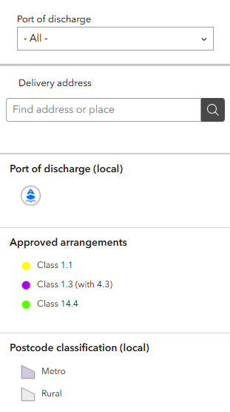
- Use the port of discharge drop-down box to select the relevant port. The map will automatically refocus on the selected location.
- To search using a delivery address, begin typing the address into the search field. As you type, suggested addresses will appear. Select the correct address from the list to add a location pin to the map.
Note: you can use the map with either option stated above, both options or by zooming and panning to a desired location.

Legend
- Port of discharge
This map displays only relevant ports of discharge with at least one Approved Arrangement (AA) Class 1.1 or Class 1.3/4.3 authorised to undertake rural tailgate (RTG) and rural transit inspections.
- Approved Arrangement locations
AA locations on the map are indicative only and are intended to assist brokers and industry in identifying potential locations for RTG or rural transit inspections, where required.
- Postcode classification
The purple areas surrounding each identified port represents the designated metropolitan postcodes and suburbs. All other areas not shown in purple are classified as rural.

Understanding map results
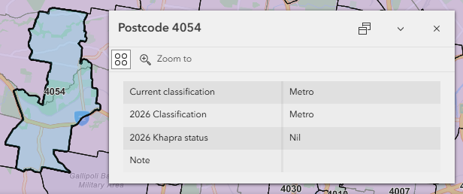
- Selecting a postcode will display information including the current classification, reclassification, khapra status, and other important notes where applicable. Postcode selections display classification status, reclassification information, khapra status and other applicable notes.

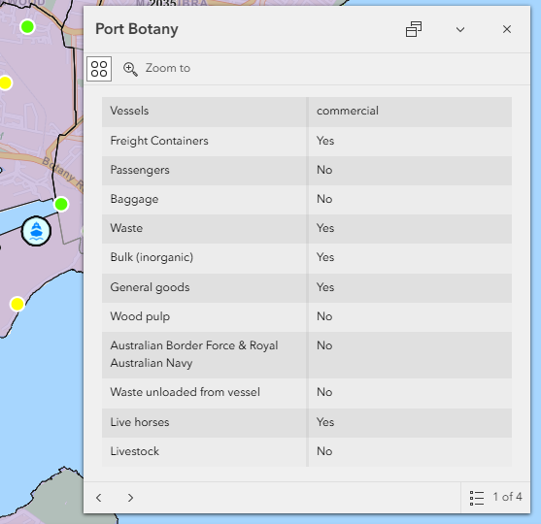
- Selecting a port icon will display the types of permitted vessels and goods for that location. Port icons display permitted vessel and goods information.

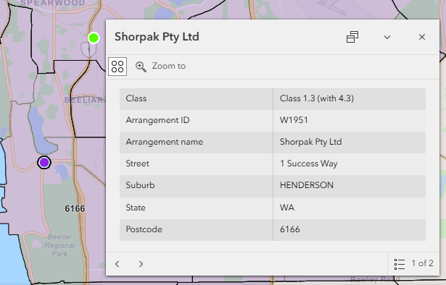
- Selecting an AA icon will display approved classes, arrangement ID, and address information. AA icons display approved classes, arrangement ID and address details.

Note: Use the arrow icons < > on the popup box to navigate between pages (if applicable).

Container movement
- POD to metro address within the same POD region: no rural tailgate or rural transit inspection required:
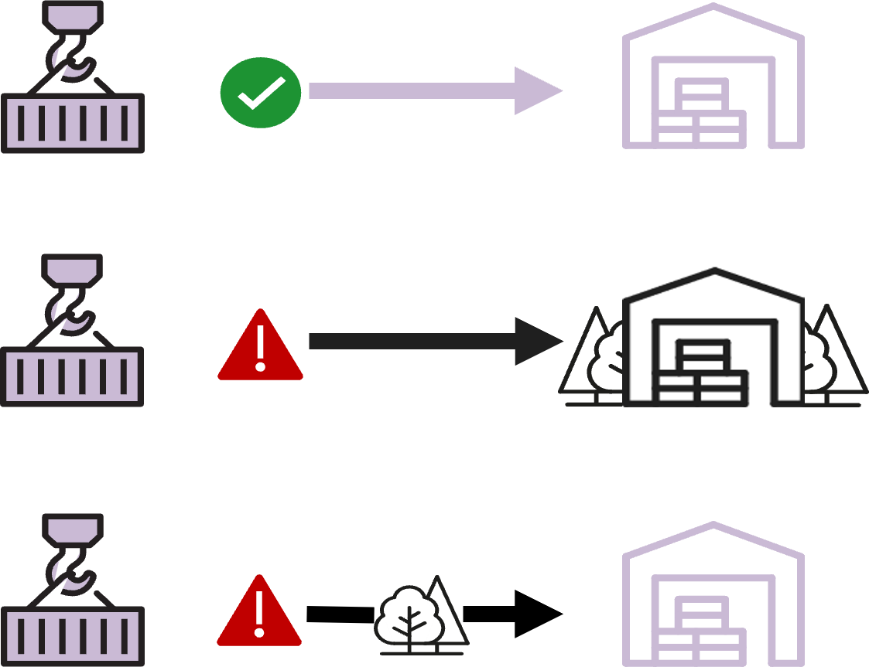

- POD to rural address: rural tailgate inspection required and any relevant khapra measures apply:

- POD to metro address outside the POD region: rural transit inspection required:

Rural tailgate inspection: internal and external five-sided container inspection.
Rural transit inspection: external-only five-sided container inspection.

More information
Learn more about:
Postcode delivery classifications
Approved arrangements
First points of entry – information for arriving vessels and goods
Email postcode.classifications@aff.gov.au

