February 2024
Modernising the agricultural levies legislation

1.1 Overview

About the agricultural levy system
The agricultural levy system is a long-standing partnership between industry and government to fund industry priorities. Levies and charges (levies) are collected from farmers, producers, processors and exporters by government at industry's request. It is industry who leads on whether to establish a levy, setting levy rates and exemptions, and whether to discontinue a levy.
In 2021–22, around $600 million in levies was raised to support the following activities for participating primary industries:
- research and development
- marketing
- biosecurity activities
- biosecurity responses
- national residue testing.
In 2021–22, the Australian Government also contributed more than $370 million for industry research and development through matching payments for eligible expenditure up to specified limits.
The current agricultural levy system has been in place since 1989 and has grown over time as industries have chosen to establish statutory levies on more commodities. This industry-led arrangement supports industry to maintain and increase its productivity, efficiency, market access and competitiveness.

Proposed agricultural levies framework
Modernising the agricultural levies legislation is an opportunity to maintain the industry driven agricultural levy system while making improvements to the legislation that supports it.
Over time, the legislation has become complex, duplicative, and inconsistent. There are more than 50 pieces of legislation governing over 110 levies across over 75 commodities and 18 levy recipient bodies (15 research and development corporations, Animal Health Australia, Plant Health Australia, and the National Residue Survey (within the department)). There are also some redundant and out of date provisions.
A review of the legislation found it serves the objectives of the levy system and is necessary for a successful industry-government arrangement. Despite this, the review found it is ineffective in meeting industries’ needs now and into the future.
The draft agricultural levies legislation proposes to:
- make it easier for industry to understand, administer, establish and amend levies
- enable levies to apply to some agricultural services
- standardise and simplify the disbursement of levy funds
- reduce complexity and inconsistency of matching funding arrangements for research and development corporations
- reduce the number of Acts and regulations stakeholders need to read to understand their levies and their obligations
- provide greater flexibility in managing compliance, and allow for a more proportionate response to non-compliance.

Structure of the proposed legislative framework
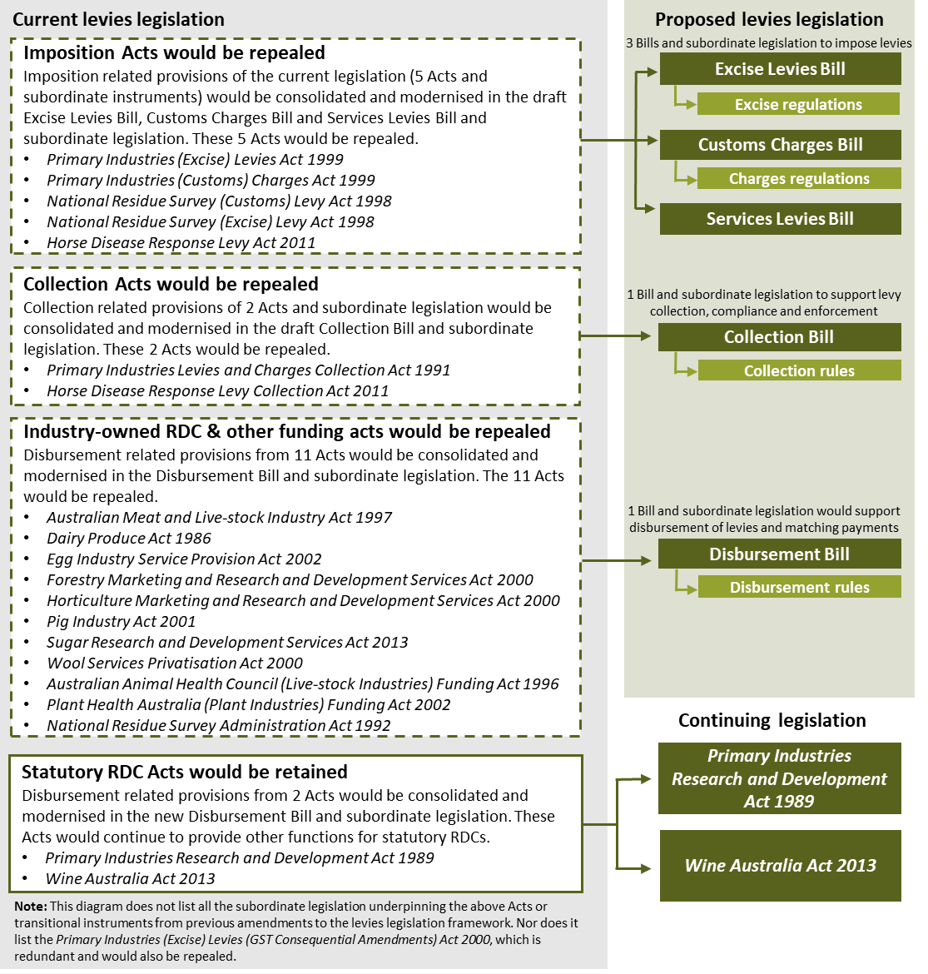

Proposed changes
The draft legislation would condense over 50 pieces of legislation down to 5 Bills and subordinate legislation to create the new structure. These Bills would provide a solid foundation for the agricultural levy system to grow and respond to opportunities and challenges into the future. Following public consultation in May to June 2023, the 5 draft Bills were introduced to Parliament in October 2023. A sixth Bill was also introduced to support the consequential and transitional arrangements for the new legislative structure.
Examples of improvements made through the Bills include the introduction of modern compliance arrangements that are flexible and have more proportionate enforcement measures, and changes to matching funding arrangements that will provide research and development corporations with more certainty about their funding limits.
The department is now seeking your feedback on the regulations and rules that will sit under the Bills and contain the operational details for all levies. The proposed regulations and rules will:
- help to streamline and modernise the agricultural levies legislation
- make it easier to understand and administer levies
- use clearer language, common terms and improve consistency across all levies and industries
- bring all operational details for each levy into as few places as possible
- state who must pay and collect levies and which organisations receive the levy funds
- streamline payment dates and simplify requirements for returns and record-keeping.

Existing features
The key features of the draft new legislative framework would remain the same.
Levy settings would continue to be industry owned and led. The draft legislation would not change individual levy settings, as these are industry led. There would also be no change to the levy proposal process. Visit the department’s website for details on how to amend a levy or charge.
The existing 18 levy recipient bodies would continue in their roles to invest levies and charges for the benefit of relevant industries for the purpose of research and development, marketing, biosecurity activities, biosecurity responses and/or residue testing.
The government remains committed to the agricultural levy system and to providing matching payments for eligible research and development expenditure up to specified limits.

Proposed timeline
We are working towards key features of the proposed new legislative framework being in place by early 2025, subject to passage through Parliament, as well as consideration by the Governor-General in Council and other instrument makers. Further details about progress will be available on the department’s website.

Have your say
Please consider the content of the draft regulations and rules, and provide your feedback via the Have Your Say page survey. For more information on the draft legislation, please consult the other fact sheets available on the Have Your Say page.
Submit your feedback by AEST 5pm 23 April 2024.

More information
Learn more about modernising agricultural levies legislation.
Email leviestaskforce@aff.gov.au

Acknowledgement of Country
We acknowledge the Traditional Custodians of Australia and their continuing connection to land and sea, waters, environment and community. We pay our respects to the Traditional Custodians of the lands we live and work on, their culture, and their Elders past and present.
© Commonwealth of Australia 2024
Unless otherwise noted, copyright (and any other intellectual property rights) in this publication is owned by the Commonwealth of Australia (referred to as the Commonwealth).
All material in this publication is licensed under a Creative Commons Attribution 4.0 International Licence except content supplied by third parties, logos and the Commonwealth Coat of Arms.
The Australian Government acting through the Department of Agriculture, Fisheries and Forestry has exercised due care and skill in preparing and compiling the information and data in this publication. Notwithstanding, the Department of Agriculture, Fisheries and Forestry, its employees and advisers disclaim all liability, including liability for negligence and for any loss, damage, injury, expense or cost incurred by any person as a result of accessing, using or relying on any of the information or data in this publication to the maximum extent permitted by law.

