Slide #1
Australian biosecurity Webinar
Budget 2023-24: Sustainable funding for a strong biosecurity system
1 June 2023
Slide #2
Speaker
Josephine Laduzko
A/g First Assistant Secretary,
Biosecurity Funding Sustainability Division
Have Your Say - haveyoursay.agriculture.gov.au/sustainable-biosecurity-funding
Slide #3
Budget 2023-2024
But with biosecurity threats increasing by the day, we cannot afford to be complacent.
And we cannot afford to leave our biosecurity operations hostage to uncertain, unpredictable funding
This Budget includes ongoing, long-term funding for biosecurity, and a fairer way to share the cost of the biosecurity system
There will always be a place for surge funding if a serious biosecurity outbreak were to occur.
But higher and more predictable base funding will enable longer-term planning
Minister Watt, Croplife Post Budget Speech 2023
Slide #4
What was announced?
Long-term, sustainable funding to strengthen Australia’s biosecurity system. ​
$1.03b over four years and $267m per year from 2027-28
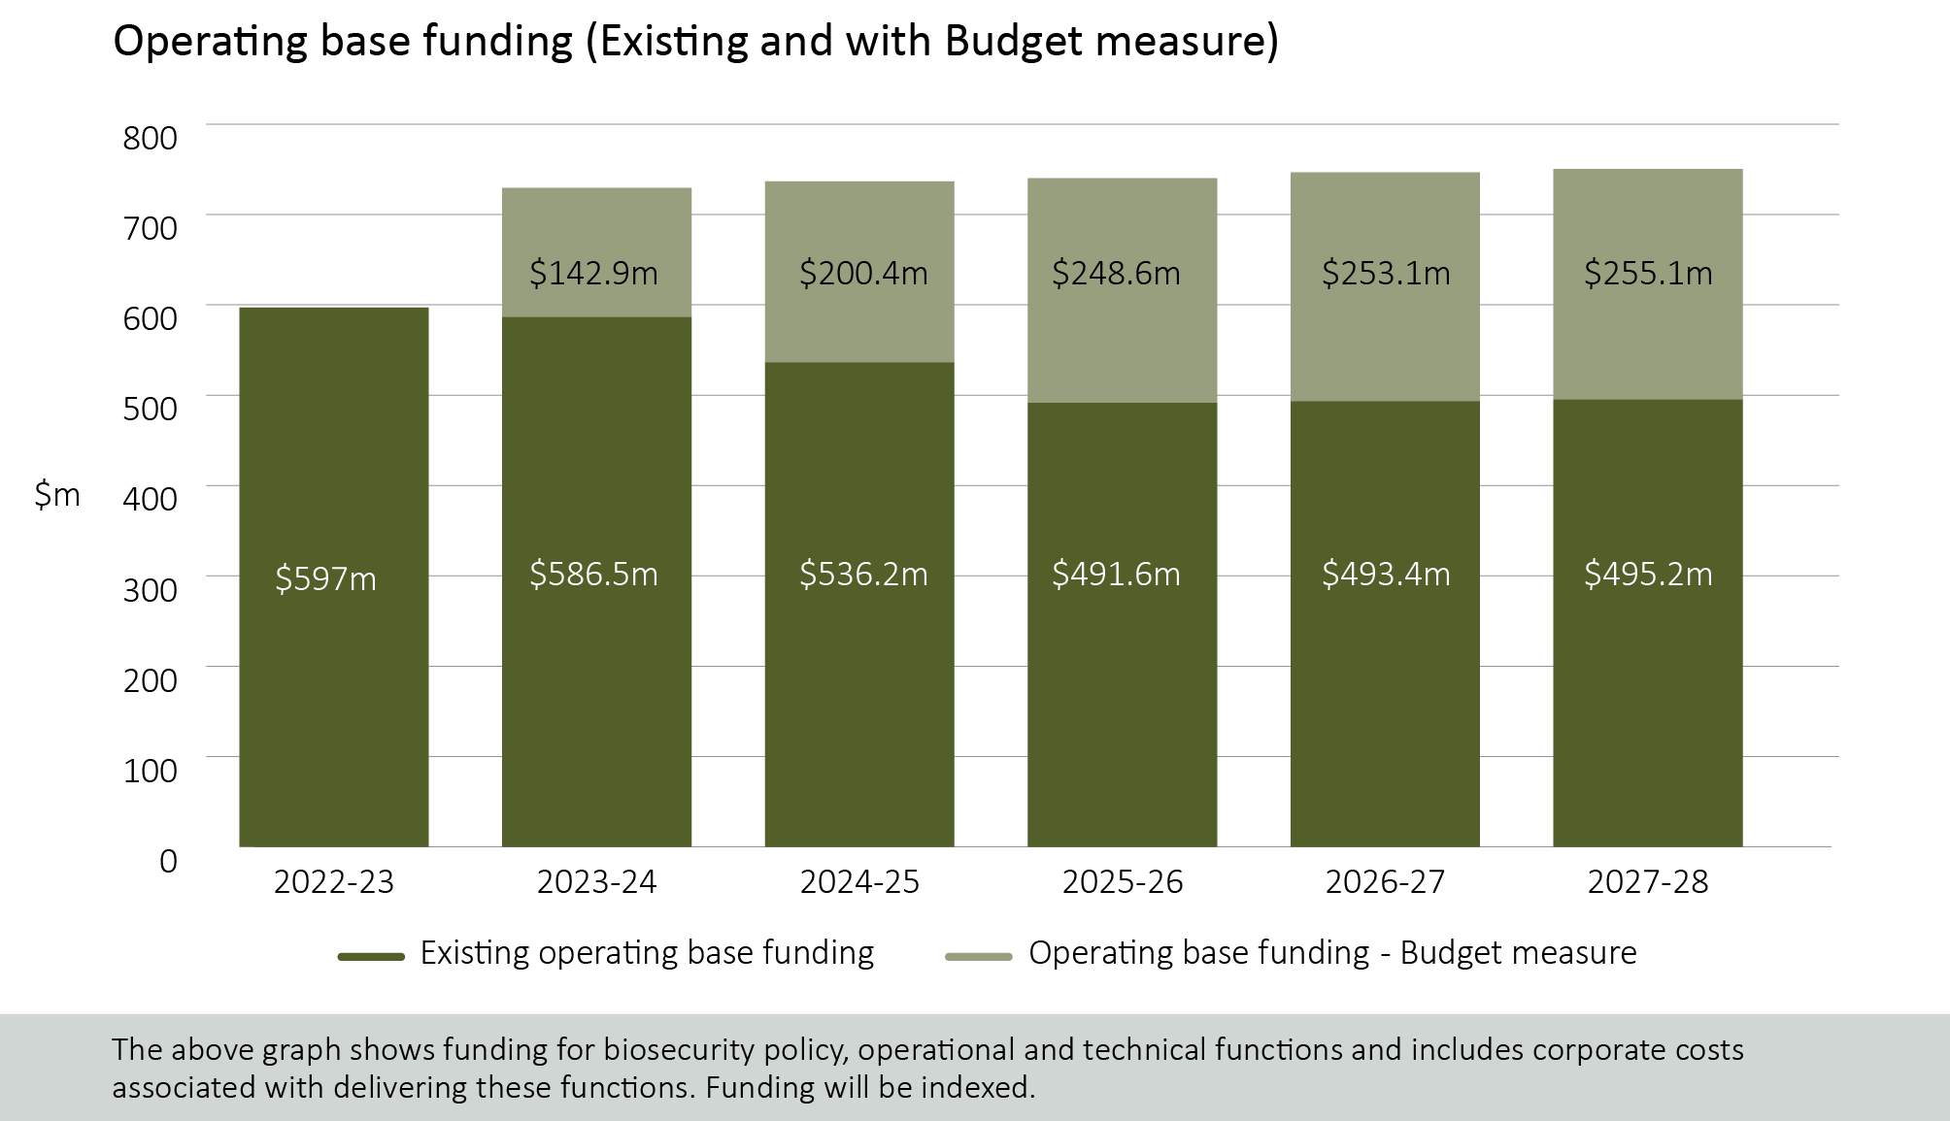

- $845m over 4 years (and then $255m p.a.) for core biosecurity effort by the department (policy, technical, operational) aimed at preventing pests and diseases entering Australia
  - $40.6m over the next 4 years and $12m ongoing to maintain the Indigenous Rangers Biosecurity Program - a key protection in relation to our northern border
  - $145m over the next 3 years for modern, digital systems in our cargo pathway (STEPS program) – delivering safer and more efficient clearance effort

Slide #5
Mixed Funding Model
We have come to the view that funding biosecurity is also a shared responsibility - between taxpayers, those who create risk and those who receive significant benefits from the biosecurity system.
We decided a mixed funding model was the fairest approach and that’s why the cost of our sustainable biosecurity funding measures will be shared, with taxpayers, importers, international travellers and producers all contributing.
Minister Watt, Croplife Post Budget Speech 2023
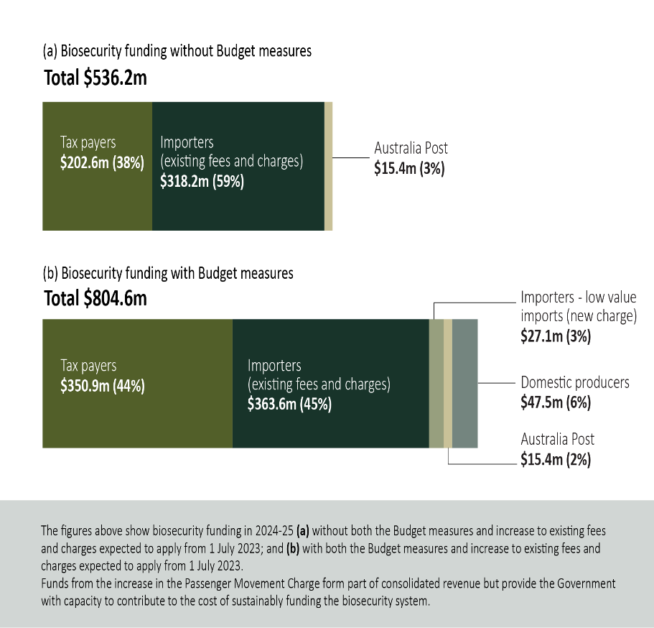

Slide #6
Import cost recovery arrangements
Existing fees and charges are to increase from 1 July 2023, following a comprehensive review of our cost base and drivers – complementing the budget measure.
- Critical to ensuring funding for current regulatory activity
- Estimated revenue collected in 2024-25 will be $363m.
Government has agreed to a new industry cost recovery arrangement in relation to imported low value items ($1,000 or less)
- Commencing from 1 July 2024
- To recover regulatory costs associated with clearance of these items – around $27m p.a.
- Estimated number of low value items entering Australia suggests around 40c per item
- Collected by international freight carriers and remitted (in arrears) to the department
- Industry to be consulted on implementation arrangements
Committed to annual reviews of these cost recovery arrangements

Slide #7
Biosecurity Protection Levy
Government has agreed to introduce a new biosecurity protection levy to apply to primary producers
- from 1 July 2024
- to recover around $50m per annum
- to be set, on a per commodity basis, at a rate broadly equivalent to 10% of 2020-21 agricultural levies or, where these are not in place, an equivalent outcome
- design details to be finalised following industry engagement
- a formal legislative review requirement will be put in place
Things to note:
- This is a new levy to be established though separate regulation.
  - It will not be implemented by changing current industry-led agricultural levy rates
  - It does not affect the modernising agriculture levies legislation consultation process
- But as we want to minimise administrative costs to producers (agents) and government, we will look to common approaches where that makes sense
- This is a complex space – we will need to work through the detail with industry
- This levy is intended to apply whether or not a producer currently pays ‘statutory’ ag levies
- It is not a 'cost recovery' charge.

Slide #8
Biosecurity Protection Levy (examples)
Based on levy rates as at 1 July 2020*, the biosecurity protection levy would mean:
- A cattle (grass fed) producer: 50 cents per head (cattle and livestock (producers) charge)
- A cotton producer: 22.5 cents per 227 kg bale (cotton levy)
- An egg producer: 3.25 cents per chick (eggs (promotion) levy)
- A honey producer: less than 0.5 cents per kg (honey levy)
- A domestic apple producer: or less than 0.19 cents per kg (apple levy)
- A forest grower, for plantation logs (exotic softwood): 1.05 cents per cubic metre of the log (forest growers levy)
- A forest grower, for other logs: 0.5 cents per cubic metre of the log (forest growers levy)
- A prawn farmer: less than 0.67 cents per kg of whole farmed prawns (farmed prawns levy)
*Note that some levy rates have changed since 1 July 2020.

Slide #9
There is more to be done
- Consideration of other costs incurred at the border (International mail gateway, military)
- A structural review (with industry) to consider future reforms to our border charging models to ensure they are fit for purpose
  - This will include consideration of import or container levy options
- Establishing arrangements that deliver on the government’s request for greater system transparency and accountability
- Ongoing work with industry to deliver business practices that drive safe and efficient import clearance; along with efforts with overseas countries, states and territories, producers on prevention and preparedness
- Taking forward the National Biosecurity Strategy
“So going forward, funding for biosecurity will be delivered with more transparency and public accountability than ever before. I will be setting up robust, accountable and transparent governance around biosecurity funding and outcomes. We will report annually to show where biosecurity funding is coming from and how it is being spent. But we also want to see real improvement for those extra dollars.”
Minister Watt
Slide #10
Next steps
  - We are currently planning our stakeholder engagement for the low value goods cost recovery arrangement and the Biosecurity Protection Levy – starting next month
  - Let us know if you wish to be involved in either: SecretariatBSF@aff.gov.au
- Information on next steps will be posted to:
haveyoursay.agriculture.gov.au/sustainable-biosecurity-funding
Slide #11
Questions?
Please submit questions using the Q and A function at the bottom of your screen
Slide #12
Thank you for attending
Biosecurity Funding Sustainability Taskforce
SecretariatBSF@aff.gov.au
Have Your Say - answers to questions will be posted on the Have Your Say site

