March 2026
Evidence Platform
Issues Paper




Acknowledgement of Country
The Authority recognises the First Nations people of this land and their ongoing connection to culture and Country. We acknowledge First Nations people as the Traditional Owners, Custodians and Lore Keepers of the world’s oldest living cultures, and pay our respects to their Elders.

About issues papers from the CCA
The Climate Change Authority (the Authority) provides independent, expert advice to the Australian Government and Parliament on the response to climate change. Advising how to speed up Australia’s journey towards a prosperous, resilient, net zero future is one of our key responsibilities.
We strive for best practice community consultation, including to capture the views and concerns of Australians whose voices and experiences are not always heard. We see consultation as an opportunity to drive positive change in Australia’s response to climate change by making sure different perspectives are included in preparing our advice.

We want to hear from you
We welcome submissions responding to the questions in this paper. You can answer as many or as few of these questions as you wish, and raise other matters of concern to you. You can refer us to relevant submissions you have made to other consultation processes, or any related research and data.
You can make a submission through our Consultation Hub until 11.00pm Thursday 30 April 2026.

Contacts
For more information about making a submission, please contact the Authority on free call 1800 475 869 or via email at consultation@cca.gov.au.

Introduction

What is the Evidence Platform
We are developing an Evidence Platform to monitor Australia’s progress towards a prosperous, resilient, net zero future. It will provide an effective, replicable approach to measuring progress and tracking early indicators of change, using reliable data sources to support year‑on‑year comparability.
Over time, the Platform will provide a balanced picture of Australia’s transition. In 2026, we’re focusing on building the methodology and piloting a small set of outcomes, metrics and benchmarks selected for their impact, urgency and feasibility.
Our work is at an early stage – with development of the emissions reduction elements more advanced, and the green growth, adaptation and enabling elements still a work in progress. However all elements are crucial to a prosperous, resilient, net zero future. We are consulting on the Platform now because:
- we want to track measures that are meaningful to – and actionable by – governments, communities, businesses and investors involved in climate action
- we want early stakeholder input to inform the initial set of outcomes, metrics, benchmarks and data sources, and how we stage development of additional measures in future years
- we think early input will help us build an enduring framework that we can efficiently replicate in future.
The Platform will help the Authority detect challenges to the transition early – enabling timely advice and action to keep Australia on track. It will be a key input to our Annual Progress Advice.
We plan to consult further on the Platform in mid-2026, along with other aspects of our 2026 Annual Progress Advice.

Purpose of the Evidence Platform
The Platform will show us what is on track and where further investigation and action is needed. For example, it will show whether crucial low emission technologies are being deployed at a scale and pace aligned to our medium and long term emission targets; and whether households and communities are improving their resilience to a warming climate. This will inform our advice to the Australian Government – published in our Annual Progress Advice – on meeting climate‑related plans and targets over the next decade and beyond (Figure 1).
The Platform will align with the following 4 principles.

Outcomes focus
Clear progress-tracking helps us move from climate commitments to delivery, directing policy focus, coordination and resources towards areas that will have the greatest impact.

Whole-of-economy view
The Platform’s whole-of-economy view will help uncover systemic risks and interdependencies that may not be noticed within sectors, programs or portfolios.

Trusted evidence base
A clear, trusted evidence base for government and the public is essential in a complex and contested policy space like climate change. The Platform will support a national conversation grounded in consistent, accessible and verifiable information. It will also highlight areas of uncertainty where further evidence or analysis is needed.

Market transparency
Strong progress-tracking also matters for the broader economy. Companies, investors and innovators look for clear signals on the pace and direction of Australia’s transition to reduce uncertainty and guide how they spend capital. Making Australia’s progress more visible reinforces policy objectives by fast-tracking investment.

Strategic context
In 2025, Australia adopted a 2035 national emissions reduction target, supported by the Net Zero Plan and 6 sector plans. The Australian Government also released Australia’s first National Climate Risk Assessment (NCRA) and its response to managing these risks, the National Adaptation Plan (NAP). Through the Future Made in Australia plan, the Government has committed $22.7 billion over a decade to strengthen competitiveness and seize economic opportunities as the world rewires global energy and industrial systems. These targets and plans aim to better prepare Australian society and the economy to prosper as the world responds to climate change. The commitments also give us a basis to track progress and identify early warning signs where progress is at risk.
The Platform exists within a well-established institutional ecosystem that spans frameworks and reports including the Authority’s Sector Pathways Review and 2035 Targets Advice, Treasury’s Measuring What Matters Framework, and the Department of Climate Change, Energy, the Environment and Water’s (DCCEEW) National Inventory Report and annual Emissions Projections (Figure 1).
Figure 1: How the Evidence Platform will add value in the broader institutional ecosystem
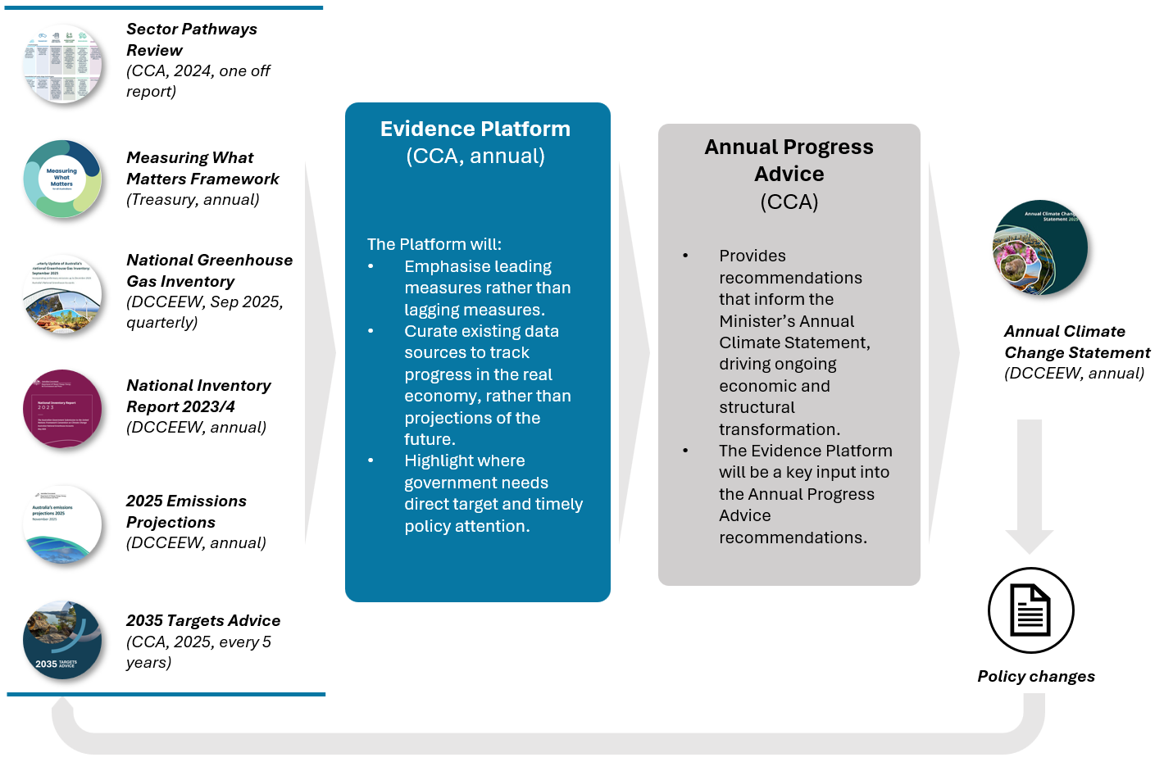

The Evidence Platform will also sit in a broader international landscape of initiatives monitoring countries’ progress towards climate targets. Organisations such as the UK Climate Change Committee and Net Zero Australia have shared insights from their experience with monitoring progress. We drew on their insights in developing our approach. For the Platform, we are combining best-practice elements and adapting them to the Australian context.
This Issues Paper is structured in 3 parts:
PART | DESCRIPTION
1. Introduction | - Explains the purpose and strategic context of the proposed Evidence Platform.
2. Evidence Platform methodology and framework | - Describes the design principles guiding our approach.  - Outlines the current state of domestic and international progress-tracking approaches considered for our Platform.  - Explains the conceptual framework underpinning the Platform, and the continuous improvement cycle we will use to expand and update it.
3. Proposed outcomes and metrics | - Gives an overview of each domain outlining what it covers, why it was chosen, and the proposed metrics and benchmarks

Evidence Platform methodology and framework

Design principles
Five design principles have guided the development of the Platform to date (Figure 2). These principles drive how we will monitor early signs of change and update our approach over time as information and better practices evolve. Both leading and lagging indicators are useful, and the Authority will use both to inform its Annual Progress Advice.
- Leading indicators signal future impacts, based on something known today. For example, “Announced coal-fired power plant closures” is a leading indicator of future electricity sector emissions.
- Lagging indicators show the effects of what has already been done (or not done) and help identify what further policies, investments or other changes are needed. An example of a lagging indicator is reported emissions.
These principles also make sure the Platform is practical, transparent, and able to evolve as Australia's climate policies, responses and data change.
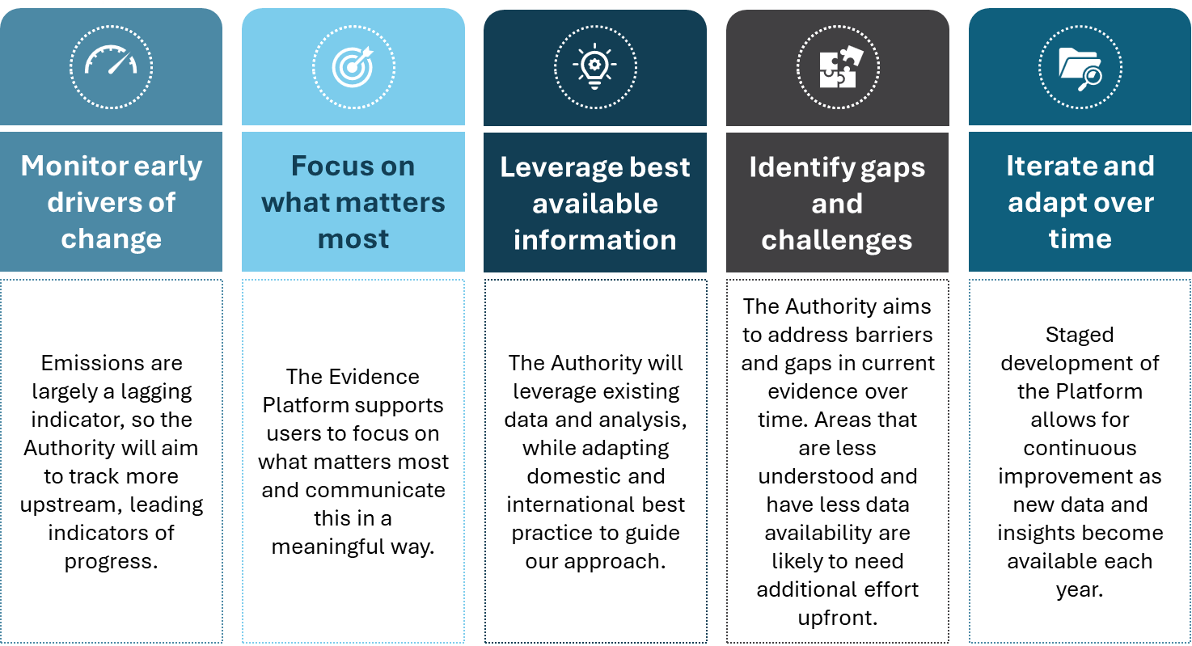
Figure 2: Design principles guiding the Authority’s Evidence Platform

Current state analysis
In designing the Platform, we looked at a range of domestic and international approaches to monitor climate policy progress. Our review included:
- International approaches like the UK Climate Change Committee’s Mitigation Monitoring Framework, Sweden’s Panorama platform, Systems Change Lab, and the Climate Action Tracker.
- State and territory initiatives including the NSW Net Zero Commission’s Annual Report and the Victorian Adaptation Monitoring and Evaluation Framework.
- Non-government efforts such as the Net Zero Australia’s Progress to Net Zero by 2050 report.
Our analysis found common elements, like the importance of transparency, clear logic between outcomes and metrics, and standardised taxonomies. We are applying these insights to ensure the Platform is accurate and has policy relevance. The Platform and our analysis will complement existing domestic reports.

Conceptual framework for the Evidence Platform

Domains and Outcomes
The Evidence Platform will be structured around 4 domains that are crucial to a prosperous, resilient, net zero future: (1) emissions reduction; (2) adaptation and resilience; (3) green growth, and (4) critical enablers (Figure 3). These 4 domains are consistent with the Climate Change Authority Act 2011, s 12 and Climate Change Act 2022, s 12 (1) and s 14, which establish the parameters for our Annual Progress Advice. These domains are also consistent with the IPCC’s Adaptation, Mitigation and Sustainable Development pathway.
Figure 3: Evidence Platform Conceptual Framework
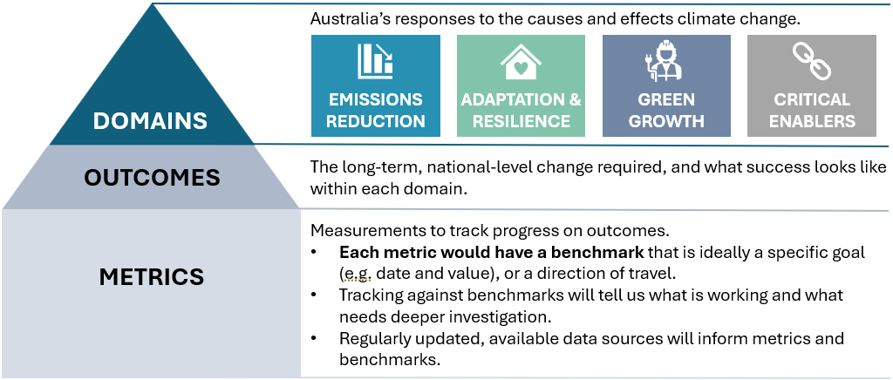
Over time, the 4 domains will track Australia’s progress against the following challenges:
- Emissions reduction: Is Australia on track to meet its 2030, 2035 and 2050 targets?
- Adaptation and resilience: Are Australia’s economy, society, and natural and built environments adapting and becoming more resilient to the physical impacts of climate change?
- Green growth: Is Australia harnessing its comparative advantages to grow and strengthen its economy through opportunities presented by the net zero transition?
- Critical enablers:
  - Social equity and acceptance: Is Australia’s climate response promoting fair outcomes and strengthening public support?
  - Finance and Investment: Where is further finance and investment required to address the challenges and opportunities of climate change?
  - Policy and governance: Are local, state and federal government responses enabling and accelerating climate action?
  - Workforce: Does Australia have the skills and capability to deliver the net zero transition?
  - Information and data: What information and data is required to track and drive progress, and how must this be managed?

Metrics and Benchmarking
There are many different paths to a prosperous, resilient and net zero future. This makes the task of establishing benchmarks for where each metric ‘should be’ at any particular point in time quite challenging. In many cases, the pathway will be nonlinear – it may involve step changes (e.g. as large assets enter or exit the market), accelerating change (e.g. as new technologies move from early adoption to widescale take-up) or volatility (e.g. for activities affected by climate or global market disruptions). Benchmark selection is complicated further where there is limited data, or where the desired outcome is particularly uncertain.
As a result, some benchmarks may be qualitative, directional (e.g. simply ‘increase’ or ‘decrease’), or approximate (e.g. assume a linear rate of change, in the absence of better information). Even where a more specific benchmark is available, it will often be indicative (what we might expect) rather than prescriptive (what we must achieve). Metrics and benchmarks will need to be considered as a full set to build a good understanding of Australia’s overall progress.

Annual refinement and outputs from the Platform
Outputs from the Platform will form insights and analysis published in our Annual Progress Advice at the end of each calendar year (Figure 1). While Part 3 of this paper discusses a relatively ‘long list’ of potential metrics to be monitored across the different domains, our Annual Progress Advice is likely to focus on a handful of headline metrics each year. These ‘headline metrics’ will be a combination of:
- Core measures of progress that warrant annual reporting – e.g. national progress towards Australia’s 2035 and 2050 emissions reduction Targets; and major drivers of abatement for each sector of the economy
- Periodic metrics selected to highlight success stories to date, spotlight major risks facing the transition, or provide timely input into major government policy reviews.
The Authority will also review and refine the Platform each year as part of its annual, ongoing improvement cycle. Yearly updates will allow for a staged and practical approach to development that will maximise impact while working within the Authority’s available resources.

Proposed outcomes and metrics
This section outlines the scope of each domain, key outcomes, and metrics that demonstrate progress or delays to a prosperous, resilient, net zero future.
In 2026, we plan to develop metrics for emissions reduction, green growth and 3 of the 5 critical enablers. The adaptation and resilience domain will be reported on from 2027, once the Australian Government’s National Adaptation Plan (NAP) Action Agenda is finalized. Nevertheless, we welcome your feedback on all domains.

Questions relating to the overarching design of the Platform:
- Will the proposed design of the Platform provide useful insights on Australia’s transition?

Questions relating to every domain of the Platform:
- Are the proposed metrics and benchmarks a reasonable starting point? Would you suggest any specific refinements or alternate data sources?
- Is the proposed sequencing of outcomes and metrics reasonable? For any outcomes or metrics not discussed in Part 3 of the paper, what data sources are available and regularly updated, that the Authority could use to measure these in future years?
- Is there anything else about indicators of early progress that the Authority might consider?

Questions specific to the critical enablers domain:
- What outcomes or metrics would help track whether the costs and benefits of decarbonisation are being shared fairly across different groups in Australia? What data sources are available and regularly updated to measure these?
- Which groups should be prioritised when assessing whether decarbonisation policies distribute costs and benefits fairly? Examples: household cohorts, regional and rural communities, workers in emissions-intensive industries, First Nations communities, energy-intensive businesses, future generations.
For the full list of questions, and to make a submission, visit our Consultation Hub.

Emissions reduction domain
The emissions reduction domain will track progress towards Australia’s Nationally Determined Contribution (NDC), at national and sectoral levels.
Australia’s Net Zero Plan and 6 sector plans set out how the government is driving emissions reductions across the economy to reach our 2030 and 2035 targets and net zero by 2050. They make it clear that sectors will decarbonise at different rates due to the different opportunities and technologies available, but that all sectors will need to play a stronger role over time.
Since our first Annual Progress Report in 2022, the Authority has published indicators (called metrics in this Platform) to track Australia’s progress in reducing emissions. From 2024, emissions analysis focused on 6 economic sectors from the Sector Pathways Review. The Authority tracks Australia’s emission reductions against the national targets of 43% below 2005 levels by 2030 and 62-70% by 2035.
While the government has not set sector-specific emission reduction targets, for the purposes of tracking progress the Authority considers it useful to assess change at both the national and sectoral level. Drawing on the Authority’s Sector Pathways Review and our 2035 Emissions Reduction Targets Advice, we have therefore developed benchmarks for metrics, based on the indicative cost-effective potential of abatement levers in each sector. However, we acknowledge that the pathways to these benchmarks will rarely be linear or smooth. These benchmarks are not – and should not be interpreted as – targets in themselves, but they are valuable indicators to monitor progress.
Table 1 describes the metrics we propose to focus on within the Emissions Reduction domain for 2026. We have identified 22 draft metrics to show progress in each sector. We recognise that emissions outcomes may be influenced by additional drivers that fall outside of the scope of these metrics. We also recognise there are many more abatement opportunities within each sector (e.g. abatement from heavy vehicles in the transport sector). This Evidence Platform will focus on the most important outcomes and metrics for the medium term; these will be revised as Australia progresses towards net zero.
In addition to the quantitative measures captured in the Platform, we will also continue to assess longer-term drivers of progress in qualitative ways. This includes technologies that are still undergoing research and development; those that are currently prohibitively costly; and those where uptake is expected to be delayed or gradual. For example:
- emerging biofuels, green ammonia and hydrogen, and other fuel substitutes
- electrification of heavy vehicles
- new iron and steel production methods
- technologies to reduce the methane intensity of cattle (if we are not able to identify suitable available metrics)
- engineered removals of carbon dioxide.
Table 1: Emissions reduction domain: First set of outcomes and metrics for consultation
Outcome | Metric | Leading or lagging | Units | Potential benchmark | Possible data source
ER1: National emissions fall in line with Australia’s NDC | National emissions | Lagging | Million tonnes carbon dioxide equivalent a year (Mt CO₂-e/yr) | 1. Rate of emissions reductions required to reach a 43% reduction on 2005 levels by 2030  2. Rate of emissions reductions required to achieve the upper or lower end of the 2031-2035 budget range | Quarterly Updates to Australia's National Greenhouse Gas Inventory
ER1: National emissions fall in line with Australia’s NDC | Electricity share of final energy consumption | Lagging | % | TBD | DCCEEW Australian Energy Statistics
ER1: National emissions fall in line with Australia’s NDC | ACCU surrender under the Safeguard Mechanism | Lagging | Million ACCUs | TBD | CER
ER2: Each sector’s emissions fall in line with Australia’s NDC | Sectoral emissions | Lagging | Mt CO₂-e | Emissions reductions in illustrative sectoral pathways to 2035 | Quarterly Updates to Australia's National Greenhouse Gas Inventory
ER3: Electricity sector emissions fall in line with Australia’s NDC | Share of on-grid electricity provided from renewables | Lagging | % | Rate of change in renewable share required to achieve 82% on-grid electricity by 2030 | Open Electricity (and Authority analysis)
 | Remaining coal capacity based on announced closure years | Leading | Gigawatts (GW) over time | Coal capacity remaining in the Step Change scenario of the 2026 Integrated System Plan | Australian Energy Market Operator (AEMO) Generation Information, other public information
 | Annual wind, solar and storage capacity additions | Leading | GW/yr | Rate of change in wind, solar and storage capacity needed to 2030 and to 2035 in the Step Change scenario of the 2026 Integrated System Plan | Clean Energy Regulator (CER), AEMO Connections Scorecard, other AEMO data
 | Annual rate of wind, solar and storage project approvals | Leading | GW/yr | Rate of change in wind, solar and storage capacity needed to 2030 and to 2035 in the Step Change scenario of the 2026 Integrated System Plan | RenewMap or similar
 | Transmission project commencement and anticipated completion dates | Leading | Years | Proposed transmission project status in the Step Change scenario of the Integrated System Plan | Public project updates
ER4: Transport sector emissions fall in line with Australia’s NDC | Share of new vehicle sales for passenger and light commercial vehicle segments that is battery electric vehicles | Leading | % | Rate of change needed for battery electric vehicles to reach 84-95% of new vehicle sales for passenger vehicles and 74-90% of new vehicle sales for light commercial vehicles by 2035 | Australian Automobile Association
 | Share of registered light vehicles that are battery electric vehicles | Lagging | % | Rate of change needed for battery electric vehicles to reach 28-30% of fleet by 2035 | Bureau of Infrastructure and Transport Research Economics
 | Electric vehicles per charger | Leading | Number (of vehicles per charger) | TBD | PlugShare or similar
ER5: Industry & waste sector emissions fall in line with Australia’s NDC | Share of industrial output produced with ‘clean’ technology (e.g. share of alumina produced with electric boilers) | Leading and lagging | % | Various, drawn from Authority sectoral analysis. | Company reports/public statements
 | Organic waste diverted from landfill | Leading | % | Rate of change needed to reach 83-90% by 2035 | DCCEEW (National waste and resource recovery reporting)
ER6: Resources sector emissions fall in line with Australia’s NDC | Methane emissions from coal and gas extraction facilities | Lagging | Mt CO₂-e | Rate of emissions reductions needed to reach a 4 Mt CO₂-e reduction in coal fugitives and 6 Mt CO₂-e reduction in gas fugitives by 2035 relative to 2024. | CER (National Greenhouse and Energy Reporting [NGER])
 | Sequestration by reservoir carbon capture and storage projects | Lagging | Mt CO₂-e | Rate of change of abatement needed to reach 9 Mt CO₂-e abatement by 2035 | CER (Australian Carbon Credit Unit scheme and NGER)
 | Energy-related emissions for resources facilities | Lagging | Mt CO₂-e | Rate of emissions reductions needed to reach a 10-21 Mt CO₂-e reduction by 2035 relative to 2024 | CER (NGER)
ER7: Agriculture and land sector emissions fall in line with Australia’s NDC | Uptake of technologies to reduce methane intensity of cattle | Leading and/or lagging | % (depending on available data) | TBD | TBD
 | Area of new tree/vegetation planting | Leading | hectares (ha) | Rate of new planted area needed to reach total 626-725 thousand ha of new plantings by 2035 relative to 2024 | Australian Bureau of Agricultural and Resource Economics and Sciences (ABARES), CER
 | Gross and net clearing of forests) | Leading and lagging | ha | Rate of change of forest conversion needed to reach a 100% reduction (primary) and 50% reduction (secondary) in forest conversion by 2035 relative to 2024 | National Vegetation Information System, DCCEEW National Greenhouse Accounts Activity Tables
ER8: Built environment sector emissions fall in line with Australia’s NDC | Number of gas disconnections | Lagging | Number (of disconnections) | Rate of commercial and residential gas disconnections consistent with Australia’s NDC | Australian Energy Regulator Gas Quarterly Disconnection Reporting
 | Heat pump imports | Leading | Number (of heat pumps) | TBD | Australian Bureau of Statistics (ABS)

Adaptation and resilience domain
Australia’s climate is changing rapidly, creating risks to the systems that underpin its economy, society and environment. The 2025 NCRA looked at Australia’s climate risk across 8 interconnected social, economic, and environmental systems. The NAP outlines the Government’s response to managing these risks. Through the Platform, the Authority will track how effectively Australia is adapting to the changing climate and identify opportunities to improve Australia’s adaptation response.
The Platform will begin tracking adaptation and resilience outcomes from 2027 onwards. Our focus this year is overcoming challenges such as developing quantitative metrics, identifying good data sources and appropriate benchmarks. We will also undertake further research and stakeholder engagement, and consider how to align with other frameworks including the Government’s upcoming Adaptation Action Agenda, the Global Goal on Adaptation, and monitoring and evaluation approaches from other climate councils around the world.
Table 2 outlines our early thinking on outcomes and possible metrics. The 8 outcomes align closely to the main systems identified in the NCRA. We welcome input on the adaptation and resilience domain framework and the 8 identified outcomes. We value suggestions for suitable metrics and corresponding reliable data sources to inform what the Authority reports on next year.
Table 2: Adaptation and resilience domain: Possible outcomes and metrics for future development
Outcome | Metrics for future years’ development  (i.e. 2027 onwards) | Leading or lagging | Units | Potential benchmark | Possible data source
AR1: The health and wellbeing of Australian communities is safeguarded and supported in a changing climate. | Annual heat-related mortality and morbidity relative to the number of heatwave events per year | Lagging | Count | Trending downwards | Australian Institute of Health and Welfare
 | People with disabilities or chronic medical conditions annually reporting they are able to adequately cool their homes | Lagging | % | Trending upwards | ACOSS Heat Survey Report
 | Annual mortality and morbidity due to climate-related disasters | Lagging | Count | Trending downwards | Australian Institute of Health and Welfare
 | Annual healthcare service disruptions due to extreme weather | Lagging | TBD | Trending downwards | TBD
AR2: Australian communities have the capability to adapt to a changing climate. | Proportion of Australians living in local government areas with low, moderate and high capacity for disaster resilience | Leading | % | Proportion with high-capacity trends upwards, low-capacity trends downwards | ABS - Measuring What Matters
 | Local governments with climate adaptation plans | Leading | Count | Trending upwards | TBD
 | Annual local, state and territory government resourcing for climate adaptation | Leading | $ | Trending upwards | TBD
AR3: Australia’s defence and national security system manage domestic climate risks and disaster events. | Metrics under development |  | TBD | TBD | TBD
AR4: Australia’s economy, trade and finance systems continue to prosper despite increasing physical climate risks. | Annual national productivity losses due to high temperatures | Lagging | $ | Trending downwards | TBD
 | Annual Australian Government spending gap for natural disasters (annual gap between money budgeted for natural disasters vs money actually spent on disaster recovery) | Leading | $ | Trending downwards | TBD
 | Annual Australian insurance protection gap for climate-related disasters (the difference between the amount of insurance in place vs the actual cost of economic damages) | Lagging | $ | Trending downwards | Insurance Council of Australia
 | Proportion of households and businesses with adequate insurance | Leading | % | Trending upwards | Insurance Council of Australia
 | Under development:  Proportion of annual government budget allocated to climate adaptation and resilience | Leading | % | Trending upwards | TBD
 | Metric to be developed relating to mandatory climate reporting and integrating climate risk and opportunities into decision-making |  | TBD | TBD | TBD
AR5: Australia’s natural environment is resilient to the accelerating impacts of climate change. | Metric to be developed relating to Government policies supporting ecosystem services and resilience |  | TBD | TBD | TBD
 | Metric to be developed relating to water security, management and supply |  | TBD | TBD | TBD
 | Metric to be developed relating to threatened species |  | TBD | TBD | TBD
AR6: Primary industry and food systems continue to be productive, profitable, resilient and sustainable in a changing climate. | Reduction in annual agricultural yield associated with climate-related drivers and events | Lagging | TBD | Trending downwards | TBD
 | Prevalence of moderate or severe food insecurity associated with climate-related drivers and events | Lagging | TBD | Trending downwards | TBD
 | Amount of climate adaptation finance disbursed annually to food and agriculture as a proportion of the costs of physical climate impacts | Leading | % | Trending upwards | TBD
AR7: Settlements, buildings and infrastructure are resilient to the impacts of climate change. | Proportion of people able to keep their home at a comfortable temperature on hot days | Lagging | % | Trending upwards | Energy Consumers Australia; ACOSS
 | Average NatHERS rating of Australian homes; Average NABERS rating of commercial buildings | Leading | Average rating | Trending upwards | NatHERS and NABERS
 | Proportion of homes with insulation features (ceiling insulation, floor insulation, double/triple glazed windows) split by either income level, demographic and/or geographic region | Leading | % | Trending upwards | ACOSS Heat Survey Report
 | Proportion of homes with air conditioning split by either income level, demographic and/or geographic region | Leading | % | Trending upwards | Energy Consumers Australia
 | Proportion of uninsured and underinsured households | Leading | % | Trending downwards | The Household, Income and Labour Dynamics in Australia (HILDA) Survey
 | Number of annual weather-related interruptions to energy, telecommunications and transport systems proportionate to the number of extreme weather events per year | Lagging | Count | Trending downwards | TBD
 | Metric to be developed regarding climate resilience standards for major infrastructure projects | Leading | TBD | TBD | TBD
AR8: Outcome for Aboriginal and Torres Strait Islander Peoples (under development) | Metrics under development. |  | TBD | TBD | TBD

Green growth domain
As Australia and its trading partners decarbonise, innovation and low-emissions industry development and technology roll-out will be essential to maintaining Australia’s prosperity. With our abundant clean energy resources, land, and strong capacity for innovation, Australia has the potential to meet rising global demand for low and zero-emissions goods and services. The Evidence Platform will track how Australia is harnessing its comparative advantages to realise this potential.
We are continuing to develop the outcomes and metrics for the green growth domain, spanning Australia’s green iron industry, foreign direct investment in decarbonisation aligned activities, and spending under the Future Made in Australia plan. We will consult on these later in the year.
We welcome your input on how best to track progress for the Green Growth domain.

Critical enablers domain
This domain covers the enablers that are essential for Australia’s economic and structural transformation to a prosperous, resilient, net zero future. We have identified 3 critical enablers for development in 2026: social equity and acceptance, finance and investment, and policy and governance. In future years we intend to expand this to include enablers such as skills and workforce and information and data.
Each of the critical enablers supports progress in the other domains (emissions reduction, adaptation & resilience, and green growth). However, our initial focus is on how they support emissions reductions.
This section outlines the scope of each enabler, and proposed outcomes and metrics for social equity & acceptance. We will consult on outcomes and metrics for the finance & investment and the policy & governance enablers later in the year.

Social equity & acceptance
Australia’s progress to net zero emissions will involve transition costs and benefits. Making sure these costs and benefits are fairly spread across society is crucial to maintain public support for climate policies and avoid delays to achieving net zero.
To reach net zero, all Australians will need to adopt low emissions technologies. However, some face particular barriers, for example renters whose landlords generally don’t have the incentive to install rooftop solar. Addressing systemic barriers to technology uptake can help people access the benefits of the transition while also helping to reduce emissions.
Similarly maintaining and building social acceptance in communities hosting clean energy infrastructure can help keep costs down and avoid delays to clean technology rollout. People are more likely to support climate action when there is better public understanding of how and why climate policies are being implemented, and the benefits they bring.
To develop outcomes and metrics for the social equity and acceptance enabler, we considered existing frameworks on social licence and equity, and surveys on household energy needs and attitudes to the renewable transition. We have identified five potential outcomes:
- Australians have equitable opportunities to adopt, and benefit from, decarbonisation technologies
- Australians have equitable opportunities to adopt, and benefit from, adaptation technologies
- Australians understand, trust and support the policies and actions required to achieve net zero
- First Nations people are empowered to participate in, and benefit from, mitigation and adaptation solutions
- Regional communities equitably benefit from an orderly transition
For 2026, we propose to focus on developing Outcome 1, and within this, focusing on the uptake of energy decarbonisation technologies for renters and owner-occupiers (Table 3). Renters make up 31% of Australia’s population and represent a significant source of untapped abatement potential – but face a range of barriers to accessing consumer energy resources (such as solar PV and batteries) and efficiency opportunities such as home insulation. In future years, we intend to expand the metrics in this outcome to include other cohorts (for example, different socioeconomic groups), and other types of decarbonisation technology uptake (for example, electric vehicles). We are also developing a metric around energy costs and affordability.
Table 3: Social equity & acceptance enabling domain: Proposed first set of outcomes and metrics for consultation
Outcome | Metric | Leading or lagging | Units | Potential benchmark | Possible data source
SE1: Australians have equitable opportunities to adopt, and benefit from, decarbonisation technologies | Uptake rates of energy decarbonisation technologies for rental and owner-occupied properties | Lagging | Percentage point difference between cohorts | Trending downwards | Energy Consumers Australia’s Consumer Energy Report Card
 | Under development  Average energy costs and affordability per person or socioeconomic strata, relative to the current fuel mix | Lagging | $ cost – total and by fuel type | TBD | TBD
We also intend to develop the remaining outcomes for social equity and acceptance in future years (Outcomes 2-5).

Finance & investment
Addressing the challenges and opportunities of climate change needs effective and efficient public and private finance for emissions reduction, adaptation, and green growth initiatives. While public funding remains essential, the scale of investment needed means that private finance will also be critical.
In 2026, we propose to focus on the finance and investment for emissions reduction, specifically focusing on monitoring private sector investment. We are still developing the outcomes and metrics for finance and investment and will consult on these further later in the year. We are considering a small range of metrics covering superannuation, corporate finance and other topics.
We welcome your input on the finance and investment enabler.

Policy & governance
Monitoring Australia’s climate policy landscape gives us some of the earliest insights into Australia’s transition. Policy and governance are governments’ responses to tackling market failures and barriers to the emissions reduction, adaptation, and green growth domains. Effective policy and governance sets out clear rules; creates stable expectations for communities and industry; provides market incentives; guides investment; and makes sure the costs and benefits of the transition are shared fairly.
In 2026, we propose to focus on policy & governance for emissions reduction. The Authority will also improve and better leverage our Climate Policy Tracker, particularly in relation identifying the coverage of Federal policies for selected domains such as emissions reduction. Note that adaptation-related policy metrics will be tracked in the future together with the adaptation domain’s development.
We are still developing the outcomes and metrics for policy and governance and will consult on these further later in the year. We welcome your input on the policy and governance enabler.

IPCC. (2014). Climate-Resilient Pathways: Adaptation, Mitigation, and Sustainable Development.
CCA. (2025). 2035 Targets Advice.
CCA. (2024). Sector Pathways Review.
This metric applies to facilities covered by the Safeguard Mechanism, which relates to sectors including Industry and waste, Resources and Transport.
The latest Integrated System Plan will likely reflect the current status of transmission projects, making it unsuitable for benchmarking in the year that it is released. For 2026, we propose to use the 2024 Integrated System Plan as the benchmark (acknowledging this requires significant caveats).
Depending on the granularity of available data, this metric may be less explicitly captured. We will also monitor actions and decisions by industrial facilities to take up abatement technologies more broadly.
ACS. (2025). Australia’s National Climate Risk Assessment.
DCCEEW. (2025). National Adaptation Plan.
Hoyle, A., & Rhodes, E. (2025). Explaining public support for net-zero climate policy instruments: Perceptions of distributive fairness under competing frames.; London School of Economics. (2024). What is the just transition and what does it mean for climate action?
IMF. (2023). Public Perceptions of Climate Mitigation Policies: Evidence from Cross-Country Surveys.
Stronge, D. C., Kannemeyer, R. L., & Edwards, P. (2024). Building social licence to operate: A framework for gaining and maintaining meaningful, trustworthy relationships; Walker, G. (2012). Environmental Justice Concepts, Evidence and Politics.
CSIRO. (2024). Australian attitudes toward the renewable energy transition; ECA. (2025). Consumer Energy Report Card data; Ipsos. (2024). Social license for the energy transition.
Australian PV Institute. (2024). Rooftop solar potential of Australian housing stock by tenure and dwelling type; The Senate Economics References Committee. (2025). Residential Electrification Inquiry.
Note: Energy decarbonisation technologies refer to rooftop solar panels, home batteries, home electrification and thermal upgrades such as double glazing, and insulation.

