Overview of the Proposed Area - Hunter, New South Wales

An area off the Hunter Region of New South Wales is being considered for  
offshore wind and other renewable energy projects.   
This initial area is a **proposal** for feedback. It is **not**the final declaration.

**Starting the conversation**

This is your first opportunity to provide feedback.

If a declaration is made in the future, developers will also be required to seek feedback on any proposed projects and   
demonstrate how they will share the area with existing users.

**Jump to:**

Provide your feedback

The offshore renewable energy process

The Hunter region

Frequently asked questions

The benefits of offshore renewable energy in the Hunter

The area under consideration

Visual amenity

Further information

Marine users and interests

### 

### The Hunter region

This area is the traditional Land and Sea Country of the Awabakal, Bahtabah, Biraban, Darkinjung, Karuah, Mindaribba, and Worimi peoples. This is an important consideration, as an offshore renewable energy industry will involve the installation of infrastructure across land and sea country in order to integrate with the New South Wales electricity grid.

The region features coastal and valley landscapes, internationally renowned wine production, important natural areas, both urban and rural lifestyles and extensive mining resources. The Hunter is Australia’s largest regional economy, valued at over $40 billion. The region prospers economically and socially, supported by a highly professional and skilled industrial workforce and strong research, health, tourism, manufacturing, and defence sectors. The region is well known for manufacturing, mining and energy exports, and energy-intensive industries such as aluminium and steel. The future focus is shifting to renewable energy and the role it could play as the region transitions away from coal-fired electricity generation.

### The benefits of offshore renewable energy in the Hunter

The Australian Government has set a target of net zero emissions by 2050 and is looking to reduce emissions by 43%, and by 2030 reach 82 per cent of Australia’s electricity generated from renewable sources. Offshore renewable energy projects can assist in achieving these goals. Offshore renewable energy has strong generation potential around Australia, including the Hunter region, and can be a source of significant new power generation for manufacturing hydrogen, green steel, and green aluminium.

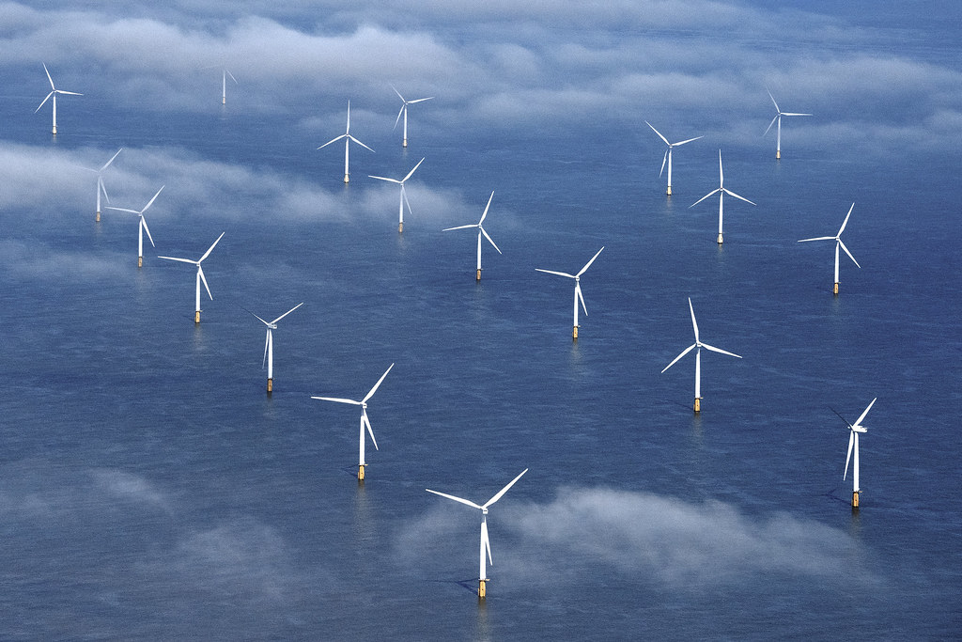Offshore renewable energy is thriving in many regions around the world, particularly offshore wind projects in the United Kingdom and Europe. Currently, offshore renewable development interest in Australia is mostly focused on potential offshore wind projects. This could change in the future as more technologies come to market. Future licences could be granted for offshore solar, wave or tidal energy, or other forms of energy generation from renewable sources.

The Hunter region is well suited for potential projects, particularly offshore wind, because:

* It has strong, consistent winds
* It is close to areas of high electricity demand and existing connections to the grid
* Industry is very interested in developing projects in the area
* Coal-fired power stations in the Hunter including Lidell, Eraring and Bayswater are planning to shut down in future years
* The area is within the New South Wales (NSW) Government’s proposed   
  Hunter-Central Coast Renewable Energy Zone (REZ).

The NSW Government is targeting the construction of 12 GW of renewable energy by 2030, enough to power the equivalent of 5.8 million homes, as well as 2 GW of long duration storage like pumped hydro. Because of its long coastline and extensive continental shelf, New South Wales has immense potential for offshore wind power generation. The capacity of the Hunter-Central Coast REZ is likely to increase over time with the growth of offshore wind.

The construction, maintenance and ongoing operations of offshore renewable energy projects must be well-integrated and support the local Hunter economy. The Global Wind Energy Council estimates approximately 8,650 jobs are created over the lifetime of a typical 500 MW offshore wind project. This is due to generally longer project timelines and more complex construction, assembly and installation activities, when compared to onshore wind. Additionally, the Blue Economy CRC report into Offshore Wind in Australia, suggests that the development of offshore wind could potentially offer alternative employment for workers in the coal industry.

**Jump to:**

**The Hunter region**

**The benefits of offshore renewable energy in the Hunter**

**The area under consideration**

**Visual amenity**

**Marine users and interests**

**The offshore renewable energy process**

**Provide your feedback**

**Frequently asked questions**

**Further information**

**Back to top of document ↑**

Over time, electricity generated by offshore wind projects in the area may replace the output of coal-fired power stations in the region as they reach the end of their useful life.

### A picture containing diagram Description automatically generatedThe area under consideration

The Minister for Climate Change and Energy has proposed an area in the Commonwealth waters off the Hunter Region of NSW for offshore renewable energy projects, such as offshore wind. The Australia Government is looking to harness renewable energy resources to help decarbonise the economy with   
year-round clean energy generation. This will reduce emissions and boost the share of renewables in the electricity grid.

This initial area is a **proposal** and consultation is now open. We are seeking your feedback on the proposal and how offshore renewable energy projects could share the area with other users and interests. The Minister will consider the submissions and may remove parts of the proposed area or place conditions on all or part of the area, before making a final declaration.

In defining the boundaries of the proposed area, a number of factors have been considered, including initial feedback received from Commonwealth and New South Wales Government agencies, and technical limitations identified in the Blue Economy CRC report into Offshore Wind in Australia.

We have also developed a map that allows users to interact with the Hunter area under consideration and geographic information relevant to other users and interests in the area. The map, other tools, visualisations and data relevant to Offshore Renewable Energy in Australian waters are also available on the [Australian Marine Spatial Information System](https://amsis-geoscience-au.hub.arcgis.com/pages/renewables) portal.

### Visual amenity

The area being considered begins at least 5.4 nautical miles (approximately 10 kilometres) from shore. Offshore wind turbines are the tallest renewable energy option being proposed in the area, with current heights of up to approximately 250m above sea level. The relative height and visual effect decreases with distance, especially due to the curvature of the earth.

We understand that the visibility of wind turbines may be of particular interest to local communities. This may be especially so if there are multiple offshore wind projects in the area. While the exact locations of future projects and number of turbines are not yet known, we encourage you to make a submission if you have suggestions as to how visual impacts could be managed.

Prospective developers will need to consult on the location and placement of any future turbines as part of their management plans, and to support assessment under the [*Environment Protection and Biodiversity Conservation Act 1999*](https://www.dcceew.gov.au/environment/epbc/referral-and-assessment-process).

##### Overseas experience

Denmark is one of the major leaders in the offshore wind industry, with years of experience developing these projects. The Denmark’s Ministry of Foreign Affairs, and The Danish Energy Agency have created a [video demonstration](https://www.offshorewindtour.org/international/?lang=en#/scene/1385/1675/1844/1851:1916) helping to show what offshore wind farms look like from certain distances from the shore. This may help to visualise what potential wind farms will look like.

### Marine users and interests

Future offshore renewable energy projects must demonstrate how they will share the area with existing users and interests.

The Australian Government wants to manage the offshore marine environment in a way that recognises all users and balances competing interests. Understanding existing users and interests in and near the area under consideration is important and will help the Minister for Climate Change and Energy’s decide whether the area is suitable for offshore renewable energy developments. **Future offshore renewable energy projects must share the area with other users and interests**.

Some sections of the area may not be suitable for some offshore renewable energy activities because of existing constraints. Potential constraints include but are not limited to:

* Significant Defence areas
* BOM weather radars like at Lemon Tree Passage
* Air space around Newcastle Airport and RAAF Williamtown
* Matters of National Environmental Significance under the *Environment Protection and Biodiversity Conservation Act 1999*

Prospective proponents are required to consult with the appropriate government agencies to ensure constraints are thoroughly considered and addressed throughout their projects.

For detailed information on existing users and interests in the vicinity of the area, please read *Marine Users, Interests and the Environment in the Hunter Region, New South Wales*.

### The offshore renewable energy process

**This is your first opportunity to provide feedback on the proposed area**. In the future and if an area is declared, developers will be required to seek feedback on their proposed projects and must demonstrate, to the satisfaction of the Offshore Infrastructure Regulator, how they will share the area with existing users. A process diagram, with consultation points identified, is provided below.



Once the consultation period has ended, the Minister will consider all submissions and the potential impacts offshore renewable energy projects may have on other users and interests. Your feedback will help inform the Minister’s decision on whether the proposed area is suitable for offshore renewable energy.

If the Minister declares the area, and feasibility licences are granted, developers will be allowed to investigate an area and begin planning their project. During the feasibility licence period, which is up to 7 years, developers must prepare a management plan. As part of the preparation of these plans, **developers will need to consult with the local community** **and demonstrate how they will share the area with other users**. Licence holders (developers) will also need to have a plan for gathering and responding to ongoing feedback from stakeholders throughout the life of the project.

The management plan must be approved by the Offshore Infrastructure Regulator before an application for a commercial licence can be granted. Before deciding whether to grant a commercial licence, **the Minister may require the developer to conduct specific kinds of consultation**. Developers must also ensure they have received all other relevant approvals, and undertake any other consultation processes, before they can apply for a commercial licence. This includes environmental approvals. It is not until a commercial licence is granted, which is for a period of 40 years, that construction of the offshore renewable energy infrastructure can commence.

We want to make sure everyone understands the proposal and process for providing feedback. We will be running a series of information sessions virtually, and in person across the Hunter region.

### Provide your feedback

**Jump to:**

**The Hunter region**

**The benefits of offshore renewable energy in the Hunter**

**The area under consideration**

**Visual amenity**

**Marine users and interests**

**The offshore renewable energy process**

**Provide your feedback**

**Frequently asked questions**

**Further information**

**Back to top of document ↑**

**This is your first opportunity to provide feedback.** We want your feedback on the proposal to declare an area and how offshore renewable energy projects could share the area with other users and interests. We encourage your feedback through a submission in our [Consultation Hub](https://consult.dcceew.gov.au/oei-hunter). Your feedback will help inform the Minister’s decision on whether the proposed area is suitable for offshore renewable energy. **Your feedback must be provided through the Consultation Hub by the submission deadline of Friday 28 April 2023.**

**There will be more opportunities to provide your feedback on specific projects and project locations.** Once the area is declared, developers will need to consult with the local community and demonstrate how they will share the area with other users. Licence holders will also need to have a plan for gathering and responding to ongoing feedback from stakeholders throughout the life of the project.

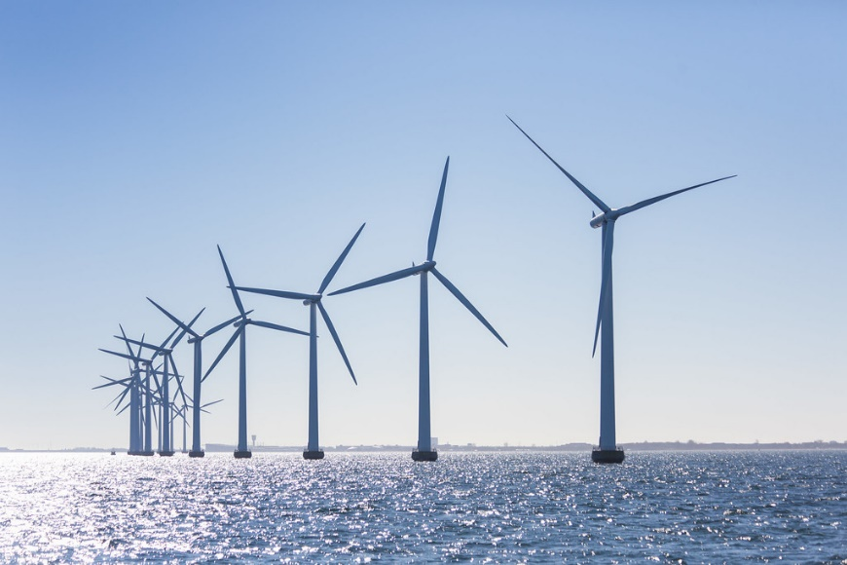

### Frequently asked questions

#### What is being proposed?

The Australian Government has established a legislative framework to enable offshore infrastructure projects to be undertaken in Australian Commonwealth waters (>3 nautical miles from shore, extending to the boundary of Australia’s exclusive economic zone). To read more about what is being proposed, please see “The area under consideration”.

Consultation on this proposal is now open and we want your feedback on the proposal and how offshore renewable energy projects could share the area with other users and interests. To read more about feedback, please see “Provide your feedback”.

#### Why is offshore renewable energy being considered?

The Australian Government has set a target of net zero emissions by 2050 and is looking to reduce emissions by 43%, and by 2030 with 82% of Australia’s electricity generated from renewable sources. Offshore renewable energy projects off the Hunter Region can help the Australian Government meet these targets.

The NSW Government is targeting the construction of 12 GW of renewable energy by 2030. The offshore area of the Hunter-Central Coast REZ has been identified as a potential future offshore wind zone.

To read more on why offshore renewable energy is being considered, please see “The benefits of offshore renewable energy in the Hunter”.

#### How will this benefit the local community?

Hunter offshore wind projects can help decarbonise the economy with year-round clean energy generation and drive regional jobs growth, with a need for skills in engineering and construction, as well strong transferable skills from other sectors including high-voltage electrical, logistics and offshore work. To read more about the benefits for the local community, please see “The benefits of offshore renewable energy in the Hunter”.

#### What sort of projects might be built in the area?

Currently, development interest is mostly focused on potential offshore wind projects. This could change in the future as more technologies come to market. Future licences could be granted for offshore solar, wave or tidal energy, or other forms of energy generation from renewable sources.

#### Will I still be able to access the area?

Yes – to the extent possible to ensure a safe marine space. The Australian Government will manage the offshore marine environment in a way that recognises all users and balances competing interests. **Future offshore renewable energy projects** **must work with existing users and interests to ensure the area is shared, while maintaining a safe marine space during construction, operation and maintenance phases.**

#### Will I be able to fish in the area?

Yes – to the extent possible to ensure a safe marine space. It is Australian Government policy that offshore renewable energy projects will need to share the marine space with existing users. Restrictions may be placed around specific infrastructure to manage safety. It is expected that project developers will consult with fishers and other impacted users to minimise any disruptions. For detailed information on fishing in the vicinity of the area, please read *Marine Users, Interests and the Environment in the Hunter Region, New South Wales*.

#### How many wind turbines could there be, and will I be able to see them?

Offshore wind turbines are likely to be visible from the shore. Their visual effect will depend on their distance to the shore, and the location and number of approved projects and where they are viewed from. The exact location of projects and number of turbines within the declared area is yet to be determined. To read more about visual amenity, please see “Visual amenity”.

#### What marine users and interests are in the area?

We have undertaken initial consultation with Commonwealth and NSW Government agencies to identify interests in the vicinity of the area. Examples of marine users and interests in the area include; Native Title holders, various species of marine animal life, Defence industry, vessel traffic, weather radars, commercial and recreational fishing, owners of existing infrastructure, and tourism industry. For more detailed information, please read *Marine Users, Interests and the Environment in the Hunter Region, New South Wales*.

#### How will the environment be protected?

We have consulted extensively and continue to work across Government, including with agencies responsible for the protection of the environment. Developers must receive approval under the EPBC Act for their proposals. This will include an assessment of the relevant impacts and proposed avoidance, management, mitigation and, where appropriate, offset measures, to demonstrate appropriate environmental outcomes can be achieved, and ensure minimal impact on the marine environment. For more information on how the environment will be protected, please see *Marine Users, Interests and the Environment in the Hunter Region, New South Wales*.

#### How will electricity generated in the area be transmitted and used?

Electricity generated by renewable energy infrastructure in the area may be transmitted onshore to be fed into the National Electricity Market (NEM) or be used to supply a specific end user, such as heavy industry.

Existing connection infrastructure may have capacity limitations that could put an upper limit on the number of prospective projects that could connect. It is the responsibility of prospective developers to understand existing and future capacity requirements and consider the prospective end use of future electricity generated in the area.

#### Do existing legal requirements continue to apply?

Yes. Prospective developers are responsible for obtaining all relevant approvals under Commonwealth and NSW Government legislation. Developers are required to be aware of all other rights and obligations that may apply to their respective projects. This may include, but is not limited to, [Underwater Cultural Heritage](https://www.legislation.gov.au/Series/C2018A00085), [Biosecurity](https://www.legislation.gov.au/Series/C2015A00061), [Navigation](https://www.legislation.gov.au/Series/C2012A00128), [Immigration](https://www.legislation.gov.au/Series/C1958A00062), [Customs](https://www.legislation.gov.au/Series/C1901A00006), [Native Title](https://www.legislation.gov.au/Series/C2004A04665), [Environment Protection and Biodiversity Conservation](https://www.legislation.gov.au/Series/C2004A00485) and [Air Services](https://www.legislation.gov.au/Series/C2004A04931).

#### How long will the area be declared for?

When declaring an area suitable for offshore energy, the Minister is not required to specify how long the declaration will last for. If the declaration instrument does not state an end date, it will remain in force until it is revoked. To revoke the declared area, the Minister must undertake a consultation process and consider any submissions received. If a declaration is revoked, or otherwise ends, any licences that have already been issued will remain; however, they cannot be changed or renewed.

#### How can I have my say?

**This is your first opportunity to provide feedback.** We want your feedback on the proposal and how offshore renewable energy projects could share the area with other users and interests. We encourage your feedback through a submission in our [Consultation Hub](https://consult.dcceew.gov.au/oei-hunter).To find out more about providing feedback, please see “Provide your feedback”.

#### Is this the only chance to have my say?

**No.** **This is your first opportunity to provide feedback**.

As part of the preparation of management plans, developers will need to consult with the local community and other interested stakeholders. The Australian Government is currently developing regulations that will set out the details and requirements of management plans, including the requirement to consult with community. As above, to find out more about providing feedback, please see “Provide your feedback”.

### Further information

For more information on how marine users, interests and the environment in the area under consideration off Hunter, New South Wales, please see *Marine Users, Interests and the Environment in the Hunter Region, New South Wales*.

For information on the *Offshore Electricity Infrastructure Act 2021* please visit the [Establishing offshore renewable energy infrastructure web page](https://www.dcceew.gov.au/energy/renewable/establishing-offshore-infrastructure). If you have any questions, you can [email our team](mailto:offshorerenewables@industry.gov.au).

**Back to top of document ↑**