March 2024

Chemical profile

# Dechlorane Plus®

## Summary

* Dechlorane Plus® (DP) is internationally recognised as an environmental pollutant. It is listed on the [Stockholm Convention on Persistent Organic Pollutants](https://chm.pops.int/TheConvention/ThePOPs/ListingofPOPs/tabid/2509/Default.aspx) to globally eliminate production and use of the chemical.
* Dechlorane Plus® is a high concern chemical due to its persistence in the environment, bioaccumulation properties and tendency to undergo long-range transport through the environment to locations far from sites of production and places of use. It may cause adverse effects in the environment and/or to human health.
* The chemical is used as a flame retardant additive in a wide range of products, such as insulation coating for cables for machinery, automobiles and electrical and electronic equipment.
* Dechlorane Plus® is a priority for scheduling under the [Industrial Chemicals Environmental Management Standard](https://www.dcceew.gov.au/environment/protection/chemicals-management/national-standard/ichems-online-register) (IChEMS) in order to manage the significant long-term risks it poses to the environment and to fulfill Australia’s international obligations.

## Introduction and use of Dechlorane Plus® in Australia

Dechlorane Plus® is a commercially available polychlorinated flame retardant. Flame retardant chemicals are added to products to prevent burning or to slow the spread of fire. Dechlorane Plus® is an additive flame retardant, which means it is not chemically bound to the material to which it is added.

Dechlorane Plus® is used primarily as a flame retardant in adhesives, sealants and polymers (plastics). The automotive sector is the majority user of DP, with estimates of up to 90% of global volume use. Within this sector, the main use is for insulation coating for cables and wires.

Other identified applications of DP include use in:

* electrical and electronic equipment including consumer electronics, heating ventilating and air conditioning and building control systems;
* polymers and plastic mouldings;
* fabrics, textiles and apparels and plastic articles;
* marine, garden, forestry, agriculture, industrial, mining and construction machinery and power equipment;
* aerospace and defence;
* monitoring instruments; and
* medical, scientific and radiotherapy devices.

The chemical also has minor uses as an extreme pressure additive in greases and as a colour intensifier in explosives in fireworks.

The Australian Industrial Chemicals Introduction Scheme (AICIS), Australia’s national regulator of the importation and manufacture of industrial chemicals, published an [Evaluation Statement for DP](https://www.industrialchemicals.gov.au/sites/default/files/2023-06/EVA00041%20-%20Evaluation%20Statement%20-%2026%20June%202023.pdf) in June 2023. It indicated that there are potential significant long-term risks to the environment from the manufacture, import and use of DP.

The AICIS risk evaluation reported that there is currently no specific information on the use, import, or manufacturing of DP in Australia. However, based on international use patterns, DP is likely to be introduced into Australia in imported articles, including automobiles, household items, electronic appliances and wiring.

Dechlorane Plus® is an additive flame retardant, which means it is not chemically bound to the material to which it is added. Unbound chemicals may migrate or leach out of articles over time. Given the widespread usage of DP-containing articles, emissions of DP into the environment from migration are likely during use and end-of-life disposal. This may result in continued emissions from waste disposal, such as e-waste from electronic products, for many years to come.

Dechlorane Plus® is promoted as a replacement substance for commercial decabromodiphenyl ether (c-decaDBE). Commercial-decaDBE is also recognised as a global environmental pollutant and is [listed as a persistent organic pollutant (POP) on the Stockholm Convention](https://chm.pops.int/TheConvention/ThePOPs/ListingofPOPs/tabid/2509/Default.aspx). Commercial-decaDBE was [listed as a Schedule 6](https://www.dcceew.gov.au/environment/protection/chemicals-management/national-standard/ichems-online-register/decabde-nonabde) chemical (import, manufacture and export is prohibited, with limited exceptions) under IChEMS in 2023.

## Controls under the Stockholm Convention

Dechlorane Plus® has the characteristics of a POP as it fulfills the required screening criteria in Annex D of the Stockholm Convention. It meets the criteria to be considered as persistent, bioaccumulative, capable of long distance transport in the environment and having adverse effects.

In May 2023, DP was listed in Annex A (Elimination) of the Stockholm Convention with time-limited exemptions on certain uses. This means that countries that have ratified the amendment to the convention for DP must take measures to eliminate its intentional production and use. These countries must also restrict the import and export of DP and are required to meet standards for managing stockpiles and wastes.

The Stockholm Convention has time-limited specific exemptions for use of DP in aerospace, space and defence applications, as well as medical imaging and radiotherapy devices. Exemptions for the manufacture of replacement parts for these applications, in addition to replacement parts for motor vehicles, stationary industrial machines, power equipment and analytical instruments, apply until the end of life of the article or 2044, whichever comes first. There are no specific exemptions for production of DP.

Australia has not yet ratified the amendments to the Stockholm Convention for this chemical.

## Chemical identity

Commercial DP is a mixture consisting of two isomers; the *syn*-isomer (*syn*-DP) and the *anti*-isomer (*anti*-DP) (see figure 1 below). Both the mixture and the individual isomers are included in the listing for DP on Annex A of the Stockholm Convention.

* **CAS name:** 1,4:7,10-Dimethanodibenzo[a,e]cyclooctene, 1,2,3,4,7,8,9,10,13,13,14,14-dodecachloro-1,4,4a,5,6,6a,7,10,10a,11,12,12a-dodecahydro-
* **CAS registry number:** 13560-89-9
* **Synonyms:** Bis(hexachlorocyclopentadieno)cyclooctane; 1,2,3,4,7,8,9,10,13,13,14,14-Dodecachloro-1,4,4a,5,6,6a,7,10,10a,11,12,12a-dodechydro-1,4:7,10-dimethanodibenzo[a,e]cyclooctene; Dodecachlorodimethanodibenzocyclooctane; Dodecachlorododecahydrodimethanodibenzocyclooctene
* **Trade names:** Dechlorane Plus®; Dechlorane Plus 25 (Dech Plus); Dechlorane Plus 35 (Dech Plus-2); DP‑515; Dechlorane 605, Dechlorane Plus 1000; Dechlorane Plus 2520; Dechlorane A; DP; Escapeflam DK-15 (China); PyroVex SG (grade 515, 25 and 35).

Dechlorane Plus® *Syn*-Dechlorane Plus *Anti-*Dechlorane Plus

(CAS No. 13560-89-9) (CAS No. 135821-03-3) (CAS No. 1358 21-74-8)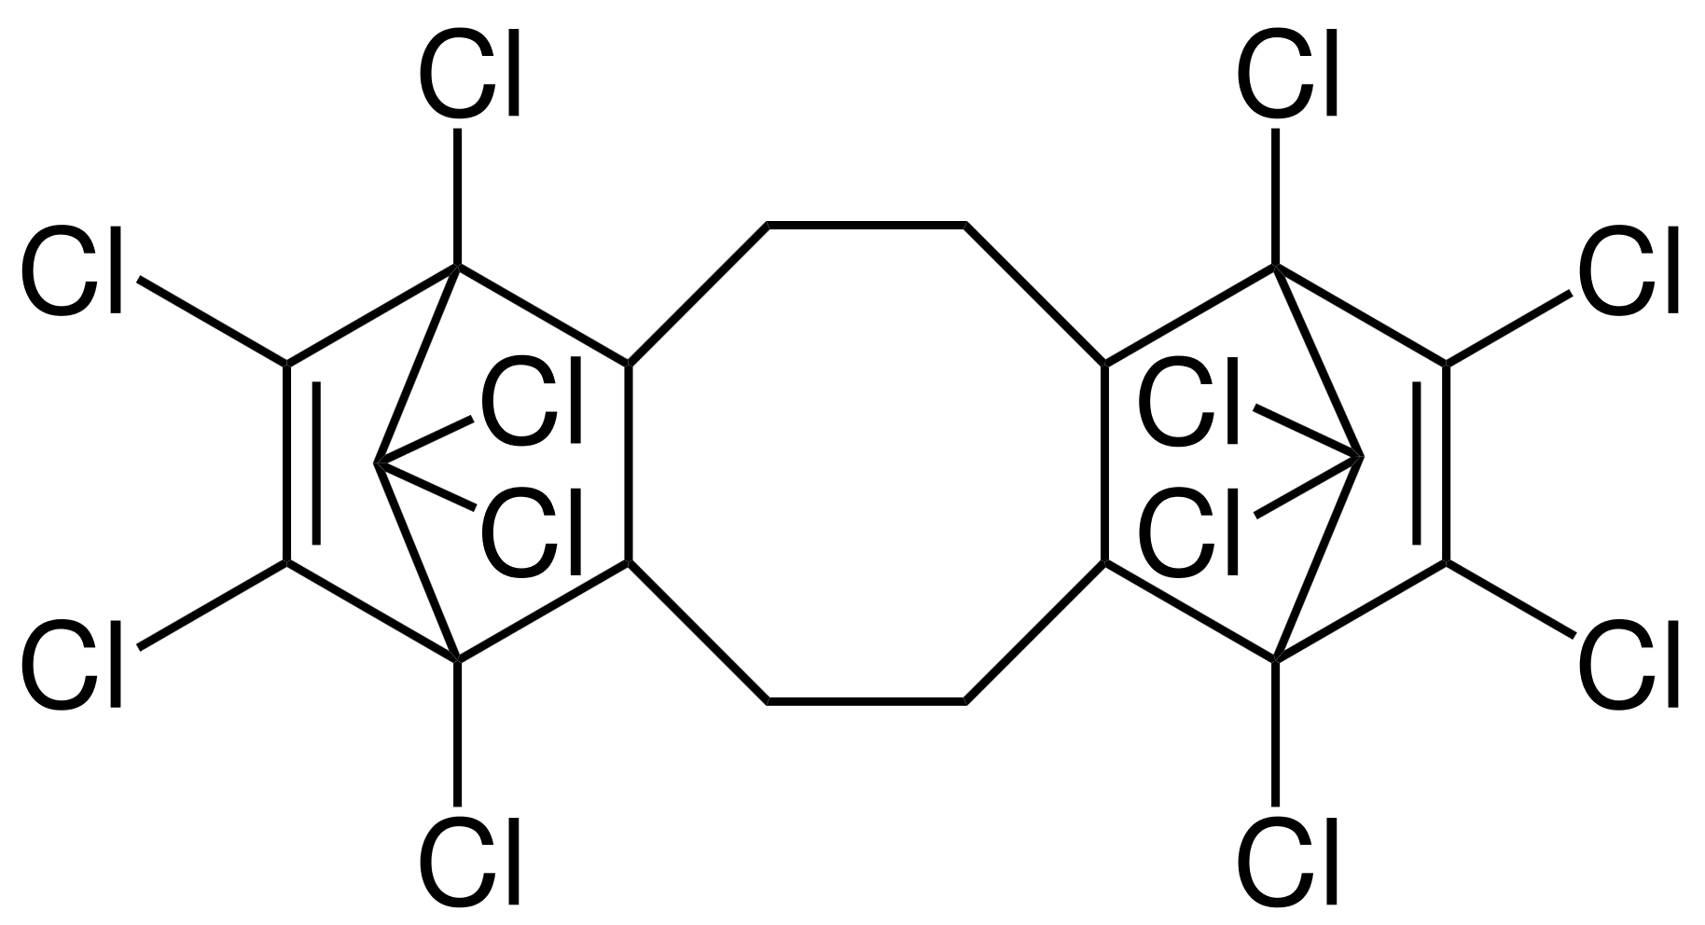 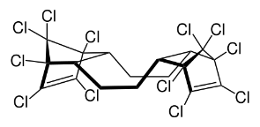 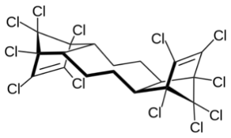

Figure 1. Chemical structure of Dechlorane Plus and its two constituent isomers (Source: UNEP 2022a)

## Hazards and risks to the environment

Dechlorane Plus® poses a risk to the environment because it is persistent, can be transported for long distances in the environment, is found throughout the environment including in remote regions, bioaccumulates and is transferred through food chains. As a result of its long-range environmental transport and POP characteristics, DP was globally agreed through the Stockholm Convention to be likely to lead to significant human health and/or environmental effects.

Dechlorane Plus® has been observed to cause oxidative damage to a wide range of organisms, including marine macroalgae, fish, marine bivalves, earthworms, birds and mice. Furthermore, there are indications that DP can cause neurodevelopmental toxicity in fish and has the potential for endocrine disruption. It has also been detected in breast milk and human blood.

Numerous monitoring studies demonstrate the environmental transport of DP to remote polar and mountainous regions via the atmosphere, ocean currents and migratory birds. DP has been detected in air, soil, sediment, water and biota of the Arctic, Antarctica and the Tibetan plateau.

Emissions of DP occur at all life cycle stages: it is released to the environment through diffuse emissions from DP-containing articles as well as from point source emissions such as manufacturing plants, wastewater treatment plants, e-waste recycling facilities and landfills.

In Australia, emissions are expected to be from use and disposal of DP-containing articles, as there are no reports of DP production in Australia.

## Additional information: regulation of Dechlorane Plus® in Australia

The AICIS [Evaluation Statement for DP](https://www.industrialchemicals.gov.au/sites/default/files/2023-06/EVA00041%20-%20Evaluation%20Statement%20-%2026%20June%202023.pdf) concluded that it poses a risk to the environment that requires management. It recommended DP be scheduled under the *Industrial Chemicals Environmental Management (Register) Act 2021* (ICEMR Act), with the application of appropriate risk management measures to minimise further release of DP to the environment from its introduction, use and release from articles.

Dechlorane Plus® is listed on the [Australian Inventory of Industrial Chemicals (AIIC)](https://services.industrialchemicals.gov.au/chemical-details-page/?id=98ba5cd3-10b0-ec11-8108-005056a07365), which means it can be introduced into Australia subject to any conditions specified in the Inventory listing. Neither the individual stereoisomers (*syn*-DP or *anti-*DP) are listed on the AIIC.

As there are no existing Australian regulatory controls currently available for DP, the use of the chemical is not subject to any specific national environmental regulations.

## Additional information: replacements for Dechlorane Plus®

There are suitable and commercially available alternatives for DP in most known applications and information indicates that global manufacturers are already transitioning to alternative chemical technologies.

Sectors using DP products that have public health and safety constraints (i.e. medical, automotive, aerospace and defence applications) may continue to use the chemical in these applications, under the terms of the Stockholm Convention listing, to allow adequate time to safely transition to alternative technologies.

## References

AICIS 2023, *1,4:7,10-dimethanodibenzo[a,e]cyclooctene, 1,2,3,4,7,8,9,10,13,13,14,14-dodecachloro-1,4,4a,5,6,6a,7,10,10a,11,12,12a-dodecahydro- (Dechlorane Plus), Evaluation Statement*, 26 June 2023, Australian Industrial Chemicals Introduction Scheme, [*1,4:7,10-*Dimethanodibenzo[a,e]cyclooctene, 1,2,3,4,7,8,9,10,13,13,14,14-dodecachloro-1,4,4a,5,6,6a,7,10,10a,11,12,12a-dodecahydro- (Dechlorane Plus) - Evaluation Statement - 26 June 2023 (industrialchemicals.gov.au)](https://www.industrialchemicals.gov.au/sites/default/files/2023-06/EVA00041%20-%20Evaluation%20Statement%20-%2026%20June%202023.pdf), accessed 29 January 2024.

UNEP 2019, [Dechlorane Plus (CAS No. 13560-89-9) and its syn-isomer (CAS No. 135821- 03-3) and anti-isomer (CAS No. 135821-74-8).](http://chm.pops.int/TheConvention/POPsReviewCommittee/Meetings/POPRC15/Overview/tabid/8052/Default.aspx) Stockholm Convention, Report of the Persistent Organic Pollutants Review Committee on the work of its fifteenth meeting, accessed 25 January 2024.

UNEP 2022a, [Risk management evaluation for Dechlorane Plus (Addendum).](https://chm.pops.int/Portals/0/download.aspx?d=UNEP-POPS-POPRC.18-11-Add.1.English.pdf) Stockholm Convention, Report of the Persistent Organic Pollutants Review Committee on the work of its eighteenth meeting, accessed 29 January 2024.

UNEP 2022b, [Risk profile for Dechlorane Plus (Addendum)](https://chm.pops.int/Portals/0/download.aspx?d=UNEP-POPS-POPRC.17-13-Add.2.English.pdf). Stockholm Convention, Report of the Persistent Organic Pollutants Review Committee on the work of its seventeenth meeting, accessed 29 January 2024.

UNEP 2023, SC-11/10 [Listing of Dechlorane Plus](https://chm.pops.int/Portals/0/download.aspx?d=UNEP-POPS-COP.11-SC-11-10.English.pdf) (Annex), Stockholm Convention, Report of the Conference of the Parties to the Stockholm Convention on Persistent Organic Pollutants on the work of its eleventh meeting, accessed 25 January 2024.

UNEP (n.d.a) [All POPs listed in the Stockholm Convention](http://chm.pops.int/TheConvention/ThePOPs/ListingofPOPs/tabid/2509/Default.aspx), Stockholm Convention website, accessed 29 January 2024.

UNEP (n.d.b) [Eleventh meeting of the Conference of the Parties to the Stockholm Convention](https://www.pops.int/TheConvention/ConferenceoftheParties/Meetings/COP11/tabid/9310/Default.aspx), Stockholm Convention website, accessed 25 January 2024.

## More information

Email [ichems.enquiry@dcceew.gov.au](mailto:ichems.enquiry@dcceew.gov.au)

Web <https://www.dcceew.gov.au/environment/protection/chemicals-management/national-standard>

**Acknowledgement of Country**

Our department recognises the First Peoples of the nation and their ongoing connection to culture and country. We acknowledge First Nations Peoples as the Traditional Owners, Custodians and Lore Keepers of the world’s oldest living culture and pay respects to their Elders past, present and emerging.

© Commonwealth of Australia 2024

Unless otherwise noted, copyright (and any other intellectual property rights) in this publication is owned by the Commonwealth of Australia (referred to as the Commonwealth).

All material in this publication is licensed under a [Creative Commons Attribution 4.0 International Licence](https://creativecommons.org/licenses/by/4.0/legalcode) except content supplied by third parties, logos and the Commonwealth Coat of Arms.

The Australian Government acting through the Department of Climate Change, Energy, the Environment and Water has exercised due care and skill in preparing and compiling the information and data in this publication. Notwithstanding, the Department of Climate Change, Energy, the Environment and Water, its employees and advisers disclaim all liability, including liability for negligence and for any loss, damage, injury, expense or cost incurred by any person as a result of accessing, using or relying on any of the information or data in this publication to the maximum extent permitted by law.