March 2024
Chemical profile –
β-Alanine, N-(2-hydroxyethyl)-N-[2-[(1-oxooctyl)amino]ethyl]-
Summary
- β-Alanine, N-(2-hydroxyethyl)-N-[2-[(1- oxooctyl)amino]ethyl]- (the chemical) is used in Australia as a component in fluorine free firefighting foams.
- The chemical was assessed for environmental risk by the Australian Industrial Chemical Introduction Scheme (AICIS) for end use in firefighting products at industrial and mining sites.
- Based on the assessed use pattern, the chemical is expected to be of low risk to the environment.
- The chemical is classified under the Globally Harmonized System of Classification and Labelling of Chemicals (GHS) as Chronic Aquatic Category 3 (‘Harmful to aquatic life with long lasting effects’).
- The chemical has risk characteristics of a Schedule 3 chemical, as set out in the IChEMS Principles.
End Use
β-Alanine, N-(2-hydroxyethyl)-N-[2-[(1- oxooctyl)amino]ethyl]- (the chemical) is used as a component in firefighting foams.
Based on information provided in the AICIS 2023 risk assessment, the chemical is imported into Australia at up to 0.5 tonne per annum as a component of products (at up to 2% concentration) for further reformulation into firefighting products. Reformulated products containing the chemical at ≤ 0.12% concentration are available for use only at industrial and mining sites.
In situations where standard measures such as bunding are designed and implemented to contain firewater, the chemical is not expected to be released to sewer or surface waters. There is a risk of firefighting products containing the chemical being released to the localised environment of industrial and mining sites, particularly soil, during firefighting events. Any harmful impacts are expected to be short term, based on the chemical’s biodegradation properties, and localised, based on its end-uses at industrial and mining sites.
Firefighting products containing the chemical are not expected to be available to the public, such as fire extinguishers sold in retail shops, or used against domestic fires.
Chemical identity
- CAS Name: β-Alanine, N-(2-hydroxyethyl)-N-[2-[(1- oxooctyl)amino]ethyl]-
- CAS registry number: 64265-45-8
- Synonyms: -(2-Hydroxyethyl)-N-[2-[(1-oxooctyl)amino]ethyl]-β-alanine
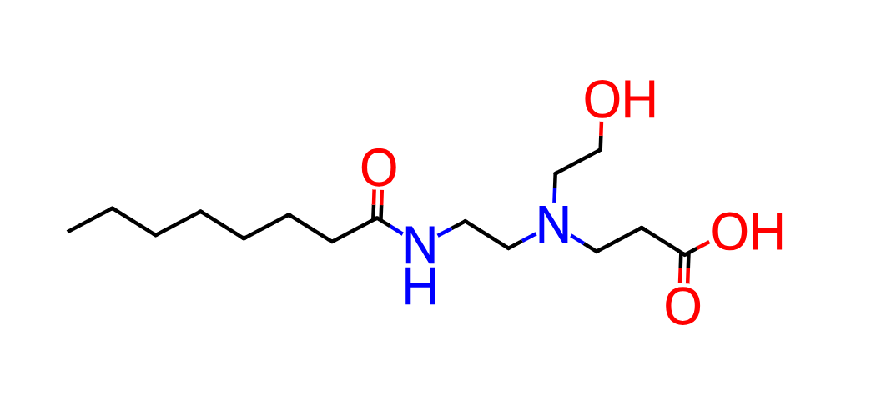
Figure 1 – Chemical structure of β-Alanine, N-(2-hydroxyethyl)-N-[2-[(1- oxooctyl)amino]ethyl]-
Provisional scheduling outcome rationale
- β-Alanine, N-(2-hydroxyethyl)-N-[2-[(1- oxooctyl)amino]ethyl]- was assessed against the IChEMS Principles. The chemical does not have risk characteristics of a Schedule 4 or higher substance.
- The Globally Harmonized System of Classification and Labelling of Chemicals (GHS) classifies this chemical as harmful to aquatic life with long lasting effects.
- Taking into account the GHS chronic toxicity classification, the chemical, if used in Australia in accordance with the particular assessed use for the chemical, has potential to cause harm to the environment.
- β-Alanine, N-(2-hydroxyethyl)-N-[2-[(1- oxooctyl)amino]ethyl]- is proposed to be listed in Schedule 3 of the IChEMS Register.

