March 2024
Chemical profile
1,3,5-triazine-2,4,6-triamine (melamine)
Summary
- Melamine is used in large volumes in Australia, mainly for the production of synthetic resins.
- The environmental risk of the chemical was evaluated by the Australian Industrial Chemical Introduction Scheme (AICIS).
- In addition to its use as an intermediate in the production of melamine resins, melamine is used as a flame-retardant additive, a component in adhesives and in coatings and inks.
- Based on these assessed use patterns, the chemical is a low risk to the environment.
- The chemical does not satisfy the criteria for classification for acute or chronic aquatic hazard under the Globally Harmonised System of Classification and Labelling of Chemicals (GHS).
- The chemical has risk characteristics of a Schedule 2 chemical, as set out in the IChEMS Principles.
End Use
The chemical is known to be used in Australia in adhesives and construction materials. Based on international use data, the chemical is used in large volumes in the manufacture of synthetic resins. These resins have a wide range of industrial uses including laminates, coatings, food packaging and tableware. The chemical also has commercial use including as an additive flame retardant and domestic use in paints, coatings and inks.
Chemical identity
- CAS Name: Melamine
- CAS registry number: 108-78-1
- Synonyms: Cyanuramide; cyanurotriamide; cyanurotriamine; 2,4,6-Triaminotriazine; 1,3,5-triazine-2,4,6-triamine.
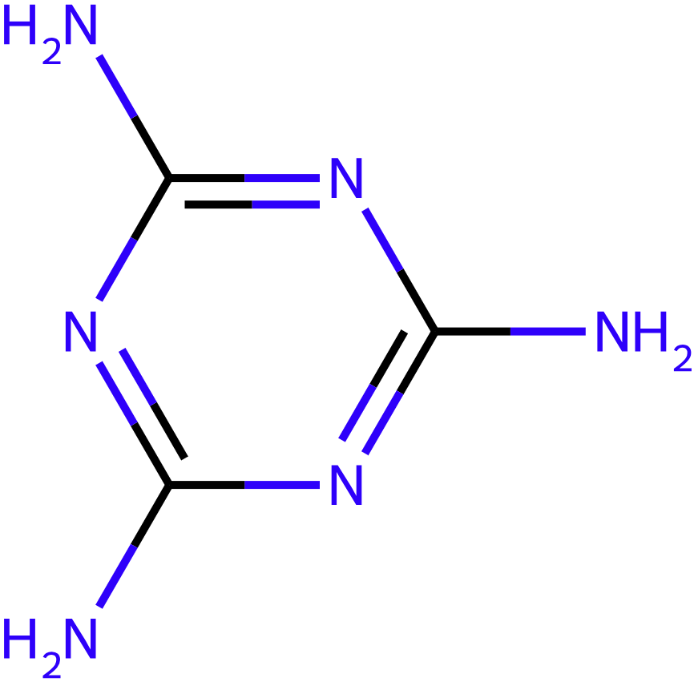
Figure 1 – Chemical structure of melamine
Provisional scheduling outcome rationale
- Melamine was assessed against the IChEMS Principles. The chemical does not have risk characteristics of a Schedule 3 or higher substance.
- The AICIS assessment calculated a Risk Quotient (RQ) below 0.1, which indicates that melamine is not expected to pose a risk to the environment.
- The chemical does not satisfy the criteria for classification under GHS.
- Melamine is proposed to be added to Schedule 2 of the Register.

