27 March 2025

Chemical profile

# 1,2-Dibromoethane

## Summary

* 1,2-Dibromoethane is used as a lead scavenger in leaded aviation fuel (Avgas), which is predominately used by Australia’s general aviation fleet of aircraft. Based on current statistics on the volume of Avgas sold in Australia, it is predicted that 35-71 tonnes of this chemical is used per year as a fuel additive.
* It is anticipated that the use of leaded Avgas will decline in Australia in-line with international initiatives to phase out its use and movement by industry to provide unleaded Avgas options.
* 1,2-Dibromoethane also has minor use as an intermediate in the synthesis of fine chemicals (e.g. dyes and pharmaceuticals) and as a solvent for resins, gums and waxes.
* The Commonwealth environmental risk assessment concluded that 1,2-dibromoethane is persistent, not bioaccumulative, and toxic. The chemical likely undergoes long-range transport to locations far from its place of release.
* Introduction and use of this chemical is closely tied to the use of leaded fuel in Australia. The use of leaded fuel is currently regulated under the *Fuel Quality Standards Act 2000*, but this regulation does not extend to its use in leaded Avgas.
* 1,2-Dibromoethane is a priority for scheduling under the [Industrial Chemicals Environmental Management Standard](https://www.dcceew.gov.au/environment/protection/chemicals-management/national-standard) (IChEMS) to manage its risks to the environment.

## Introduction and use of 1,2-dibromoethane in Australia

The primary use of 1,2-dibromoethane in Australia is as a lead scavenger in leaded aviation fuel (leaded Avgas). 1,2-Dibromoethane prevents the accumulation of lead in the engine by reacting with the leaded combustion product, lead oxide, to form volatile lead salts that are expelled from the engine.

Based on current statistics on the volume of Avgas sold in Australia (70 million litres in 2023), the minimum and maximum lead concentration in leaded AvGas (0.56 g/L in AvGas 100LL and 1.12 g/L in AvGas 100), and the proportion of 1,2-dibromoethane to lead (90 g per 100 g of lead), it is estimated that up to 71 tonnes of 1,2-dibromoethane is used in Australia each year. (DCCEEW 2024, NICNAS 2014).

Leaded avgas is used by a proportion of Australia’s general aviation (light) aircraft used for instructional flying, agricultural mustering and spraying, policing, firefighting and rural medical care (DITRDCA 2023).

The chemical is also used as an intermediate in the synthesis of fine chemicals such as dyes and pharmaceuticals, and as a solvent for resins, gums and waxes (NICNAS 2014).

The chemical may have natural background levels in oceans as it may be a natural product of arctic brown, red and green microalgae (GoC 2013).

Release of the chemical to the environment from its use in fuels is low. The chemical decomposes in the engine through combustion of the fuel, however there is evidence that a proportion of unreacted chemical is expelled in exhaust gas (NCoM 2005).

## Controls under international conventions

The industrial use of 1,2-dibromoethane is not subject to any controls under international conventions.

1,2-Dibromoethane is listed on Annex III of the Rotterdam Convention on the Prior Informed Consent Procedure for Certain Hazardous Chemicals and Pesticides in International Trade. The listing, however, only applies to use in pesticides and is not applicable to the trade of the chemical for industrial uses.

## Chemical identity

* **Chemical name:** Ethane, 1,2-dibromo-
* **CAS registry number**: 106-93-4
* **Synonyms:** ethylene dibromide, EDB, 1,2-dibromoethane, glycol dibromide, sym-dibromoethane,

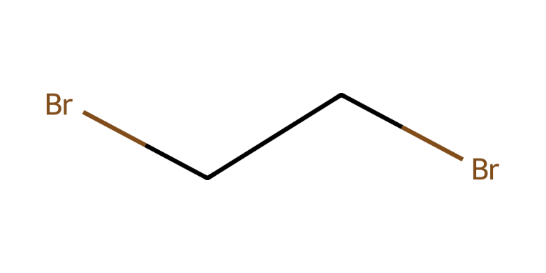

Figure 1. Chemical structure of 1,2-dibromoethane

## Hazards and risks to the environment

The National Industrial Chemicals Notification and Assessment Scheme (NICNAS) published an environmental risk assessment of 1,2-dibromoethane in 2014 (NICNAS 2014). The assessment concluded that the current industrial uses of the chemical as a fuel additive are not expected to pose an unreasonable risk to the environment.

The chemical is expected to move to the atmosphere after release to the environment. The chemical is persistent in air. It degrades slowly in water, except under specific anaerobic conditions (NICNAS 2014).

The chemical is not bioaccumulative but has high chronic toxicity in fish (NICNAS 2014).

1,2-Dibromoethane is expected to undergo long-range transport due to its high volatility and long lifetime in the atmosphere, however measurement of concentrations in remote regions is confounded by potential natural sources of the chemical (NICNAS 2014).

## Additional information: regulation of 1,2-dibromoethane in Australia

1,2-Dibromoethane is not currently subject to environmental regulation in Australia.

The chemical is subject to reporting under the National Pollutant Inventory (NPI). Annual reporting for emissions of more than 10 tonnes is required (NPI 2022).

## References

DCCEEW 2024, [Australian Petroleum Statistics 2024](https://www.energy.gov.au/publications/australian-petroleum-statistics-2024), Department of Climate Change, Energy, the Environment and Water, accessed 25 November 2024

DITRDCA 2023, [Aviation Green Paper](https://www.infrastructure.gov.au/infrastructure-transport-vehicles/aviation/aviation-green-paper), Australian Government Department of Infrastructure, Transport, Regional Development, Communications and the Arts, accessed 25 November 2024

GoC 2013, [Screening Assessment Report – Ethane, 1,2-dibromo- (1,2-Dibromoethane)](https://www.canada.ca/content/dam/eccc/migration/ese-ees/c1b0bbd3-7844-4f5e-b2fb-cbad1e7e055e/dbe_fsar_en.pdf), Environment Canada and Health Canada, Government of Canada, accessed 22 November 2024

NCoM 2005, Potential Ozone Depleting Substances, Uses and Alternatives in the Nordic Countries, TemaNord 2005:580, Nordic Council of Ministers, Copenhagen 2005, accessed 15 January 2025.

NICNAS 2014, [Ethane, 1,2-dibromo-: Environment tier II assessment](https://www.industrialchemicals.gov.au/sites/default/files/Ethane%2C%201%2C2-dibromo-_%20Environment%20tier%20II%20assessment.pdf), 18 September 2014, National Industrial Chemicals Notification and Assessment Scheme, Department of Health, accessed 19 November 2024.

NPI 2022, [Substance lists and thresholds](https://www.dcceew.gov.au/environment/protection/npi/substances/substance-list-and-thresholds), National Pollutant Inventory, Department of Climate Change, Energy, the Environment and Water, accessed 25 November 2024.

SWA 2018, [WES Review 2018 – Non-threshold based genotoxic carcinogens, Australian workplace exposure standards and advisory notations,](https://www.safeworkaustralia.gov.au/system/files/documents/1806/non-threshold_based_genotoxic_carcinogens_-_accessory_document_to_recommending_health-based_workplace_exposure_standards_and_notations.pdf) Safe Work Australia, accessed 25 November 2024.

## More information

Email [ichems.enquiry@dcceew.gov.au](mailto:ichems.enquiry@dcceew.gov.au)

Web <https://www.dcceew.gov.au/environment/protection/chemicals-management/national-standard>