27 March 2025

Chemical profile

# Decabromodiphenyl ethane (DBDPE)

## Summary

* Decabromodiphenyl ethane is a high concern chemical as it is persistent in the environment, bioaccumulative, has potential for adverse effects to aquatic and terrestrial organisms, and undergoes long-range transport to locations far from its place of release.
* The chemical is used as an additive flame retardant in a wide range of plastic and rubber products, such as plastic parts or insulation coating for cables for automotive equipment, and electrical and electronic equipment. It is also used in building and construction applications, and textiles.
* Introduction and use of the chemical itself is restricted in Australia. There are no restrictions, however, on the import and use of DBDPE-containing articles resulting in indirect exposure to the environment.
* Decabromodiphenyl ethane is a priority for scheduling under the [Industrial Chemicals Environmental Management Standard](https://www.dcceew.gov.au/environment/protection/chemicals-management/national-standard) (IChEMS) to manage its long-term risks to the environment.

## Introduction and use of DBDPE in Australia

Decabromodiphenyl ethane (DBDPE) is used as a flame retardant which is added to products to prevent burning or to slow the spread of fire.

The chemical is used in plastic and rubber materials for a variety of applications, at concentrations of 5–‍30%. It is used in cables and plastic parts for electrical and electronic equipment, automotive equipment and transport applications. It is also found in adhesives and sealants, films and coatings, building and construction materials, and in textiles.

The introduction of DBDPE as a chemical on its own, or in mixtures, is severely restricted in Australia. Articles containing DBDPE, however, are not currently restricted despite expected import in substantial quantities.

Decabromodiphenyl ethane is an additive flame retardant, which means it is not chemically bound to the material to which it is added. Unbound chemicals may migrate or leach out of articles over time. Given the widespread usage of DBDPE-containing articles, emissions of DBDPE into the environment from migration are likely during use and end-of-life disposal. This may result in continued emissions from waste disposal, such as e-waste from electronic products, for many years to come.

## Controls under international conventions

Decabromodiphenyl ethane is not listed under the [Stockholm Convention on Persistent Organic Pollutants](https://chm.pops.int/Home/tabid/10001/Default.aspx). The chemical, however, was assessed by the Australian Industrial Chemicals Introduction Scheme (AICIS) to have the characteristics of a persistent organic pollutant (POP) as it fulfills the required screening criteria in Annex D of the convention.

Australia is a party to the Stockholm Convention and has obligations to take measures to regulate with the aim of preventing production and use of chemicals with the characteristics of POPs.

## Chemical identity

* **Chemical name:** Benzene, 1,1'-(1,2-ethanediyl)bis[2,3,4,5,6-pentabromo-
* **CAS registry number:** 84852-53-9
* **Synonyms:** Decabromodiphenyl ethane, DBDPE, 1,2‑bis(pentabromophenyl) ethane
* **Trade names:** FR-1410, Saytex 8010, Firemaster 2100

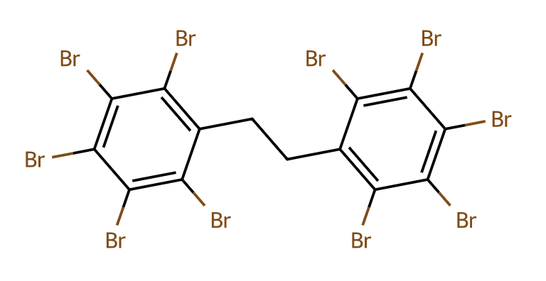

Figure 1. Chemical structure of DBDPE

## Hazards and risks to the environment

The Australian Industrial Chemicals Introduction Scheme (AICIS), Australia’s national regulator of the importation and manufacture of industrial chemicals, published a series of assessments on DBDPE between 2021 and 2022. The assessments concluded that DBDPE has the characteristics of a persistent organic pollutant (POP), and that introduction and use of DBDPE could pose significant long-term risks to the environment.

Decabromodiphenyl ethane poses a risk to the environment because it is persistent, can be transported for long distances in the environment, is found throughout the environment including in remote regions, bioaccumulates and is transferred through food chains. It also has potential to have adverse effects on aquatic and terrestrial organisms.

Decabromodiphenyl ethane does not readily biodegrade and is persistent in water, soils and sediments. It has been reported to bioaccumulate and biomagnify in aquatic food webs (AICIS 2021a).

Decabromodiphenyl ethane has the potential to have adverse effects on aquatic and terrestrial organisms with hepatotoxicity indicated in fish, rats and mice; potential for producing hypothyroidism in rats; and thyroid hormone related effects observed in chicken hepatocytes at environmentally relevant concentrations (AICIS 2021a).

Release of DBDPE into the environment may occur through diffuse emission from leaching from DBDPE-containing articles, as well as from point source emissions such as waste-water treatment plants, landfill and recycling facilities (AICIS 2021a).

Available evidence indicates that DBDPE can be transported by wet and dry deposition through the environment and to remote polar regions. The chemical has been found in air, soils, sediment, moss, lichens, trees and surface waters long distances away from emission sources, including in Antarctica and the Arctic (AICIS 2021a).

Decabromodiphenyl ethane has also been detected in Australia (AICIS 2021a). In Australia, emissions are expected to be from the use and disposal of DBDPE-containing articles, as manufacture, import or use of the chemical substance is not authorised in Australia.

## Additional information: regulation of DBDPE in Australia

Decabromodiphenyl ethane is not listed on the Australian Inventory of Industrial Chemicals, which means the chemical cannot be introduced (imported or manufactured) or used in Australia without prior authorisation.

In 2021, the AICIS recommended DBDPE be scheduled under the *Industrial Chemicals Environmental Management (Register) Act 2021*, with the application of appropriate risk management measures.

Evaluation by the AICIS emphasised that DBDPE could pose significant long-term risks to the environment resulting in [cancellation](https://cdnservices.industrialchemicals.gov.au/statements/VA-1039%20-%20Assessment%20Statement%20-%2012%20July%202022.pdf) of its assessment certificate in 2022 on the basis that risks to the environment posed by use of DBDPE could not be managed within existing frameworks.

Articles containing DBDPE are neither regulated nor subject to risk management requirements under the AICIS.

## Additional information: replacements for DBDPE

Decabromodiphenyl ethane is promoted as a replacement substance for commercial decabromodiphenyl ether (c‑decaBDE). The chemical c-decaBDE is [listed in Schedule 6](https://www.dcceew.gov.au/environment/protection/chemicals-management/national-standard/decabromodiphenyl-ether-decabde-and-nonabromodiphenyl-ether-nonabde) of the Industrial Chemicals Environmental Management Standard (IChEMS), meaning import, manufacture and export is prohibited, with limited exceptions.

Alternative technologies can be used instead of DBDPE (and c-decaBDE) to impart fire retardancy, such as use of non-flammable materials, physical barriers or product redesign (UNEP 2015). However, transition by industry to use alternative chemicals or technologies may require research, development and adequate time, especially for those sectors that rely on flame retardants for public health and safety outcomes.

## References

AICIS (Australian Industrial Chemicals Introduction Scheme) (2021a), [Benzene, 1,1'-(1,2-ethanediyl)bis[2,3,4,5,6-pentabromo-, Public Report [STD/1676], August 2021](https://www.industrialchemicals.gov.au/sites/default/files/2021-08/STD1676%20public%20report%20%5B1371%20KB%5D.pdf), AICIS, accessed 25 February 2025.

AICIS (Australian Industrial Chemicals Introduction Scheme) (2021b), [Benzene, 1,1'-(1,2-ethanediyl)bis[2,3,4,5,6-pentabromo-, Evaluation Statement [EVA00072], 18 November 2021](https://www.industrialchemicals.gov.au/sites/default/files/2021-12/Final%20Evaluation%20Statement%20-%20EVA00072%20Decabromodiphenylethane%20-%2018%20Nov%202021%20%5B434%20KB%5D.PDF), [AICIS](https://www.industrialchemicals.gov.au/sites/default/files/2021-12/Final%20Evaluation%20Statement%20-%20EVA00072%20Decabromodiphenylethane%20-%2018%20Nov%202021%20%5B434%20KB%5D.PDF), accessed 25 February 2025.

AICIS (Australian Industrial Chemicals Introduction Scheme) (2022), [Benzene, 1,1'-(1,2-ethanediyl)bis[2,3,4,5,6-pentabromo-, Assessment Statement [VA-1039], 24 June 2022](https://cdnservices.industrialchemicals.gov.au/statements/VA-1039%20-%20Assessment%20Statement%20-%2012%20July%202022.pdf), AICIS, accessed 25 February 2025.

UNEP (United Nations Environment Programme) (2015), [Risk management evaluation on decabromodiphenyl ether (commercial mixture, c-decaBDE)](https://chm.pops.int/Portals/0/download.aspx?d=UNEP-POPS-POPRC.11-10-Add.1.English.pdf), 23 November 2015, Report of the Persistent Organic Pollutants Review Committee on the work of its eleventh meeting (Addendum), UNEP, accessed 25 February 2025.

## More information

Email [ichems.enquiry@dcceew.gov.au](mailto:ichems.enquiry@dcceew.gov.au)

Web <https://www.dcceew.gov.au/environment/protection/chemicals-management/national-standard>