27 March 2025

Chemical profile

# Methylcyclopentadienyl manganese tricarbonyl (MMT)

## Summary

* Methylcyclopentadienyl manganese tricarbonyl (MMT) is used as a multifunctional anti-valve seat recession and octane enhancer fuel additive.
* Methylcyclopentadienyl manganese tricarbonyl-containing fuel was originally used as a lead-free alternative to leaded petrol.
* Methylcyclopentadienyl manganese tricarbonyl is categorised as not persistent, not bioaccumulative and toxic according to Australian Environmental Criteria for Persistent, Bioaccumulative and/or Toxic Chemicals (GHS Acute Category 1).
* Manganese compounds are inorganic by-products from the combustion of MMT. Manganese is a naturally occurring and ubiquitous element in the environment and an essential nutrient for plants and animals. The metal and its inorganic compounds aren’t considered a risk for terrestrial or aquatic environments as emissions into the environment from use of fuels containing MMT is unlikely to develop to levels of concern.

## Introduction and end use of MMT in Australia

Methylcyclopentadienyl manganese tricarbonyl (MMT) is used as a multifunctional anti-valve seat recession (AVSR) fuel additive and is commonly added to internal combustion engine fuels as a smoke abatement agent, an octane enhancer and inhibitor of valve seat recession. It is either pre-blended at the refinery or added to unleaded petrol by the vehicle owner.

Methylcyclopentadienyl manganese tricarbonyl was originally marketed to be used as an antiknock agent in internal combustion engine lead replacement fuels. The chemical is also reported to be used in household, commercial, industrial, and marine burners to reduce particulate smoke emissions.

The manufacture of MMT does not occur in Australia.

Fuel additives containing MMT are available for both industrial and consumer use and are delivered either by pre-blending to unleaded petrol at the oil refinery or purchased and added to unleaded petrol by the vehicle owner.

The use of MMT-containing fuels is declining as fuels containing MMT and other metallic fuel additives may cause issues in vehicle engines.

## Controls under international conventions

Methylcyclopentadienyl manganese tricarbonyl is not listed under any international conventions.

## Chemical identity

Methylcyclopentadienyl manganese tricarbonyl is an organo-manganese compound with the formula C9H7MnO3. It is a dark orange or yellow liquid that decomposes rapidly when exposed to light. The manganese atom in MMT is coordinated with three carbonyl groups as well as to all five main carbon atoms of the methylcyclopentadienyl ring. These hydrophobic organic ligands make MMT highly lipophilic.

**CAS Name:** Methylcyclopentadienylmanganese tricarbonyl

**CAS registry number:** 12108-13-3

**Synonyms:** MMT, methylcyclopentadienyl manganese tricarbonyl, methylcymantrene, Manganese, tricarbonyl[(1,2,3,4,5-.eta.)-1-methyl-2,4-cyclopentadien-1-yl]-.

**Trade Names:** AK-33X, Antiknock-33, CI-2, Combustion Improver-2.

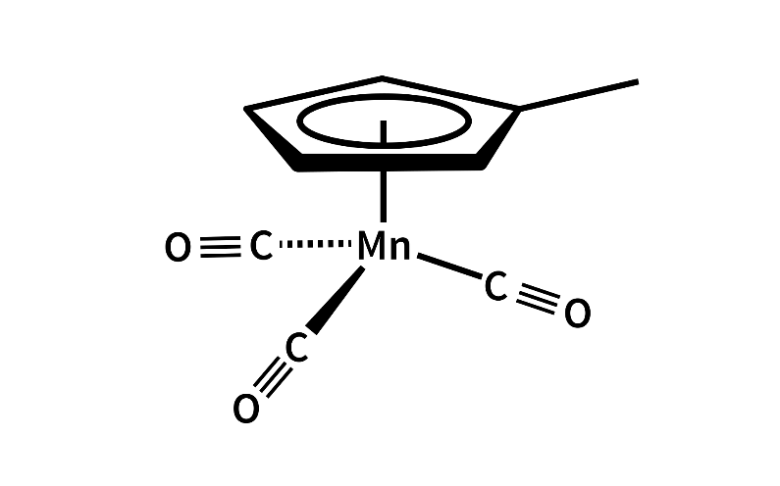

**Figure 1 - Chemical structure of MMT**

## Hazards and risks to the environment

In 2003, a [NICNAS assessment](https://www.industrialchemicals.gov.au/sites/default/files/2020-12/PEC24-Methylcyclopentadienyl-manganese-tricarbonyl-MMT.pdf) concluded that it is unlikely for terrestrial and aquatic organisms to be exposed to MMT at or above levels of concern. The chemical is not persistent (where sunlight is prevalent), not bioaccumulative but is toxic according to [Australian Environmental Criteria for Persistent, Bioaccumulative and/or Toxic Chemicals](https://www.dcceew.gov.au/environment/protection/chemicals-management/national-standard/australian-pbt-criteria) (PBT).

Methylcyclopentadienyl manganese tricarbonyl is classified under the Globally Harmonized System of Classification and Labelling of Chemicals (GHS) as Aquatic Chronic Category 1 (‘Very toxic to aquatic life with long lasting effects’) and Aquatic Acute Category 1 (‘Very toxic to aquatic life).

Once MMT is released to the environment, it’s not expected to be persistent where sunlight is prevalent as the chemical is susceptible to photochemical degradation in the atmosphere, rapidly decomposing into a mixture of manganese oxides with a reported atmospheric half-life of 8-18 seconds. However, in environments with no exposure to sunlight, MMT may not readily degrade.

Leakages from underground fuel storage tanks where MMT-containing fuel is stored provide a potential process for point source releases of MMT into soils and groundwater and potentially other environmental media (e.g. surface waters, air).

Due to the rapid degradation of MMT through direct photolysis and/or reaction with atmospheric hydroxyl radicals, any risk from un-degraded or un-combusted MMT is expected to be negligible.

Methylcyclopentadienyl manganese tricarbonyl that is combusted produces inorganic manganese compounds. Manganese is a naturally occurring and ubiquitous element in the environment and is an essential nutrient for plants and animals. Manganese and its compounds have moderate acute and chronic toxicity to aquatic life. However, the emission of manganese into the environment from use of fuels containing MMT is unlikely to develop to levels of concern and therefore poses a low risk for terrestrial or aquatic environments.

## References

NICNAS (National Industrial Chemicals Notification and Assessment Scheme) (2003), [Methylcyclopentadienyl Manganese Tricarbonyl (MMT) Priority Existing Chemical Assessment Report No. 24](https://www.industrialchemicals.gov.au/sites/default/files/2020-12/PEC24-Methylcyclopentadienyl-manganese-tricarbonyl-MMT.pdf), Commonwealth of Australia, accessed 1 December 2025.

ICCT (The international Council on Clean Transportation) (2009), [Methylcyclopentadienyl Manganese Tricarbonyl (MMT): A Science and Policy Review](https://theicct.org/wp-content/uploads/2021/06/MMT_dec08.pdf), accessed 9 December 2025.

Australian Government Department of the Environment (2014), [Ecotoxicological assessment of manganese](https://www.dcceew.gov.au/sites/default/files/documents/ir630.pdf), accessed 9 December 2025.

Department of Climate Change, Energy, the Environment and Water (2022), [Manganese & compounds Substance Fact Sheet](https://www.dcceew.gov.au/environment/protection/npi/substances/fact-sheets/manganese-compounds#tabs-3), accessed 10 December 2025.

United States Environmental Protection Agency (2007), [Screening-level Hazard Characterization of High Production Volume Chemicals, Methylcyclopentadienyl Manganese Tricarbonyl (MMT) (CAS No. 12108-13-3)](https://nepis.epa.gov/Exe/ZyNET.exe/P1013SX9.TXT?ZyActionD=ZyDocument&Client=EPA&Index=2006+Thru+2010&Docs=&Query=&Time=&EndTime=&SearchMethod=1&TocRestrict=n&Toc=&TocEntry=&QField=&QFieldYear=&QFieldMonth=&QFieldDay=&IntQFieldOp=0&ExtQFieldOp=0&XmlQuery=&File=D%3A%5Czyfiles%5CIndex%20Data%5C06thru10%5CTxt%5C00000047%5CP1013SX9.txt&User=ANONYMOUS&Password=anonymous&SortMethod=h%7C-&MaximumDocuments=1&FuzzyDegree=0&ImageQuality=r75g8/r75g8/x150y150g16/i425&Display=hpfr&DefSeekPage=x&SearchBack=ZyActionL&Back=ZyActionS&BackDesc=Results%20page&MaximumPages=1&ZyEntry=1&SeekPage=x&ZyPURL), accessed 10 December 2025.

OECD, [Categorization Results from the Canadian Domestic Substance List, Manganese, tricarbonyl[(1,2,3,4,5-<C)-1-methyl-2,4-cyclopentadien-1-yl]-](https://canadachemicals.oecd.org/ChemicalDetails.aspx?ChemicalID=C9A8069A-0CE6-4E4E-873B-38AD5B30BD8C), accessed 11 December 2025.

Department of Health and Ageing (2003), [National Drugs and Poisons Schedule Committee, Record of Reasons 39th Meeting 14-16 October 2003](https://www.tga.gov.au/sites/default/files/ndpsc-record-39.pdf), accessed 15 January 2025.

## More information

Email [ichems.enquiry@dcceew.gov.au](mailto:ichems.enquiry@dcceew.gov.au)

Web [www.dcceew.gov.au/environment/protection/chemicals-management/national-standard](http://www.dcceew.gov.au/environment/protection/chemicals-management/national-standard)