26 August 2025
Chemical profile

Carbonodithioic acid, O-(2-methylbutyl) ester, sodium salt (1:1) and Carbonodithioic acid,

O-(3-methylbutyl) ester, sodium salt (1:1)

Summary
- Carbonodithioic acid, O-(2-methylbutyl) ester, sodium salt (1:1) and carbonodithioic acid, O₋(3₋methylbutyl) ester, sodium salt (1:1) are used as flotation agents in mineral processing.
- The chemicals in this group pose a low risk to the environment.
- The chemicals in this group are a priority for scheduling due to their high-volume usage in Australia.

Chemical identity
The chemicals in this group are isomers which differ only by the position of the methyl substituent on the butyl group. These chemicals have been placed in a group as they have known applications as flotation agents and have similar hazard properties.

Carbonodithioic acid, O-(2-methylbutyl) ester, sodium salt (1:1)
- Chemical name: Carbonodithioic acid, O-(2-methylbutyl) ester, sodium salt (1:1)
- CAS registry number: 72187-33-8
- Synonyms: sodium 2-methylbutoxymethanedithioate
- Molecular formula: C₆H₁₂OS₂.Na

Carbonodithioic acid, O-(3-methylbutyl) ester, sodium salt (1:1)
- Chemical name: Carbonodithioic acid, O-(3-methylbutyl) ester, sodium salt (1:1)
- CAS registry number: 34761-63-2
- Synonyms: sodium 3-methylbutoxymethanedithioate; Dithiocarbonic acid O-isopentyl ester sodium salt; O-(3,3-Dimethylpropyl)carbonodithioate, sodium salt; Sodium isoamylxanthate;
- Molecular formula: C₆H₁₂OS₂.Na
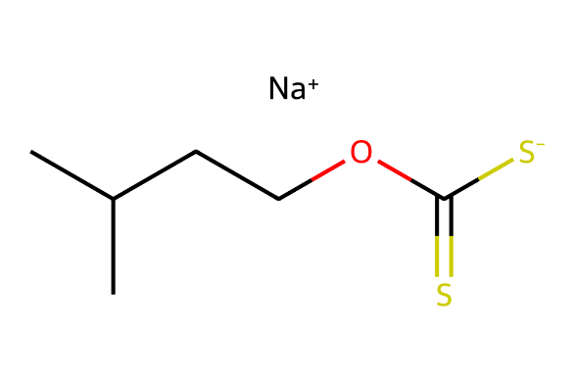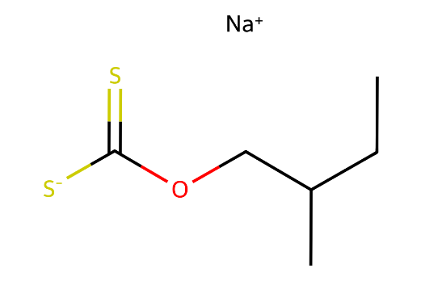
Figure 1 – Chemical structures of Carbonodithioic acid, O-(3-methylbutyl) ester, sodium salt (1:1) (left) and Carbonodithioic acid, O-(2-methylbutyl) ester, sodium salt (1:1) right.

Hazards and risks to the environment
Carbonodithioic acid, O-(2-methylbutyl) ester, sodium salt (1:1) and carbonodithioic acid, O-(3-methylbutyl) ester, sodium salt (1:1) were assessed for environmental risk by the Australian Industrial Chemical Introduction Scheme (AICIS) in 2024. The chemicals in this group are categorised as not bioaccumulative (not B) and as toxic (T) according to the Australian Environmental Criteria for Persistent, Bioaccumulative and/or Toxic Chemicals.
The assessed chemicals are readily biodegradable and hydrolytically unstable under environmental conditions. They have been categorised in the AICIS assessment as persistent based on the formation of a persistent degradant product.
The chemicals are not released to the environment under normal conditions of use.

Introduction and use of the chemicals in Australia
The chemicals in this group are used as flotation agents for mineral processing in industrial mining facilities. The chemicals in this group are used in volumes greater than five thousand tonnes per year in Australia.

References
AICIS (Australian Industrial Chemicals Introduction Scheme) (2024). Carbonodithioic acid, O-(2-methylbutyl) ester, sodium salt (1:1), Assessment Statement [CA09899], 14 June 2024, Australian Industrial Chemicals Introduction Scheme.
AICIS (Australian Industrial Chemicals Introduction Scheme) (2024). Carbonodithioic acid, O-(3-methylbutyl) ester, sodium salt (1:1), Assessment Statement [CA09735], 25 March 2024, Australian Industrial Chemicals Introduction Scheme.

More information
Email ichems.enquiry@dcceew.gov.au
Web https://www.dcceew.gov.au/environment/protection/chemicals-management/national-standard

