26 August 2025
Chemical profile

Ethoxylated alcohols

Summary
- Ethoxylated alcohols are a class of structurally related non-ionic surfactants that have the general structure R(OCH₂CH₂)_{n}OH.
- All chemicals in the class are categorised as not bioaccumulative and not persistent. They have varying levels of toxicity due to the degree of ethoxylation.
- Large volumes of ethoxylated alcohols are used worldwide as surfactants in a variety of consumer or commercial products. They are used extensively in domestic cleaning products and personal care products and may be found in paints, coatings, sealants and adhesives. They may also have use in processing industries, such as for pulp and paper, textiles and chemicals.
- Ethoxylated alcohols have been identified as substitutes for nonylphenol and octylphenol ethoxylates in oil and gas extraction operations.
- Ethoxylated alcohols are a priority for scheduling due to their high-volume usage in Australia.

Chemical identity
Ethoxylated alcohols are structurally similar non-ionic surfactants that have the general structure R(OCH₂CH₂)_{n}OH.
The ethoxylated alcohols within this class have varying levels of toxicity. For the purposes of scheduling under the IChEMS, ethoxylated alcohols have been divided into two distinct standards based on their environmental hazard classification under the Globally Harmonized System (GHS).
- Standard 1 chemical class name: Ethoxylated alcohols (Group A), chemicals with GHS Aquatic Chronic 2 classification
- Standard 2 chemical class name: Ethoxylated alcohols (Group B), chemicals with GHS Aquatic Chronic 3 or no GHS Chronic classification
- CAS registry numbers: Total of 55 CAS RNs (see CAS RN list)
- Representative Molecular formula: R-(OCH₂CH₂)_{n}-OH, where R is a linear alkyl with ≥ 6 carbons.

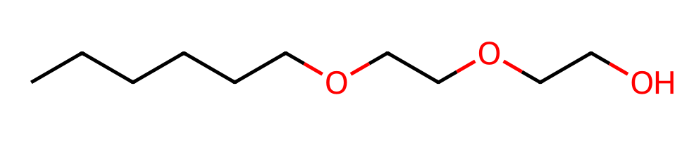

Figure 1. Representative chemical structure for the ethoxylated alcohol class (Ethanol, 2-[2-(hexyloxy)ethoxy]- (CAS RN 112-59-4))

Hazards and risks to the environment
The Australian Industrial Chemicals Introduction Scheme (AICIS) evaluated the environmental risk of the class of chemicals in 2025. The evaluation categorised all chemicals in this class as not persistent (nP) and not bioaccumulative (nB) according to the Australian Environmental Criteria for Persistent, Bioaccumulative and/or Toxic Chemicals. Some chemicals in the class are categorised as toxic (T), with GHS classifications for acute toxicity ranging from Category 1 to 2 and chronic toxicity from Category 2 to 3.
The chemicals in this class are typically released to sewers through normal use and have the potential to cause toxic effects in aquatic organisms. All chemicals in this class rapidly degrade in the environment. The AICIS evaluation concluded that ethoxylated alcohols are expected to be present in Australian surface waters at concentrations below the level of concern.
The AICIS 2025 evaluation concluded the current industrial use of these chemicals in Australia is not expected to pose a significant risk to the environment.

Introduction and use of ethoxylated alcohols in Australia
Ethoxylated alcohols are used as surfactants in a wide variety of consumer, commercial products and articles, including adhesives and sealants, air fresheners, apparel and footwear care products, cleaning and furniture care products, fuels and related products, lubricants and greases, paints and coatings, paper products, and personal care products. Cumulative annual use in Australia may reach up to 9,999 tonnes.
The chemicals in this class have similar industrial uses and similar environmental release patterns. They are primarily released to surface water from sewage outfall. Direct or diffuse release of ethoxylated alcohols to the environment may occur through niche uses, such as when used in car washing products. The chemicals are used in high volumes worldwide. All are expected to have broad commercial use in processing industries such as pulp and paper, the textiles, and the chemicals.
Ethoxylated alcohols have been identified as substitutes for nonylphenol and octylphenol ethoxylates in oil and gas extraction operations.

References
AICIS (Australian Industrial Chemicals Introduction Scheme) (2025), Ethoxylated alcohols: Evaluation Statement, accessed on 1 March 2025.

More information
Email ichems.enquiry@dcceew.gov.au
Web https://www.dcceew.gov.au/environment/protection/chemicals-management/national-standard

