26 August 2025
Chemical profile

Medium and long chain alkyl sulfates

Summary
- The chemicals are a group of 54 structurally similar, medium to long chain (C₆ ─ C₂₀) alkyl sulfates and alkyl sulfuric acids that are used in high volumes in Australia as anionic surfactants in various domestic and commercial products.
- The chemicals are used in personal care products, household cleaning products, fire-fighting foams and chemical and polymer manufacture.
- The chemicals in this group are expected to be of low risk to the environment.
- The chemicals in this group are a priority for scheduling due to their high-volume usage in Australia.

Chemical identity
Chemicals in this group are of structurally similar, medium to long chain (C₆ ─ C₂₀) alkyl sulfates and alkyl sulfuric acids. These chemicals have been placed in a group as they have similar use patterns and produce alkyl sulfate anions with similar environmental effects when released to the environment.
- Chemical class name: Medium and long chain alkyl sulfates
- CAS registry numbers: 142-31-4 and 53 others (See CAS RN list)
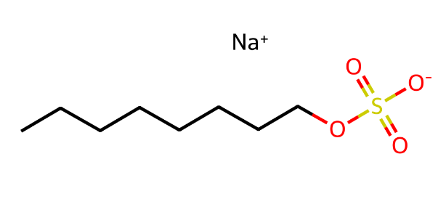
Figure 1 - Representative chemical structure for the medium and long chain alkyl sulfates group (sodium octyl sulfate, CAS RN 142-31-4)

Hazards and risks to the environment
The Australian Industrial Chemicals Introduction Scheme (AICIS) evaluated the environmental risk of the class of chemicals in 2024. All chemicals in this group are categorised as not persistent (nP) and not bioaccumulative (nB) according to the Australian Environmental Criteria for Persistent, Bioaccumulative and/or Toxic Chemicals. Most of the chemicals in this group are not toxic (nT). C14 and C16 alkyl sulfates are categorised as toxic (T) according to Australian thresholds. All chemicals are classified under the Globally Harmonized System of Classification and Labelling of Chemicals (GHS) for environmental hazards.
Alkyl sulfates are expected to be present in Australian surface waters at concentrations below the level of concern. The AICIS assessment derived a risk quotient (RQ) based on modelled concentrations in surface water of 0.016.
The chemicals in this group have comparable hazard and risk properties to lauryl sulfates already scheduled under the ICHEMS.

Introduction and use of medium and long chain alkyl sulfates in Australia
Medium and long chain alkyl sulfates are used as surfactants in a range of consumer and industrial products. The chemicals in this group were assessed for their use as surfactants in personal care products, household cleaning products, fire-fighting foams and chemical and polymer manufacture.
Based on information provided in the environmental risk assessment, the chemicals in this group have a use volume in the thousands of tonnes per year in Australia. The concentrations of the surfactants in products vary from 5 to 30%.
The medium and long chain alkyl sulfates group are used in the following products:
- Personal care products
- Cleaning and furniture care products
- Automotive care products
- Laundry and dishwashing products
- Fabric, textile and leather products
- Paint and coating products
- Ink, toner and colourant products
- Adhesive and sealant products
- Plastic and polymer products
- Photographic products
- Anti-freeze and de-icing products
- Fire-extinguishing products

References
AICIS (Australian Industrial Chemicals Introduction Scheme) (2024), Medium and long chain alkyl sulfates, Evaluation Statement [EVA00146], 26 June 2024, AICIS, accessed 22 May 2025

More information
Email ichems.enquiry@dcceew.gov.au
Web https://www.dcceew.gov.au/environment/protection/chemicals-management/national-standard

