26 August 2025
Chemical profile

Parabens

Summary
- The chemical group consists of eighteen esters of para-hydroxybenzoic acid (pHBA). Parabens are used as antimicrobial preservatives in cosmetics, personal care products and surface coatings.
- Parabens are biodegradable and have a low bioaccumulation potential. Short chain parabens (methyl-, ethyl-, propyl- etc.) have a moderate aquatic toxicity where the long-chain parabens (e.g., lauryl-, heptyl-) have higher aquatic toxicity.
- Parabens are a priority for scheduling to manage any potential risks to the environment.

Chemical identity
This group contains 18 chemicals that are members of a chemical class called parabens. They are all alkyl esters of para-hydroxybenzoic acid. Alkyl chain lengths range from short chain (methyl-, ethyl-, propyl- and butyl) to long chain (heptyl-, octyl-, lauryl). The group includes a benzyl ester, as well as some salts of the short chain homologues.
- Chemical class name: Parabens
- CAS registry number: Group of 18 chemicals (see CAS RN list)
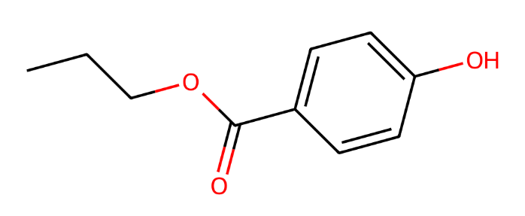
Figure 1. Representative chemical structure for the paraben group (propylparaben, CAS RN 94-13-3)

Hazards and risks to the environment
The National Industrial Chemicals Notification and Assessment Scheme (NICNAS) assessed the environmental risk of the class of chemicals in 2017. The assessment concluded that all chemicals in this group are not persistent (nP) under the Australian Environmental Criteria for Persistent, Bioaccumulative and/or Toxic Chemicals (PBT). All chemicals in this group were categorised as not bioaccumulative (nB), except for laurylparaben which may be bioaccumulative (B). Heptylparaben, octylparaben, isooctylparaben, and benzylparaben are categorised as toxic (T) to aquatic organisms. The other chemicals in the group are not toxic (nT).
Emission of the chemicals to the environment primarily occurs via domestic and industrial wastewater discharge. Products containing parabens enter sewage systems through normal consumer use. Sewage treatment plants are effective at removing parabens, achieving over 90% reduction through biodegradation and sludge adsorption. Trace amounts may persist in treated effluent and biosolids, which are sometimes applied to land. These residues can lead to minor contamination of surface water and soil. In general, environmental concentrations remain below harmful levels.
Estimated Risk Quotient (RQ) values for the short chain parabens exceed 0.1, indicating potential concern. Ethylparaben, benzylparaben, heptylparaben, isooctylparaben, and octylparaben, have estimated RQ values greater than 1 based on conservative emission assumptions, however, these values likely overestimate the risk to surface waters in Australia. Ethylparaben may have point source releases that pose a hazard to localised water systems, but dispersive release of this chemical to Australian surface waters is not expected to be of concern. The long chain parabens are unlikely to pose a concern based on their low use volumes and low potential for release.

Introduction and use of parabens in Australia
In Australia, short chain parabens have been reported to be used as antimicrobial preservatives in personal care products. Additionally, methylparaben and propylparaben are used in paints and coatings. These chemicals are also commonly used in personal care products, cleaning and furnishing care products, and adhesives and sealants based on international use information. The long chain parabens are expected to be used in similar products, but at a much lower volume.

References
NICNAS (National Industrial Chemicals Notification and Assessment Scheme) (2017), Parabens: Environment tier II assessment, accessed on 27 February 2025.

More information
Email ichems.enquiry@dcceew.gov.au
Web https://www.dcceew.gov.au/environment/protection/chemicals-management/national-standard

