26 August 2025
Chemical profile

Phthalate esters

Summary
- The phthalate esters class comprises 15 chemicals that are ortho-phthalate diesters.
- Phthalate esters are used to increase the flexibility of plastics such as polyvinyl chloride (PVC), rubber, cellulose and polystyrene. The chemical loading of phthalate esters can be high; plasticised PVC can contain 30-60% plasticiser by weight.
- These chemicals are found in a variety of articles and chemical products including construction materials (adhesives, sealants and caulk), cosmetics (nail enamel, hair spray), coatings (sealants, paints, varnish), lubricants, printer ink, and de-foaming agents for paper manufacture.
- The chemicals mostly enter the environment from weathering of articles or coated surfaces that contain phthalate esters.
- The Commonwealth environmental risk assessment concluded that none of the phthalate esters in this class are bioaccumulative. Those with side-chains containing fewer than 8 carbon atoms are not persistent, while those with side-chains containing 8 or more carbon atoms are persistent. The assessment concluded that all chemicals are either toxic or have uncertain toxicity properties to aquatic organisms.
- Phthalate esters are a priority for scheduling to manage risks to the environment from their high volume use in a wide range of plastics in Australia.

Chemical identity
For the purposes of scheduling under the IChEMS, the phthalate esters have been divided into two standards based on their hazard properties. Dibutylphthalate, di(2-ethylhexyl)phthalate and diisooctylphthalate have schedule 5 hazard characteristics and the short chain alkyl- and aryl- phthalates have schedule 4 hazard characteristics. Both standards apply to the same industrial end uses.

- Standard 1 chemical class name: Dibutylphthalate, di(2-ethylhexyl)phthalate and diisooctylphthalate
- Standard 2 chemical class name: Short chain alkyl- and aryl- phthalates
- CAS registry number: Total of 15 CAS RNs (see CAS RN list).
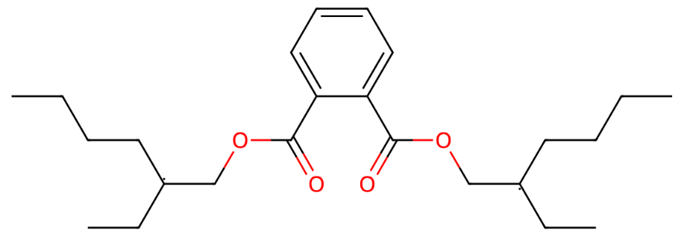
Figure 1. Representative chemical structure for the phthalate esters class (di(2-ethylhexyl)phthalate (DEHP, CAS RN 117-81-7).

Hazards and risks to the environment
The National Industrial Chemicals Notification and Assessment Scheme (NICNAS) published an environmental risk assessment of phthalate esters in 2019.
Two of the chemicals in this class, di(2-ethylhexyl)phthalate (DEHP) and diisooctylphthalate (DIOP), are persistent (P) in the environment. The remaining chemicals are not persistent (nP). The assessment concluded that all chemicals in the class are not bioaccumulative (nB). Six of the chemicals in this class were categorised as toxic (T) based on experimental toxicity endpoints in aquatic organisms.
The largest releases to the environment are expected to result from the weathering of products or coated surfaces that contain these chemicals. Environmental emissions of phthalate esters may also occur at industrial manufacturing sites.
The assessment concluded that the current scale of industrial use of dibutylphthalate (DBP) and DEHP results in environmental concentrations that may cause adverse outcomes in aquatic organisms. Of these, DEHP was identified as carrying a particular risk; this chemical has high chronic toxicity and endocrine activity that is sufficient to cause adverse outcomes in fish at environmentally relevant exposure concentrations.

Introduction and use of phthalate esters in Australia
Phthalate esters are used as plasticisers to increase the flexibility, and therefore utility, of plastics. Their main use is as a plasticiser in polyvinyl chloride (PVC) where their chemical loading can be very high; plasticised PVC can be composed of 30-60% plasticiser by weight. Plasticised PVC is used to make a wide range of articles including food packaging, toys, vinyl upholstery, flooring, electrical cables, and pipes.
Phthalate esters are also used to improve the functionality of rubber, cellulose, polystyrene, and other chemical products. They are also added to construction materials (adhesives, caulk, filling materials), cosmetics and fragrances (nail enamel, hair spray, perfume), coatings (sealants, paints, varnish, lacquer), lubricants, printer ink, and de-foaming agents for paper manufacture.
Several of the chemicals in this class have large use volumes in Australia. Di(2-ethylhexyl)phthalate has use volumes of 10,000 – 99,000 tonnes per year, and DBP and butylbenzylphthalate (BBzP) have use volumes of 100 – 999 tonnes per year. It is expected that the remaining chemicals in the class have use volumes of less than 100 tonnes per year.

Regulation of phthalate esters in Australia
Phthalate esters are not currently subject to environmental regulation in Australia.
Both DEHP and DBP are subject to reporting under the Australian National Pollutant Inventory (NPI). Annual reporting for emissions of more than 10 tonnes of either chemical is required.
The Australian Competition and Consumer Commission (ACCC) has placed a ban on products containing DEHP (more than 1% by weight or 10,000 mg/kg) that can be mouthed by children, such as toys and feeding products, for children aged up to and including 36 months.
Five of the phthalate esters in this class (dimethoxyethylphthalate (DMEP), diisobutylphthalate (DIBP), DBP, DEHP and BBzP) are listed on schedule 10 of the Therapeutic Goods (Poisons Standard – June 2025) Instrument 2025 (authorised by the Therapeutic Goods Act 1989), which prohibits their use in cosmetic products.
The Australian Drinking Water Guidelines recommends a limit of 0.01 mg/L of DEHP in Australian drinking water.

References

ACCC 2025, DEHP in children’s plastic items ban, The Australian Competition and Consumer Commission, Commonwealth of Australia. Accessed 03 July 2025.
ANZECC & ARMCANZ 2000, Toxicant default guidelines values for the protection of aquatic ecosystems, Australian and New Zealand Guidelines for Fresh and Marine Water Quality (2018 revision). Accessed 16 April 2025.
DCCEEW 2022a, Australian Environmental Criteria for Persistent, Bioaccumulative and/or Toxic Chemicals, Department of Climate Change, Energy, the Environment and Water, Commonwealth of Australia. Accessed 10 February 2025.
DCCEEW 2022b, Substance fact sheet – Di-(2-Ethylhexyl) phthalate (DEHP), National Pollutant Inventory, Department of Climate Change, Energy, the Environment and Water, Commonwealth of Australia. Accessed 16 April 2025.
DCCEEW 2022c, Substance list and thresholds, National Pollutant Inventory, Department of Climate Change, Energy, the Environment and Water, Commonwealth of Australia. Accessed 19 May 2025.
EC & HC 2000, Canadian Environmental Protection Act Priority Substances List Assessment Report – Butylbenzylphthalate, Environment Canada and Health Canada, Government of Canada. Accessed 16 May 2025.
LCSP 2011, Phthalates and their Alternatives: Health and Environmental Concerns, Lowell Centre for Sustainable Production, at the University of Massachusetts Lowell. Accessed 03 July 2025.
NHMRC & NRMMC 2011, Australian Drinking Water Guidelines Paper 6 National Water Quality Management Strategy, National Health and Medical Research Council, National Resource Management Ministerial Council, Commonwealth of Australia. Accessed 16 April 2025.
NICNAS 2019, Phthalate esters: Environment tier II assessment, 08 March 2019, National Industrial Chemicals Notification and Assessment Scheme, Department of Health, Commonwealth of Australia. Accessed 03 July 2025.
Van Vliet, EDS; Reitano, EM; Chhabra, JS; Bergen, GP & Whyatt, RM 2011, A review of alternatives to di (2-ethylhexyl) phthalate-containing medical devices in the neonatal intensive care unit, Journal of Perinatology, 31, 551 – 560. Accessed 03 July 2025.
VCA 2025, Making PVC Products – Plasticisers for Flexibility, Vinyl Council of Australia. Accessed 19 May 2025.

More information
Email ichems.enquiry@dcceew.gov.au
Web https://www.dcceew.gov.au/environment/protection/chemicals-management/national-standard

